Formal Model and System Architecture
Contextual Lexical Knowledge Graph and Adaptive Practice System

1. Correcting the Initial Graph Model
The first version of the model implicitly treated the graph as a derivation chain (increase → rise → grow), as if one word produced another. This is linguistically incorrect and was revised before further design work continued. Four statements replace it:
- Lexical items are not derived from one another. The graph represents relations between senses, not an ontology in which one word generates the next.
- A searched word is a query entry point into a locally retrieved neighborhood, not a root node. No anchor word is required for the graph to be well-formed.
- A single undifferentiated “synonym” relation is insufficient. Relations between senses differ in kind (synonymy, near-synonymy, register shift, intensity shift, paraphrase, grammatical transformation, hypernymy, hyponymy, antonymy) and must be typed explicitly.
- The object being modeled is contextual substitutability — whether sense A can replace sense B in a specific sentence — not synonymy as an abstract, context-free property.
Consequently, the internal linguistic graph and the learner-facing graph are kept distinct: the system can retrieve and reason over a richer, fully typed network, while the interface exposes only the subset of relations (synonym, near-synonym, paraphrase, register shift) needed for a given task.
A fifth statement resolves why two senses are considered for comparison at all, and revises the answer given in an earlier draft of this chapter. WordNet already groups senses that share an exact meaning into synsets; reusing that structure directly as a semantic concept gives the same justification for free, without building a separate clustering pipeline. A semantic cluster — a named, curated grouping such as an IELTS topic bundle that can span several different concepts — remains a legitimate idea, but it answers a different question (how should this content be organized for a learner) and is kept as an optional, application-level layer outside the linguistic core, not as MVP-critical infrastructure.
This substitution has a limit worth stating plainly: WordNet synsets group only strict synonyms, so most of the relations this project actually cares about — near-synonyms, intensity shifts, register shifts — connect senses that sit in different concepts. Semantic concepts explain within-concept neighborhoods; cross-concept relations still require the candidate-generation and human curation pipeline described in the following chapters. The concept layer removes one unnecessary engineering step; it does not remove the need for the rest of the pipeline.
A further limit applies to edge typing specifically. WordNet is a reliable source for SYNONYM, HYPERNYM, HYPONYM, and ANTONYM — two senses in the same synset are, by WordNet's own definition, synonyms, not merely “near” synonyms, and the model's typing must say so rather than hedge. WordNet is not an authoritative source for REGISTER_SHIFT, an intensity-shift relation, PARAPHRASE, or COLLOCATION_ALTERNATIVE; those require corpus evidence, embedding neighborhoods, and curator judgment, and are never asserted on WordNet's authority alone.

2. Formal Definitions
Let a word sense be defined as:
S = (lemma, POS, gloss, CEFR, frequency, examples)
A semantic concept groups senses that share a WordNet synset, established directly from the imported lexical resource rather than a derived clustering algorithm:
C = (synset_id, definition, source = “WordNet”), belongs_to: S → C
Let a lexical edge between two senses Si and Sj be typed, and directed by convention rather than by uniform rule:
E(Si, Sj, type), type ∈ {SYNONYM, NEAR_SYNONYM, PARAPHRASE, REGISTER_SHIFT, GRAMMATICAL_TRANSFORMATION, COLLOCATION_ALTERNATIVE, HYPERNYM, HYPONYM, ANTONYM}
Symmetric types (NEAR_SYNONYM, ANTONYM) are stored with directed = false; directional types (HYPERNYM, HYPONYM, REGISTER_SHIFT, and any intensity-shift relation) default to directed = true. This is a curation-time convention applied through the directed flag already present on every edge in the domain model — it does not require a schema change.
Each edge carries two distinct scores, not one. A raw semantic similarity, produced directly from sentence embeddings, indicates only that two senses occupy nearby regions of meaning space:
semantic_similarity(E) ∈ [0, 1]
A separate base substitutability discounts that similarity by edge type before any context is considered. This distinction matters because high semantic similarity does not imply substitutability: “car” and “vehicle” are closely related but stand in a hypernym relation, not a substitution one, and a system that treated embedding closeness as the final answer would recommend replacing one with the other in running text. Base substitutability is therefore capped by edge type (informational relations such as hypernym/hyponym are capped low regardless of similarity) and adjusted using corpus collocation evidence before curator review:
base_substitutability(E) = g(semantic_similarity(E), edge_type(E), collocation_evidence(E)) ∈ [0, 1]
Contextual suitability C(E, x) refines base substitutability further for a specific context x (a sentence or grammatical frame), as a weighted combination of five measurable dimensions:
C(E, x) = w₁·semantic + w₂·grammar + w₃·collocation + w₄·register + w₅·naturalness
Weights are part-of-speech dependent. For verbs, grammar compatibility is weighted more heavily (0.30) because frame mismatches are the dominant source of error; for nouns, collocation compatibility is weighted more heavily (0.30) for the same reason applied to noun–modifier pairing. The baseline (adjective/general) distribution is 0.35 / 0.25 / 0.20 / 0.10 / 0.10 across the same five dimensions. Not every dimension is measurable for every context in practice; the service layer returns the aggregate score together with the per-dimension breakdown and an explicit confidence value, rather than presenting all five as always populated.
Learner mastery of a given edge, for user u at time t, is a decayed function of past attempts. The decay must be written so that the stated half-life is the actual half-life, not merely a time constant with the same units:
M(E, u, t) = α · M(E, u, t′) · 2^(−Δt / H) + (1 − α) · attempt_score
with H = 14 (a true 14-day half-life, unlike an earlier draft's e^(−Δt/14), whose actual half-life works out to about 9.7 days — a real error, corrected here), attempt_score equal to 1.0 / 0.5 / 0.0 for correct / partial / incorrect answers, and α = 0.75. The coefficient α is an initial hyperparameter chosen for the prototype, not an empirically validated constant; the diploma's experimental chapter is the appropriate place to test whether a different split between prior state and new evidence performs better.
Context mastery is the same construct applied at finer grain, keyed explicitly to a context rule rather than to an unstructured notion of “context”:
M_C(u, E, r, t) ∈ [0, 1], r ∈ ContextRule
so that a learner can be shown, concretely, to know increase→rise works for prices while still being unreliable for interest rates — each a distinct ContextRule, not a free-text label.
Future direction, not implemented in the MVP: once sufficient attempt data exists, the deterministic C(E, x) and M(E, u, t) formulas above could be supplemented by a fitted model estimating P(appropriate choice ∣ u, e, x) directly from learner data. The MVP deliberately uses transparent, hand-verifiable formulas instead of a learned estimator, since a diploma-stage system needs scores a reviewer can check by hand, not a black-box prediction — this is a direction for future work, not a gap in the current design.

3. Domain Model
The domain model separates eleven entities, summarized below, falling into three groups: a global linguistic graph (WordSense, SemanticConcept, LexicalEdge, ContextRule, TransformationRule) that is true independent of any learner; a learning system (Exercise, Attempt, EdgeMastery, ContextMastery) that is personal to each learner; and content management (SemanticCluster, ContentVersion) that governs how content is organized and published. Exercises, attempts, and mastery are deliberately not modeled as part of the linguistic graph itself — the graph does not know who is learning from it.
Entity | Purpose | Key attributes
WordSense | Atomic node of the graph: one meaning of one lemma, not the surface word itself. | lemma, POS, gloss, CEFR level, frequency rank, example sentences, concept id
SemanticConcept | An imported semantic grouping used as a stable reference point for senses, initially represented one-to-one with a WordNet synset — not a claim that WordNet supplies the project's complete semantic representation. | synset id, definition, source
SemanticCluster | An optional, curated pedagogical grouping (e.g. an IELTS topic bundle) that may span multiple semantic concepts. Deferred outside MVP scope and kept separate from linguistic truth. | name, description (membership curated manually if/when built)
LexicalEdge | A typed relation between two senses — referred to in prose as a lexical relation, since different types (synonymy, register shift, grammatical transformation) are different kinds of things, not variations on one relation. Stored as lexical_edges for consistency with the API and pipeline. Directed by convention (symmetric for SYNONYM/NEAR_SYNONYM/ANTONYM, directional otherwise). | source sense, target sense, edge type, directed flag, semantic similarity, base substitutability, curator status
TransformationRule | Grammatical mapping required when an edge is not a drop-in substitution. | source frame, target frame, operations, before/after example
ContextRule | Constraints under which an edge is valid, plus the graded suitability breakdown and the authored explanation used when a learner picks a poor fit for that context. | frame, subject/object type, register, context score, suitability breakdown, valid/invalid examples, explanation, fine-grained constraints (preposition, domain, intensity) where relevant
Exercise | A single test item anchored to a real sentence context. | type, target sense, related edges/rules, prompt, correct/partial/incorrect options, explanation, review status
Attempt | One learner response to one exercise, classified by a controlled reason-code vocabulary rather than a bare pass/fail flag. | exercise id, selected sense, score, status (correct/partial/incorrect), reason code
EdgeMastery | How well a learner distinguishes and uses a given lexical relation in general. | user id, edge id, confidence, attempt count, last tested, next review
ContextMastery | How well a learner applies a given relation under one specific contextual condition — keyed to a ContextRule, not to a generic notion of “context.” | user id, edge id, context_rule id, confidence, attempt count, last tested, next review
ContentVersion | Versioning anchor for every published edge, rule, and exercise. | version id, published date, notes

Attempt is classified by a controlled reason-code vocabulary rather than a bare correct/incorrect flag, since these codes are consumed twice: once to generate the learner-facing “why not” explanation, and again as raw data for the diploma's evaluation chapter, where error-type frequency (for example, how often WRONG_COLLOCATION occurs relative to WRONG_REGISTER) is itself a reportable result.
- WRONG_SENSE, WRONG_GRAMMAR, WRONG_PREPOSITION, WRONG_COLLOCATION, WRONG_REGISTER, WRONG_INTENSITY, PARTIAL_MEANING, UNNATURAL, VALID_BUT_LESS_APPROPRIATE
The “why not” response returned to a learner is a computed object, not a separately persisted entity: it is assembled at request time from the learner's Attempt, the matched ContextRule (including that rule's own authored explanation field), and the reason code, then paired with the rule's valid examples as better alternatives. The one exception is deliberate: a context rule's explanation field is still curator-authored, because a specific, well-written explanation (“ESTABLISH ≠ IMPLEMENT — implement means to put a plan into effect”) teaches more than an explanation generated generically from a reason code alone, and that authored text belongs on the rule that all future occurrences of the same mistake reuse.

4. System Architecture
The system is organized in five layers: a Next.js frontend; a FastAPI service layer exposing graph, exercise, and mastery services; a PostgreSQL store holding senses (linked to their WordNet-derived semantic concepts), edges, rules, exercises, attempts, and mastery records; an offline knowledge pipeline that produces candidate content from lexical and corpus resources; and a mandatory human-review step before any content is published.
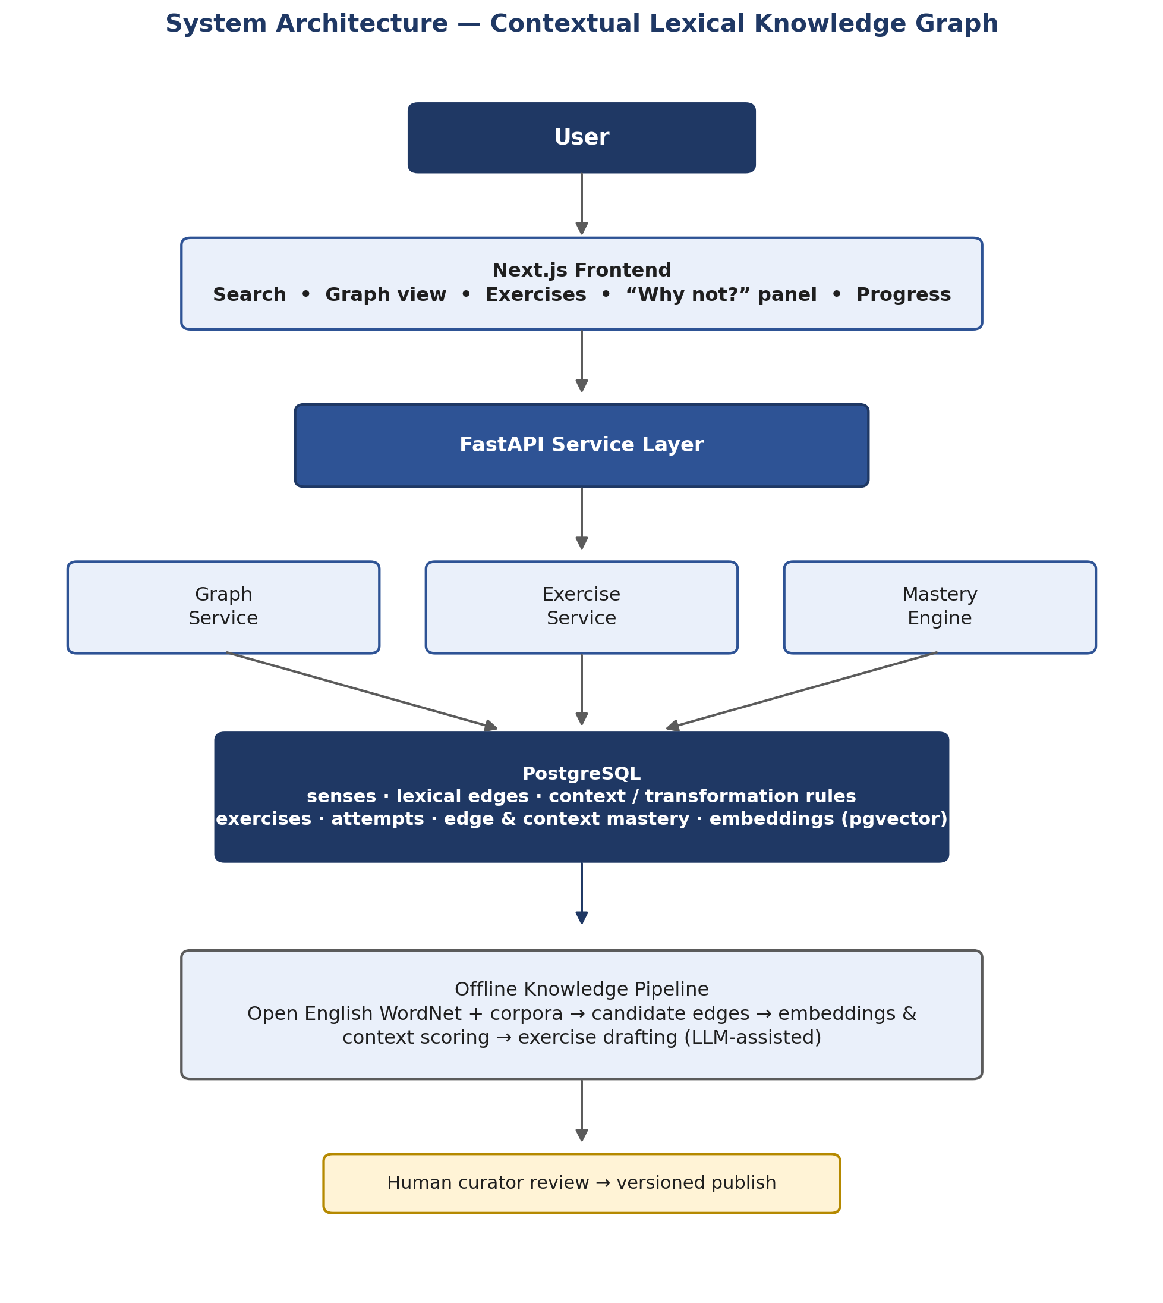
Figure 1. System architecture of the contextual lexical knowledge graph.
Two properties of this architecture are deliberate design decisions, not defaults:
- The offline pipeline is batch-run and versioned, not a live model call. Every edge, rule, and exercise a learner sees has already passed human curation, which is what allows the system to make truth claims about lexical correctness rather than probabilistic suggestions.
- The knowledge graph is the source of truth for correctness; deterministic NLP rules verify; a language model, where used, is restricted to generating explanations and drafting candidate content for review — it does not decide whether a substitution is valid.
- Embeddings answer only “is this pair worth a curator's attention,” never “are these senses substitutable.” Semantic similarity shortlists candidates; edge typing, corpus evidence, and human review decide substitutability — the pipeline is never allowed to collapse a high similarity score directly into a synonym judgment.

5. Locked Technical Decisions
The following decisions are treated as fixed for the MVP; each has an explicit condition under which it should be revisited rather than an open-ended “maybe later.”
Decision | Choice | Rationale
Lexical backbone | Open English WordNet | Sense-oriented structure by design; avoids treating a general knowledge graph as a linguistic resource
Primary storage | PostgreSQL | 1–2 hop graph queries are well within adjacency-table performance; avoids a second database to operate and test
Graph database | Not used initially (Neo4j deferred) | Justified only if traversal depth, graph size, or graph-algorithm needs grow beyond the MVP
Vector search | PostgreSQL + pgvector | Avoids running a separate vector database before there is a proven need for one
AI role | Assistant, not source of truth | The knowledge graph and deterministic rules decide lexical correctness; models draft content and generate explanations, subject to human review
LLM dependency | Optional; MVP runs on a template-only provider | The core product must function without any external LLM API

6. MVP Scope
The MVP is deliberately narrow in domain and broad in depth: it targets IELTS and academic English vocabulary rather than general English, and prioritizes a small number of high-quality, human-reviewed items over broad automatic coverage.
- First prototype: 50–100 senses, 100–200 edges, 30–50 context rules, 20–30 exercises — sufficient to validate the graph interaction and the “Why not?” feedback loop.
- MVP release: 300–500 senses, 1,000–2,000 edges, 100–300 context rules, 100–300 exercises, still confined to core academic vocabulary.
- Explicitly excluded from the first release: a graph database, a separate vector database, a general-purpose LLM framework, community content editing, and a mobile client.

7. Risks and Mitigations
Risk | Mitigation
Attempting to model all of English | Scope the MVP to IELTS / academic English vocabulary only
Noisy synonym data | Treat WordNet as a starting point, not ground truth; require human review before publication; store counterexamples alongside examples
Unreliable LLM feedback | Keep the scoring core deterministic; ground any generation in retrieved graph data; maintain a labeled evaluation set before deploying model-based judging
Visually overwhelming graph | Limit traversal depth by default; show only synonym/near-synonym/paraphrase edges unless the user opens the advanced view
Content becoming stale | Version every edge, rule, and exercise; invalidate or flag dependent exercises when an edge changes

8. Summary Statement
The system is formally defined as a directed, typed graph over word senses grouped into WordNet-derived semantic concepts, in which each edge carries both a context-independent substitutability score — split into raw semantic similarity and curated base substitutability — and a set of context-dependent suitability rules, and in which a personal mastery function tracks a learner's demonstrated command of each specific relation. This definition replaces the initial, linguistically unsound framing of the project as a chain of derived synonyms, reuses WordNet's own synset structure instead of a bespoke clustering pipeline wherever it already answers the question, and gives the diploma a model that is precise enough to implement, evaluate, and defend.

