BEE-TECH

HARDWARE-MANUAL

PROJECT DESCRIPTION 2

SYSTEM OVERVIEW 2

UNIT TYPES 2

UNIT COMMUNICATION 2

SCEMATICS 3

RE-UNIT 3

SCEMATICS 3

SENSORS 4

S1/S2: TEMPERATURE SENSOR 1 AND 2 4

S3: SOUND SENSOR 4

S4: WEIGHT SENSOR (SCALE) 4

# PROJECT DESCRIPTION

Bee-Tech is an opensource beehive-monitoring system. Designed to be further developed, it offers a basic approach to gather sensor data from one or multiple hives. This data is collected by one mobile unit and sent into the GSM Network, where it is processed.

For data processing and software, see the BeeTech software-manual.

# Ein Bild, das drinnen, aus Holz enthält. Automatisch generierte BeschreibungSYSTEM OVERVIEW

Figure 1: Schematic oft the location

Figure 2: Three Hives, the RE-Unit to the left

## UNIT TYPES

For the monitoring of each hive, one Logging-Unit is needed.   
There are two types of Logging-Units. The Normal ‘Unit’ and the ‘RE-Unit’ [radio-enabled]. Both Unit-types log their sensor-data onto an onboard SD-Card and can be used standalone, if no other communication is required.

## UNIT COMMUNICATION

The RE-Unit logs data onto the SD-Card AND publishes its data via a radio-module to any web-application server or database. In this case, a GSM Module is used to connect to the mobile network, since there is no Wifi on location.   
Alternatively, a Wifi or Lora-Module could be used instead of the GSM Module.

To monitor multiple hives, one RE-Unit can be combined with as many as 256 Units to form a chain. In this chain, the data of all the Units is collected via a serial bus and published by the RE-Unit. The SD-Card acts here as a backup or additional logging system.

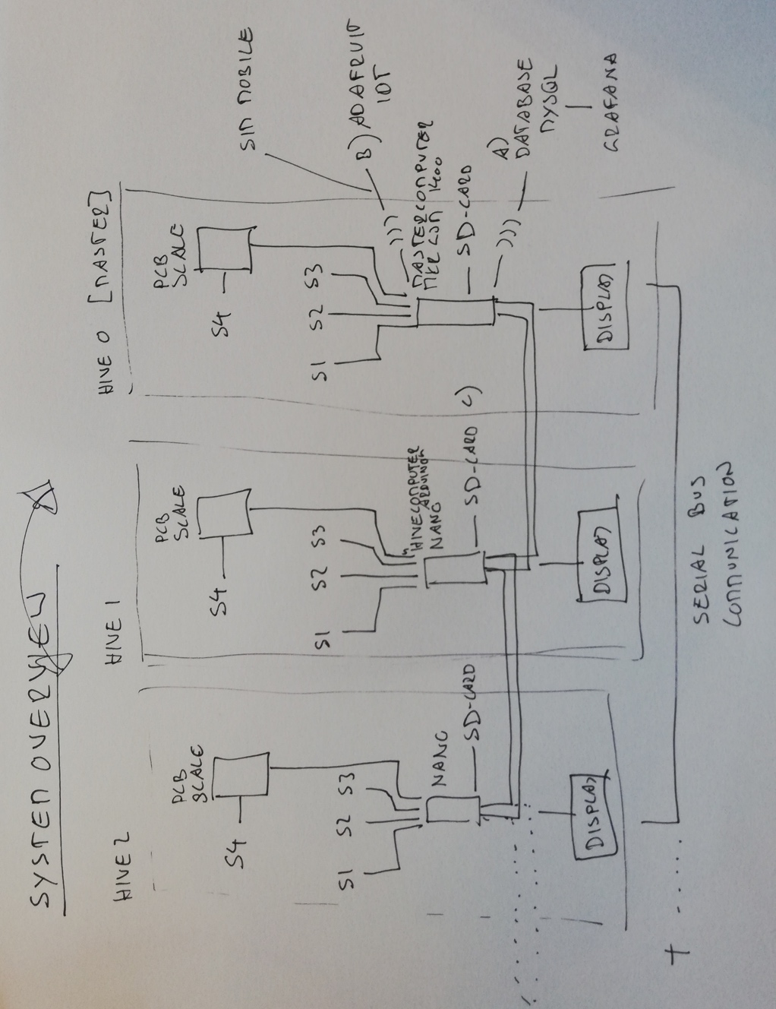UNIT

Figure 3: Component Overview

Every Unit and RE-Unit collects data via four different sensors: Temperature 1&2, Sound and Weight

## SCEMATICS

# RE-UNIT

Every Unit and RE-Unit collects data via four different sensors: Temperature 1&2, Sound and Weight

## SCEMATICS

# SENSORS

Every Unit and RE-Unit collects data via four different sensors: Temperature 1&2, Sound and Weight.

Additional sensors can be added through a fifth sensor-port, that has no set function yet??

## S1/S2: TEMPERATURE SENSOR 1 AND 2

For functional purpose there are two separate, identical temperature sensors, one Is suggested to use for monitoring the hive-temperature inside, one for outside-temperature.  
The selected sensors are stainless steel and waterproof.

The three cables are:

* VCC (red)
* Data (yellow)
* Ground (black)

Ein Bild, das Kabel enthält.
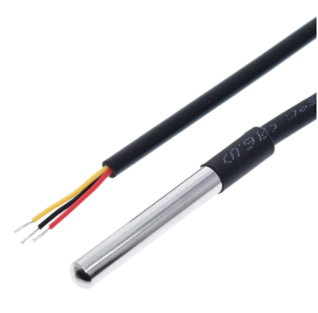

## S3: SOUND SENSOR

Lorem ipsum

## S4: WEIGHT SENSOR (SCALE)

The scale consists of four load cells, mounted on a flat, sturdy surface of your choice (ex.: coated plywood), in the measurements you need.

* Coated plywood x2
* Loadcells (+ load cell mount) x4
* Scale-PCB, including the HX711 x1

## 

## PLYWOOD

Double-sided coated plywood 530cm x 330cm x 9mm thickness, ordered in the local Hardware-shop (Coop Bau+Hobby). On top of the bottom one the four load-cells will be mounted, plus the PCB in the middle.

Ein Bild, das drinnen enthält.

Figure 4: RE-UNIT with scale on location, without the hive

## LOAD CELLS

Load cells with a capability of at least 50kg. ---which one did we use?----

**Tip**: Get loadcells that don’t have any protruding parts on the bottom. If they are completely flat, you can just tape them to the wood with strong double-sided tape. If you have protruding screws on the bottom (like we do), you need to see that the load cell frame is mounted a little higher to have the load cell lay flat on its frame. We used a 3D-printed little frame that we taped to the wood with double sided tape.

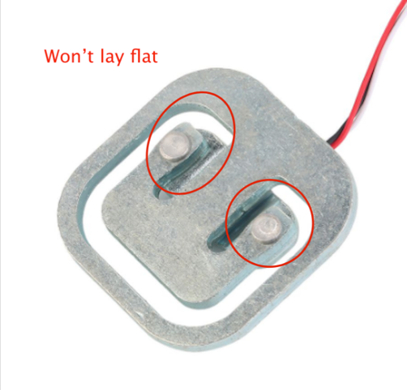 --- PICTURE OF THE 3D-PRINTED MOUNT---

CALIBRATION

For the calibration of the scale, see the software manual???