## Development and deployment guidelines



### Development guideline

#### Environment for development

☞ Laptop Dell Inprison

⮚ Integrated development environment:

• Visual Studio Code version 1.48.2

⮚ Node.js version 12.8.1

⮚ XAMPP 7.3.12

⮚ React-native-cli version 2.0.1

☞ Android Phone with Android 7.0

#### Setup development environment

##### *Install Visual Studio Code*

• Go to URL: <https://code.visualstudio.com/>, click on “Download” button, the Download page appears, choose the Windows package ( 32 bit or 64 bit, depends on the system ), the Save pop-up appears, click Save button to start download the installation file

Double click the file **“VSCodeUserSetup-x64-1.41.0.exe”** to start install Visual Studio Code



Figure 98 - Interface of Visual Studio Code

• Start using Visual Studio Code by opening it from Desktop

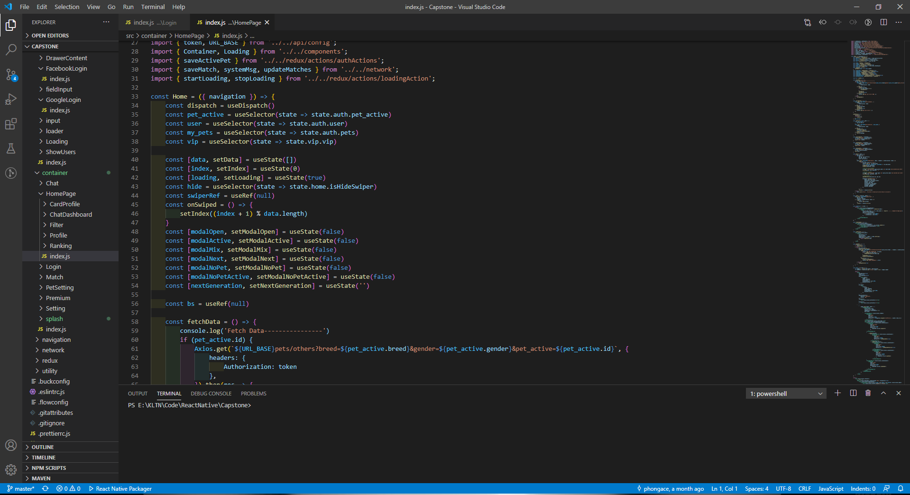

Figure 99 - Interface of Visual Studio Code

##### *Install Node.js version 12.8.1*

• Go to URL:<https://nodejs.org/en/download/releases/>, choose the 12.8.1 version and click Download, the Index page of the corresponding version appears, choose the [node-v12.8.1-win-x64.zip](https://nodejs.org/download/release/v10.16.3/node-v10.16.3-win-x64.zip) hyperlink, the Save pop-up appears, click Save button to start download the installation folder.



Figure 100 - Nodejs setup folder

Extract the folder **“node-v12.8.1-win-x64.zip”**

• Open the folder, double click the file **“node.exe”** to start install Nodejs.

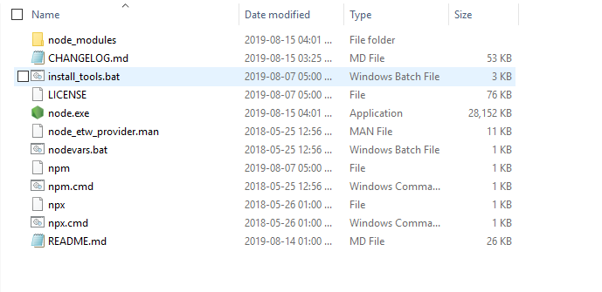

Figure 101 - Nodejs setup folder after extracting

• After the setup file running completely, check if Nodejs was installed successfully by opening Command Prompt and running the command “node -v”

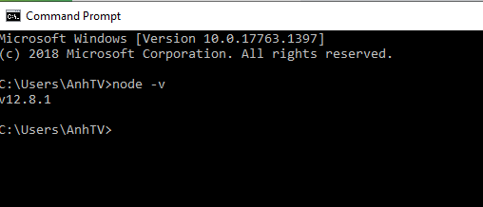

Figure 102 - Nodejs was installed succesfully

##### *Install react-native-cli version 2.0.1*

• Open Command Prompt and running the command “*npm install -g react-native-cli*”



Figure 105 - Command for installing expo-cli

• After the command running succesfully, check if expo-cli was installed successfully by running the command “*react-native -v*”



Figure 106 - expo-cli was installed succesfully

### Deployment guideline

#### Environment for deployment

☞ Heroku.com

☞ Google Firebase with following services:

⮚ Authentication

⮚ Realtime Database

#### Setup deployment

##### *Set up hosting on Heroku.com*

• Go to <https://heroku.com> to create an account

• Go to <https://heroku.com> to create app

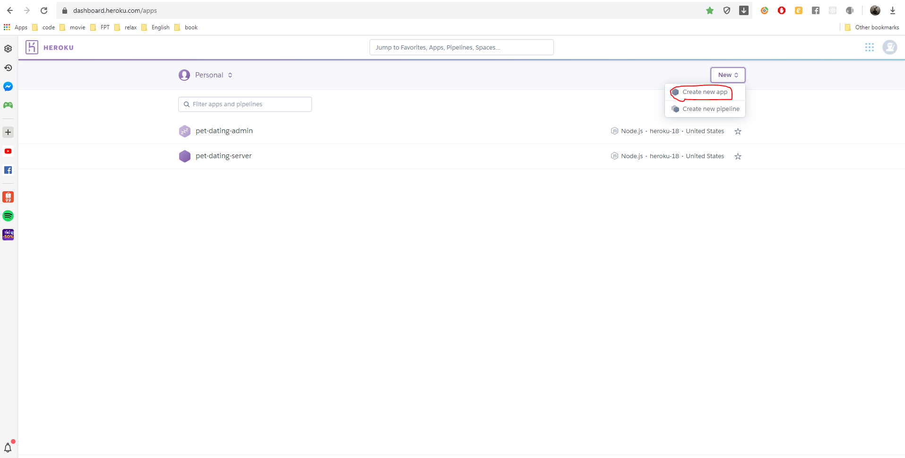

Figure 109 - Create application interface on Heroku.com

• Enter app name and press Create app button

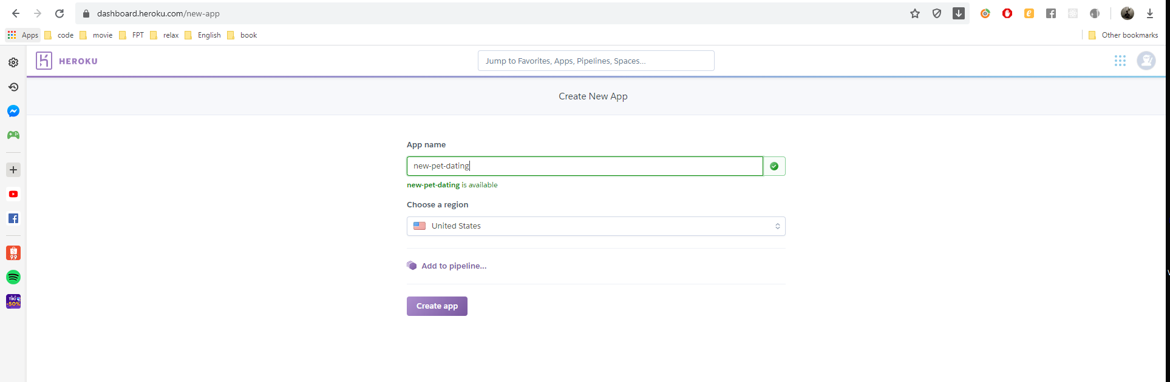

Figure 110 – create app interface

• Enter app name and press Create app button and do follow guideline to setup Heroku environment

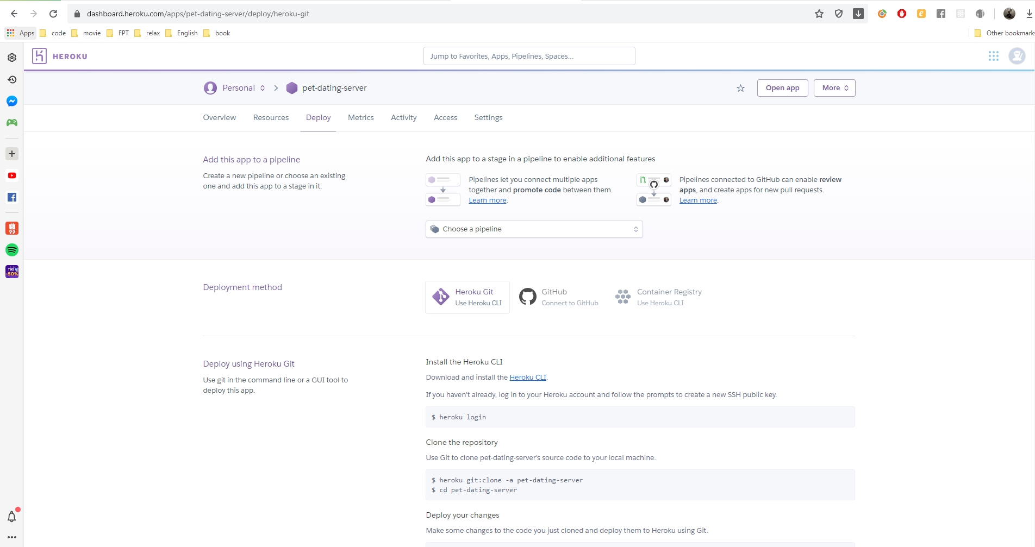

Figure 111 – deploy interface

• Go to folder contain source code, open command line and enter ‘git push heroku master’

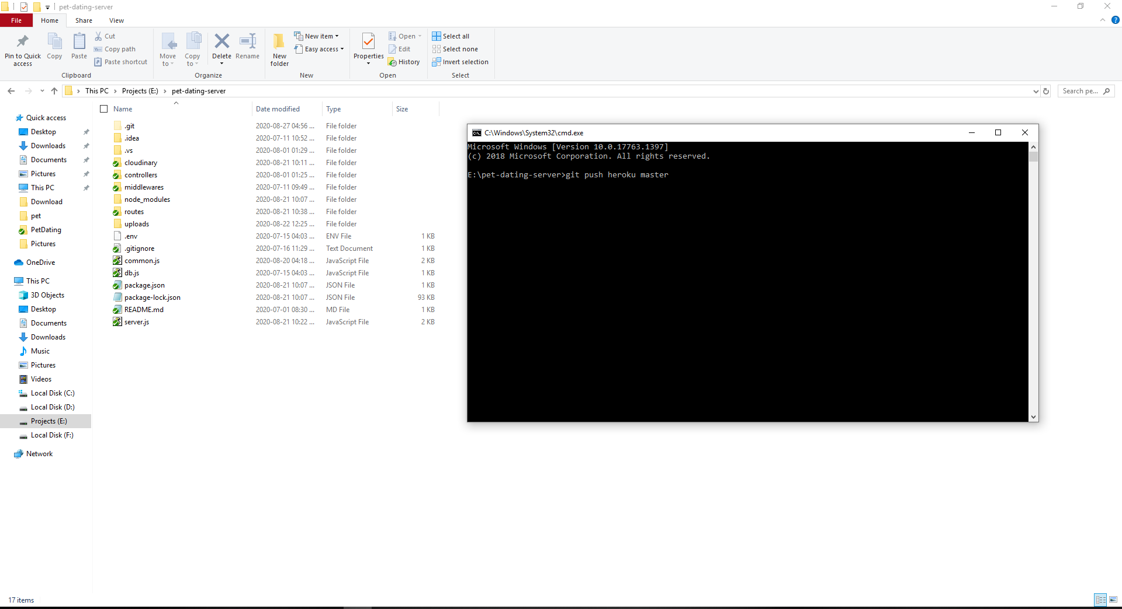

Figure 112 – deploy command line

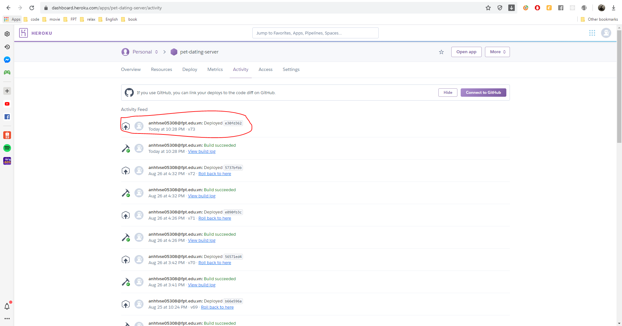

Figure 113 – result interface

##### *Set up services of Google Firebase*

• Go to <https://console.firebase.google.com/u/0/> and signing in with Google account

• Click Add project to create a project with Firebase console

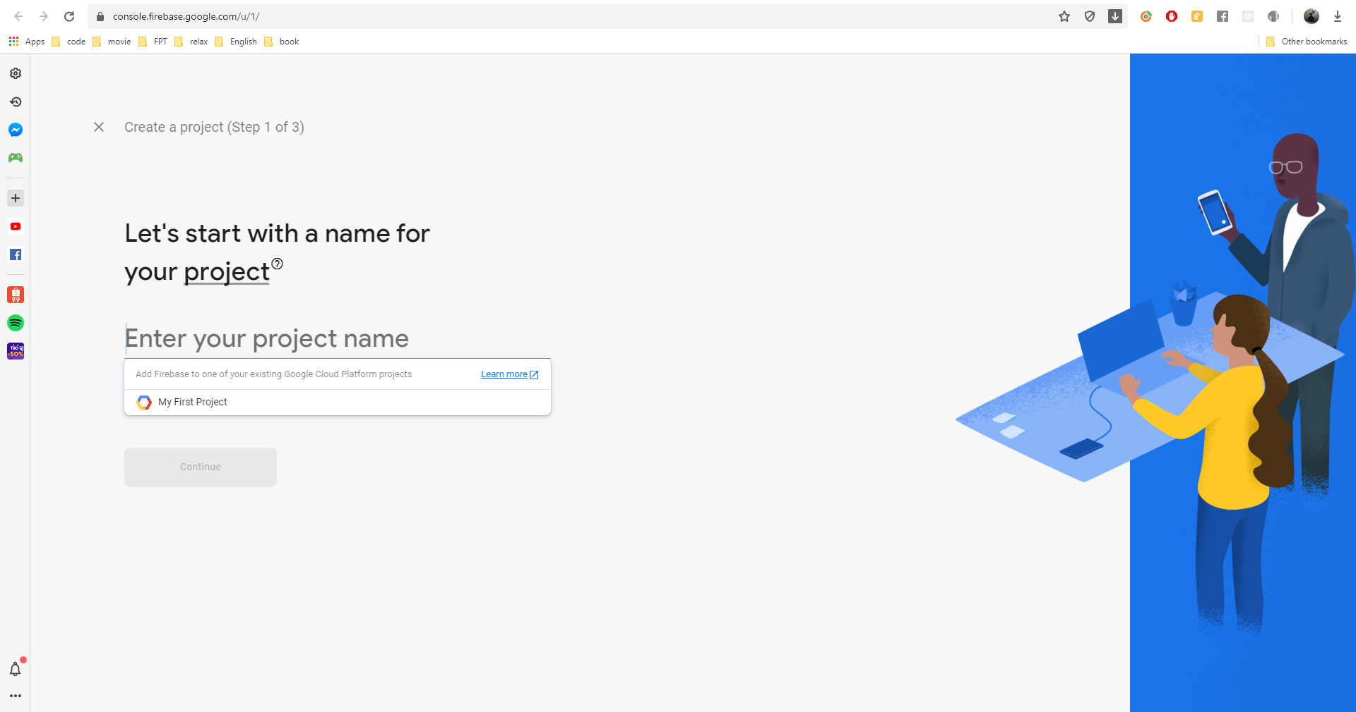

Figure 114 - Create project interface

• From the sidebar menu, click Authentication

• Switch to Sign-in method tab, in the Sign-in providers section, switch Disable to Enable on Google and Facebook

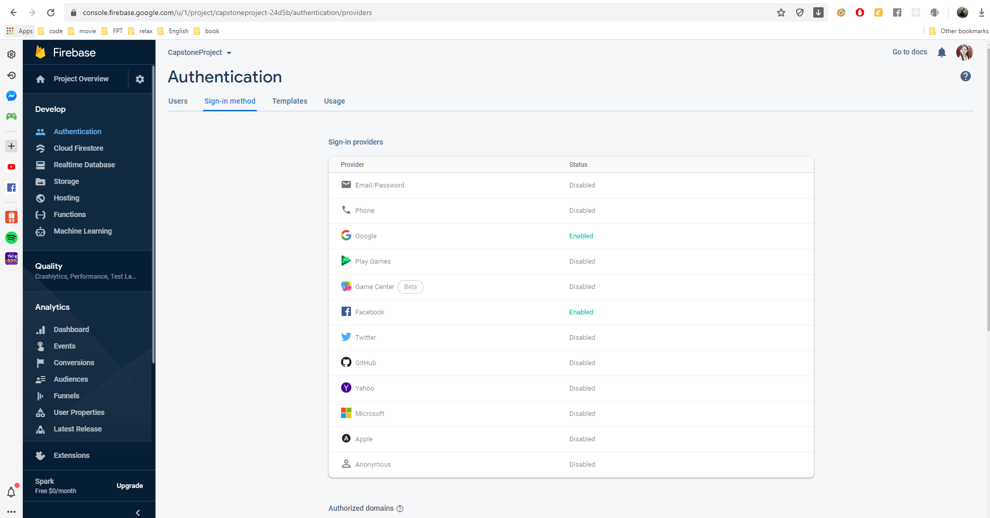

Figure 115 - Sign-in method set up interface for database

• From the sidebar menu, click Database

• Go to Realtime Database section and click Create database button

• Choose option “Start in locked mode”, then click Enable button

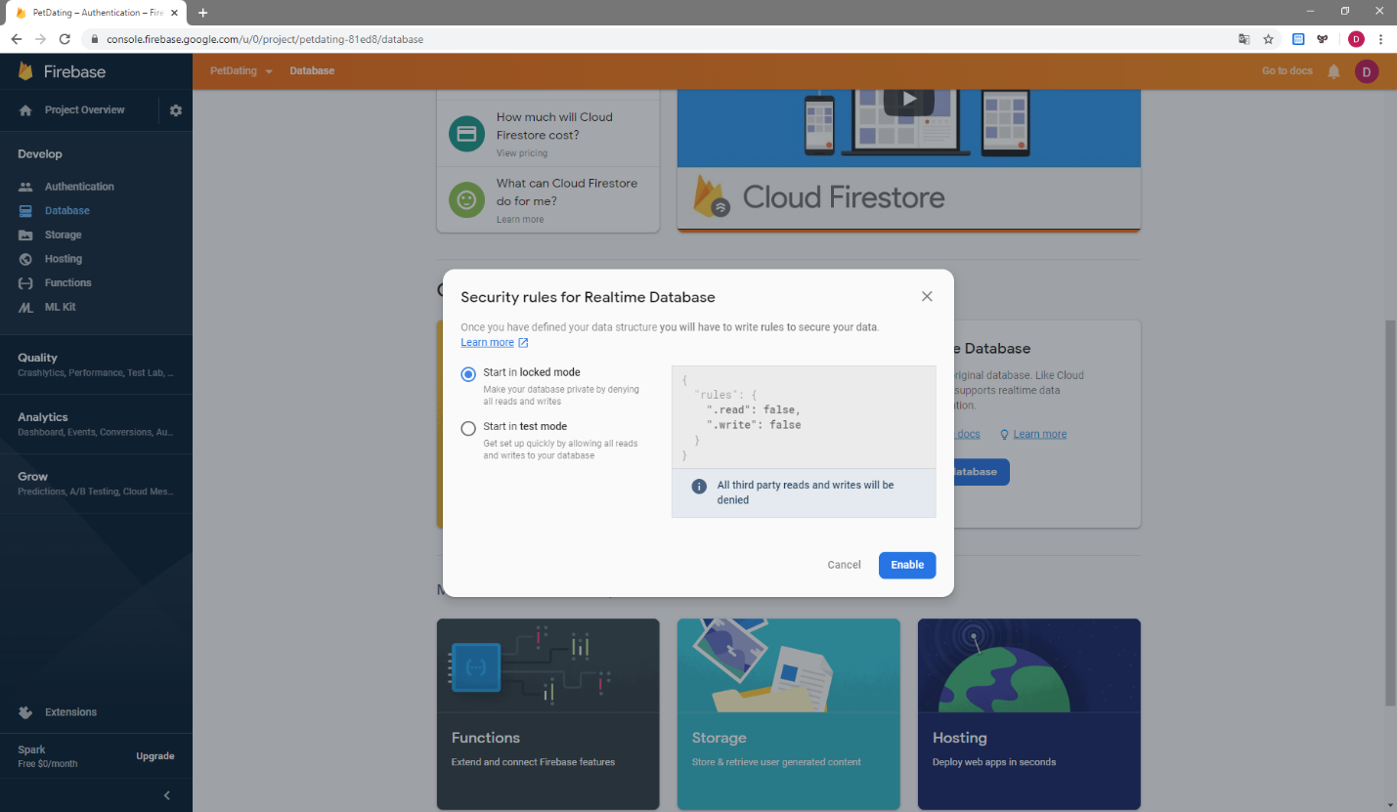

Figure 116 - Create database interface

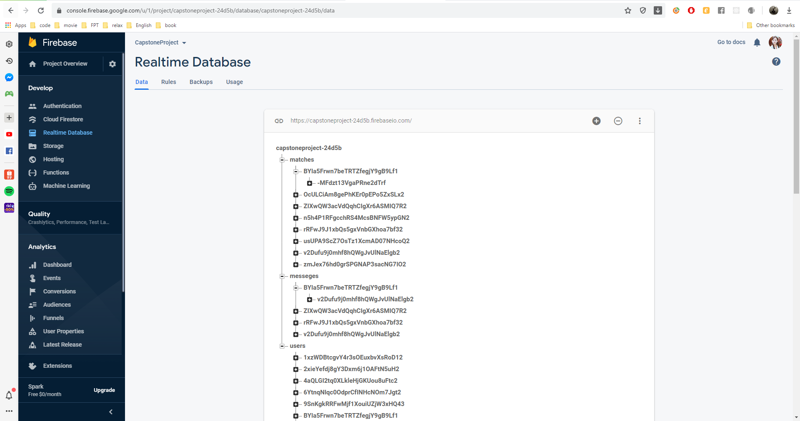

Figure 117 - Realtime Database interface