Erik Sanchez

Leily Khatibi

Art-75

March 3, 2020

Art Proposal - Identity and the Meaning of Home

**Concept**

We often times think about home as a physical space in a specific location. We adhere to those places and hold them as if they were the source of our happiness but the truth is more complex than that. As much as identity relates to the individual the same does to the place we call home. Home, as a concept, is not the place in which we live but the place that gives us the feeling of being alive. Home can be an apartment in the crowded city of New York or it can be a simple house in the calm valley of Edinburg. The main point to consider is the fact that we are the ones that create the concept of home and can range from individuals to couples in the same way as identity applies to the person and not the place. Therefore, whenever we think about home we don’t necessarily think about the place but the feeling that conveys with us in it – the place where your heart lies within.

**Proposal**

The idea behind this project is to convey the idea of what identity and home is based on my experience. Identity is an intimate part of ourselves that we decide to show to the world. That being said, our identity relates directly to our perception of home because it represents an intimate place in which we can be ourselves. Furthermore, a small but intimate place like our room can be the perfect example of what home is to each one of us. The same as identity, each people’s room will never be the same. Some of them may have posters while others have pictures on the walls. In the end, each personal space is unique experience in the same way our identity is.

My idea is to make an interactive video of someone’s room that showcases how that person lives and develops. The room will act as a visual narrative about how to the person goes on their everyday life. Every detail counts such as the type of sheets they like, what kind of desk they have, how their wardrobe looks like, and what kind of decorations they like to have. Because the small details is what counts, the video will contain all those little pieces of identity that defines that person’s room, and with a VR device the viewer will be able to experience the immersion of that room as they look around (not interactive).

**Visualization of the space**

Space:

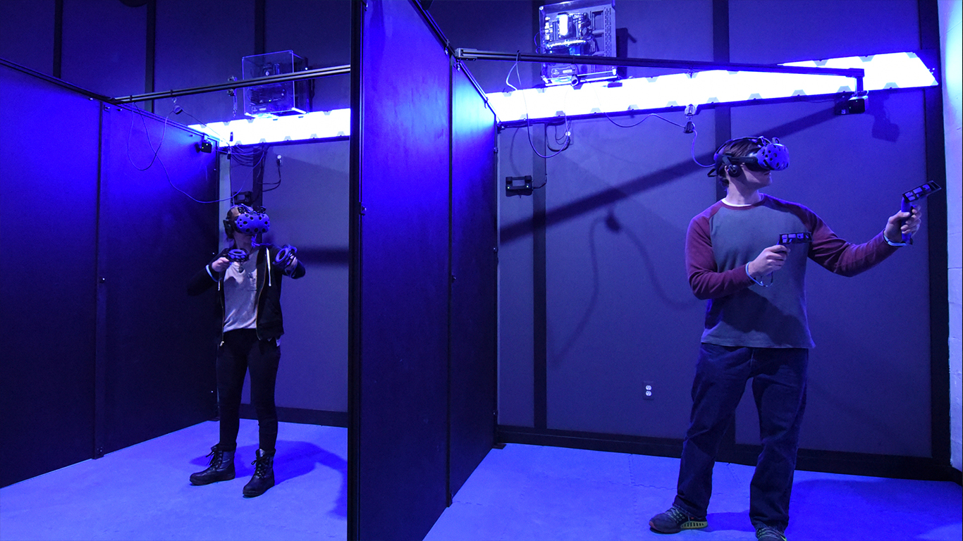

**Description:**

The idea is to immerse the viewer in a virtual room made possible with 360 degree camera and adding 3D elements with ADOBE AERO. Then, with the help of a VR device, the viewer will be able to experience the personal space of a room and explore what the room has to offer such as personal belongings of the owner of that room. Moreover, thanks to the setup of the room, the viewer will be able to explore and experience the identity of the individual (the subject of the room is not specified as it can be anyone’s room) and see what makes them unique.