CS22510 Assignment One, 2012-2013 Runners and Riders – “Out and about”

Aidan Fewster

22 March 2013

1 Event Creation Program

* 1. Code for the program

The code for the event creation program is on the following page

* 1. Compiling results

Bellow is the output from the compiler:  
  
*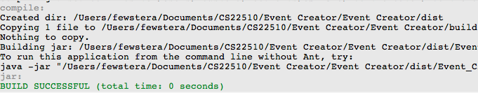*

* 1. Terminal Sessions

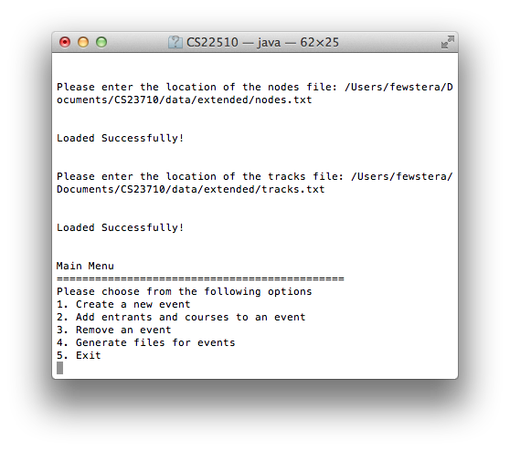1.3.1 View on start up after entering file paths

1.3.2 Adding a new event and validate time

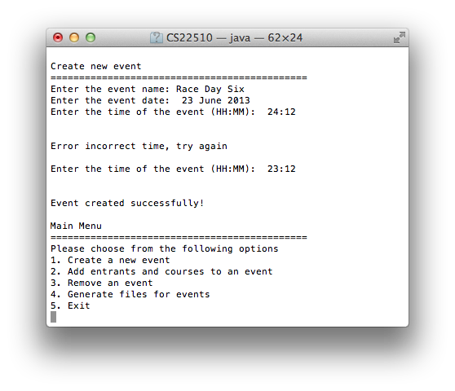  
  
1.3.3 Adding a course to an event   
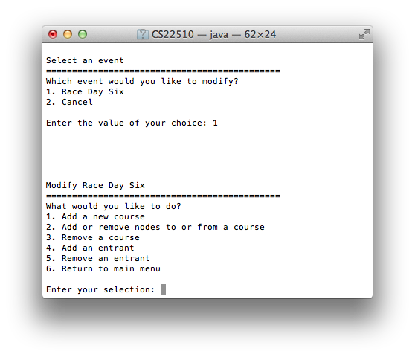

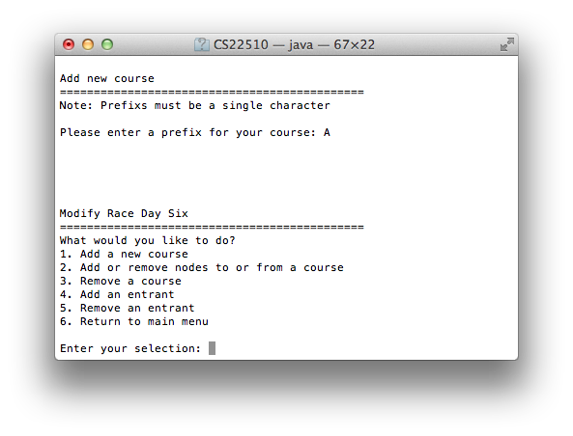

1.3.4 Adding 2 nodes to a course  
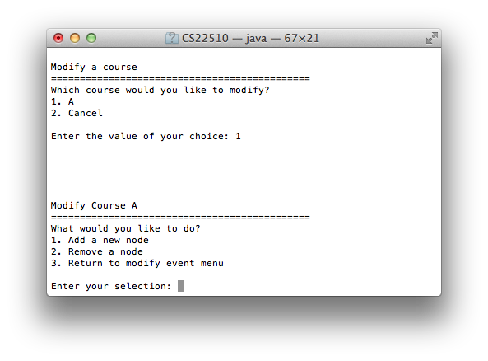

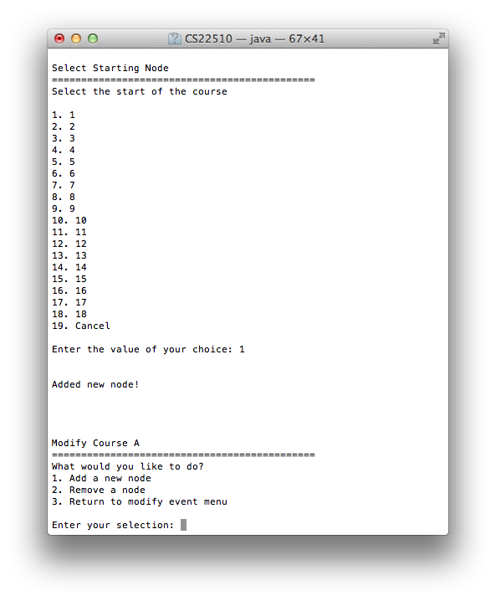

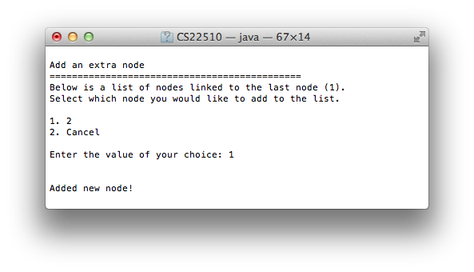

1.3.5 Add entrants to an event

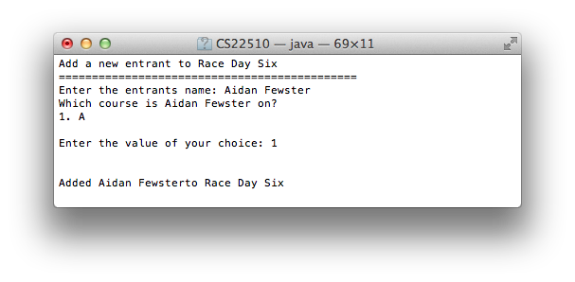

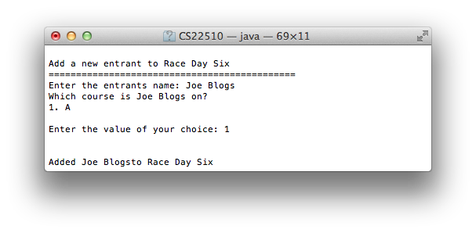

1.3.6 Making an extra event

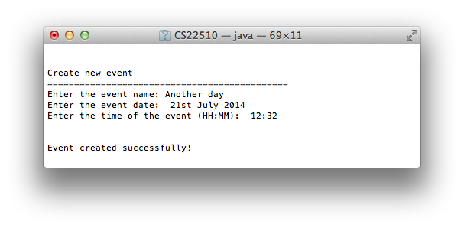

1.3.7 Generate event files

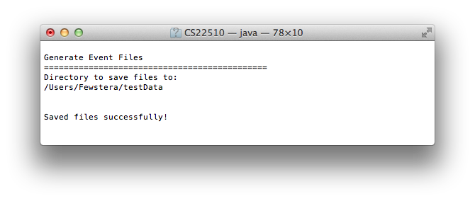

* 1. Created files
     1. File hierarchy (New folder for each event)

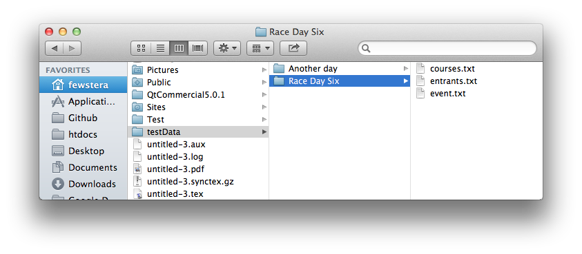

* + 1. File contents

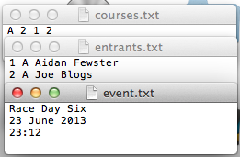

2 Checkpoint Manager Program

2.1 Code for the program

The code for the checkpoint manager program is on the following page

2.2 Compling the code

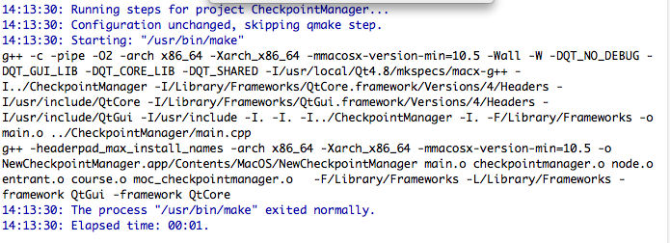

2.3 Screenshots of the program working

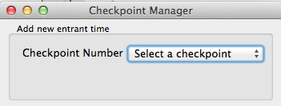

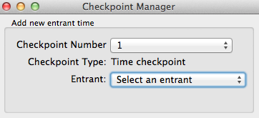  
  
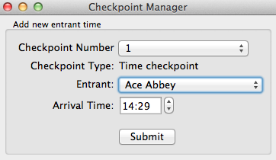

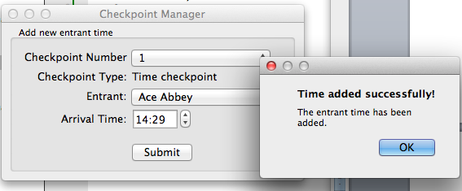

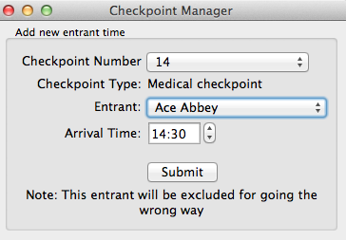

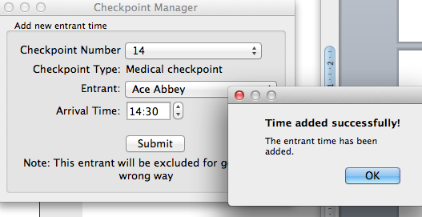

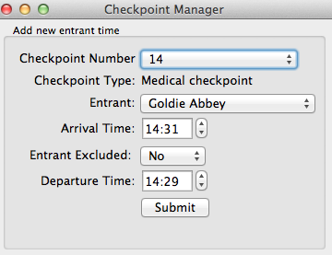

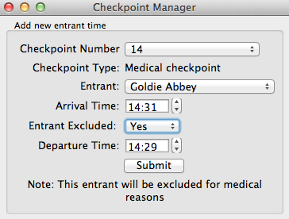

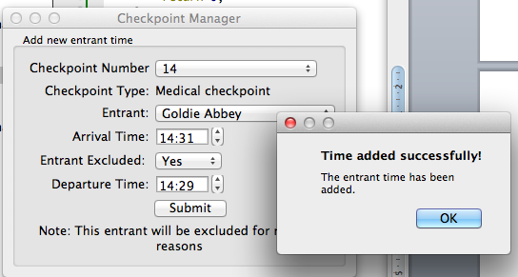

File lock Demo

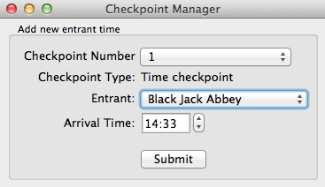

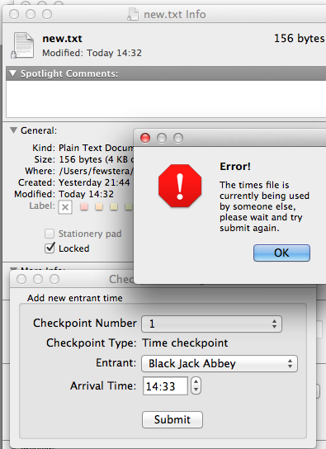

3 Event Manager Program

3.1 Compiling the code

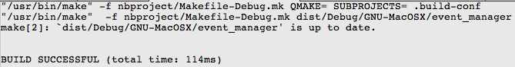

3.2 Screenshots of the system seeing used

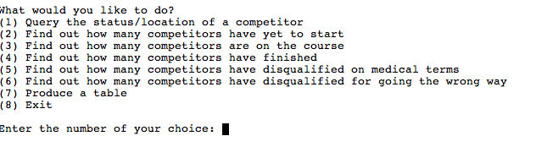

Query users location:

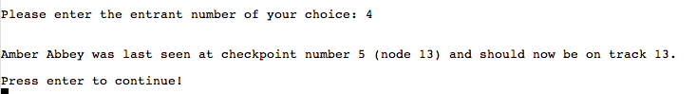  
  
List competitors yet to start:

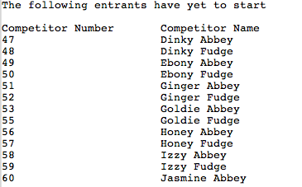

List competitors on the course:

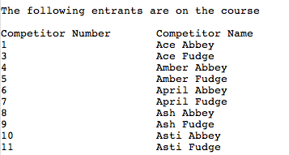

List of finished competitors:

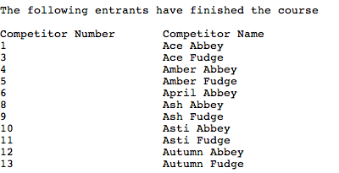  
  
Disqualifed for taking wrong route:

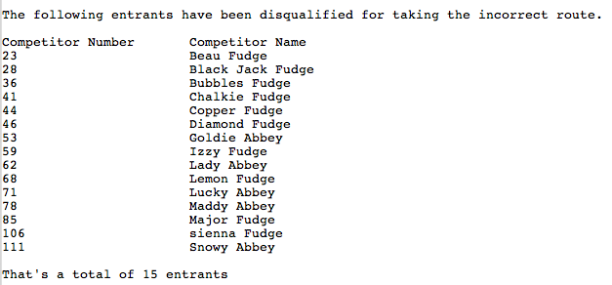

3.3 Screenshot of leaderboard at end of race

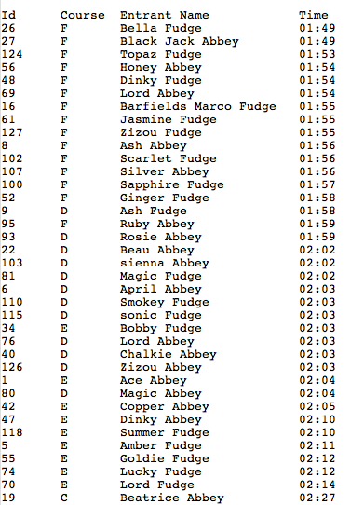

3.4 Screenshot of log file produced

