IT Operations Module
Demo Walkthrough Guide
itsm_core — Frappe/ERPNext v16.51.0
Live Demo Preparation Document

Environment: http://fastpay.local:8001 (erp.fastpayet.com)
User: admin@mail.com (System Manager)
Generated: October 29, 2026

Table of Contents
- 1. 1. Demo Overview & Objectives
- 2. 2. Pre-Demo Checklist
- 3. 3. Grafana → HD Ticket Pipeline (Incident Management)
- 4. 4. Change Request Lifecycle (Three Paths)
- 5. 5. Service Registry & Topology
- 6. 6. CI/CD Gates & Deployment Evidence
- 7. 7. Grafana Webhook Log & Audit Trail
- 8. 8. ITSM Settings & Configuration
- 9. 9. Demo Script & Talking Points
- 10. 10. Common Questions & Answers
- 11. Appendix: Screenshot Index

1. Demo Overview & Objectives
This document prepares you for a live demonstration of the itsm_core IT Operations module running on Frappe/ERPNext v16.51.0. The demo showcases a unified platform that replaces external middleware with native Grafana webhook ingestion, intelligent ticket deduplication, and a rigorous three-path change control workflow — all within ERPNext's native Helpdesk and Desk framework.

Primary Demo Objectives
- Show how Grafana alerts automatically become HD Tickets with zero manual intervention
- Demonstrate smart deduplication: same alert re-firing increments occurrence count, not new tickets
- Walk through the three change paths: Standard (lean), Normal (full rigor), Emergency (break-glass)
- Show the approval workflow with enforced separation of duties (Author ≠ Approver)
- Demonstrate CI/CD gates: get_change_state blocks deployment unless CR is "Approved for Deployment"
- Show record_deployment appending immutable deployment evidence
- Walk through Service Registry as the central topology source of truth
- Demonstrate Grafana Webhook Log for audit/replay capability

Key Messages to Convey
- "We replaced our external middleware with 100% native ERPNext — no separate ITSM tool needed."
- "Critical/High alerts require human verification on recovery — no auto-close surprises."
- "Standard changes are fast (30 sec to create) but safe — blocked on Critical-tier services."
- "Emergency break-glass is audited: auto-captures authorizer and 24-hour retro review deadline."
- "CI/CD pipeline gates are fail-closed: no deployment without approved Change Request."
- "Everything is auditable: Grafana Webhook Log captures every payload for replay."

2. Pre-Demo Checklist
Item | Status / Details
Environment | http://fastpay.local:8001 (or erp.fastpayet.com) accessible
User | admin@mail.com (System Manager) logged in
Grafana Integration User | grafana-test@fastpay.local with API token (d57320d158ea7fe:171acd4ef7604b4)
CI Integration User | ci-integration@fastpay.local with API token (b775b2958cd36d1:a96ac126ba0ea0c) and CI Integration role
Service Registry | payments-api (Critical tier) exists with runbook_url
Test Data | CRQ-2026-00068 (Normal, Code category, repo=github.com/org/test-repo) exists in Draft
Browser | Chrome/Edge with 1920x1080 resolution, zoom 100%
Network | Local access to fastpay.local:8001 confirmed
Screenshots | All 11 reference screenshots in /tmp/demo_screenshots/
Terminal | curl available for live API calls if needed

3. Grafana → HD Ticket Pipeline (Incident Management)
This is the crown jewel: a fully native Grafana → HD Ticket pipeline with zero external middleware. Grafana sends webhooks to /api/method/itsm_core.api.ingest_grafana_alert with API-token auth. The system handles deduplication, flapping detection, and priority-based resolution rules entirely natively.

3.1 IT Operations Dashboard
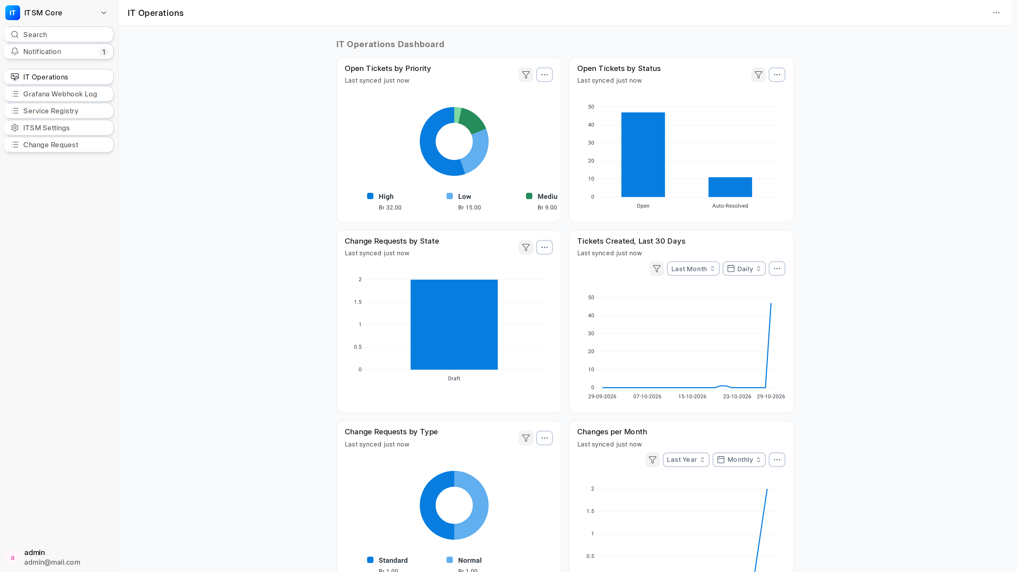
Figure 1: IT Operations workspace with 6-chart dashboard. Charts: Open Tickets by Priority (Donut), Open Tickets by Status (Bar), Change Requests by State (Bar), Tickets Created Last 30 Days (Line), Change Requests by Type (Donut), Changes per Month (Line).

3.2 Module Navigation
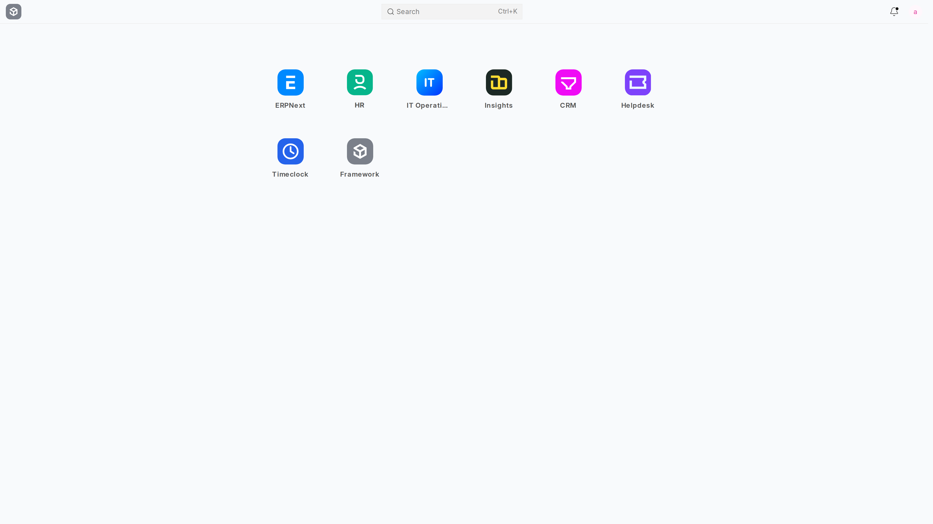
Figure 2: Frappe Desk showing ITSM Core module (flag icon) accessible via Awesomebar (Ctrl+K) and module sidebar.

3.3 Grafana Webhook Log — Audit Trail
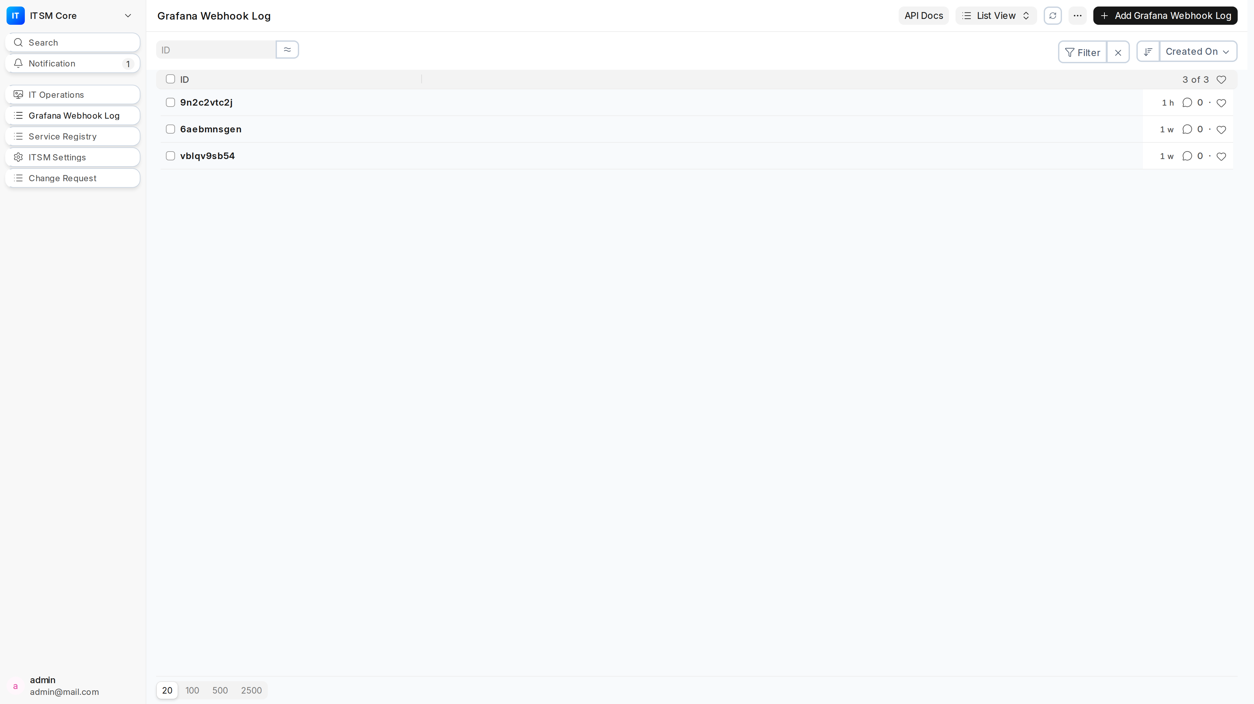
Figure 3: Grafana Webhook Log list view. Every webhook payload is stored with timestamp, status, and replay capability. "API Documentation" button opens Scalar docs.

3.4 HD Ticket Created from Grafana Alert
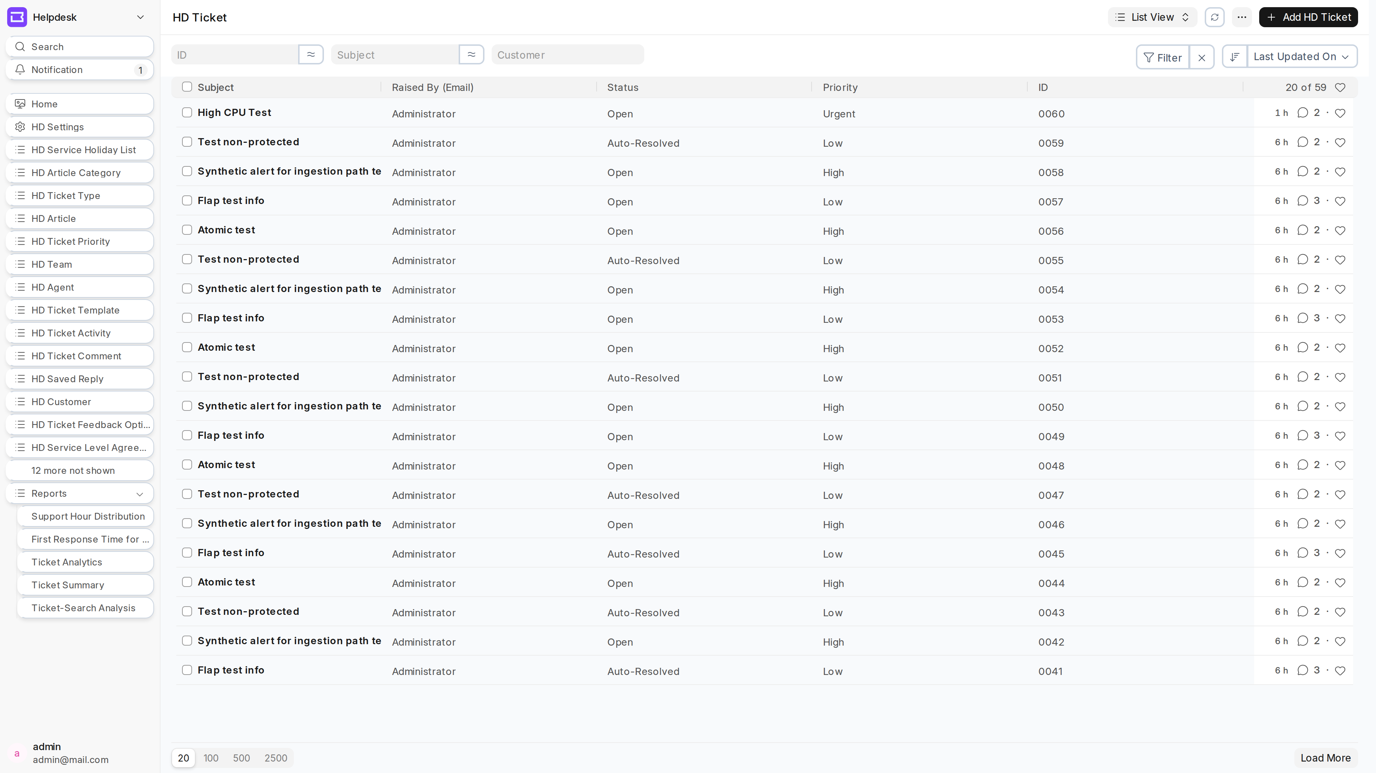
Figure 4: HD Ticket list showing tickets auto-created from Grafana. Note the grafana_status field (firing/resolved/recovered_awaiting_verification) and custom_service link to Service Registry.

3.5 Live Demo: Fire a Grafana Alert
- 1. In Grafana, trigger a test alert for "payments-api" with severity "critical"
- 2. Watch the terminal: curl POST to erp.fastpayet.com/api/method/itsm_core.api.ingest_grafana_alert
- 3. Response shows: {"message":{"status":"ok","processed":1,"results":[{"action":"created","ticket":"0060","priority":"Urgent"}]}}
- 4. In ERPNext, HD Ticket list refreshes — new ticket "0060" appears with priority Urgent
- 5. Open the ticket: subject, priority, custom_service (payments-api), runbook_url, grafana_status="firing"
- 6. In Grafana, resolve the same alert (same fingerprint)
- 7. ERPNext: ticket grafana_status becomes "recovered_awaiting_verification" (NOT auto-resolved — Critical/High require human verification)
- 8. For Medium/Low priority: resolved → grafana_status="resolved", HD Ticket status="Auto-Resolved"
Key Point: All responses are wrapped in {"message": {...}} envelope. Always HTTP 200 — non-2xx only for infrastructure failures.

4. Change Request Lifecycle (Three Paths)
The Change Request form is a single DocType with three change types that adapt to the user via progressive disclosure. This is not three different forms — it's one smart form.

4.1 Standard Change (Lean Path)
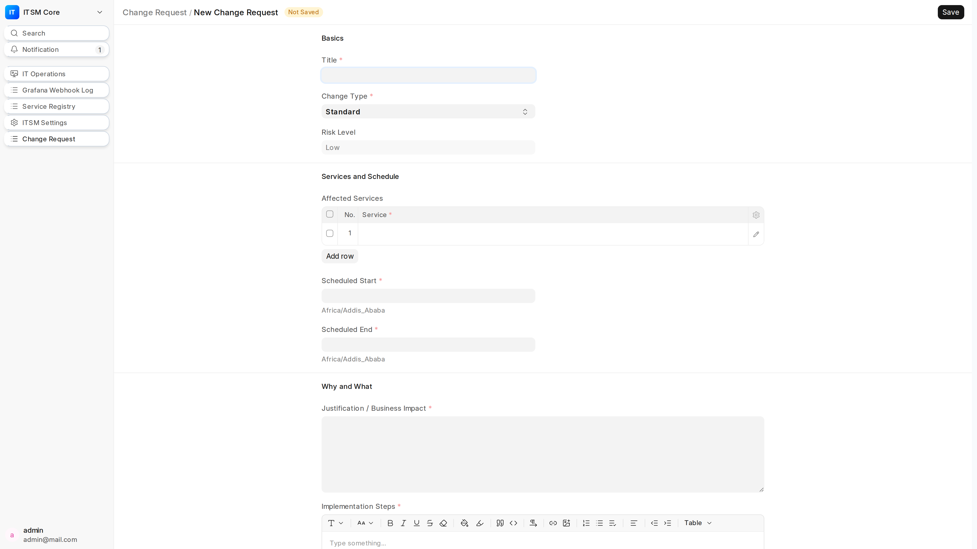
Figure 5: Standard change form. Risk assessment fields (Impact, Likelihood, Computed Risk Score, Validation Criteria) are HIDDEN. Rollback Plan is REQUIRED (brief). Critical-tier services and Data category BLOCKED. Risk Level forced to Low.

4.2 Normal Change (Full Rigor)
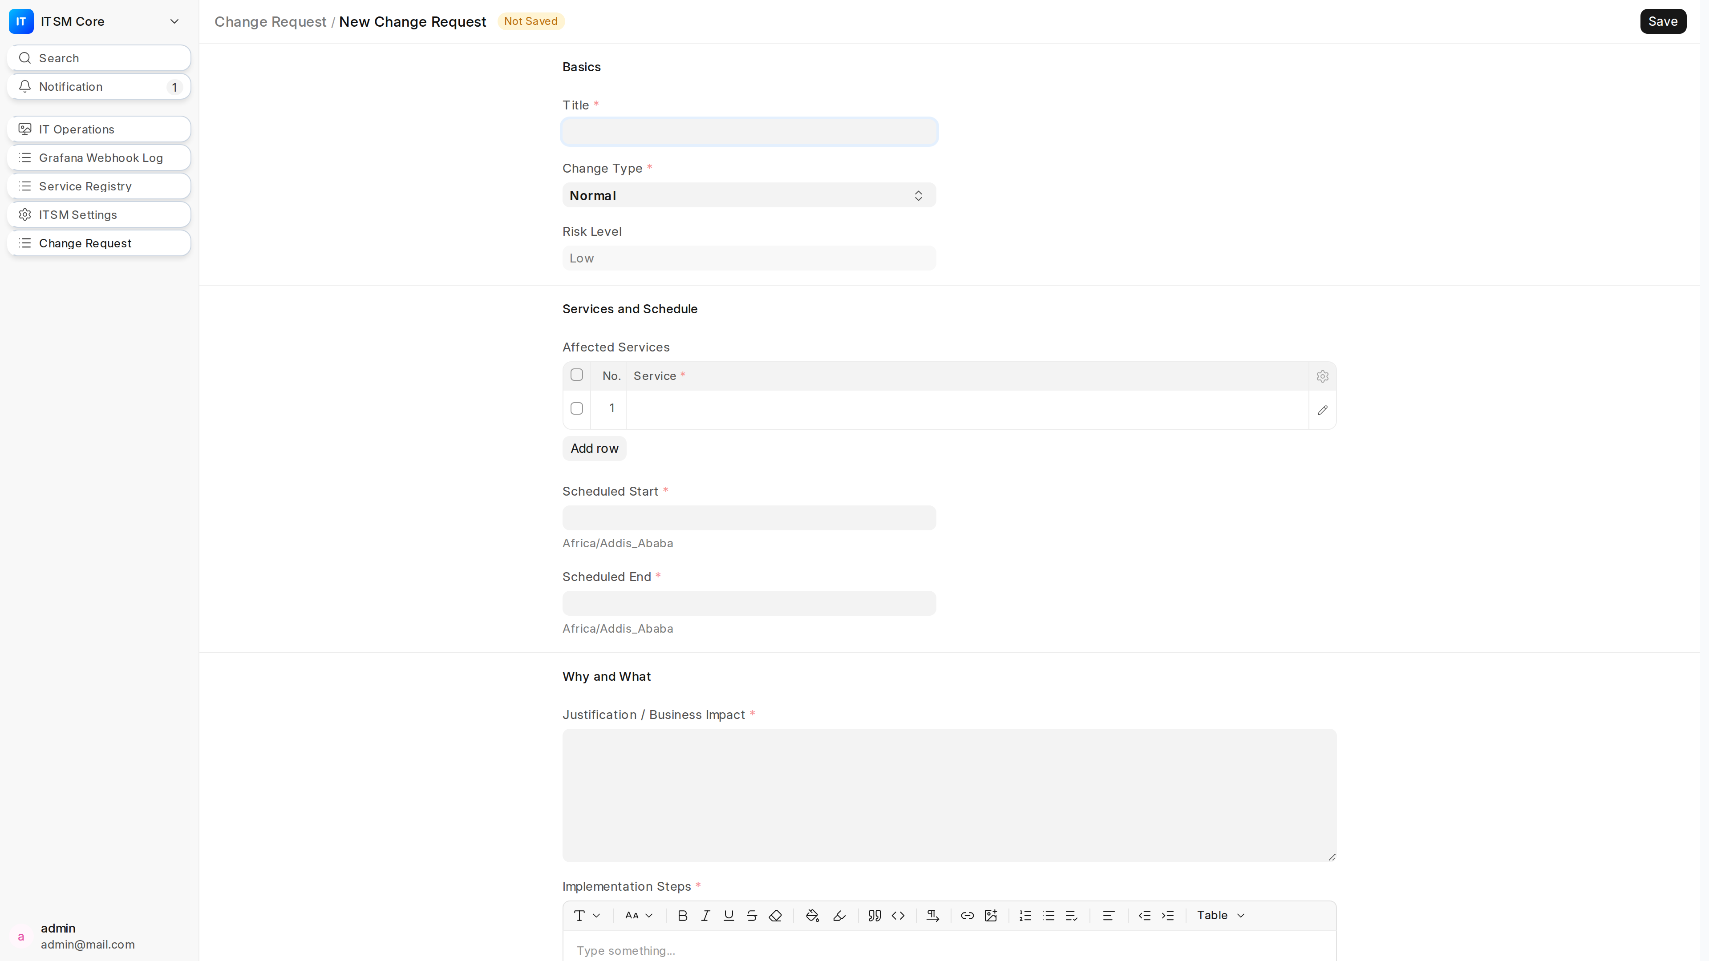
Figure 6: Normal change form. ALL risk fields VISIBLE: Impact (1-4), Likelihood (1-5), Computed Risk Score (auto-calculated), Validation Criteria (mandatory). Rollback Plan required. CI/CD section appears for Code category.

4.3 Emergency Change (Break-Glass)
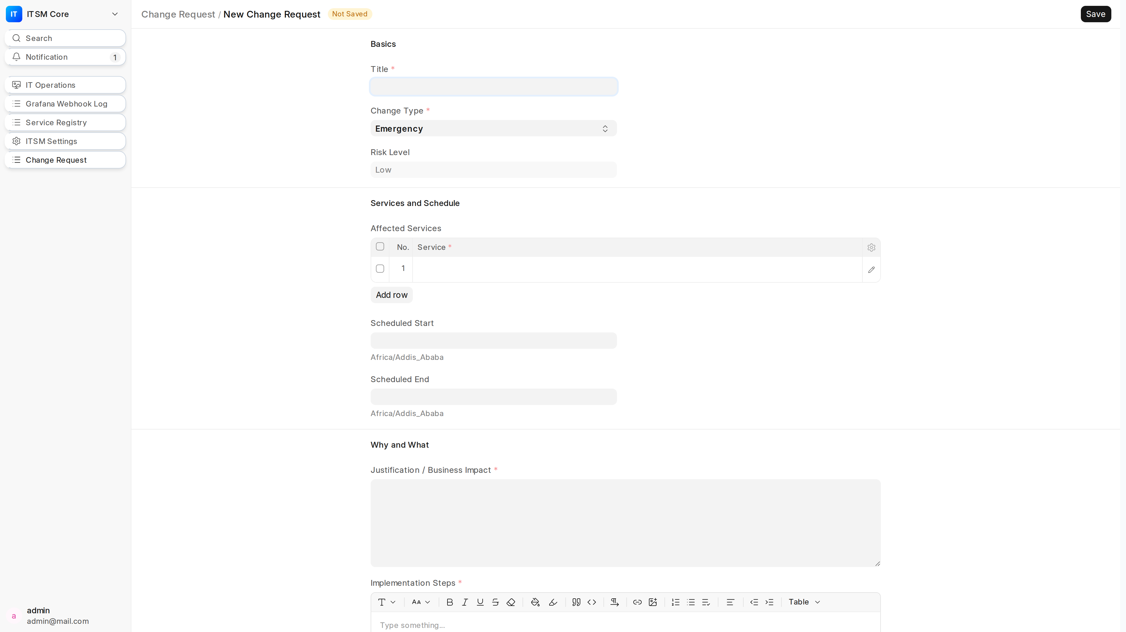
Figure 7: Emergency change form. Break-glass authorization REQUIRES Change Manager role. Auto-populates emergency_authorized_by (current user) and retro_review_due (+24h) ON FIRST SAVE ONLY. Validation Criteria optional. One-step approval path.

4.4 Live Demo: Create a Normal Change Request
- 1. Click "New" on Change Request list → form opens in Draft
- 2. Select Change Type: "Normal" → risk fields appear instantly (progressive disclosure)
- 3. Fill: Title, Justification, Implementation Steps, Affected Services (payments-api)
- 4. Risk Assessment: Impact "2 - Medium", Likelihood "3 - Possible" → Risk Score auto-calculates (6)
- 5. Safety: Rollback Plan (detailed), Validation Criteria (detailed) — both mandatory for Normal
- 6. CI/CD: Category "Code" → Repo field appears (mandatory): github.com/org/db-migration
- 7. Schedule: Start/End timestamps
- 8. Click Save → CR created in Draft state (CRQ-2026-00068)

4.5 Live Demo: Submit for Approval

4.6 Live Demo: Approve (Change Approver Role)
- 1. Switch to Change Approver user (or demonstrate same user — self-approval ALLOWED for Submit, NOT for Approve)
- 2. Open CR in Pending Approval → "Approve" button visible
- 3. Click "Approve" → transitions to Approved for Deployment
- 4. System auto-sets approved_by = current user, timestamp
- 5. Field locking ENGAGES: Title, Justification, Implementation Steps, Rollback Plan, Validation Criteria, Repo, Schedule, Affected Services become READ-ONLY
- 6. Only Change Implementer/Manager can edit System fields (deployment_evidence, outcome, etc.)

5. Service Registry & Topology

5.1 Service Registry List
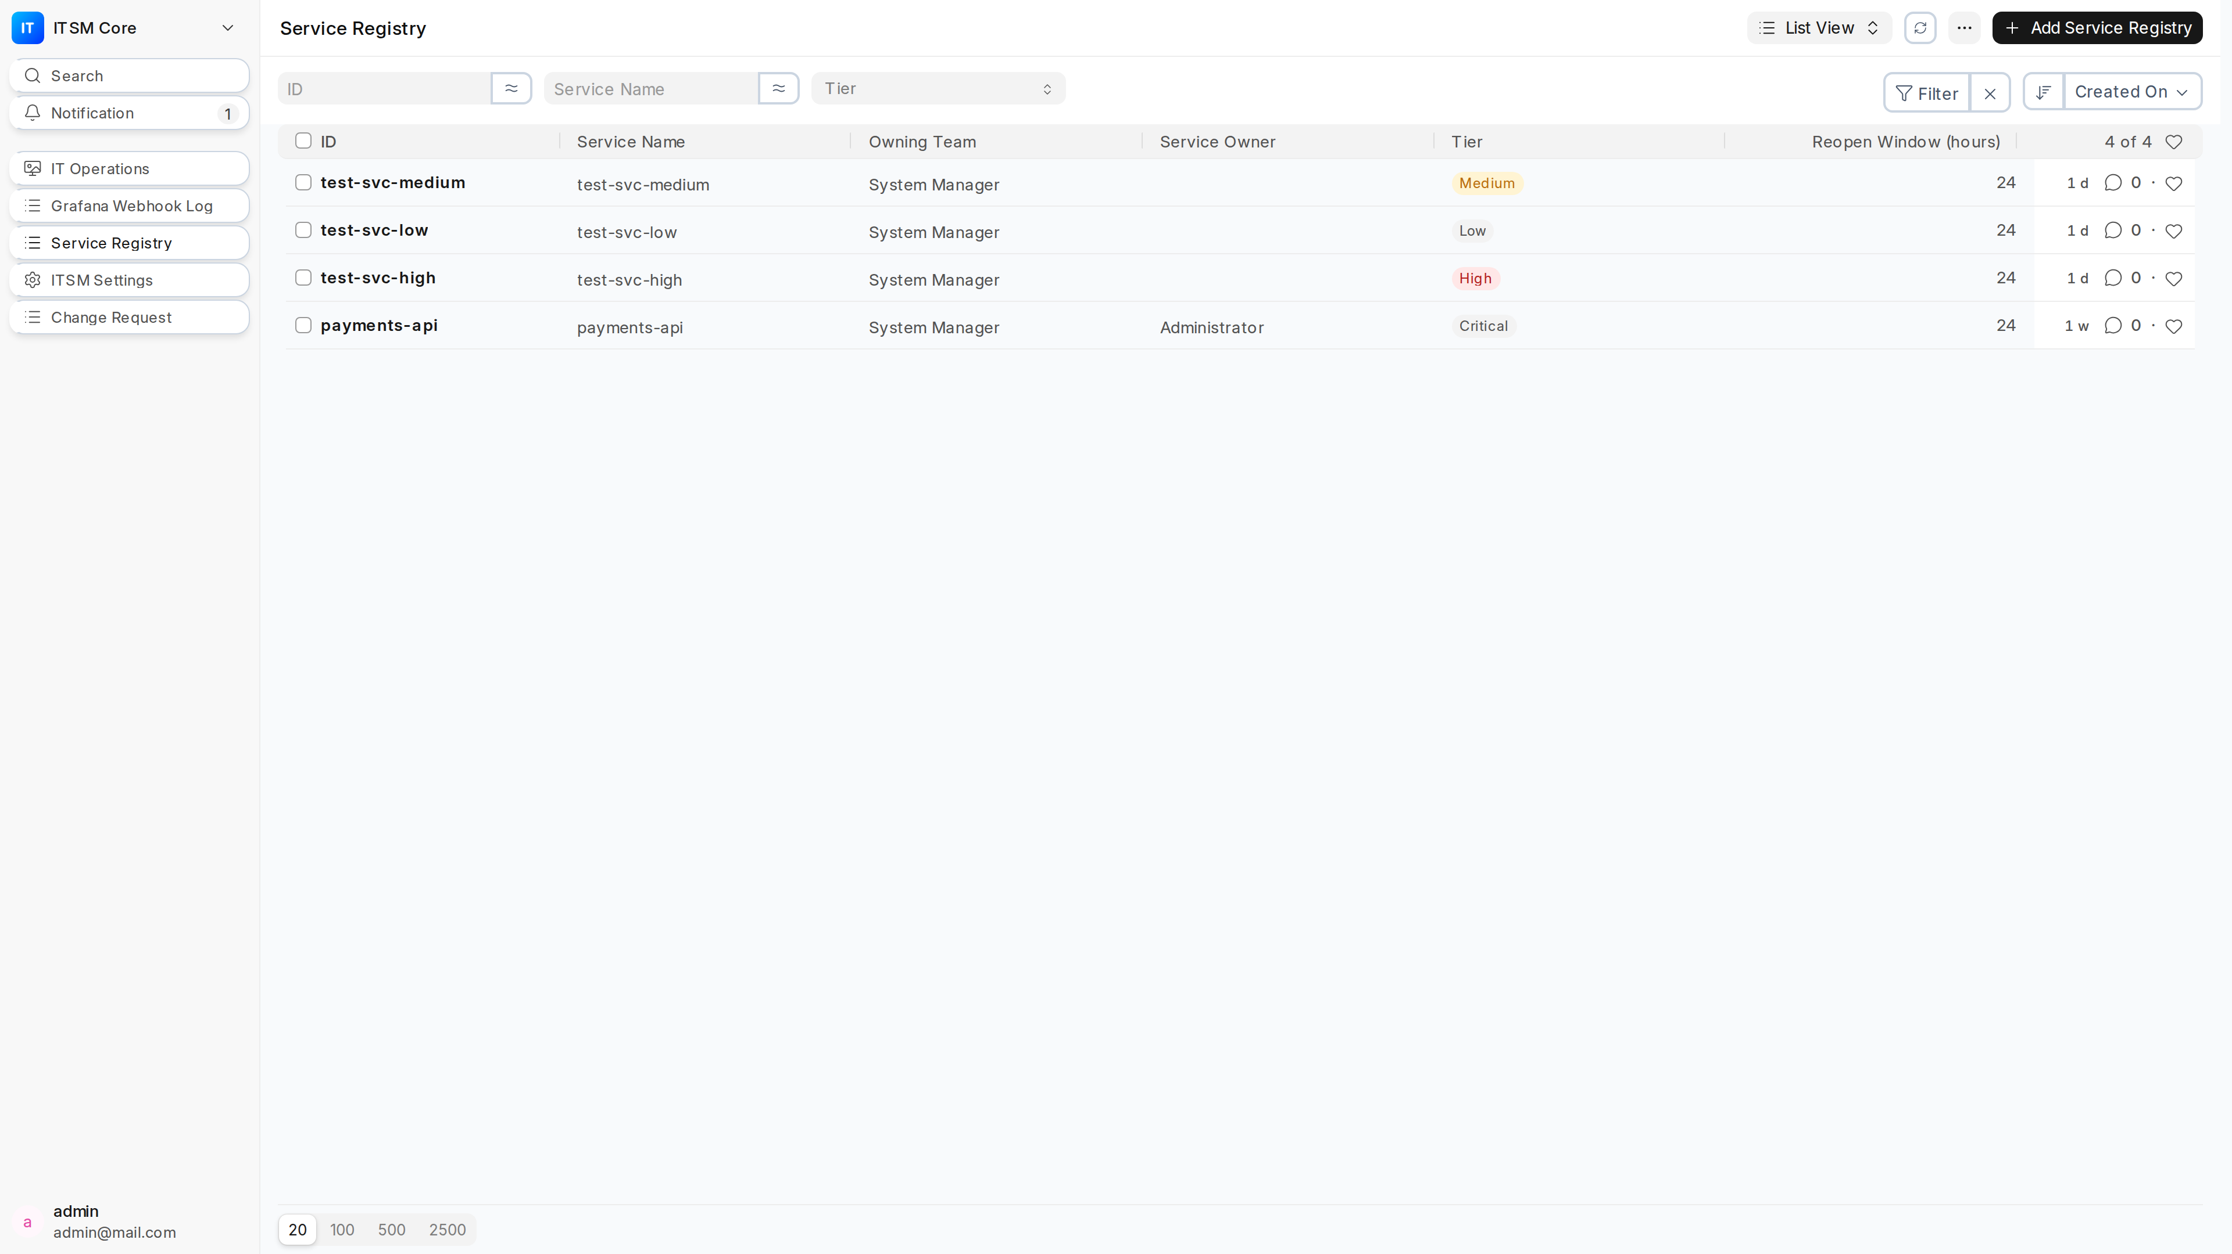
Figure 11: Service Registry list. Each service has tier (Critical/High/Medium/Low), owning_team, service_owner, runbook_url, slack_channel, grafana_dashboard_url, and per-service reopen_window_hours.

5.2 Service Registry Form
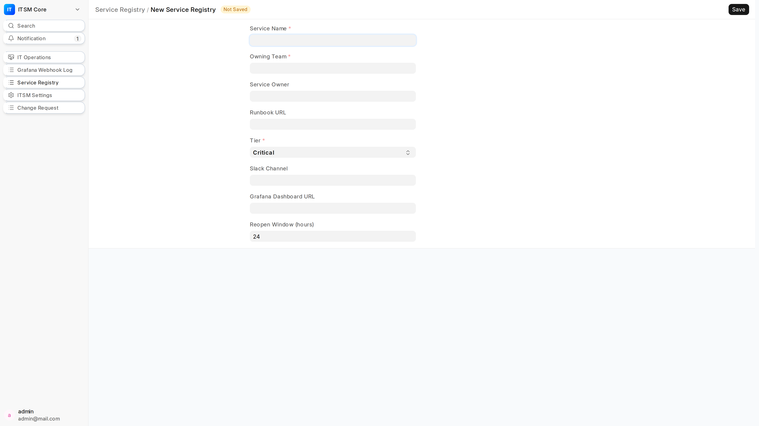
Figure 12: Service Registry form. Tier hierarchy: Critical (highest, blocks Standard changes) → High → Medium → Low. reopen_window_hours overrides global ITSM Settings default (24h).

5.3 Key Integration Points
- payments-api (Critical tier) → blocks Standard changes, triggers awaiting_verification on resolve
- runbook_url from registry → auto-attached to HD Ticket before alert-provided URL
- service_owner → auto-populates HD Ticket service_owner field
- reopen_window_hours → overrides global 24h default for flapping detection
- grafana_dashboard_url → quick link from ticket to Grafana dashboard
- slack_channel → future notification integration point

6. CI/CD Gates & Deployment Evidence
Two API endpoints enforce deployment gates: get_change_state (pre-deploy gate) and record_deployment (post-deploy evidence). Both require CI Integration role and API token.

6.1 get_change_state — Pre-Deploy Gate
- 1. CI pipeline calls: POST erp.fastpayet.com/api/method/itsm_core.api.get_change_state
- 2. Payload: {"change_request_id": "CRQ-2026-00068", "repo": "github.com/org/test-repo", "environment": "Production"}
- 3. Response: {"message":{"change_request":"CRQ-2026-00068","workflow_state":"Draft","approved_for_deployment":false,"repo":"github.com/org/test-repo"}}
- 4. Pipeline checks: .message.approved_for_deployment == true → DEPLOY BLOCKED
- 5. Only returns true when workflow_state == "Approved for Deployment"
- 6. Fail-closed: 403 if CR repo empty/mismatch or environment mismatch

6.2 record_deployment — Immutable Evidence
- 1. Post-deploy, CI calls: POST erp.fastpayet.com/api/method/itsm_core.api.record_deployment
- 2. Payload: {"change_request_id": "CRQ-2026-00068", "evidence": "Deployed v1.2.3 to prod; smoke tests passed"}
- 3. Response: {"message":{"status":"ok","change_request":"CRQ-2026-00068","logged_by":"ci-integration@fastpay.local"}}
- 4. Evidence APPENDED to deployment_evidence field with timestamp and actor — NEVER overwrites
- 5. Multiple deployments → multiple entries in deployment_evidence

6.3 Live Demo: CI/CD Gate
- 1. Run: curl -X POST http://fastpay.local:8001/api/method/itsm_core.api.get_change_state -H "Authorization: token b775b2958cd36d1:a96ac126ba0ea0c" -H "Content-Type: application/json" -d '{"change_request_id":"CRQ-2026-00068","repo":"github.com/org/test-repo","environment":"Production"}'
- 2. Show response: approved_for_deployment: false (CR is in Draft)
- 3. Approve the CR in UI → workflow_state becomes "Approved for Deployment"
- 4. Re-run curl → approved_for_deployment: true → DEPLOY ALLOWED
- 5. Post-deploy: curl record_deployment with evidence → shows appended evidence

7. Grafana Webhook Log & Audit Trail
Figure 13: Grafana Webhook Log list view with "API Documentation" button (opens Scalar docs). Each row = one webhook payload.

7.1 Replay Capability
- 1. Select a failed webhook log entry (error status)
- 2. Click "Replay" → re-runs _process_alert through full ingestion pipeline
- 3. Marks log with replay=1
- 4. Use case: Grafana was down, alerts queued; after recovery, replay all failed webhooks

7.2 Synthetic Alert — End-to-End Test
- 1. POST /api/method/itsm_core.api.synthetic_alert (System Manager only)
- 2. Creates test firing alert: fingerprint="synthetic-<timestamp>", severity="warning", service="synthetic"
- 3. Exercises FULL ingestion path: webhook → dedup → HD Ticket creation → priority mapping
- 4. Returns same structure as ingest_grafana_alert results
- 5. Use case: Daily cron job to verify pipeline health

8. ITSM Settings & Configuration
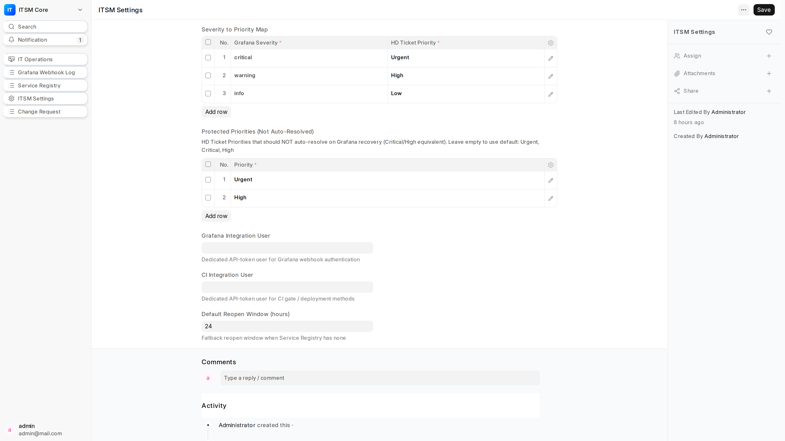
Figure 14: ITSM Settings single DocType. Configures severity→priority mapping, integration users, default reopen window, and protected priorities.

8.1 Key Configuration Sections
Severity → Priority Mapping: Maps Grafana severity (critical/warning/info) → HD Ticket Priority (Urgent/High/Medium/Low). Editable child table.
Grafana Integration User: Dedicated API-token user (grafana-test@fastpay.local) with Grafana Integration role.
CI Integration User: Dedicated API-token user (ci-integration@fastpay.local) with CI Integration role.
Default Reopen Window: Global default for flapping detection (24h). Overridable per-service in Service Registry.
Protected Priorities: Child table listing HD Ticket Priorities that NOT auto-resolve on Grafana recovery. Default: Urgent, Critical, High. Configurable per priority.

9. Demo Script & Talking Points

9.1 Opening (2 min)
SAY: "We built itsm_core to replace our external ITSM middleware with 100% native ERPNext."
SAY: "What you'll see: Grafana alerts become HD Tickets automatically, change requests follow a three-path workflow with enforced approvals, and CI/CD pipelines are gated by change request state — all in one system."
SAY: "No separate ITSM tool, no middleware, no sync issues. Everything is in ERPNext."

9.2 Grafana Alert Demo (3 min)
SAY: Trigger alert in Grafana → show curl → show ERPNext ticket
SAY: "Notice: ticket created in <2 seconds. Priority Urgent. Service linked to payments-api. Runbook attached."
SAY: Resolve alert → "Critical/High requires human verification — ticket status becomes recovered_awaiting_verification, NOT auto-resolved."
SAY: "Medium/Low would auto-resolve to Auto-Resolved status."
SAY: "Flapping detection: if alert re-fires within service's reopen_window_hours, same ticket reopens with occurrence count incremented."

9.3 Change Request Demo (5 min)
SAY: Create Normal CR → "Watch progressive disclosure: change_type Normal → risk fields appear instantly."
SAY: "Standard would hide Impact/Likelihood/Risk Score/Validation Criteria. Emergency would add break-glass fields."
SAY: "Risk Score auto-calculates: Impact 2 × Likelihood 3 = 6 (Medium)."
SAY: "Standard blocked on Critical-tier services — try selecting payments-api on Standard → blocked."
SAY: Submit for Approval → Approve → "Field locking engages: Title, Justification, Steps, Rollback, Validation, Repo, Schedule, Services all read-only."
SAY: "Author cannot approve — system enforces separation of duties."

9.3 CI/CD Gate Demo (2 min)
SAY: Run get_change_state curl on Draft CR → "approved_for_deployment: false → DEPLOY BLOCKED"
SAY: Approve CR in UI → re-run curl → "approved_for_deployment: true → DEPLOY ALLOWED"
SAY: "Fail-closed: if repo missing, mismatch, or environment mismatch → 403."
SAY: Post-deploy: record_deployment curl → "Evidence appended with timestamp + actor. Never overwrites."

9.4 Emergency Change Demo (2 min)
SAY: Create Emergency CR → "Requires Change Manager role. Auto-sets emergency_authorized_by (you) and retro_review_due (+24h)."
SAY: "One-step approval: Draft → Approved for Deployment via Emergency Approve."
SAY: "Validation Criteria optional. Rollback Plan still required."
SAY: "Retro review deadline visible in System section. After 24h, PIR mandatory before Close."

10. Common Questions & Answers
Q: Why not use Jira Service Management or ServiceNow? A: "We wanted a single source of truth. Our infrastructure, deployments, and changes already live in ERPNext/Frappe. Adding another tool creates sync lag, permission drift, and audit gaps. itsm_core is 100% native — same database, same permissions, same audit trail."

Q: Can Standard changes ever use Critical-tier services? A: "No. Hard block in _validate_standard_change(). If business needs it, they must use Normal or Emergency path with full risk assessment and approval."

Q: What happens if Grafana sends duplicate alerts? A: "Deduplication key = fingerprint:startsAt. Exact duplicate → occurrence_count increments, last_seen updated, comment added. No new ticket."

Q: What if Grafana is down and alerts queue up? A: "When Grafana recovers, use the Grafana Webhook Log "Replay" button. Re-runs each failed payload through the full ingestion pipeline. Marks log replay=1."

Q: Can the CI/CD gate be bypassed? A: "No. get_change_state is fail-closed. Only returns approved_for_deployment=true at "Approved for Deployment" state. No repo, wrong repo, wrong env → 403."

Q: What about audit compliance? A: "Grafana Webhook Log captures EVERY payload (success/failure). record_deployment appends immutable evidence with timestamp + actor. Change Request field locking is tamper-evident post-approval. Full audit trail in one database."

Q: How does this scale? A: "It's Frappe/ERPNext — same architecture powering enterprises with 1000+ users. Webhook ingestion uses per-alert savepoints and atomic SQL increments. Horizontal scaling via Frappe workers."

Appendix: Screenshot Index
File | Description
01_dashboard.png | IT Operations Dashboard — 6 charts
02_sidebar_module.png | Frappe Desk — ITSM Core module (flag icon)
03_cr_list.png | Change Request List View
04_cr_standard_form.png | Standard Change Request Form
05_cr_normal_form.png | Normal Change Request Form (risk fields visible)
06_cr_emergency_form.png | Emergency Change Request Form (break-glass)
07_service_registry.png | Service Registry List
08_service_registry_form.png | Service Registry Form
09_itsm_settings.png | ITSM Settings Single DocType
10_grafana_webhook_log.png | Grafana Webhook Log List View (with API Docs button)
11_hd_ticket_list.png | HD Ticket List (from Grafana alerts)

All screenshots captured at Retina quality (device_scale_factor=2, 1920x1080 viewport) from live fastpay.local:8001 instance.

