IT Operations Module
Technical Overview & Functional Specification
itsm_core — Frappe/ERPNext v16 Custom Application

Table of Contents
- Executive Summary
- Key Capabilities
- The Change Request Process
- API Endpoints Reference (Technical)
- User Interface
- Future Enhancements
- Appendix A: API Usage Examples

1. Executive Summary
The IT Operations module (itsm_core) is a Frappe/ERPNext v16 application that replaces external middleware with a unified, native platform for incident management, change control, and service topology. It operates entirely within ERPNext's Helpdesk and Desk framework, providing a single system of record for IT operations teams.
Key Capabilities:
• Incident Management: Automated Grafana-to-ticket pipeline with smart deduplication and priority-based resolution rules — critical alerts require human verification on recovery.
• Change Management: Single Change Request form with three paths (Standard, Normal, Emergency) that adapt to the user — hiding complexity for routine changes while enforcing full rigor for risky ones.
• Service Topology: Central registry linking services to owners, tiers, runbooks, and reopen windows.
• CI/CD Gates: Pipeline integration endpoints that enforce deployment approval and capture evidence.
• Observability: Built-in audit logs, health checks, and end-to-end test capability.
Security Posture: API-token authentication only (dedicated service accounts), fail-closed authorization, role-based access control, and break-glass emergency authorization.

2. Key Capabilities

2.1 Incident Management (Automated Grafana → Ticket Pipeline)
- Automated webhook ingestion with API-token authentication — no manual ticket creation needed.
- Smart deduplication using fingerprint + timestamp — prevents duplicate tickets for the same firing alert.
- Automatic occurrence counting — re-firing alerts increment a counter instead of creating new tickets.
- Flapping detection with configurable reopen windows — per-service override of the default 24-hour window.
- Priority-based resolution rules — Critical/High alerts require human verification on recovery; Medium/Low auto-resolve.
- Unregistered service handling — creates tickets with clear "Unregistered service" notation for visibility.
- Per-alert transaction isolation — failures roll back automatically without affecting other alerts.

2.2 Change Management (Smart Forms, Three Paths)
- Single Change Request form with three change types: Standard (lean), Normal (full rigor), Emergency (break-glass).
- Forms that adapt to the user — Standard changes hide risk assessment fields; Normal/Emergency expose full diagnostic suite.
- Emergency changes require break-glass authorization — auto-captures authorizer and sets 24-hour retrospective review deadline.
- Standard changes blocked on Critical-tier services and Data category changes — enforced at form level.
- Approval workflow with role-based gates — Requester submits, Approver approves (cannot self-approve), Implementer deploys, Manager closes.
- Custom security locking after approval — fields become read-only once a request reaches "Approved for Deployment".
- CI/CD integration — repository field mandatory for code changes; deployment evidence captured automatically via API.

2.3 Service Registry (Central Topology)
- Central registry linking services to owning teams, individual owners, runbooks, Slack channels, and Grafana dashboards.
- Tier hierarchy (Critical → High → Medium → Low) drives change validation and SLA assignment.
- Per-service reopen window overrides the global default for flapping detection.
- Runbook URLs from the registry automatically attach to generated tickets for faster resolution.

3. The Change Request Process
The Change Request lifecycle follows a clear, role-based workflow. All states use custom security locking (rather than native submit locking) to protect fields after approval. The author of a request can never approve their own change — the system enforces separation of duties.

3.1 Workflow States
State | Who Acts | Description
Draft | Change Requester | Initial creation; all fields editable.
Pending Approval | Change Approver | Awaiting technical/managerial sign-off.
Approved for Deployment | Change Implementer | Locked state — fields locked; ready to deploy.
Implemented | Change Implementer | Post-deployment; evidence captured; outcome recorded.
Post-Implementation Review | Change Manager | Review phase for Emergency/Failed changes; outcome mandatory.
Closed | Change Manager | Final closure; all documentation complete.
Rejected | Change Requester | Denied by Approver; can reopen with changes.
Cancelled | Requester / Manager | Withdrawn before deployment.

3.2 Three Change Paths

Standard (Lean)
- For routine, low-risk changes (config, docs, minor patches).
- Risk assessment fields hidden — no Impact/Likelihood scoring required.
- Rollback plan required (brief).
- Blocked on Critical-tier services and Data category changes.
- Risk level forced to Low.
- Fastest path: Draft → Pending Approval → Approved → Implemented → Closed.

Normal (Full Rigor)
- For code deployments, infrastructure changes, migrations.
- Full risk assessment: Impact (1-4), Likelihood (1-5), computed risk score.
- Rollback plan and validation criteria both mandatory.
- Repository URL mandatory for code changes.
- Standard approval workflow with all gates.

Emergency (Break-Glass)
- For production incidents requiring immediate action.
- Requires Change Manager authorization (break-glass).
- Auto-captures emergency_authorized_by and sets retro_review_due (+24h).
- Validation criteria optional; rollback plan still required.
- One-step approval: Draft → Approved for Deployment (Emergency Approve).
- Must go through Post-Implementation Review before Close.

4. API Endpoints Reference (Technical)
All endpoints under /api/method/itsm_core.api.<function>. Authentication via API token (Authorization: token <token>). Fail-closed on missing/invalid tokens. Responses wrapped in {"message": ...} envelope. Content-Type: application/json required for POST.

4.1 ingest_grafana_alert
Endpoint | /api/method/itsm_core.api.ingest_grafana_alert
HTTP Method | POST
Authentication Role | Grafana Integration
Allow Guest | No
Purpose | Receive Grafana webhooks; create/update HD Tickets with deduplication, flapping handling, and priority-based resolution rules

Request Payload Example: {
"alerts": [{
"fingerprint": "abc123",
"status": "firing|resolved",
"startsAt": "2026-10-28T12:00:00Z",
"labels": { "service": "payments-api", "severity": "critical" },
"annotations": { "summary": "High CPU", "runbook_url": "https://..." }
}]
}
Response: Response (firing): {"message":{"status":"ok","processed":1,"results":[{"fingerprint":"test-fp-001","action":"created","ticket":"0060","priority":"Urgent"}]}}
Response (resolved - Critical/High priority): {"message":{"status":"ok","processed":1,"results":[{"fingerprint":"test-fp-001","action":"awaiting_verification","ticket":"0060","priority":"Urgent"}]}}
Response (resolved - Medium/Low priority): {"message":{"status":"ok","processed":1,"results":[{"fingerprint":"test-fp-001","action":"auto_resolved","ticket":"0060","priority":"Medium"}]}}

4.2 get_change_state
Endpoint | /api/method/itsm_core.api.get_change_state
HTTP Method | POST
Authentication Role | CI Integration
Allow Guest | No
Purpose | CI gate: verify Change Request state and repo match before allowing deployment

Request Payload Example: {
"change_request_id": "CRQ-2026-00001",
"repo": "github.com/org/repo",
"environment": "Production"
}
Response: {"message":{"change_request":"CRQ-2026-00068","workflow_state":"Draft","approved_for_deployment":false,"repo":"github.com/org/test-repo"}}

4.3 record_deployment
Endpoint | /api/method/itsm_core.api.record_deployment
HTTP Method | POST
Authentication Role | CI Integration
Allow Guest | No
Purpose | Append deployment evidence to Change Request (never overwrites)

Request Payload Example: {
"change_request_id": "CRQ-2026-00001",
"evidence": "Deployed v1.2.3 to prod; smoke tests passed"
}
Response: {"message":{"status":"ok","change_request":"CRQ-2026-00068","logged_by":"ci-integration@fastpay.local"}}

4.4 replay_webhook
Endpoint | /api/method/itsm_core.api.replay_webhook
HTTP Method | POST
Authentication Role | System Manager
Allow Guest | No
Purpose | Manually replay a stored Grafana Webhook Log payload through the ingestion pipeline

Request Payload Example: {
"webhook_log_name": "GWL-00001"
}
Response: {"message":{"status":"ok","processed":1,"results":[{"fingerprint":"test-fp-001","action":"created","ticket":"0060"}]}}

4.5 heartbeat
Endpoint | /api/method/itsm_core.api.heartbeat
HTTP Method | GET
Authentication Role | None (guest allowed)
Allow Guest | Yes
Purpose | Liveness/health check endpoint with basic rate limiting (60 req/min/IP)

Request Payload Example: None (GET or no body)
Response: {"message":{"status":"ok"}}

4.6 synthetic_alert
Endpoint | /api/method/itsm_core.api.synthetic_alert
HTTP Method | POST
Authentication Role | System Manager
Allow Guest | No
Purpose | End-to-end test of the full ingestion pipeline (creates test firing alert)

Request Payload Example: None (GET or no body)
Response: {"message":{"status":"ok","processed":1,"results":[{"fingerprint":"synthetic-2026-10-29T18:00:00","action":"created","ticket":"0061","priority":"High"}]}

5. User Interface
The following screenshots demonstrate the current state of the IT Operations module.

5.1 IT Operations Dashboard
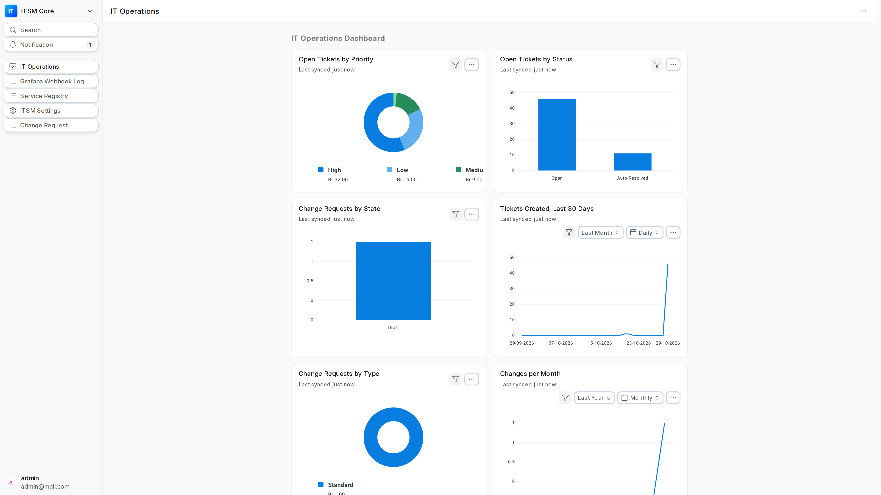
The IT Operations workspace showing the 6-chart dashboard layout: Open Tickets by Priority (Donut), Open Tickets by Status (Bar), Change Requests by State (Bar), Tickets Created Last 30 Days (Line), Change Requests by Type (Donut), and Changes per Month (Line).

5.2 Change Request Form — Standard Type
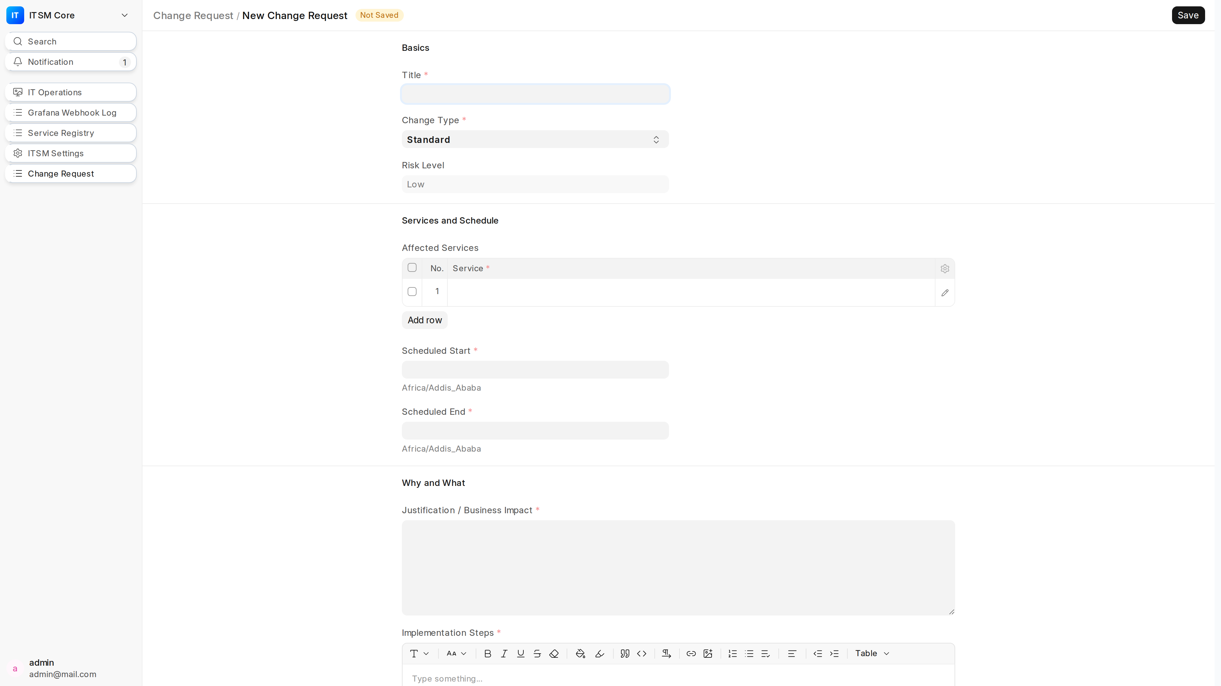
The Change Request form demonstrating smart progressive disclosure for a Standard change: Basics (title, change type, risk level), Services & Schedule, Why & What (justification, steps), Risk Assessment (hidden for Standard), Safety (collapsible, rollback plan required), CI/CD (hidden unless Code category), System (collapsible, hidden on new documents). No "Invalid depends_on" errors.

6. Future Enhancements
Template Catalog for High-Volume Changes: When Standard changes exceed a volume threshold (X% of changes over 90 days) or cause an incident, the Template Catalog becomes mandatory. Threshold X% is DECISION NEEDED based on operational data.
Return to Draft from Pending Approval: Proposed transition allowing Approvers to send a request back to Draft with a required review comment. Awaits stakeholder approval.
Workflow State Mapping: Current workflow uses custom locking (all states at doc_status=0). Consider adding a native "Submitted" state (doc_status=1) at "Approved for Deployment" if Frappe workflow engine supports it.
HD Ticket Priority "Critical": HD Ticket Priority fixture includes Critical but Helpdesk v16 may not expose it — severity map uses "Urgent" as fallback. Verify and align with Helpdesk v16 schema.
Auto-Resolved SLA Pause: Whether "Auto-Resolved" status pauses SLA via HD Service Level Agreement rules — needs Helpdesk v16 verification.
CI/CD Evidence Automation: Current deployment evidence is free-text. Future: integrate with GitHub/GitLab tags for automated verification and immutable evidence chains.

Appendix A: API Usage Examples
# Grafana Webhook Configuration
curl -X POST https://erp.fastpayet.com/api/method/itsm_core.api.ingest_grafana_alert \
-H "Authorization: token <grafana_integration_token>" \
-H "Content-Type: application/json" \
-d '{"alerts":[{"fingerprint":"fp-001","status":"firing","startsAt":"2026-10-28T12:00:00Z","labels":{"service":"payments-api","severity":"critical"},"annotations":{"summary":"High CPU","runbook_url":"https://runbooks/cpu.md"}}]}'
# CI Pipeline Gate (GitHub Actions / GitLab CI)
STATE=$(curl -s -X POST https://erp.fastpayet.com/api/method/itsm_core.api.get_change_state \
-H "Authorization: token <ci_integration_token>" \
-H "Content-Type: application/json" \
-d '{"change_request_id":"CRQ-2026-00001","repo":"github.com/org/repo","environment":"Production"}')
if echo "$STATE" | jq -e '.message.approved_for_deployment' >/dev/null; then
echo "Deploy approved"
else
echo "Deploy blocked: $(echo "$STATE" | jq -r '.message.message')"
exit 1
fi
# CI Post-Deploy Evidence Recording
curl -X POST https://erp.fastpayet.com/api/method/itsm_core.api.record_deployment \
-H "Authorization: token <ci_integration_token>" \
-H "Content-Type: application/json" \
-d '{"change_request_id":"CRQ-2026-00001","evidence":"Deployed v1.2.3 to prod; smoke tests passed"}'
# Health Check
curl https://erp.fastpayet.com/api/method/itsm_core.api.heartbeat
# Manual Webhook Replay (System Manager)
curl -X POST https://erp.fastpayet.com/api/method/itsm_core.api.replay_webhook \
-H "Authorization: token <system_manager_token>" \
-H "Content-Type: application/json" \
-d '{"webhook_log_name":"GWL-00001"}

