Term Deposit Subscription Analysis — Bank Marketing Dataset

Introduction
This report presents a comprehensive analysis of a bank's direct marketing campaign for term deposits using customer demographic, financial, and campaign data. The objective is to identify the key drivers of customer subscription behaviour, uncover actionable business insights, and provide data-driven recommendations to optimise future marketing campaigns and improve customer targeting.

Business Problem Statement
- What factors drive customers to subscribe to a term deposit?
- Which customer segments should the bank prioritize in future marketing campaigns to improve response rates?

Dataset Description
Metric | Value
Number of records | 11,162
Number of features | 17
Target variable | deposit (yes / no)
Overall subscription rate | 47.4% yes / 52.6% no
Missing values / duplicates | None found

The dataset includes customer demographics, financial details, and campaign contact history, and further other details.

Data Analysis Process
- Data understanding: Examined the dataset structure, data types, and unique values for each variable to gain an understanding of the data. The dataset consisted of 11,162 customer records across 17 features, with no missing values or duplicate records identified.
- Data cleaning: Standardised the formatting of categorical variables, including job, education, marital status, contact method, previous campaign outcome, and campaign month, to ensure consistency and improve the accuracy of the analysis.
- Exploratory analysis: Performed descriptive statistical analysis and evaluated subscription rates across key customer and campaign variables, including job, age group, campaign month, day of the month, previous campaign outcome, education level, marital status, and contact method.
- Comparative analysis: Compared subscription rates with total account balances across selected customer segments to determine whether the groups with the highest financial value were also the most likely to subscribe to a term deposit.
- Visualization: Developed a range of visualisations, including bar charts, pie charts, box plots, and line charts, to identify trends, compare customer segments, and communicate key business insights effectively.

Key Findings

Figure 1: Distribution of Term Deposit Subscription
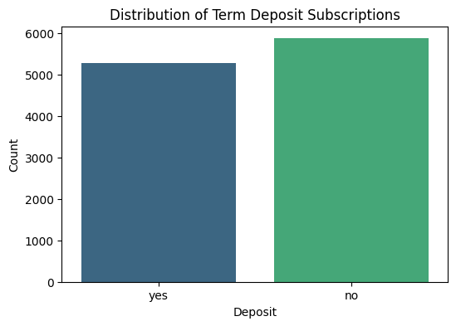
Deposit distribution: yes vs. no.

Insight: This chart presents the distribution of term deposit subscriptions among customers contacted during the marketing campaign. Of the 11,162 customers, 5,289 (47.4%) subscribed to a term deposit, while 5,873 (52.6%) did not. The results indicate a relatively balanced outcome, with slightly more customers declining the offer than accepting it.

Figure 2: Subscription Rate by Job
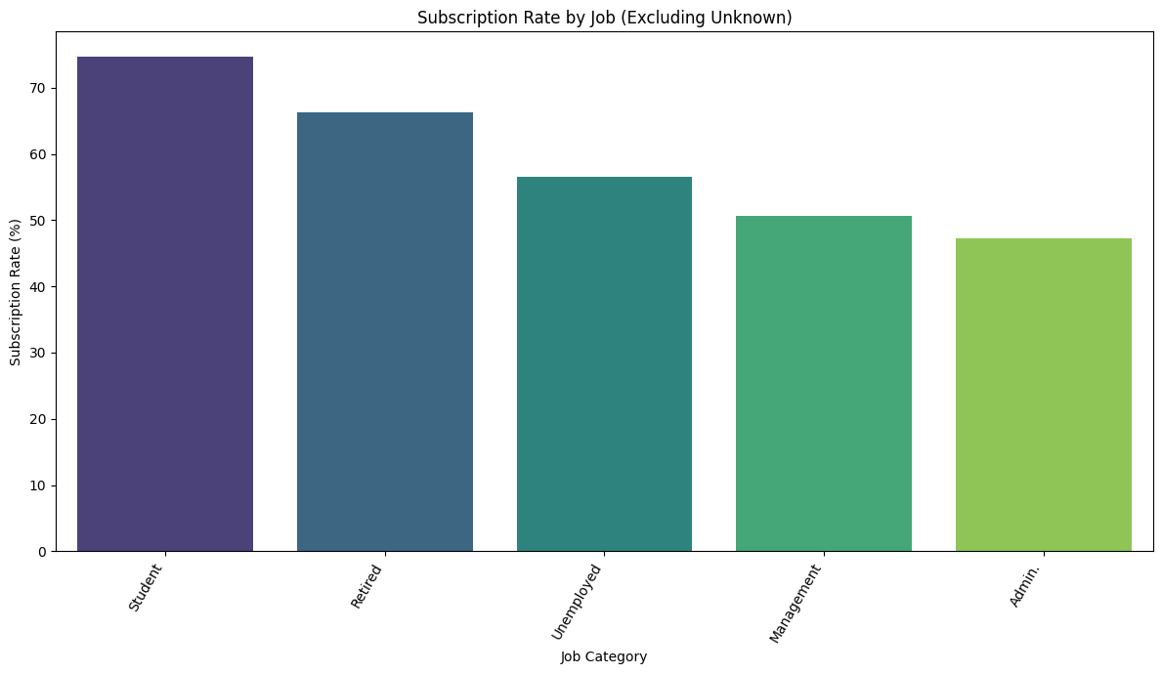
Subscription rate by job type.

Insight: This chart compares subscription rates across different job categories. Students (74.7%) and retirees (66.3%) recorded the highest subscription rates, while blue-collar (36.4%) and entrepreneur (37.5%) customers recorded the lowest. The findings suggest that life stage may influence customers' likelihood of subscribing to a term deposit. Although the Management group held the largest total account balance (£4.6 million), it recorded only a moderate subscription rate (50.7%), indicating that higher account balances do not necessarily correspond to higher subscription rates.

Figure 3: Subscription Rate by Age Group
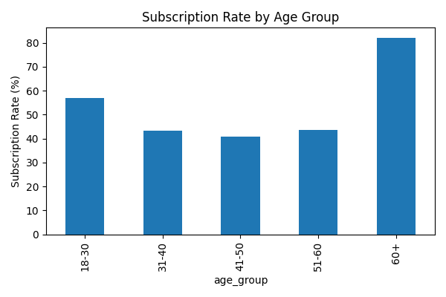
Subscription rate by age group.

Insight: This chart compares subscription rates across five age groups. Customers aged 60 and above recorded the highest subscription rate (82.2%), nearly double that of the other age groups, while customers aged 31–50 recorded the lowest subscription rates (41–44%). The findings suggest that age and life stage play an important role in term deposit subscriptions, with older customers appearing more willing to invest in long-term savings products than working-age adults.

Figure 4: Subscription Rate by Day of Month, Grouped by Month
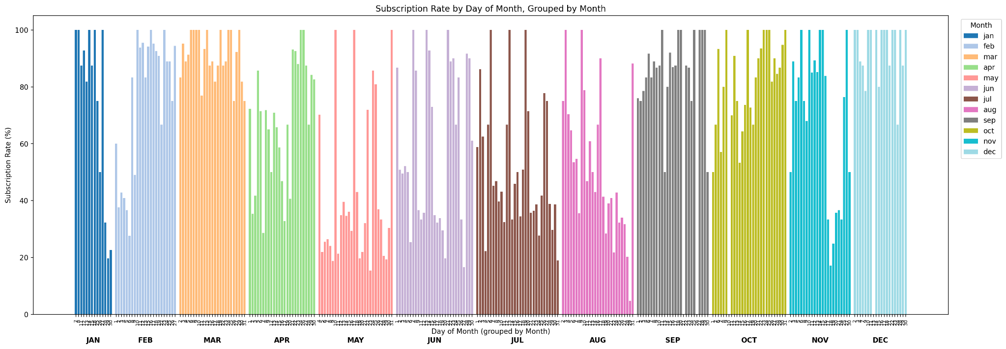
Daily subscription rate within each campaign month.

Insight: This chart plots the subscription rate for each day of the month, grouped and colour-coded by campaign month, allowing both daily fluctuations and monthly trends to be observed simultaneously. March, September, October, and December show repeated clusters of exceptionally high subscription rates, frequently ranging between 80% and 100%. In contrast, May consistently recorded lower subscription rates throughout the month, despite having the highest number of customer contacts during the entire campaign. These findings suggest that campaign timing and customer targeting had a greater influence on subscription rates than the volume of customer contacts alone. Simply increasing the number of calls, as observed in May, did not result in improved campaign performance.

Figure 5: Subscription Rate by Previous Campaign Outcome
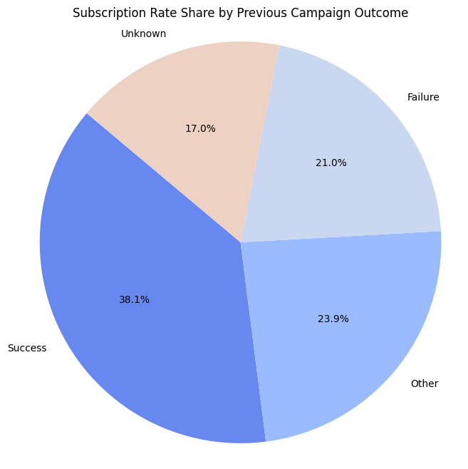
Subscription rate by previous campaign outcome.

Insight: This chart compares subscription rates according to the outcome of previous marketing campaigns. Customers with a successful previous campaign outcome achieved the highest subscription rate (91.3%), compared with 40.7% for customers with no recorded previous campaign outcome. This finding identifies previous campaign success as the strongest predictor of future term deposit subscriptions, highlighting the importance of leveraging historical customer behaviour when planning future marketing campaigns.

Figure 6: Subscription Rate by Education Level
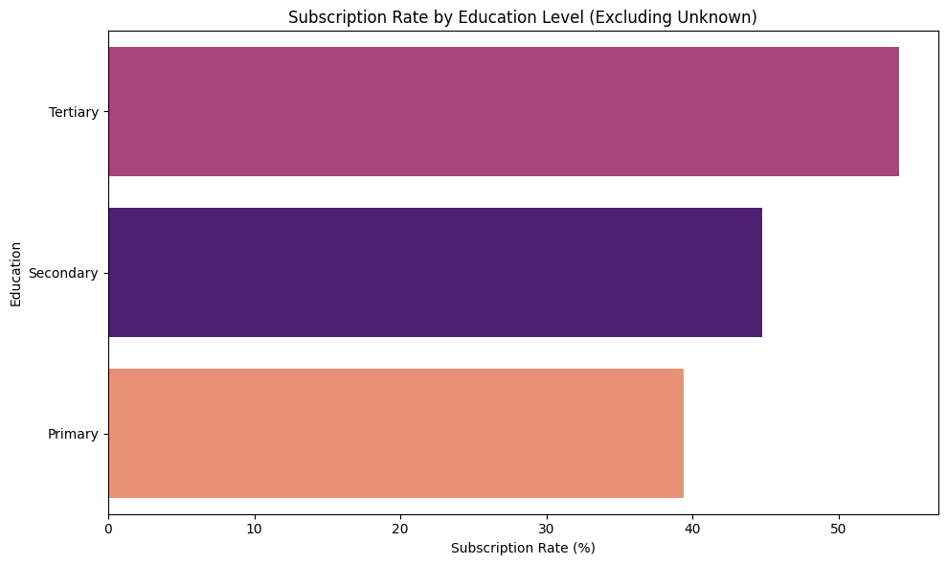
Subscription rate by education level.

Insight: This chart compares subscription rates across education levels. Customers with tertiary education recorded the highest subscription rate (54.1%), followed by secondary (44.7%) and primary education (39.4%). The findings suggest that customers with higher levels of education were more likely to subscribe to a term deposit.

Figure 7: Subscription Rate by Marital Status
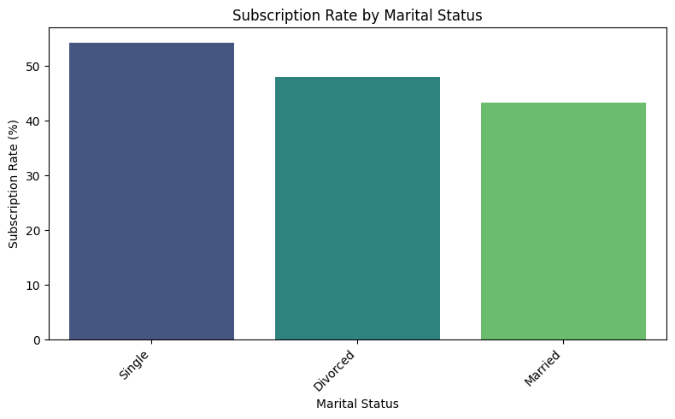
Subscription rate by marital status.

Insight: This chart compares subscription rates across marital status categories. Single customers recorded the highest subscription rate (54.3%), followed by divorced customers (48.1%) and married customers (43.4%). Despite holding the largest total account balance (£10.2 million), married customers were the least likely to subscribe to a term deposit. In comparison, single and divorced customers held total balances of £5.1 million and £1.8 million, respectively. This finding reinforces a key insight from the analysis: higher account balances do not necessarily correspond to higher subscription rates, highlighting the importance of using conversion metrics rather than financial value alone when identifying target customer segments.

Figure 8: Subscription Rate by Contact Method
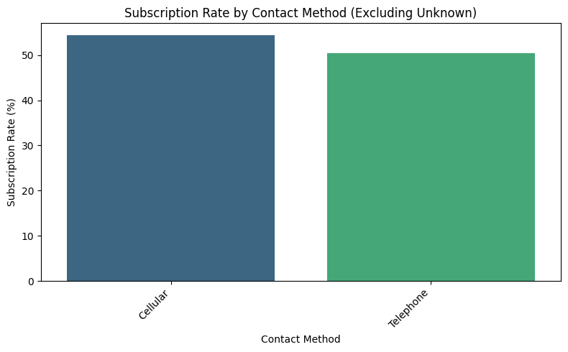
Subscription rate by contact method.

Insight: This chart compares subscription rates across the available customer contact methods. Cellular contact achieved the highest subscription rate (54.3%), outperforming telephone contact (50.4%). These findings suggest that cellular communication was the most effective channel for promoting term deposits during the campaign. Focusing future marketing efforts on the most effective communication channels could help improve campaign performance and increase overall conversion rates.

Figure 9: Account Balance Distribution by Subscription Outcome
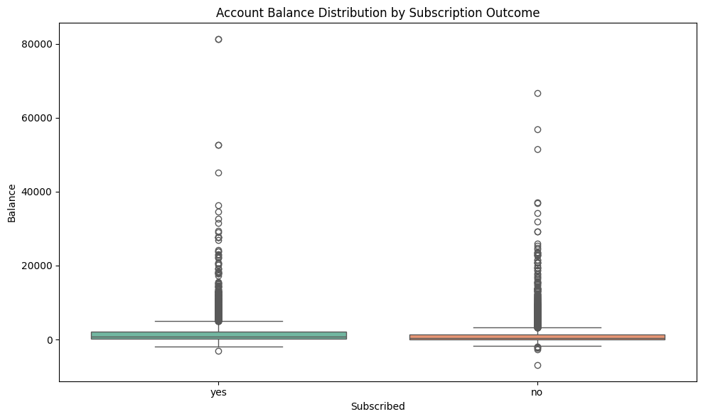
Balance distribution: subscribed vs. not subscribed.
Insight: This box plot compares the distribution of account balances between customers who subscribed to a term deposit and those who did not. Customers who subscribed recorded a higher median account balance (£733) than those who did not (£414), suggesting a positive association between account balance and the likelihood of subscription. However, both groups display a similar right-skewed distribution, indicating that although a small proportion of customers hold substantially higher balances, the majority maintain relatively modest account balances. These findings suggest that while account balance may influence subscription behaviour, it is not a strong predictor on its own.

Why Subscription Rate and Sum of Balance Tell Different Stories
To better understand customer behaviour, subscription rates and total account balances were compared across five key variables. The analysis revealed that the customer segments with the highest subscription rates were generally different from those holding the largest total account balances, indicating that financial value alone is not a reliable indicator of a customer's likelihood to subscribe.

Variable | Highest Subscription Rate | Highest Sum of Balance
Job | Student (74.7%) | Management (£4.6M)
Education | Tertiary (54.1%) | Secondary (£7.1M)
Marital Status | Single (54.3%) | Married (£10.2M)
Previous Outcome | Success (91.3%) | Unknown (£12.0M)
Contact Method | Cellular (54.3%) | Cellular (£12.4M)

Contact Method was the only variable for which the customer segment with the highest subscription rate also recorded the highest total account balance. Across all other variables, the rankings differed, demonstrating that customer segments with the greatest financial value were not necessarily the most likely to subscribe. This difference arises because total account balance reflects the cumulative financial value of a customer segment, whereas subscription rate measures the proportion of customers who accepted the term deposit offer. As the primary objective of this analysis is to identify the customer segments most likely to respond positively to marketing campaigns, subscription rate provides a more appropriate basis for customer targeting than total account balance.

Business Insights

- What patterns were identified?
The analysis revealed that previous customer behaviour is the strongest predictor of future subscription. Customers who had a successful outcome in a previous marketing campaign achieved a subscription rate of 91.3%, significantly higher than the overall average. Campaign timing also emerged as an important factor. Marketing activities conducted during March, September, October, and December consistently achieved higher daily subscription rates, whereas May recorded relatively low conversion despite having the highest volume of customer contacts. This suggests that campaign effectiveness depends more on timing and targeting than on the number of customers contacted.

- What customer behaviours stand out?
Subscription behaviour varies considerably across customer groups. Students, retirees, and customers aged 60 and above recorded the highest subscription rates, indicating a greater willingness to invest in term deposits. In contrast, working-age customers, particularly those between 31 and 50 years, were less likely to subscribe, suggesting that financial priorities and life stage may influence investment decisions.

- Which customer segments require attention?
Although working-age and blue-collar customers recorded below-average subscription rates, they represent a substantial proportion of the customer base. Rather than reducing marketing efforts toward these groups, the bank should consider developing more targeted campaigns that address their specific financial needs and preferences. Improving campaign relevance for these customers presents an opportunity to increase overall conversion rates.

- What risks and opportunities exist?
One potential risk is that the highest-converting customer segments, such as students, retirees, and customers aged over 60, represent a relatively small proportion of the overall customer population. Consequently, focusing exclusively on these groups may limit the potential for substantial growth in overall subscriptions. Conversely, the strong performance observed during March, September, October, and December presents a valuable opportunity. Understanding the factors that contributed to the success of campaigns during these periods could help the bank improve future marketing performance without increasing campaign volume.

Recommendations

1. Prioritise customers with successful previous campaign outcomes
Customers who responded positively to previous marketing campaigns recorded the highest subscription rate (91.3%). Developing targeted follow-up campaigns for these customers is likely to improve conversion rates while reducing unnecessary marketing expenditure.
2. Focus on high converting customer segments
Marketing efforts should place greater emphasis on customers aged 60 and above, as well as students and retirees, as these groups consistently demonstrated above-average subscription rates. Tailoring campaign messages and product offerings to these segments could improve campaign effectiveness.
3. Optimise campaign timing
The analysis indicates that campaigns conducted during March, September, October, and December achieved stronger subscription rates than those conducted during other periods, particularly May. The bank should review the strategies employed during these higher-performing months and incorporate successful practices into future campaigns.
4. Strengthen customer communication strategies
Cellular contact proved to be the most effective communication channel for promoting term deposits. Future marketing campaigns should prioritise this channel where appropriate while ensuring customer contact information is accurate and up to date.
5. Use subscription rate as the primary performance metric
Although some customer segments held larger total account balances, they were not necessarily the most likely to subscribe to a term deposit. Consequently, future targeting decisions should be based primarily on subscription rate, with account balance serving as a supporting metric rather than the principal measure of campaign success.

Conclusion
This analysis demonstrates that previous campaign success, customer life stage, and campaign timing are the strongest factors influencing term deposit subscriptions. While demographic and financial characteristics provide useful context, they are less effective predictors of customer response than behavioural indicators such as previous campaign outcomes. By prioritising high-converting customer segments, optimising campaign timing, and focusing on the most effective communication channels, the bank can improve campaign performance and increase subscription rates without significantly increasing marketing expenditure.

