# To Do

* Redo pcb

# To check

**How do trace widths, trace spacing etc affect the price**

# Info on PCB Design

Trace width Calculator: <https://www.4pcb.com/trace-width-calculator.html>

* Leave 0.0254 mm between all traces and pads
* Create ground plane and use vias to connect components
* Make Your Power and Ground Traces Wider
* May use Power dissipating vias

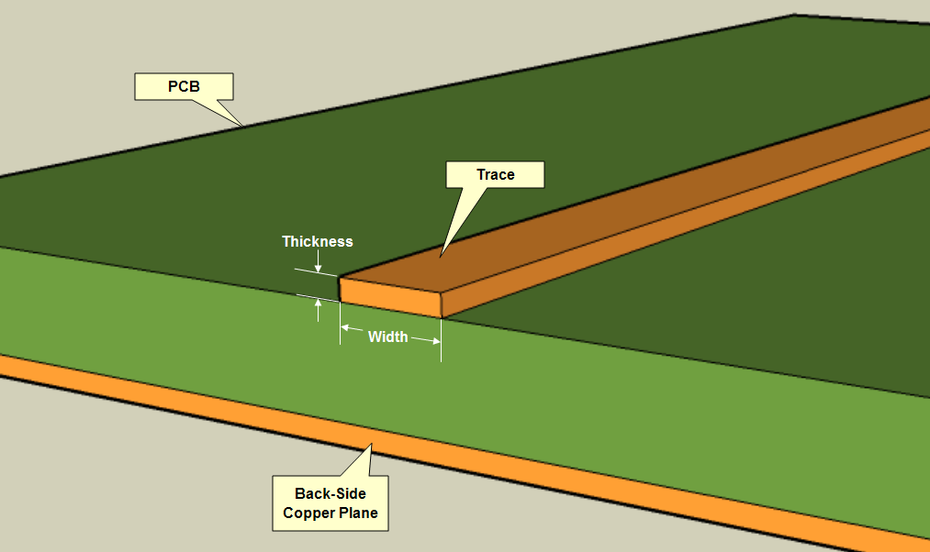

* Outer and upper later thickness is going ot be 1oz
  + For 1 oz board, make sure the trace width and spacing are larger than 5mil for 2 layer board: 5 mil = 0.0127
  + Make still size roughly the same as the track width, and.pad size double that

155 mms longest track for ignition

After review:

* Go over required track thicknesses for each power circuit