Thermal-Electrical Analysis of Interposer Based Micro-Channel Cooling System for 3-D Integrated Microsystems

Huan Huang
School of Electronics and Information (School of IC Science and Engineering)
Hangzhou Dianzi University
Hangzhou, China
256040071@hdu.edu.cn
Absalom El-Shamir Ezugwu
Unit for Data Science and Computing
North-West University
Potchefstroom, South Africa
absalom.ezugwu@nwu.ac.za
Peng Zhang
School of Electronics and Information (School of IC Science and Engineering)
Hangzhou Dianzi University
Hangzhou, China
zpta517@163.com
Hairong Wang
School of Computer Science and Applied Mathematics
University of the Witwatersrand
Johannesburg, South Africa
hairongwng@gmail.com
Da-Wei Wang
School of Electronics and Information (School of IC Science and Engineering)
Hangzhou Dianzi University
Hangzhou, China
davidw.zoeq@hdu.edu.cn
Wen-Sheng Zhao
School of Electronics and Information (School of IC Science and Engineering)
Hangzhou Dianzi University
Hangzhou, China
wshzhao@hdu.edu.cn

Abstract—Thermal management is a critical challenge for 3-D integrated microsystems because the increased power density can lead to severe heat accumulation. In this work, an interposer based micro-channel cooling system (IMCCS) with cylindrical micro pin-fins is investigated. A coupled thermal-electrical model is established to evaluate coolant flow, heat transfer, and TSV signal transmission. The effects of micro pin-fin radius and inlet/outlet position are analyzed. The results show that the IMCCS can effectively improve heat dissipation, while different geometric parameters lead to trade-offs among temperature reduction, pressure drop, and electrical transmission. This study provides useful guidance for the design of micro-channel cooling structures in thermally constrained 3-D integrated microsystems.
Keywords—3-D integrated microsystem, thermal performance, electrical performance, TSV signal transmission

Introduction
The continuous development of advanced packaging has promoted vertically stacked integration technologies for high-density heterogeneous microsystems [1]. Compared with conventional two-dimensional integration, three-dimensional (3-D) integration can shorten interconnect length, reduce signal transmission delay, and improve integration density and overall system performance [2]. However, compact stacking and high-density interconnection also lead to increased heat flux and power density. The resulting heat accumulation may cause local hot spots, degrade device reliability, and affect the stable operation of the microsystem [3]. Therefore, efficient thermal management is essential to ensure the reliable operation of high-power 3-D integrated microsystems.
Micro-channel cooling has been widely recognized as an effective approach for removing high heat flux in compact electronic packages. Song et al. optimized microchannels under complex power distribution in 3-D integrated microsystems and demonstrated improved cooling efficiency [4]. To further enhance heat transfer, pin-fin structures have been introduced into micro-channel cooling systems by increasing the solid-fluid contact area and promoting local coolant disturbance. Kuruva et al. showed that cylindrical inserts can improve heat transfer performance [5]. Mohit and Gupta reported that micro pin-fin geometry strongly affects the balance between heat transfer enhancement and flow resistance [6]. In addition, comparisons among circular, square, and triangular pin fins confirmed the important role of fin geometry in microchannel thermal performance [7]. These studies indicate that embedded micro-channel with pin-fin structures provide a promising solution for thermal management in 3-D integrated microsystems.
This work was supported by the National Key R&D Program of China under Grant 2025YFE0102500 and the National Natural Science Foundation of China under Grant U24A20296.
Despite these advances, the electrical influence of embedded micro-channel cooling systems remains insufficiently studied. Since coolant and micro pin-fins may be close to interconnect structures, a coupled thermal-electrical evaluation is necessary. This work investigates an interposer based micro-channel cooling system (IMCCS) with cylindrical micro pin-fins by analyzing temperature distribution, pressure drop, and signal transmission characteristics. The results provide useful guidance for designing thermally efficient and electrically reliable cooling structures for advanced packaging.

Numerical Model of the interposer based micro-channel cooling system

Physical Model and Geometric Configuration
Fig. 1 shows the schematic of the 3-D integrated microsystem, including stacked chip layers, the IMCCS, TSV, microbumps, and a package substrate. The coolant flows through the micro-channel region to remove heat from the upper chip layers. This configuration enables interposer-level cooling close to the heat source while maintaining compatibility with TSV interconnection.
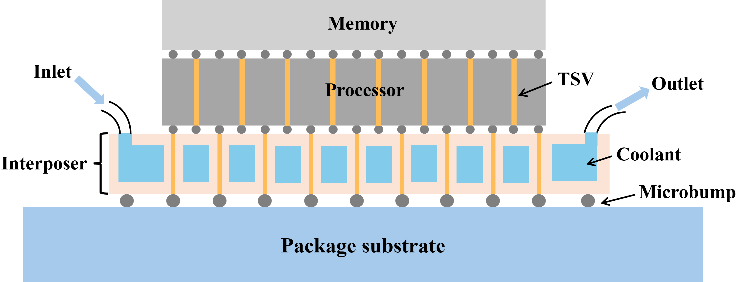
- Schematic of the 3-D integrated microsystem with interposer based micro-channel cooling system.
To simplify the numerical analysis, only the interposer region is explicitly modeled. This treatment retains the main physical features of interest, including coolant flow in the IMCCS, conjugate heat transfer between the solid and fluid domains, and signal transmission through the TSV array. The thermal effect of the upper chip layers is replaced by an equivalent heat flux applied to a local region on the top surface of the interposer.
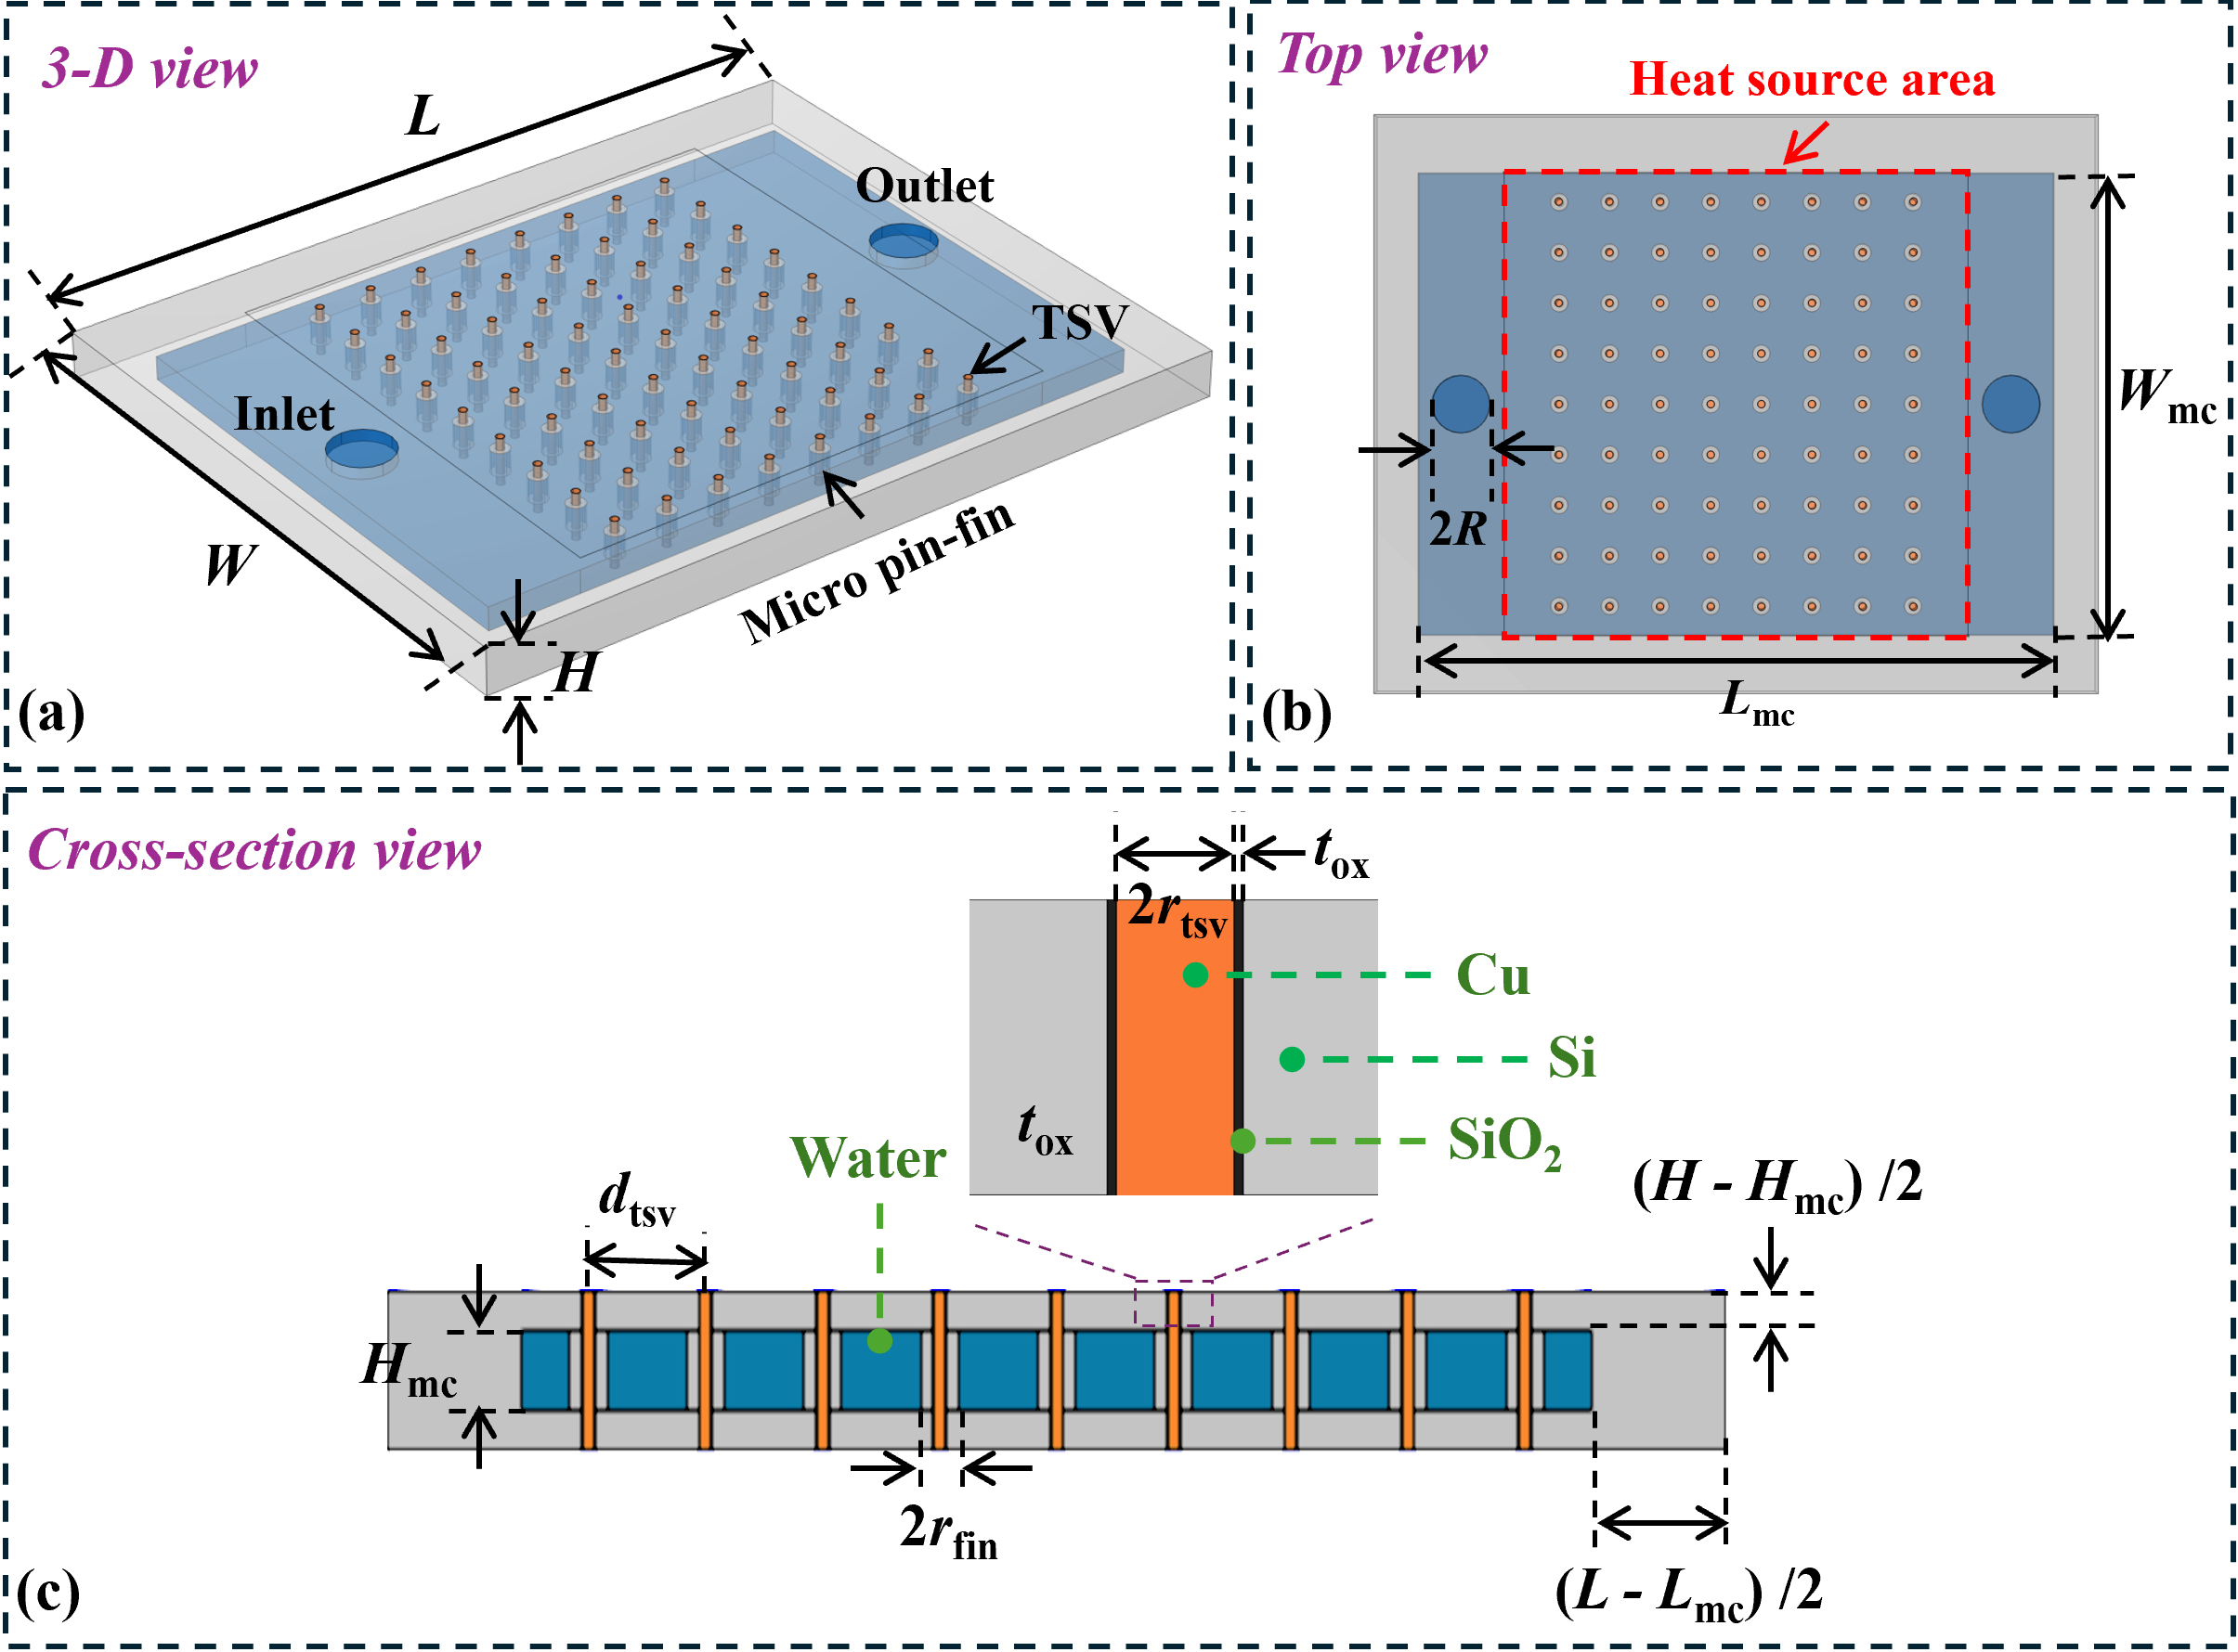
- Geometric model of the IMCCS: (a) 3-D view, (b) top view, and (c) cross-sectional view.
Fig. 2 shows the geometric model of the simplified interposer region with the IMCCS, including the 3-D view, top view, and cross-sectional view. In the model, a 4 mm × 4 mm heat flux region is applied on the top surface of the interposer to represent the heat input from the stacked chips. The main geometric parameters are listed in Table I.
- The main geometric parameters of IMCCS
Parameter | Symbol | Value | Unit
Interposer length | L | 5.0 | mm
Interposer width | W | 4.0 | mm
Interposer height | H | 0.3 | mm
IMCCS length | L_{mc} | 4.4 | mm
IMCCS width | W_{mc} | 3.2 | mm
IMCCS height | H_{mc} | 0.15 | mm
Inlet/outlet radius | R | 200 | μm
TSV radius | r_{tsv} | 25 | μm
TSV pitch | d_{tsv} | 350 | μm
TSV insulation thickness | t_{ox} | 2 | μm
Micro pin-fin radius | r_{fin} | 50-100 | μm

Thermal Modeling and Boundary Conditions
A steady-state thermal-flow model is established for the IMCCS. Water is used as an incompressible laminar coolant, with an inlet temperature of 25 °C and a velocity determined by the selected Reynolds number. Heat fluxes of 625 W/cm² and 125 W/cm² are applied to the TSV and non-TSV regions, respectively. The coolant and solid domains are solved using the corresponding flow, energy, and heat conduction equations.
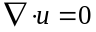 | (1)
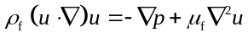 | (2)
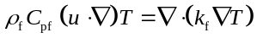 | (3)
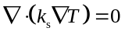 | (4)
where u, p, and T denote the coolant velocity vector, pressure, and temperature, respectively. ρ_{f}, μ_{f}, C_{pf}, and k_{f} represent the density, dynamic viscosity, specific heat capacity, and thermal conductivity of the coolant, respectively, while k_{s} is the thermal conductivity of the solid material.
The inlet velocity is determined from the specified Reynolds number Re, which is defined based on the hydraulic diameter D_{h} of the circular inlet:
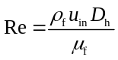 | (5)
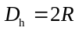 | (6)

Electromagnetic Modeling and Signal Evaluation
The electromagnetic model is established to evaluate the influence of the IMCCS on TSV signal transmission. As shown in Fig. 3, the TSV array adopts a checkerboard ground-signal (G-S) configuration, in which adjacent ground TSV provide local return paths and reduce coupling between neighboring signal TSV.
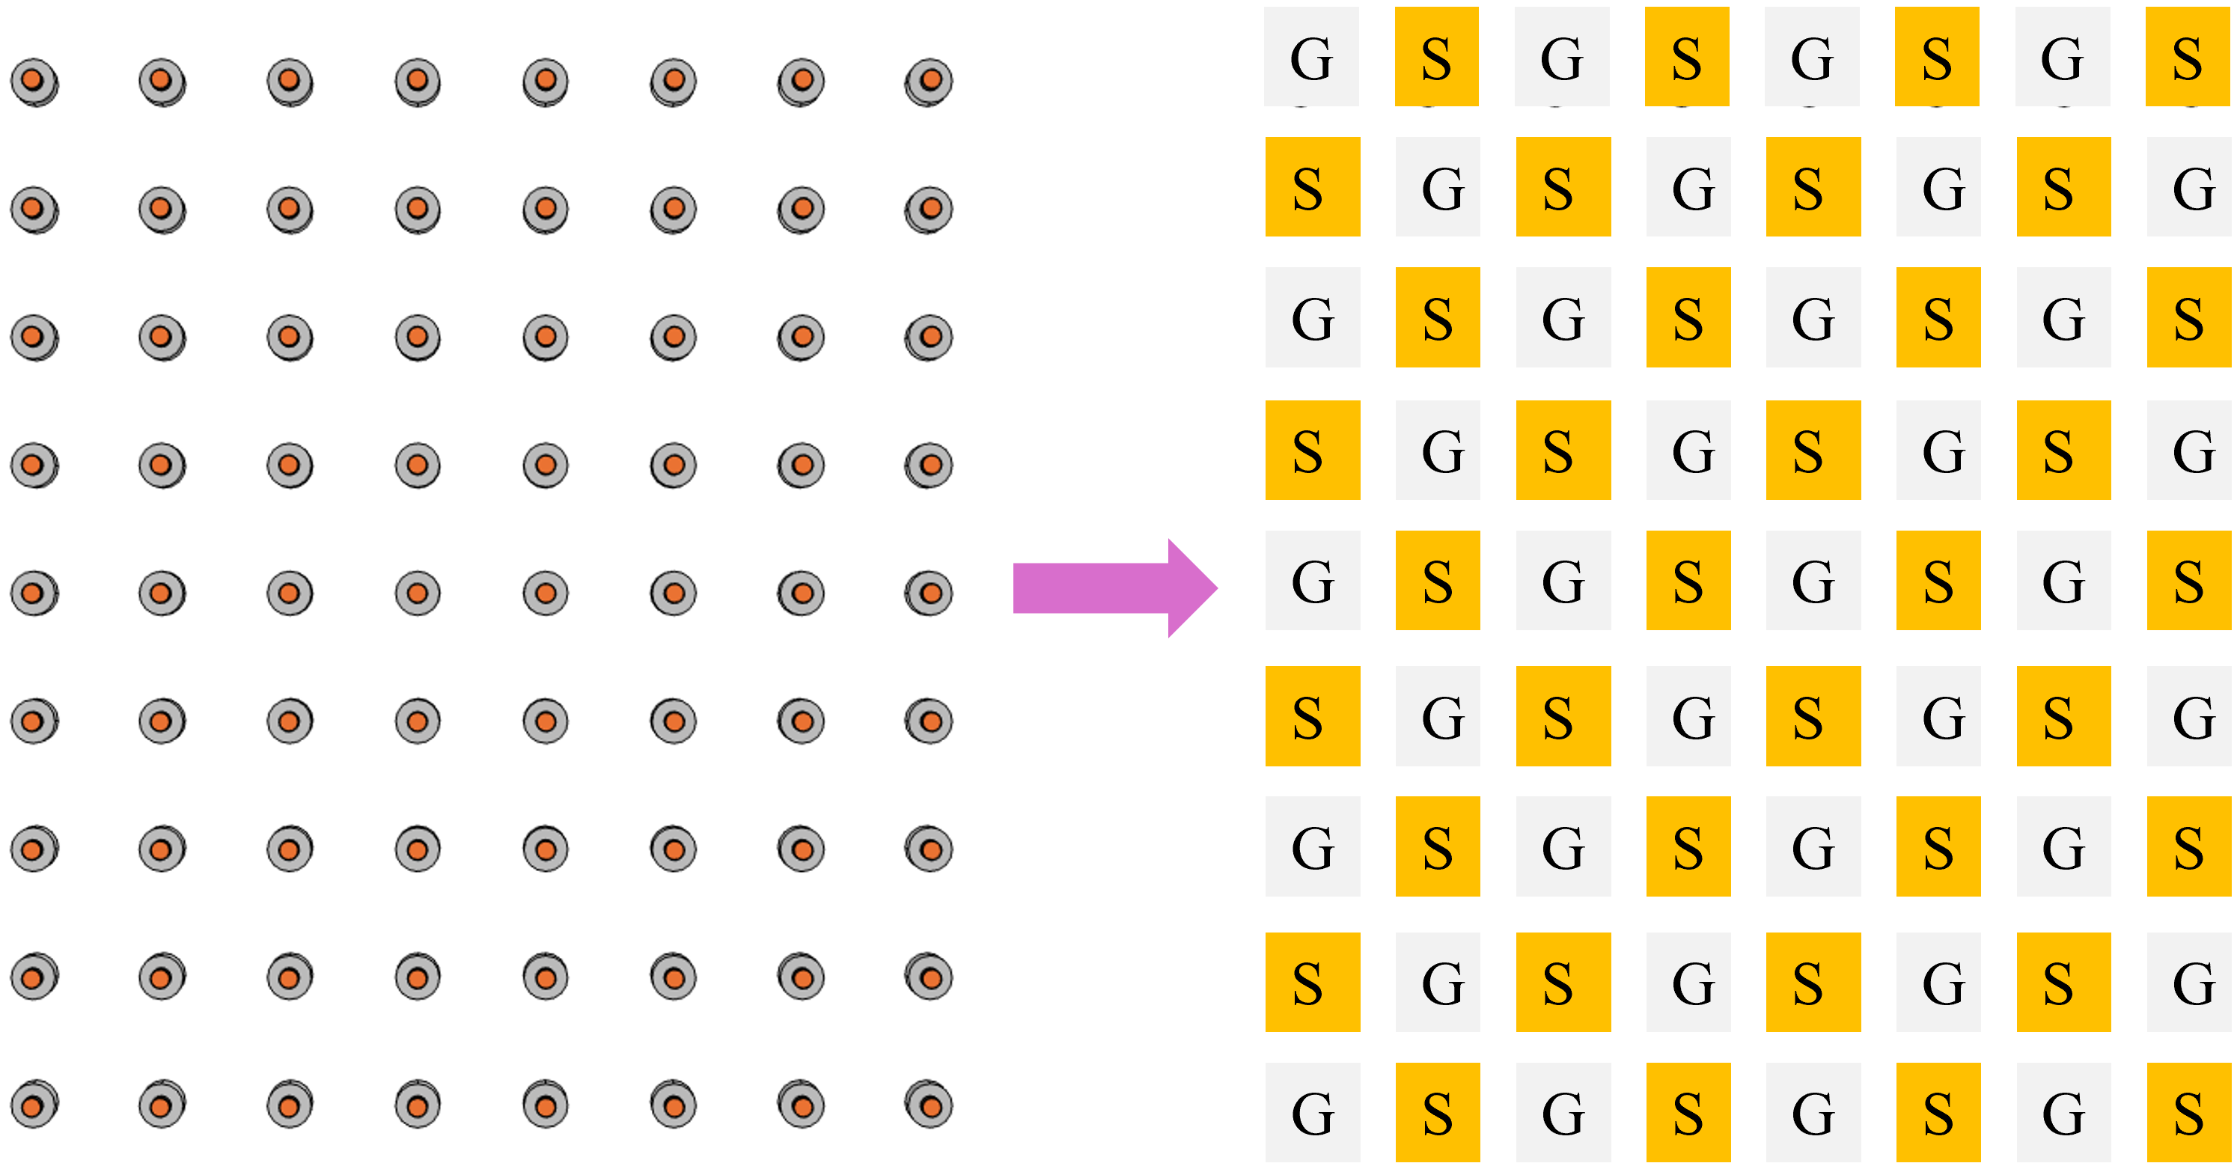
- G-S configuration of the TSV array.
The frequency response of the TSV array is evaluated using S-parameters. For a multi-port network, the S-parameter is defined as follows:
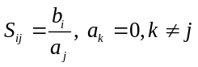 | (7)
where a_{j} and bᵢ denote the incident wave at port j and the outgoing wave at port i, respectively, and the other ports are terminated with matched loads. In this work, the transmission coefficient S₂₁ is extracted for each signal TSV path to evaluate signal transmission.
The temperature dependent dielectric properties of water are included to capture the coolant induced electromagnetic effect. The thermal simulation results are mapped to the coolant region, and the complex relative permittivity is calculated using a temperature dependent Debye model[8]:
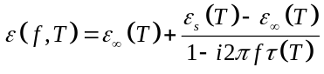 | (8)
where f is the frequency, T is the coolant temperature, ε_{s}(T) is the static relative permittivity, ε∞(T) is the high-frequency limiting permittivity, and τ(T) is the relaxation time. The corresponding temperature dependent parameters are calculated from empirical correlations [9].

Results and Discussion
The effects of micro pin-fin radius and inlet/outlet position on the IMCCS are investigated in this section. Thermal and electrical responses are evaluated in terms of temperature distribution, pressure drop, and TSV signal transmission at Re = 300 and f = 20 GHz.

Effect of Micro Pin-Fin Radius on Thermal and Electrical Performance of IMCCS
Fig. 4 shows the thermal performance under different micro pin-fin radius. As the radius increases, the maximum and average temperatures decrease by 15.83% and 12.59%, respectively, compared with the smallest radius case. This improvement is attributed to the enlarged solid-fluid contact area and enhanced coolant disturbance. However, the pressure drop increases by 55.08%, indicating a clear trade-off between heat removal and flow resistance.
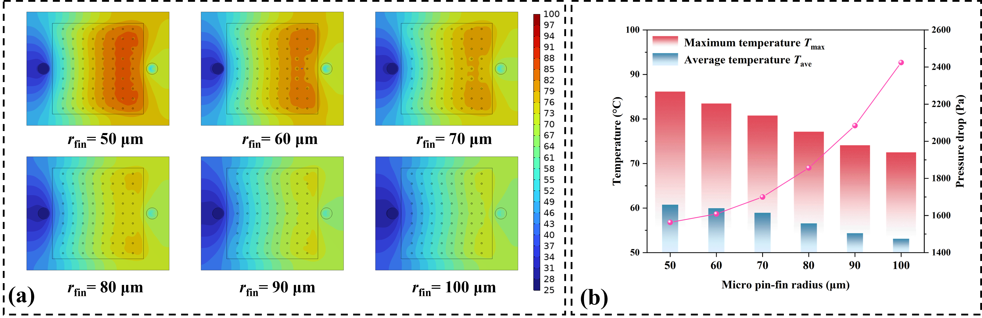
- Effect of micro pin-fin radius on thermal performance: (a) temperature distribution of heated surface and (b) variations of temperature and pressure drop.
Fig. 5 presents the transmission coefficient distribution under different pin-fin radius. The best average transmission coefficient is obtained at 100 μm, reaching -0.82 dB, while the least attenuation of the weakest TSV signal path appears at 80 μm, with the minimum transmission coefficient reaching -1.97 dB. This indicates that the electrical response is jointly affected by pin-fin geometry, temperature distribution, and coolant dielectric properties. Therefore, the pin-fin radius should be selected by balancing heat dissipation, flow resistance, and TSV signal transmission.
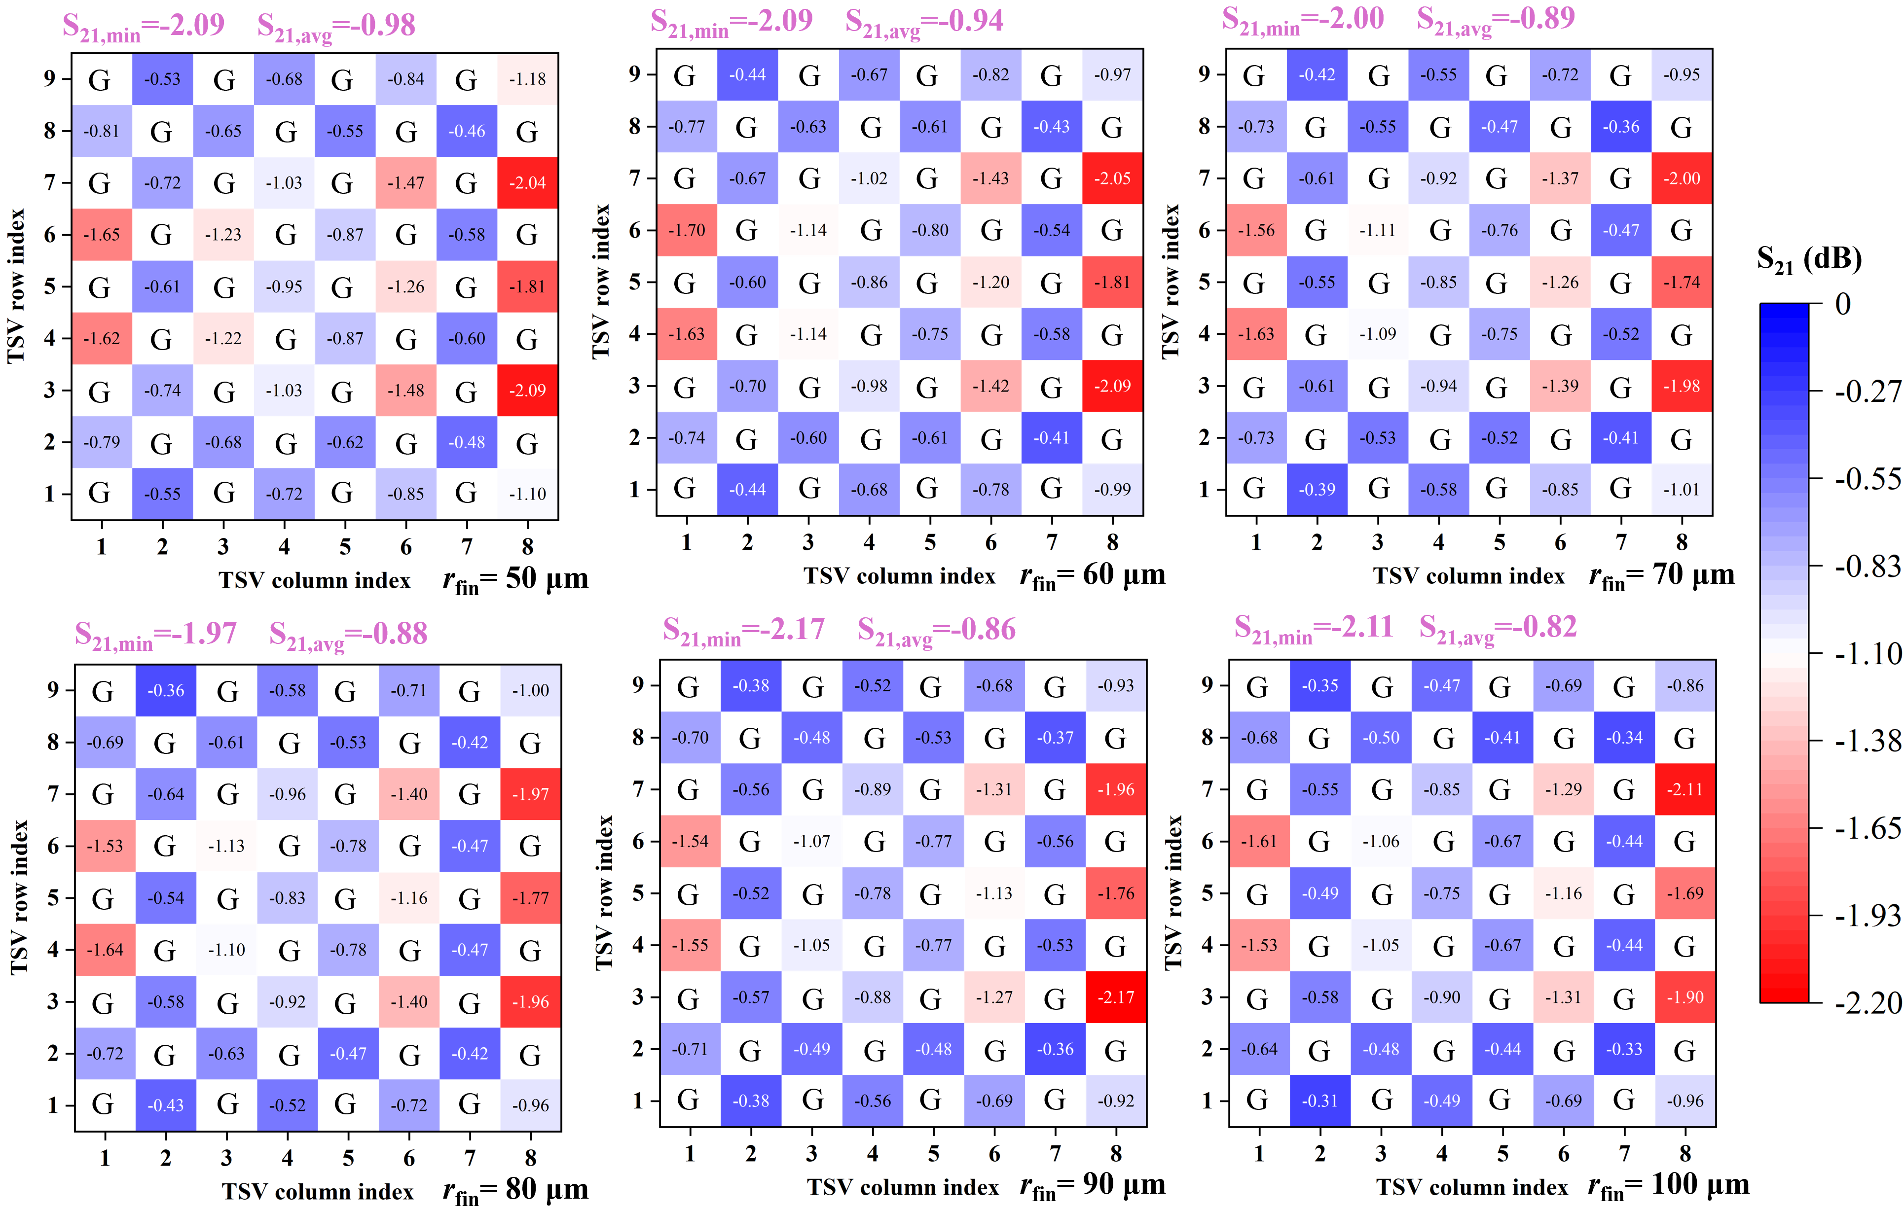
- Transmission coefficient distribution of TSV signal paths under different micro pin-fin radius.

Effect of Inlet/Outlet Position on Thermal and Electrical Performance of IMCCS
Since the weakest TSV signal path shows the least attenuation at a micro pin-fin radius of 80 μm, this radius is selected as the baseline condition, namely Case 1, to further investigate the effect of inlet/outlet position on thermal and electrical performance. Fig. 6 shows the thermal performance under different inlet/outlet positions. Case 4 achieves the lowest temperature, reducing the maximum temperature by 15.56% compared with Case 2, because its flow path improves coolant coverage around the TSV array. However, Case 4 also produces the highest pressure drop, which is 42.64% higher than that of Case 1. Therefore, the inlet/outlet position should be designed by balancing cooling performance and pressure drop penalty.
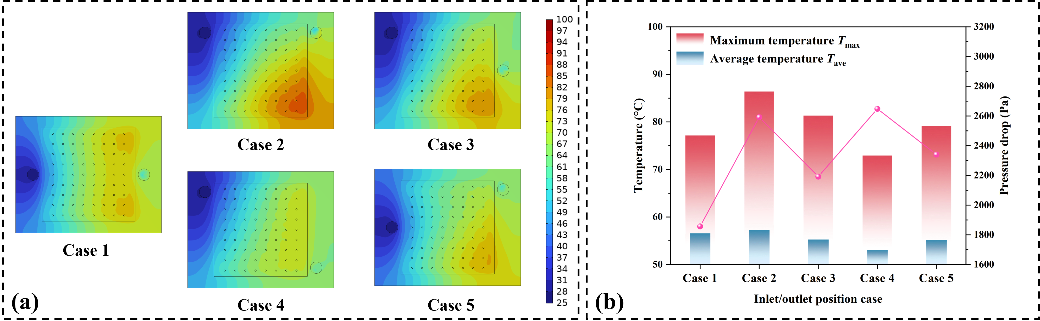
- Effect of inlet/outlet positions on thermal performance: (a) temperature distribution of heated surface and (b) variations of temperature and pressure drop.
Fig. 7 shows the transmission coefficient distribution under different inlet/outlet positions. The S₂₁ results are similar among the five cases, indicating that the inlet/outlet position has a limited influence on TSV signal transmission. This is because the TSV geometry, G-S arrangement, and cylindrical pin-fin structure remain unchanged, while only the coolant flow path and temperature field are modified. The slight S₂₁ variation is mainly related to the redistributed temperature field and temperature dependent coolant dielectric properties. Therefore, the inlet/outlet position affects thermal performance more significantly than electrical performance.
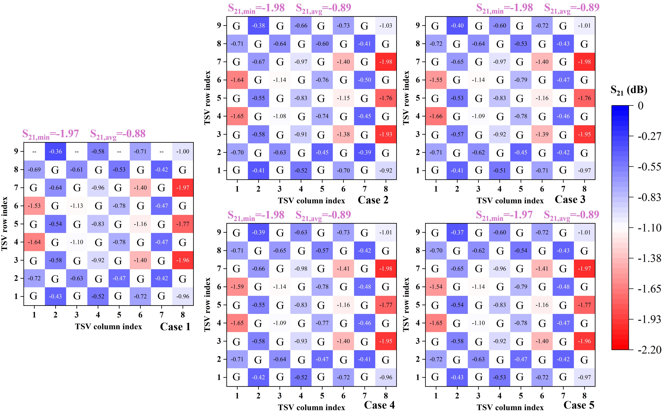
- Transmission coefficient distribution of TSV signal paths under different inlet/outlet positions.

Conclusion
This work analyzes the thermal and electrical performance of the IMCCS for 3-D integrated microsystems. Increasing the micro pin-fin radius improves heat dissipation but increases pressure drop, while 80 μm provides the best minimum transmission coefficient. The inlet/outlet position mainly affects thermal performance, with Case 4 achieving the lowest temperature due to better coolant coverage. Overall, IMCCS design should balance cooling performance, flow resistance, and electrical transmission behavior.

References
[1] J. Kim et al., “Chiplet/Interposer Co-Design for Power Delivery Network Optimization in Heterogeneous 2.5-D ICs,” IEEE Trans. Compon. Packag. Manuf. Technol., vol. 11, no. 12, pp. 2148–2157, Dec. 2021.
[2] Z. Wang, R. Dong, R. Ye, S. S. K. Singh, S. Wu, and C. Chen, “A review of thermal performance of 3D stacked chips,” Int. J. Heat Mass Transf., vol. 235, p. 126212, Dec. 2024.
[3] S. S. Salvi and A. Jain, “A Review of Recent Research on Heat Transfer in Three-Dimensional Integrated Circuits (3-D ICs),” IEEE Trans. Compon. Packag. Manuf. Technol., vol. 11, no. 5, pp. 802–821, May 2021.
[4] D. Song, G. Dong, Y. Yao, Z. Zhu, and Y. Yang, “Optimization and Analysis of Microchannels Under Complex Power Distribution in 3-D ICs,” IEEE Trans. Compon. Packag. Manuf. Technol., vol. 12, no. 3, pp. 537–543, Mar. 2022.
[5] K. M. Kuruva, K. V. K. Reddy, I. A. Badruddin, A. S. Shaik, and M. A. Ali, “Numerical study of microchamber and cylindrical inserts on enhancement of heat transfer in microchannel heat exchanger,” J. Therm. Anal. Calorim., vol. 149, no. 5, pp. 2385–2401, Mar. 2024.
[6] M. K. Mohit and R. Gupta, “Numerical investigation of the performance of rectangular micro-channel equipped with micro-pin-fin,” Case Stud. Therm. Eng., vol. 32, p. 101884, Apr. 2022.
[7] M. Alteneiji, A. Raafat, and S. K. Alnuaimi, “Impact of height and secondary flow patterns of circle, square and triangle shaped pin fins on microchannel heat sinks performance,” Therm. Sci. Eng. Prog., vol. 67, p. 104166, Nov. 2025.
[8] X. Zhang et al., “3-D Printed Swastika-Shaped Ultrabroadband Water-Based Microwave Absorber,” IEEE Antennas Wirel. Propag. Lett., vol. 19, no. 5, pp. 821–825, May 2020.
[9] W. J. Ellison, “Permittivity of Pure Water, at Standard Atmospheric Pressure, over the Frequency Range –25THz and the Temperature Range –100°C,” J. Phys. Chem. Ref. Data, vol. 36, no. 1, pp. 1–18, Mar. 2007.

