FoxFab Design Cheat Sheet
Revision F – Added more information

PC Setup
Ensure your workstation is properly configured with the following tools and file paths.
- Wrike – Project management (job assignments and priorities).
- Everything – File search utility.
- Teams – Communication platform.
- Email – Outlook or equivalent client.
- Quick links to mapped drives and folders:
Z:\FOXFAB_DATA\ENGINEERING
├─ PRODUCTION\ASSEMBLIES
├─ 2 JOBS
├─ 0 PRODUCTS (100 Standard Enclosures, 200 Builds, 300 Stock Parts)
├─ MODEL LIBRARY (Lugs, Fasteners, Insulation, Interlocks)
└─ SOLIDWORKS\Foxfab Templates
- Excel Quick Links:
• Quote Index: Z:\FOXFAB_DATA\ENGINEERING\1 QUOTES\_Quote Info
• BOM Macro: Z:\FOXFAB_DATA\ENGINEERING\BOM Macro
• Bend Calculator: Z:\FOXFAB_DATA\ENGINEERING\SOLIDWORKS
- SolidWorks – Verify templates and setup before starting work.

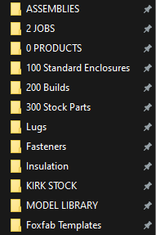
Figure 1: Quick Links Example

1. Wrike
1. Open Wrike to locate your assigned job.
2. Review deadlines and job details.
3. Check job priority(left green section) or DLT (right green section) before starting work.
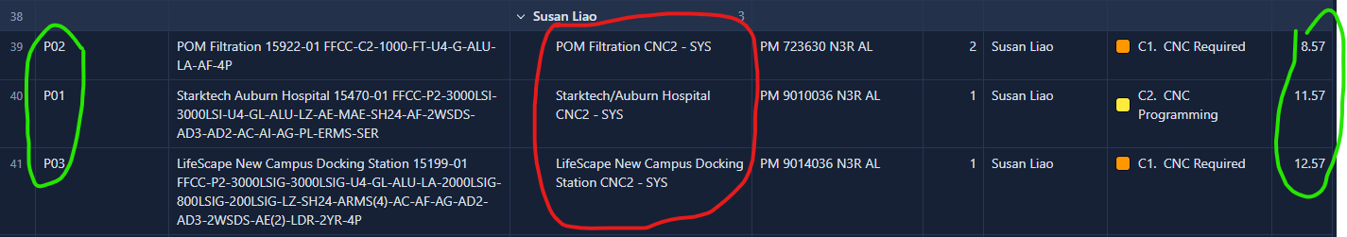
Figure 2: Wrike Dashboard

2. Inputs
- Gather required inputs from: Z:\FOXFAB_DATA\ENGINEERING\2 JOBS, and staple together
- PRF (Project Request Form): Z:\FOXFAB_DATA\ENGINEERING\2 JOBS\[JOB]\300 Inputs\302 Production Release Form
- Electrical Drawing: Z:\FOXFAB_DATA\ENGINEERING\2 JOBS\[JOB]\100 Elec\102 Drawings
- Lug Configuration: Z:\FOXFAB_DATA\ENGINEERING\2 JOBS\[JOB]\100 Elec\102 Drawings

3. Job Comparison
- Compare with previous jobs for similar enclosure sizes, reusable components, and adaptable designs.
- Use Quote Index to find similar jobs:
• Location: Z:\FOXFAB_DATA\ENGINEERING\1 QUOTES\_Quote Info
• Filter by Status: Won and Shipped
• Sort by Job # (descending)
• Filter by enclosure size
• Search Description for similar jobs
- Tip: Filter for enclosure and then check closest voltage.
- Check Standard Builds: Z:\FOXFAB_DATA\ENGINEERING\0 PRODUCTS\200 Builds
- Use Product Index for reusable parts: Z:\FOXFAB_DATA\ENGINEERING\0 PRODUCTS\In Progress

4. Design Work

4.1 General
- Always work in Sheet Metal tab in SolidWorks.
- Fully define all sketches.
- Use standard copper widths to reduce custom work.
- Follow FoxFab part numbering standards.
- Maintain minimum wire bending space.
- Use 75°C copper rating for wire diameter estimation.
- Use Stock Parts as much as possible Z:\FOXFAB_DATA\ENGINEERING\0 PRODUCTS\300 Stock Parts\CAD
- When Designing try to use the least parts possible (Reuse as much of the reference as you can to reduce production speed)
- CHECK PRF AND ENCLOSURE SIZE BEFORE STARTING

4.2: Hole Design
When designing for holes or cuts for screws, always refer to the CU PROFI TOOL Table
Part Number | Dimension | Use Size (for clearance)
0420 | ¼” or 0.25” | 0.281”
0518 | 5/16” or 0.312” | 0.344”
0616 | 3/8” or 0.375” | 0.406”
0813 | ½” or 0.5” | 0.530”
Figure 3: Basic Hole Dimensions and Part Number

4.3 Copper Design
Copper: The maximum amperage for copper components is determined by multiplying the contact area of two conductors (S) by 200 or the conductor width (L) by 250, depending on the design configuration.
▪ Max amp = S*200

▪ Max amp = L*250
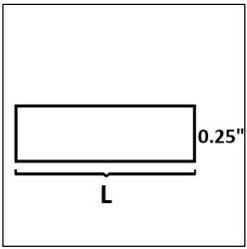
• L = 1, 1.5, 2, 2.5, 3, 3.5, 4, 5, 6, 8” : USE THESE SIZES FOR COPPER DESIGN
• Ground amperage = 1/4 Amperage: The ground conductor amperage must be onefourth of the maximum system amperage for adequate safety and functionality.
Ensure there is a mimum 1” gaps between copper parts. Use fishpaper if its less than 1”

4.4 Bending Material
- Check bend reductions:
  - Use Bend Calculator.xlsx for non-90° bends
  - Bend Deduction @ 90°
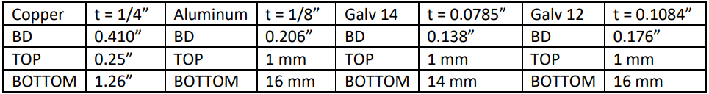
Figure 4: Bend Deduction Things

Top and bottom means the die, the one responsible for the bend
- Standard bend radii:
  - Copper: 0.25”
  - Aluminum/Galv: 0.024”
- Use custom bend deductions:
  - Copper: 0.410” at 90°
- Use the Custom Bend deduction table for bends not 90°
  - Z:\FOXFAB_DATA\ENGINEERING\SOLIDWORKS
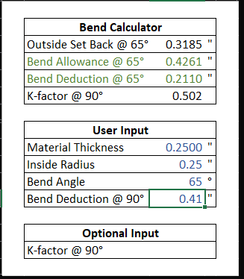
Set inside radius as the ‘TOP’ from the bend deduction table
Set Bend angle to the Bend angle used in solidworks
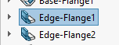Right click ‘edge flange’
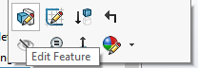
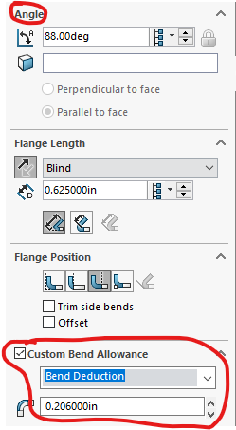 Input the angle to the excel and

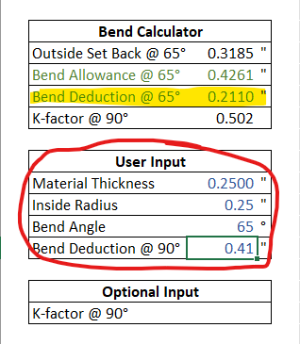

4.5 Fasteners and Hardware
- Use #10-24 self-threading screws for DIN rails
- Prefer 3/8” fasteners over 1/2”
- Avoid 1/2” PEM nuts
- Use carriage bolts for easier assembly * use for Copper Bus parts
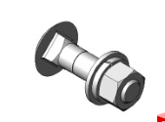
- Ensure all proper components are fully constrained
  - No “–” in assembly
  - Fix a component
- STC = Self Tap Screws, use ‘Taps’ hole on solidworks.

4.6 Lugs
The top lugs: Customer Lugs.
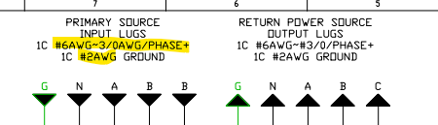
Lugs: Z:\FOXFAB_DATA\ENGINEERING\MODEL LIBRARY\Lugs\STOCK

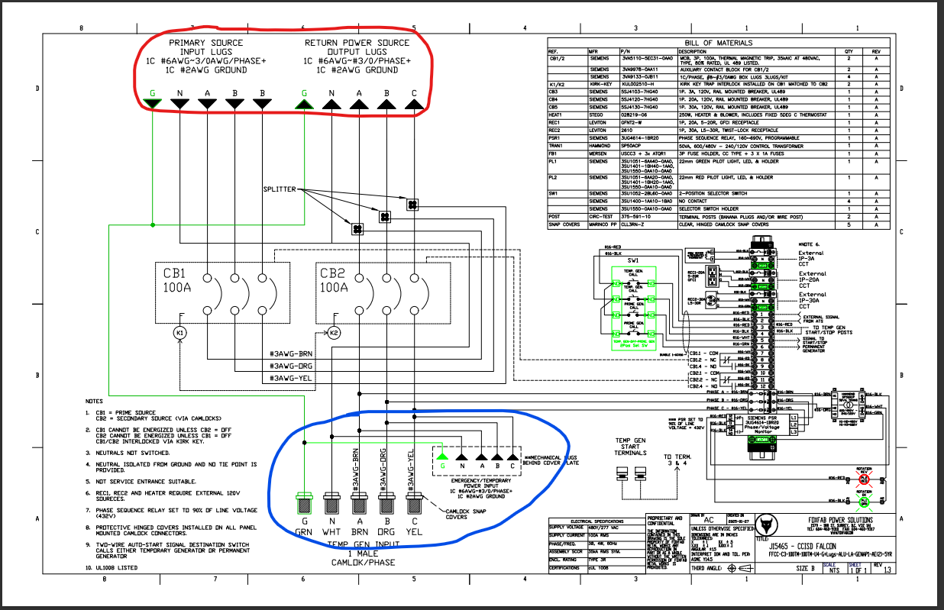
For internal Lugs, we use the lugs below depending on the AMPHERE of the job. These are designers choice
- When using 4/0 wire, use S350 Lugs
- When using 2/0 or 3/0 wire, use S250 Lugs
- When using 1/0 wire, use S2/0 Lugs

4.7 Kirk Pairs
- When using Kirk key, refer to Kirk Location Per breaker.cxv, located in Z:\FOXFAB_DATA\ENGINEERING\MODEL LIBRARY\Interlocks\Matching Key Location for the Dimensions.
- Check for Matching Kirk key in Kirk Key Stock Spreadsheet.cxv, located in Z:\FOXFAB_DATA\ENGINEERING\PRODUCTION\KIRK STOCK
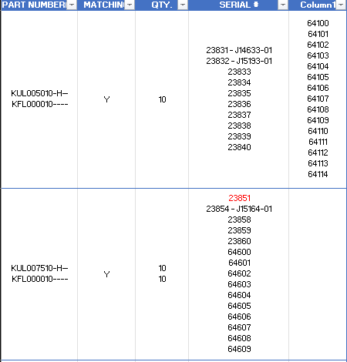

- Don’t forget to say which kirk pair you used in the email

5. Outputs

5.1 DXF, PDF, and DWG
- Save parts as DXF from Part Editor (ensure unfolded, check geometry and bend lines).
- Save drawings as PDF and DWG using FoxFab templates.
- Create two top-level assembly drawings: standard and -LAY version.
- Ensure all assemblies(100-) and 245- parts are included in PDFs.
- Double-check dimensions, bend lines, annotations, and units (inches).
- Check out J15689 for Drawing Examples: Z:\FOXFAB_DATA\ENGINEERING\2 JOBS\J15689 Oncor Building C ATSDS\200 Mech\201 CAD

5.2 BOM
1. Create BOM using FFMPL Template: SOLIDWORKS\Foxfab Templates
2. Export as Excel 2007 file
3. In Excel:
- Review → Unshare Workbook
- Developer → Run Macro BOM
- Rename new BOM → J(job number)
4. In FFMPL tab:
- Check material + thickness
- Mark stock parts: “S” = PDF + CNC tabs, “X” = Stock tab
- Ensure each component has PDF + DXF
- Mark completed items in PDF tab

7. Programming
- Email programming team with finalized files.

8. Production
- Prepare Production Package: Fabrication Work Order, BOM, CNC prints, and Parts Drawing.
- Assemble documents in divider and binder as per procedure.
- Prepare Assembly Package: PRF, Electrical Drawings, Assembly Drawings.

9. Feedback
- Collect feedback from Assemblers, Production, and Electrical team.
- Apply improvements to future designs.

📧 Email Templates
Standardized email formats for communication.

Email to CNC Team – Parts Ready Notification
Subject: Parts Ready for Programming – [Job Name]
Hi Susan and Kevin,
The job, [Job Name] is ready for programming. See the BOM folder for spreadsheet and quantities.
PDFs and Flats are located in the job folder path.
Please let me know if you encounter any issues.
Thank you,

Email to Team Lead – Drawing Completion Notification
Subject: [Job Name] Drawing Completed
Hi [Team Lead's Name],
The design for [Job Name] has been completed and is ready for review.
All required files (CADs, PDFs, DXFs, BOM, documentation) have been saved in the project folder.
Best regards,

Email to Team Lead – Design Completion Notification
Subject: [Job Name] Drawing Completed
Hi Amir,
The design model for [Job Name] has been completed and is ready for review.
Path: Z:\FOXFAB_DATA\ENGINEERING\2 JOBS\[JOB]\200 Mech
Best regards,

Email to Team Lead – Design Completion WITH KIRK Notification
Subject: [Job Name] Drawing Completed
Hi Amir,
The design model for the J16007-01 has been completed and ready for review. Let me know if I need to change anything.
I used the Kirk Pair:
KUL005010-H—
KUL005010-H—
Best,

