**SYS 4044 Course Project:**

**Proposal Analysis - jetBlue CHO Operations**

**November 30, 2017**

**Team 6**

**James Campbell, Fan Feng, George Ingber, Kelly Norfleet, Charles Rogers, Louis Tanous**

**Current Market Environment**

The current market is comprised of people flying both in and out of Charlottesville. According to the airport’s 2016 statistics, the airport served 592,922 passengers. 70% of these passengers were traveling to or from either Charlottesville or Albemarle County (CHO Airport). There are various reasons for their travel, including business, family, and pleasure. Since Charlottesville is home to the University of Virginia, a significant portion of the market is students at the University who may be flying home, to interviews, or to vacation destinations, particularly during breaks. The University also attracts many visitors, including family members of students, prospective students, alumni, and sports fans. Charlottesville and the surrounding Blue Ridge Mountains are also popular tourist and wedding destinations that draw in travelers through CHO. Currently, the three airlines that fly into and out of CHO are Delta, United, and American Airlines. Available direct flights reach Charlotte, Atlanta, Chicago, New York City, Washington D.C., and Philadelphia. In addition to current travelers, the market also includes individuals who wish to fly, but cannot find appropriate, affordable, or satisfactory flights to their desired destinations.

**Projections**

There are many different factors that may affect the market for the CHO airport over the next decade. Population growth of Charlottesville will impact the market and increase demand for flights, as more people move to the area. According to the US Census Bureau, the population of Charlottesville has grown by 8% between 2010 and 2016. (US Census Bureau) The city’s population and surrounding area’s are expected to continue to grow over the next several years. Increases in the employment opportunities and local salaries may also boost the number of flights individuals take per year, as they may have more disposable income and be more likely to take a vacation or visit friends or family. The number of jobs grew by 4.72% between 2014 and 2015 in Charlottesville (DataUSA). As Charlottesville is expected to continue to grow, the job market should also be expected to increase.

Commercial aviation as a whole is expected to continue to grow over the next 5-10 years. It is presumed that JetBlue’s entry into the Charlottesville market would be relative short-term to test the market over a few years so our projections focus only on the next decade. Patrick Dixon at globalchange.com predicts, like many others, that commercial airline passengers will continue to further segment themselves into “budget, premium budget, economy,...business class”, and first class (globalchange.com). This continued segmentation could be beneficial for jetBlue in the Charlottesville market. Currently the three airlines serving the airport are economy-up airlines. CHO does not have a low cost provider and JetBlue could capitalize on that potential customer segment.

Aviation experts like Kevin Crowley, VP of Digital Aviation at Boeing, and Jude Schramm, CIO at GE Aviation, recognize that flying commercially has not been a seamless experience over the past couple decades, but they predict that increased “digital tools” and “digital analytics” will make the experience much easier, less stressful, and, most importantly for JetBlue, cheaper for airlines to operate. Crowley suggests that “big data” will help tremendously with airline operations and most importantly, their margins (Businessinsider.com). In the airline industry, a single percentage saving in fuel cost, maintenance time, passenger loading time, and more can lead to very tangible results such as increased flights per week, less fuel cost per flight, or planes serving more airports more often because they are in the maintenance hangar less often or for less time.

Several sources, like the FAA Aerospace Forecast, anticipate that planes, specifically regional jets, are not only becoming more energy efficient, but also growing in passenger capacity. The FAA and others see that “50 seat regional jets” will be grounded to be “replaced by 70-90 seat aircraft” (FAA.gov page 28). This trend is advantageous for JetBlue because their fleet is comprised of several aircraft in the 70-120 passenger range, such as the 100 passenger Embraer 190 which makes up 25% of their fleet (jetblue.com). JetBlue was actually the first airline to launch the Embraer 190 in 2005. This size aircraft currently does not serve the CHO airport but the airport infrastructure (i.e. runway length and width) is suitable for such larger mid-sized jet airliners that can carry more passengers longer distances such as Boston or Orlando, FL.

In 2016, approximately 11,500 passengers travelled between CHO and both Boston and Orlando through connecting flights offered by the three current providers. 23,000 passengers travelled to or from Charlottesville to those two cities alone in 2016. Among the top 15 cities frequented by CHO travelers, JetBlue serves 13 of them. This means that not only do they have the opportunity to serve customers flying directly to Boston and Orlando, but travellers will be able to connect through JetBlue hubs to reach their final destination just as they would flying any other airline serving CHO now. Quantitatively, 82.9% of the passengers (~209,000 of ~252,000) flying to or from the top 15 frequented cities by CHO travellers could have been served by JetBlue in 2016. (Table 1)



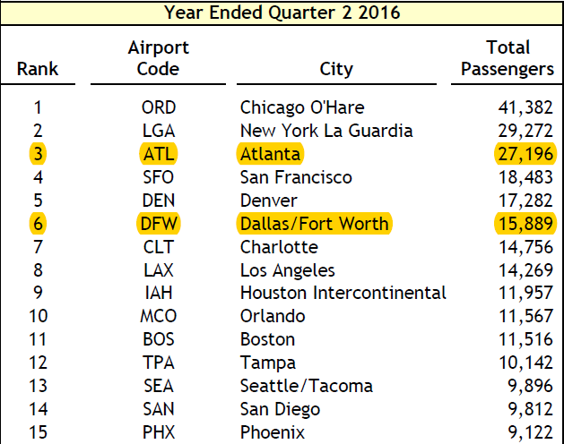

**Table 1: Charlottesville-Albemarle-Airport-CAFR-2016**

**Major Factors Considered in Making Decisions**

The major business goal of JetBlue, we assume, will be to maximize the profit both in the short term and long term. However, other considerations, such as market share, may also be important goals. If entering the CHO market does not increase yearly profit significantly because of the lower passenger volume, but doing so can tap into the market share of some of JetBlue's major competitors, we propose servicing CHO. Gaining market share can be cost intensive, but increasing market share provides long-term potential for company growth and a reduction of risk. The domestic airline industry is extremely competitive and market share is difficult to maintain due to a variety of unpredictable factors. Operating in smaller airports like CHO can provide opportunities for disruption in static markets, and although it involves an investment with foreseen risk, it can create explosive change in the market share dynamics over years to come.

To provide a snapshot of the current market condition, below is a histogram showing the total operating revenue streams of U.S. airlines from 2004 to 2016 (in billions U.S. dollars). The industry aggregate revenue varies from year to year, but has been oscillating around $200 billion in recent years.

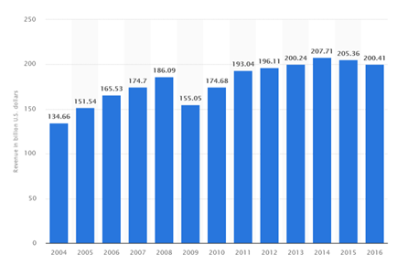

**Table 2 (Statista-Total Operating Revenues)**

Since JetBlue focuses mainly on the domestic flights in the U.S, we looked at the domestic market share of leading U.S. airlines in 2016. From Table 3 below, it is apparent that the top four companies make up around 70% of the total domestic market. Ranked fifth, JetBlue has around 5.5% market share. Since JetBlue has a smaller market share, expansionary actions such as adding new destinations, like Charlottesville, and increasing daily flight offerings could help achieve the secondary goal of increasing domestic market share.

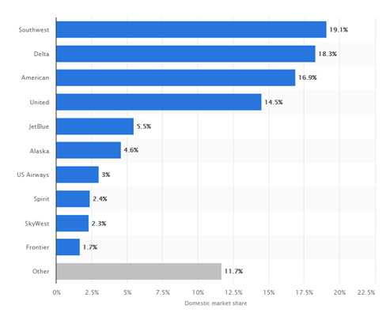

**Table 3 (Statista-Domestic Market Share)**

JetBlue does not partner with any of the other airlines currently operating out of Charlottesville, so the existing three airlines would remain Jetblue’s main competitors in the Charlottesville market. Additionally, it is important to note that these three airline companies do not have alliances amongst each other. We can assume that they will make business decisions based on their in-house predictions of other companies’ behaviors instead of agreements made with each other.

JetBlue's target customer are the people who travel frequently to and from JetBlue's focus cities - Boston, Los Angeles, New York, Fort Lauderdale, and Orlando. They can either be the residents from these cities, or frequent these cities due to an array of reasons. In regards to Charlottesville, travelers who frequent CHO airport are likely related to the University of Virginia. These customers usually value the price, service, and punctuality as the major concern while purchasing flights. Under these considerations, JetBlue's relatively lower prices and friendly service (as illustrated by Jetblue's awards for North America's Leading Budget Airline in 2004 and Highest in Customer Satisfaction Among Low Cost Carriers in North America in 2010) are likely to fit their favor.

One aspect of JetBlue that will need to improve to better serve all its customers in general is its punctuality. JetBlue's punctual rate is 78.3%, lower than the other three airlines currently serving CHO (USA Today). This low punctuality rate would make JetBlue flights slightly less attractive than other airlines’ flights and thus should be a focus of the company. Below is a table provided by JetBlue showing the volume and duration of departure delays.

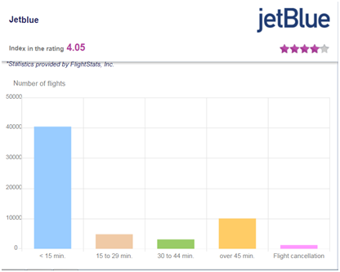

**Table 4 (Tickets.pl)**

If JetBlue decided to enter the Charlottesville market, there could be additional factors to consider about their marketing strategies:

* Market competition degree: If JetBlue enters the market, it is likely they become price makers such that their strategies will have the potential to influence and lower the average price in the CHO market.
* Advertisement: Upon entering the market, it is critical customers know the existence and service details provided by Jetblue. We recommend JetBlue advertise its services heavily. Moreover, an informative advertising strategy should be used to notify customers of the prices and services provided by JetBlue compared to other airlines. As common in advertising, inter-company externalities could be a concern. However, externalities can be avoided in this case because of JetBlue’s distinctive pricing and destination differentiation.
* Product differentiation: In order to compete with other airline companies, JetBlue needs to differentiate themselves. Besides their vertical differentiation in lower price offerings, JetBlue could differentiate horizontally to help the airline stand out in the CHO market. Opportunities for horizontal differentiation include waiving additional baggage checking fees, complimentary refreshment services, bundle ticket sales, etc.
* Hiring Cost: In entering the Charlottesville market, hiring new employees is an indispensable but costly process.
* Current Financial Conditions: The current financial trend is another important factor in making business decisions. Below is a plot of Jetblue’s annual net profit(loss) in millions of US dollars. As observed from the plot, the net profit has an increasing trend in the recent 5 years, and there is currently no significant evidence of Jetblue’s financial difficulty. Therefore, we do not consider the financial conditions of Jetblue as an obstacle in entering the new market.

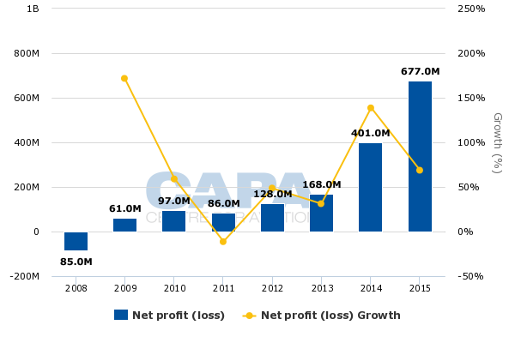

**Table 5 (Centreforaviation.com)**

**Feasible Responses**

The market is currently comprised of the following airlines: American, United, and Delta. Each airline could respond in any of the following ways given the emergence of JetBlue in the market. They could engage in competitive pricing, or could possibly go a step further and engage in predatory pricing, decreasing its prices to a point at which it might be operating at a loss in an effort to drive JetBlue, and likely others, out of the market. A given airline might increase its investments in advertising. Advertising heavily, although at a higher cost, would draw consumer attention away from JetBlue and towards the respective airline. A given airline could also take legal action against CHO regarding the rights of gate space. Each airline might have a contract with CHO concerning the amount of gate space it is entitled to. A JetBlue-entry into the market would require current airlines to reduce their gate spaces unless CHO were to expand, which would not occur in the short-run. Reduced gate space would limit the amount of flights existing airlines in the market would be able to send into or out of Charlottesville. An existing CHO-serving airline could also increase provided amenities to stand out from its competitors. United, for example, could enact the “bags fly free” concept in which any bag checked does not incur a fee to the consumer. Other potential amenities provided include wifi and food and beverage. JetBlue would have to enact similar policies or provide incentives elsewhere to remain competitive; moreover, JetBlue would have to be able to assume those extra costs.

Other airlines such as Southwest and Spirit not currently serving CHO could enter the market. These new entrants would further increase competition in the Charlottesville market by giving consumers more choices. Furthermore, if other low cost carriers such as Southwest or Spirit enter the market, Jetblue’s price differentiation advantage would diminish because they would no longer be the only low cost carrier out of CHO. However, a given airline could decide not to enter the market at all if the costs to enter the market such as the hiring of new employees and the purchasing of new licenses outweigh the benefits.

Because there is no alliance among airlines in the market, each airline is given a set of choices to make in which its outcomes correspond to the choices of other airlines.

**Strategy Description:**

In generating the strategy that JetBlue should adopt if they were to enter the market, it is important to note that their #1 goal in a competitive strategy is to differentiate from preexisting market in order to establish some kind of unique value. We believe that when JetBlue enters the market they can differentiate themselves from the other competitors in the market in 3 key ways: price, convenience, and destination offerings.

Historically, JetBlue has established themselves as a low-cost airline. Currently, the three airlines that offer service out of Charlottesville Airport - Delta, United and American Airlines - do not share that quality. As such, the Jetblue’s flights are cheaper on average than any of the airlines currently offering flights out of CHO, which we believe could be a meaningful factor in Jetblue’s ability to enter the market. By setting lower prices for their flights than any other airline currently at the airport, JetBlue could penetrate the market and gain market share from a segment of passengers that are willing to perhaps sacrifice flight luxury in pursuit of lower prices.

A second way that JetBlue could separate itself from the competition is by offering more timely flight options and reducing cancellations or delayed departures to increase customer convenience. With only 73% of flights from CHO leaving on time in the last 5 years, there is certainly an issue of flight dependency in this market, especially when examining competing airports such as Richmond (76%), Roanoke (77%), and Dulles (79%) (Transtats-Bureau of Transportation Statistics). Although JetBlue currently has a relatively low punctuality rate, if they could improve their reliability and enter the market and offer a more logistically sound flight schedule that is less prone to delays and cancellations, their status as a reliable way to fly in and out of the area could serve to benefit them largely. Furthermore, offering flights at specific high demand hours and with short layovers will give JetBlue a competitive advantage because consumers highly value optimizing their travel schedule.

Lastly, offering new destinations not currently served by any airlines out of CHO will differentiate JetBlue’s offerings from the competition and potentially allow them to access the segment of the CHO market currently not flying from this airport because of a lack of destination offerings. Currently, Charlottesville airport functions as somewhat of a secondary airport - offering flights to hubs like Atlanta, Charlotte, Chicago, New York, Philadelphia, and Washington, D.C. We believe that Jetblue can gain market share by expanding on this list of target cities - in particular, we think that Boston and Orlando represent good destinations for Jetblue to offer as those cities are not offered out of CHO currently, but are proximal to Charlottesville and are established focus cities for Jetblue.

While not as high-level as the aforementioned three strategies, another potential way for JetBlue to garner market share is to target and cater to UVa students. Many students fly home or to a travel destination during school breaks, yet are forced to fly from Richmond, Dulles, or Baltimore due to a lack of flights from Charlottesville. If Jetblue were to research student flight needs and preferences, particularly around holidays and extended school breaks, they could very much serve to benefit.

By adopting a combination of these strategies, our group believes that JetBlue can differentiate itself significantly from the three other airlines that currently fly out of CHO. In doing so, they can come into the market and very quickly pick up market share as a low-cost, flexible yet reliable, airline that offers flights to new destinations. Furthermore, by offering flights that appeal to UVa students, JetBlue could win the support of a fairly significant portion of the market that is not currently being served as well as it could be.

**Recommendation:**

Across the board, the group believes that entering the Charlottesville market represents a strong business opportunity for JetBlue, for a number of reasons. Based on the analyses performed in this report, the group sees Charlottesville as a expanding market with promise in the future, that is not currently being served as well as it could. A combination of expensive flights to a small number of hub airports, as well as comparatively unreliable flight arrivals and departures compared to bordering airports, makes CHO a strong candidate for another airline to enter the market and enact change. Furthermore, the competitive landscape allows for JetBlue to enter the market as a very unique provider of flights, being significantly different from the three airlines that currently serve the area.

**Works Cited**

1. [**http://gocho.com/content/uploads/2014/05/Checking-in-with-CHO-May-2017.pdf**](http://gocho.com/content/uploads/2014/05/Checking-in-with-CHO-May-2017.pdf)
2. [**https://www.census.gov/quickfacts/fact/table/charlottesvillecityvirginiacounty/PST045216**](https://www.census.gov/quickfacts/fact/table/charlottesvillecityvirginiacounty/PST045216)
3. [**https://datausa.io/profile/geo/charlottesville-va/#economy**](https://datausa.io/profile/geo/charlottesville-va/#economy)
4. [**https://www.globalchange.com/future-of-aviation-industry-radical-change.htm**](https://www.globalchange.com/future-of-aviation-industry-radical-change.htm)
5. [**http://www.businessinsider.com/sc/7-experts-predict-the-future-of-flight/#jude-schramm--cio-ge-aviation-2**](http://www.businessinsider.com/sc/7-experts-predict-the-future-of-flight/#jude-schramm--cio-ge-aviation-2)
6. [**https://www.faa.gov/data_research/aviation/aerospace_forecasts/media/FY2017-37_FAA_Aerospace_Forecast.pdf**](https://www.faa.gov/data_research/aviation/aerospace_forecasts/media/FY2017-37_FAA_Aerospace_Forecast.pdf)
7. [**https://www.jetblue.com/travel/planes/**](https://www.jetblue.com/travel/planes/)
8. [**https://www.statista.com/statistics/197680/total-operating-revenues-in-us-airline-industry-since-2004/**](https://www.statista.com/statistics/197680/total-operating-revenues-in-us-airline-industry-since-2004/)
9. [**https://www.statista.com/statistics/250577/domestic-market-share-of-leading-us-airlines/**](https://www.statista.com/statistics/250577/domestic-market-share-of-leading-us-airlines/)
10. [**https://tickets.pl/en/avia/rating/B6/punctuality**](https://tickets.pl/en/avia/rating/B6/punctuality)
11. [**https://centreforaviation.com/insights/analysis/jetblue-offers-little-visibility-into-its-revenue-outlook-as-us-domestic-capacity-continues-to-grow-266360**](https://centreforaviation.com/insights/analysis/jetblue-offers-little-visibility-into-its-revenue-outlook-as-us-domestic-capacity-continues-to-grow-266360)
12. [**https://www.usatoday.com/story/travel/flights/todayinthesky/2016/01/07/airline-on-time-performance/78407958/**](https://www.usatoday.com/story/travel/flights/todayinthesky/2016/01/07/airline-on-time-performance/78407958/)
13. [**https://www.transtats.bts.gov/airports.asp?pn=1&Airport=CHO&Airport_Name=Charlottesville,%20VA:%20Charlottesville%20Albemarle&carrier=FACTS**](https://www.transtats.bts.gov/airports.asp?pn=1&Airport=CHO&Airport_Name=Charlottesville,%20VA:%20Charlottesville%20Albemarle&carrier=FACTS)