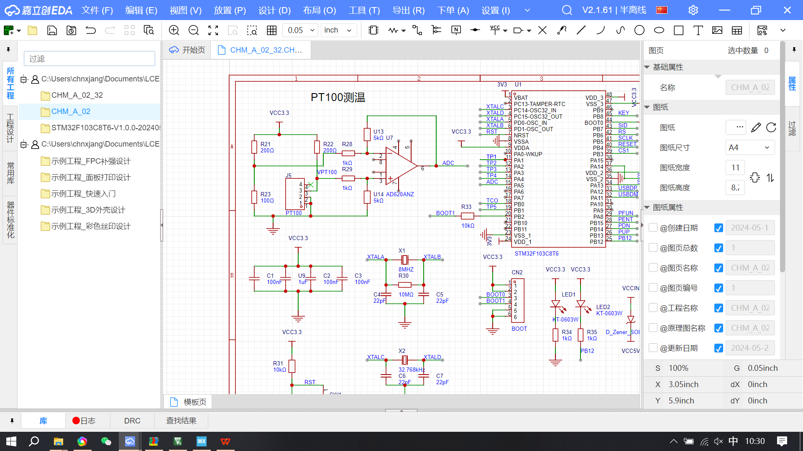

K=5
V_{ADC}=K[(3.3R_{pt100})/(200+R_{pt100})-3.3/3]
->V_{ADC}/K+1.1=(3.3R_{pt100})/(200+R_{pt100})
->200(V_{ADC}/K+1.1)+(V_{ADC}/K+1.1)R_{pt100}=3.3R_{pt100}
->(2.2-V_{ADC}/K)R_{pt100}=200(V_{ADC}/K+1.1)
->R_{pt100}=[200(V_{ADC}/K+1.1)]/(2.2-V_{ADC}/K)

R_{pt100}=100(1+0.385t)
->t=(R_{pt100}/100-1)/0.385

Pt100温度阻值对照表
