Screen Time, Sleep, and Mental Fatigue:
A Multiple Linear Regression Analysis

New Jersey City University
FINC405-1137 Programming Data Science Spring 2026
Professor Vijay Kumar
By: Emily Valarezo and Faith Fairley

Table of Contents

- Introduction………………………………………………………………………………2
- Materials and Methods…………………………………………………………………..4
2.1 Dataset Description 4
2.2 Exploratory Data Analysis 5
2.3 Multiple Linear Regression 5
- Results and Interpretation…………………………………………………………………6
3.1 Correlation Analysis 6
3.2 Scatter Plot Analysis 8
3.3 Multiple Linear Regression Results 10
- Conclusion………………………………………………………………………………13
4.1 Findings 13
4.2 Limitations 14
4.3 Recommendations for Future Analysis 15
- References……………………………………………………………………………..…16

Introduction
In today’s society, screen usage has become a major part of everyday life across all age groups and professions. Smartphones, computers, and other digital devices are now heavily used for both work and entertainment. Because of this, there has been growing concern about how excessive screen time may affect physical and mental health. Some of the most common concerns include poor sleep quality, increased stress levels, and mental fatigue, which can negatively impact productivity, focus, decision-making, and overall well-being.
Sleep plays an important role in maintaining both physical and mental health. Studies have shown that not getting enough sleep can reduce cognitive performance, affect mood, weaken the immune system, and increase the risk of health problems (Lim & Dinges, 2010). Stress is also closely connected to both screen use and sleep disruption. High stress levels can make it more difficult for the body and mind to recover properly, leading to greater feelings of fatigue and exhaustion (American Psychological Association, 2017).
In this study, mental fatigue is used as an indicator of reduced productivity and cognitive performance. This project focuses on three main research questions:
- Does daily screen time predict mental fatigue scores after controlling for sleep duration and stress levels?
- What is the relative contribution of screen time, sleep duration, and stress level to mental fatigue?
- Can a multiple linear regression model reliably estimate mental fatigue using these behavioral and physiological factors?
Using exploratory data analysis and multiple linear regression, this project examines how screen time, sleep, and stress may influence mental fatigue and overall productivity.
Materials and Methods
The dataset contains behavioral and physiological measurements collected from individuals with varying lifestyle habits. Eleven variables were recorded for each participant. The four variables central to this analysis are summarized in Table 1.

Variable | Type | Description
Daily screentime hours | Continuous | Average hours of screen use per day (range: ~1–10 hrs)
Sleep duration hours | Continuous | Average hours of sleep per night (range: ~4–9 hrs)
Stress level | Numeric scale | Self-reported stress level (range: ~1–10)
Mental fatigue score | Continuous | Composite cognitive exhaustion score — response variable (range: 1–10)
Table 1. Summary of key variables used in the analysis.
The dataset was loaded into Python using the pandas library. Column names were standardized by removing leading and trailing whitespace. Non-numeric columns were excluded from the correlation analysis so that only numerical variables were used for statistical modeling.
2.2 Exploratory Data Analysis
Exploratory data analysis (EDA) was conducted prior to modeling to understand the structure and pairwise relationships of variables. Two techniques were applied:
- Correlation Matrix: A Pearson correlation heatmap was generated using the seaborn library to evaluate the strength and direction of linear relationships between numeric variables. A coolwarm color palette was used, where dark red represents strong positive correlation and dark blue represents strong negative correlation.
- Scatter Plots: These were created to visualize the relationship between each predictor variable and mental fatigue. These plots helped identify trends, clustering patterns, and possible linear relationships within the data.
2.3 Multiple Linear Regression
Multiple linear regression (MLR) was used to model mental fatigue as a function of three predictor variables: screen time, sleep duration, and stress level. MLR is appropriate when the response variable is continuous and influenced by multiple predictors simultaneously.
mental_fatigue_score = β₀ + β₁(screen_time) + β₂(sleep_duration) + β₃(stress_level) + ε
Where β₀ is the intercept; β₁, β₂, β₃ are partial regression coefficients representing the expected change in mental fatigue per one-unit increase in the respective predictor, holding all others constant; and ε is the error term. The regression coefficients were estimated by minimizing the residual sum of squares (RSS), shown below:
RSS = Σ(yᵢ − ŷᵢ)²
The model was fitted using scikit-learn's Linear Regression class (Pedregosa et al., 2011)

Results and Interpretation
3.1 Correlation Analysis
The Pearson correlation matrix (Figure 1) revealed several important relationships among the numeric variables in the dataset. The strongest relationship was observed between stress level and mental fatigue score, with a correlation coefficient of r = +0.95. This extremely strong positive correlation suggests that higher stress levels are closely associated with increased mental fatigue.
A strong positive relationship was also found between daily screen time hours and mental fatigue score (r = +0.83), indicating that individuals with greater daily screen use tend to report higher levels of mental fatigue. Additionally, daily screen time hours and stress level were strongly positively correlated (r = +0.88), suggesting that individuals with higher screen usage also tend to experience greater stress levels.
In contrast, sleep quality score showed a strong negative correlation with mental fatigue score (r = −0.81). This suggests that better sleep quality is associated with lower mental fatigue and improved cognitive well-being. Interestingly, sleep duration hours showed almost no linear relationship with mental fatigue score (r ≈ −0.01). This finding suggests that the quality of sleep may be more important than the total number of hours slept when examining mental fatigue.
Although sleep quality showed a strong correlation with mental fatigue, sleep duration was retained in the regression model because it aligned more directly with the original research objective.

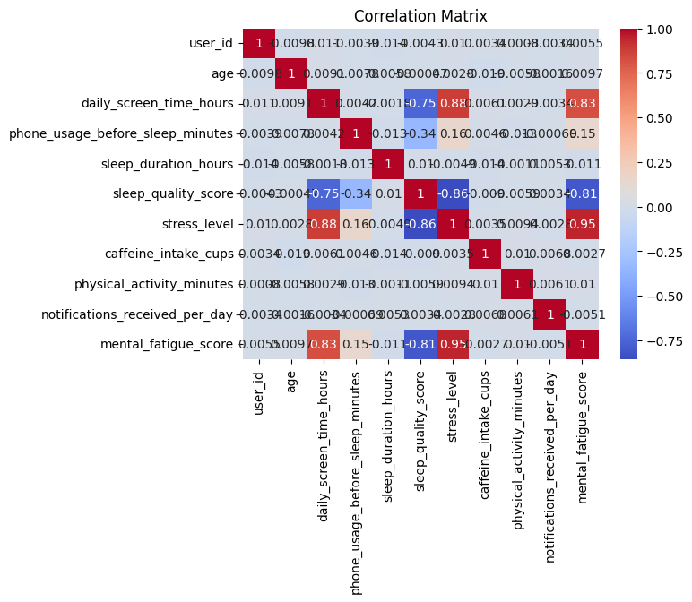
Figure 1. Pearson correlation heatmap of all numeric variables. Darker red = stronger positive correlation; darker blue = stronger negative correlation.

3.2 Scatter Plot Analysis
Three bivariate scatter plots were produced to visually assess the relationship between each predictor variable and mental fatigue score.
Sleep Duration vs. Mental Fatigue (Figure 2): The scatter plot shows a diffuse, rectangular cloud of points with no clear directional trend. Mental fatigue scores span nearly the full range from 1–10 at every level of sleep duration (approximately 4–9 hours). This pattern is consistent with the near-zero correlation (r ≈ −0.01) observed in the correlation matrix and suggests that sleep duration alone is not a meaningful linear predictor of mental fatigue in this dataset.
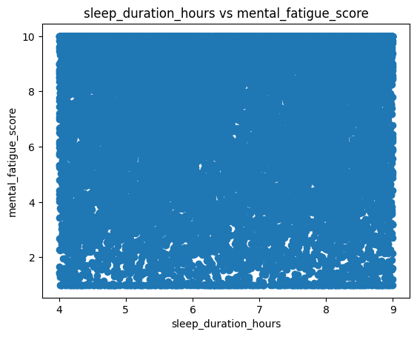
Figure 2. Sleep duration (hours) vs. mental fatigue score. No linear trend is apparent.

Daily Screen Time vs. Mental Fatigue (Figure 3): This scatter plot shows a clear positive linear trend between daily screen time and mental fatigue score. As daily screen time increases from approximately 1 to 10 hours, mental fatigue scores also increase systematically. The data points form a broad but directionally consistent upward pattern, although there is still variability at each screen time level. This visual trend is consistent with the strong positive correlation (r = +0.83) identified in the correlation analysis.

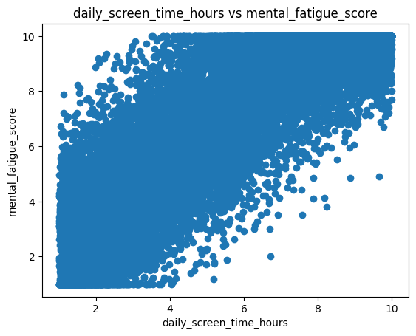
Figure 3. Daily screen time (hours) vs. mental fatigue score. A clear positive linear relationship is evident.

Stress Level vs. Mental Fatigue (Figure 4): The scatter plot for stress level and mental fatigue demonstrates the strongest visible linear relationship among the three predictor variables. As stress levels increase from approximately 1 to 10, mental fatigue scores also rise consistently across the dataset. The points cluster closely around a strong upward trend, which aligns with the extremely strong positive correlation (r = +0.95) observed in the heatmap. This suggests that stress level is the strongest predictor of mental fatigue in the dataset.

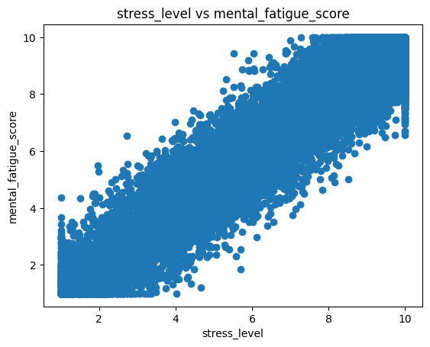
Figure 4. Stress level vs. mental fatigue score. A strong, tight positive linear relationship is visible

Overall, the scatter plots support the findings from the correlation matrix and regression model. Stress level and daily screen time both show strong positive relationships with mental fatigue, while sleep duration demonstrates little to no meaningful linear relationship with mental fatigue in this dataset.

3.3 Multiple Linear Regression Results
The fitted multiple linear regression model produced the parameter estimates shown in Table 2.

Predictor | Coefficient (β) | Interpretation
Intercept (β₀) | 0.3663 | Baseline mental fatigue when all predictors equal zero
Daily screen time hours (β₁) | −0.0258 | Each additional hour of screen time decreases fatigue by approximately 0.026 points, holding other variables constant
Sleep duration hours (β₂) | −0.0120 | Each additional hour of sleep decreases fatigue by approximately 0.012 points, holding other variables constant
Stress level (β₃) | +0.9637 | Each one-unit increase in stress increases fatigue by approximately 0.964 points, holding other variables constant
Table 2. Estimated regression coefficients from the multiple linear regression model.

The full fitted model equation is:
mental_fatigue= 0.3663 − 0.0258(screen_time) − 0.0120(sleep_duration) + 0.9637(stress_level)
Several important observations emerge from these results. Stress level has the strongest effect in the model. The coefficient for stress level β₃ = +0.9637 is much larger in magnitude than the other coefficients, indicating that for every one-unit increase in stress level, mental fatigue is predicted to increase by approximately 0.964 points while holding the other variables constant. This finding is consistent with the extremely strong positive correlation r = +0.95 observed during the exploratory data analysis.
The coefficient for daily screen time changes direction in the multiple regression model. In the correlation analysis, screen time showed a strong positive relationship with mental fatigue (r = +0.83). However, after controlling for stress level, the coefficient becomes slightly negative (β₁ = −0.026). This suggests that much of the relationship between screen time and mental fatigue may be explained through its strong association with stress level (r = +0.88). Once stress is included in the model, screen time contributes very little additional explanatory power.
Sleep duration also shows very limited predictive power in the regression model. The coefficient for sleep duration (β₂ = −0.012) is very small, which aligns with the near-zero correlation observed earlier. This suggests that the number of hours slept may not be as important as sleep quality when examining mental fatigue in this dataset.
Finally, the intercept (β₀ = 0.366) represents the estimated baseline mental fatigue score when all predictor variables are equal to zero. While this value has limited practical meaning in a real-world context, it is necessary for constructing the regression equation.
Conclusion

4.1 Findings
This project analyzed the relationship between daily screen time, sleep duration, stress level, and mental fatigue using correlation analysis, scatter plot visualization, and multiple linear regression applied to a behavioral health dataset.
The results show that stress level is the strongest predictor of mental fatigue in the dataset, with a regression coefficient close to 1.0 and a very strong positive correlation r = +0.95. These findings suggest that reducing stress may be the most effective strategy for lowering mental fatigue and improving overall productivity and well-being
Daily screen time also showed a strong positive relationship with mental fatigue in the correlation analysis (r = +0.83). However, after controlling for stress level in the regression model, the independent effect of screen time became very small. Since screen time and stress level are themselves highly correlated (r = +0.88), this suggests that the relationship between screen time and mental fatigue may be largely explained through increased stress rather than through a direct effect alone.
Sleep duration showed very little relationship with mental fatigue in both the correlation analysis and regression model. However, the correlation matrix revealed that sleep quality score had a much stronger negative relationship with mental fatigue (r = −0.81). This suggests that sleep quality may be more important than the total number of hours slept when examining fatigue and cognitive performance.
Overall, the regression model supports the conclusion that mental fatigue in this dataset is primarily stress-driven, while screen time acts as a related but less independently influential factor.

4.2 Limitations
This study has several limitations. First, because the data is cross-sectional, causal relationships cannot be definitively established. It is possible that individuals experiencing greater mental fatigue may spend more time using screens, rather than screen time directly causing fatigue.
Secondly, the strong relationship between screen time and stress introduces multicollinearity into the regression model, making it more difficult to isolate the independent effects of each variable.
Finally, overall model performance metrics such as R² were not formally evaluated in this analysis, which limits the ability to fully assess predictive performance.

4.3 Recommendations for Future Analysis
Future studies could improve the regression model by incorporating sleep quality as a predictor variable, since it demonstrated a much stronger relationship with mental fatigue than sleep duration in the correlation analysis. Including sleep quality may provide a more accurate understanding of how sleep-related factors influence mental fatigue and productivity.
Additional analyses could also apply regularization methods such as Ridge regression to address the multicollinearity observed between screen time and stress level. This may improve the stability and interpretability of the regression coefficients.
Finally, longitudinal studies that follow individuals over time would provide a stronger framework for examining causal relationships between screen use, stress, sleep, and mental fatigue. Tracking changes over longer periods may help determine whether screen time directly contributes to fatigue or whether the relationship is primarily influenced by stress levels.
References
American Psychological Association. (2017). Stress in America: Technology and social media. APA.

Hale, L., & Guan, S. (2015). Screen time and sleep among school-aged children and adolescents: A systematic literature review. Sleep Medicine Reviews, 21, 50–58.

Hirshkowitz, M., Whiton, K., Albert, S. M., et al. (2015). National Sleep Foundation's sleep time duration recommendations: Methodology and results summary. Sleep Health, 1(1), 40–43.

Lim, J., & Dinges, D. F. (2010). A meta-analysis of the impact of short-term sleep deprivation on cognitive variables. Psychological Bulletin, 136(3), 375–389.

Pedregosa, F., Varoquaux, G., Gramfort, A., et al. (2011). Scikit-learn: Machine learning in Python. Journal of Machine Learning Research, 12, 2825–2830.

Waskom, M. L. (2021). Seaborn: Statistical data visualization. Journal of Open Source Software, 6(60), 3021.

