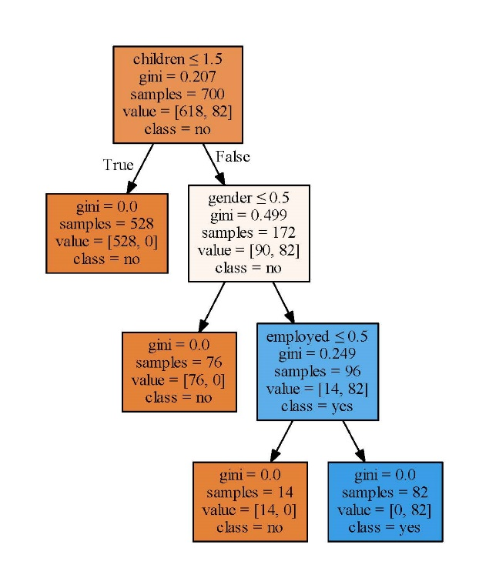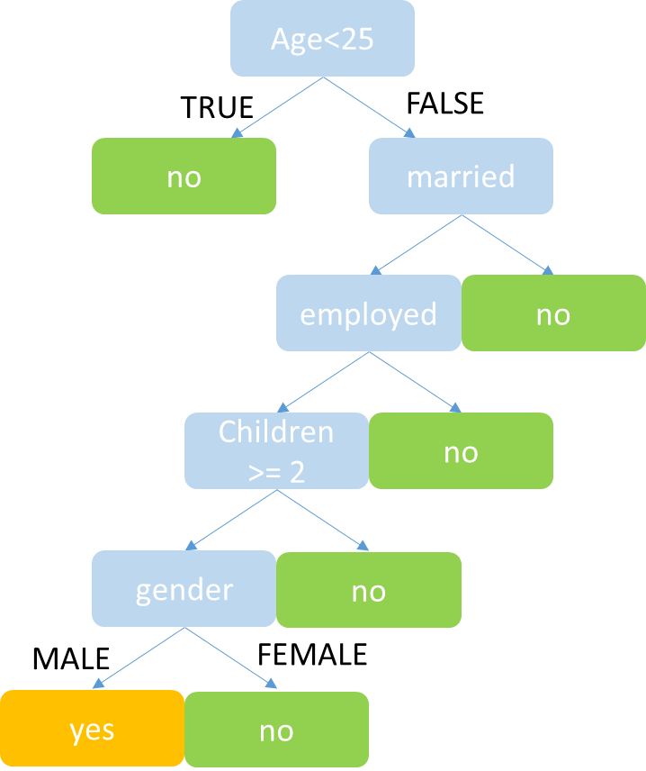

Decision tree generated by designed rule Decision tree generated by sklearn

1. Compare two trees can find that some attributes that we designed as an important feature may be not so important when generated the tree by code.
2. If some attributes are related (ex. married and children), one of them may become useless feature when generated by code.