UML class diagram

|  |
| --- |
| MainWindow |
| - ui : MainWindow * |
| <<constructor>>+MainWindow(parent: QWidget *)  <<destructor>>+MainWindow()  - on_pushButton_2_clicked()  - on_pushButton_clicked() |

|  |
| --- |
| MyGame |
| - ui: MyGame *  -scene: QGraphicsScene *  - countdown: QLCDNumber *  - scoreNum : QLCDNumber *  - count: int  - score: int |
| <<constructor>>+MyGame(parent: QWidget *);  <<destructor>>+MyGame();  +timerEvent(event: QTimerEvent *)  +setCountDownTime()  +createNewKo_J()  +createNewKo_k()  +showNum() |

|  |
| --- |
| ResultWindow |
| -ui: ResultWindow *  -result: QLCDNumber * |
| <<constructor>>+ResultWindow(parent: QWidget *)  <<destructor>>+ResultWindow();  -on_pushButton_2_clicked();  - on_pushButton_clicked(); |

|  |
| --- |
| Taiko_j |
|  |
| <<constructor>>+Taiko_j();  +keyPressEvent(j_event: QKeyEvent *);  + move(); |

|  |
| --- |
| Taiko_k |
|  |
| <<constructor>>+Taiko_k();  +keyPressEvent(j_event: QKeyEvent *);  + move(); |

Screen shot

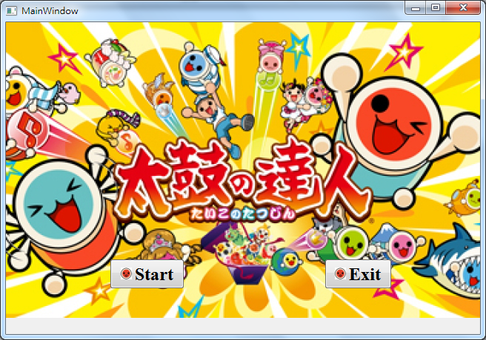

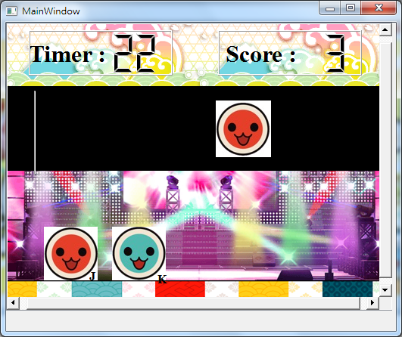

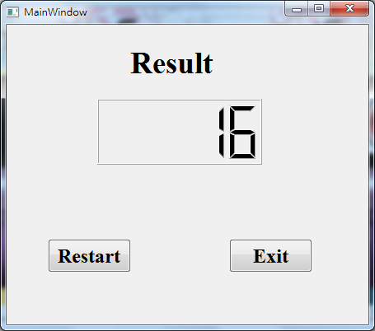

How to play

There will be two kind of Taikos display on the screen, you need to press “j” to eliminate the red one and press “k” to eliminate the blue one. You will get one point after you eliminate one Taiko, and there will be 30 seconds for the game.

Program architecture

我設了三個視窗: mainwindow、mygame 跟resultwindow。在mainwindow裡有兩個按鈕，分別控制開始遊戲和結束遊戲。開始遊戲之後就會跳到mygame這個視窗。三十秒後遊戲結束，resultwindow就會跳出來，顯示score和兩個按鈕，分別控制重新開始遊戲和結束遊戲。