Synchronization Tool Usage

Way 1:
- Click [Select Board] Button
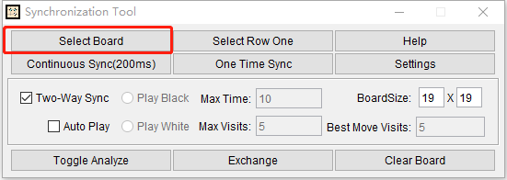
- Select the whole board region(a little more is fine)
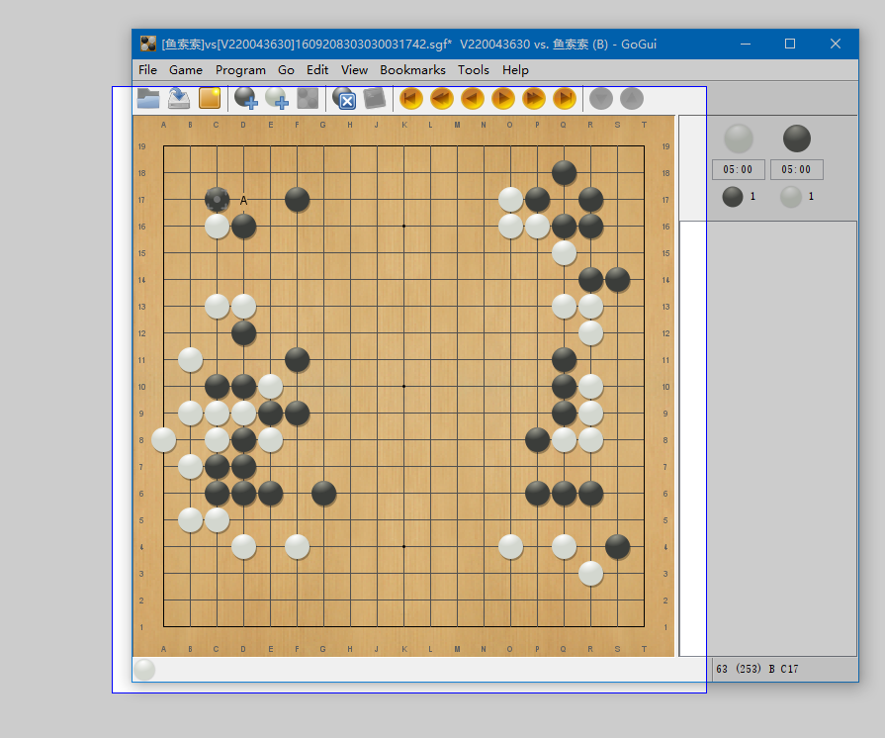
- Click [Continuous Sync]/[One Time Sync] button
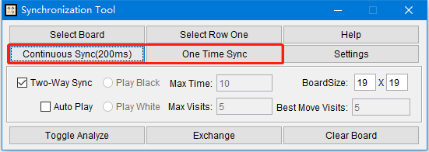

Way2(Use it only if way 1 does not work)
- Click [Select Row One] Button
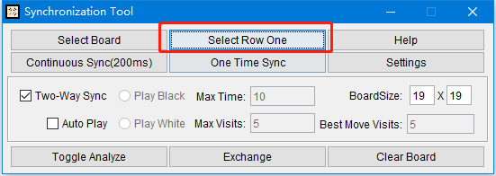
- Select Row One accurately
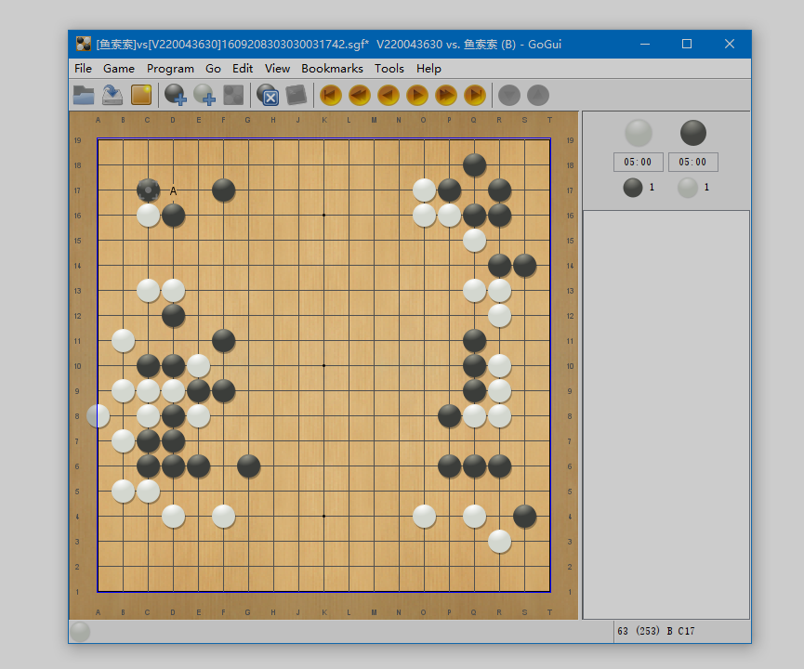
3. Click [Continuous Sync]/[One Time Sync] button


Other
- Two-Way Sync and Auto Play: If selected ‘Two-Way Sync’, Synchronization Tool will place stone on the selected board when a stone placed in ‘LizzieYzy’,if ‘Auto Play’ is selected,’LizzieYzy’ will automatically place stones on the condition of Max Time/Max Visits/Best Move Visits.
- KataGo Rules Settings: Because of lack of move history,captures will be incorrectly,So we can only use area scoring.You can set area scoring+7.0komi+hasbutton to simulate Japanese rule.
- Require the original board can not be moved or resized or coverd during Synchronization.

