Contract creation  
<https://sepolia.etherscan.io/tx/0x1cc3b531553c2ce020c339e0a60b5cebf4e33f8b63b978a729e88772ddb130a1>

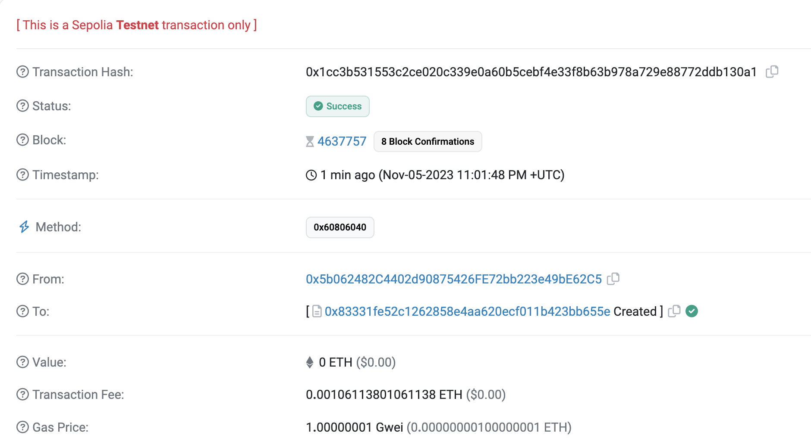

Vote

https://sepolia.etherscan.io/tx/0x0cb252fd047186df42f595f590ce0be5d703479ec2d8a782df3f06dd4353ab59

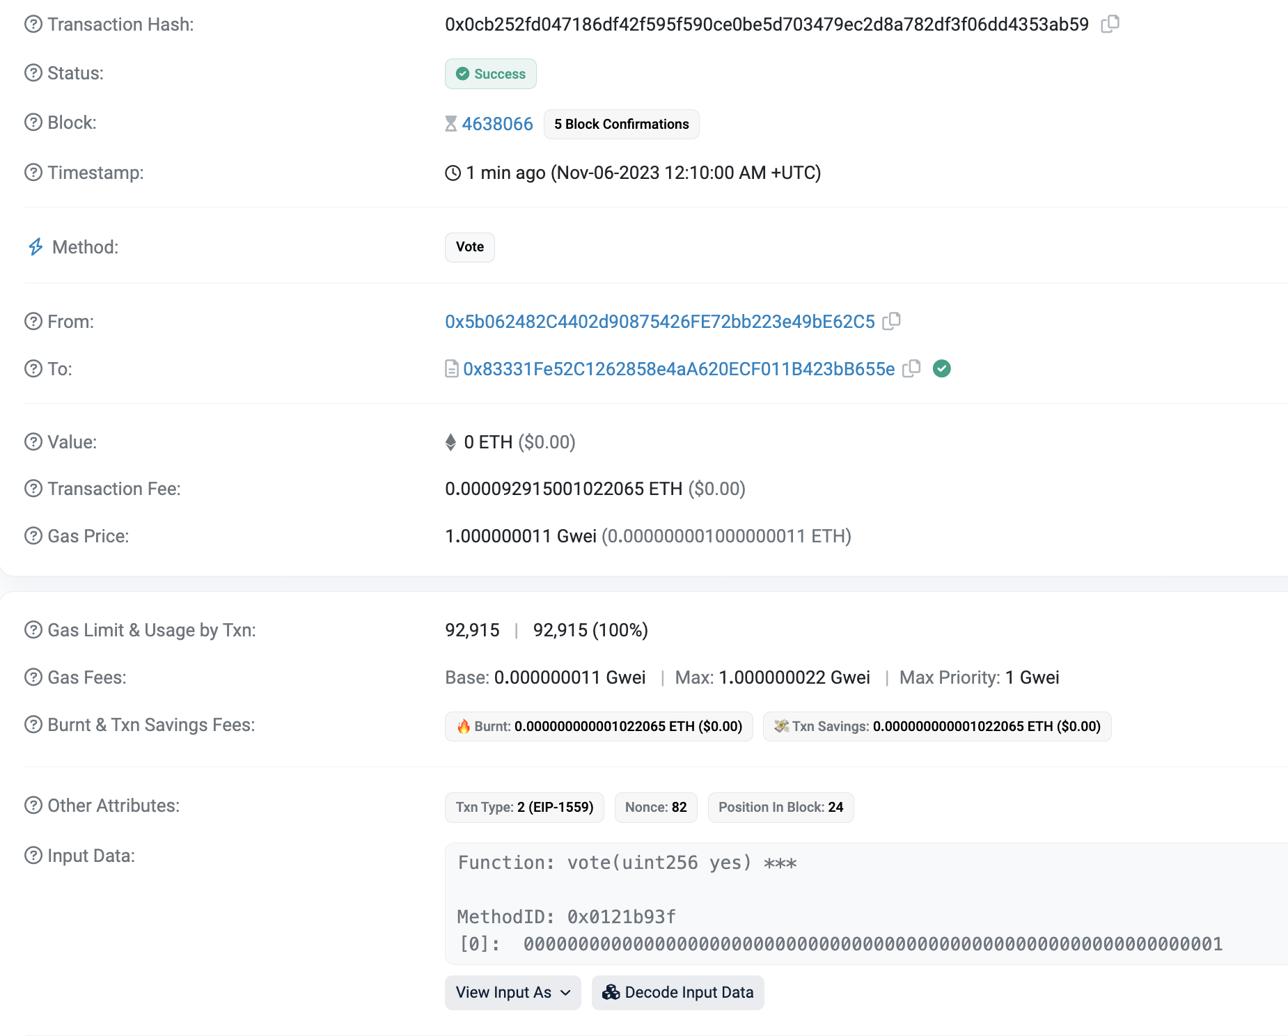

Give Right To Vote

<https://sepolia.etherscan.io/tx/0x64af0ae1d93c0594ac9f47fbf3f8ebc9f8d2de71b413261d4536f0965f67a2e0>

