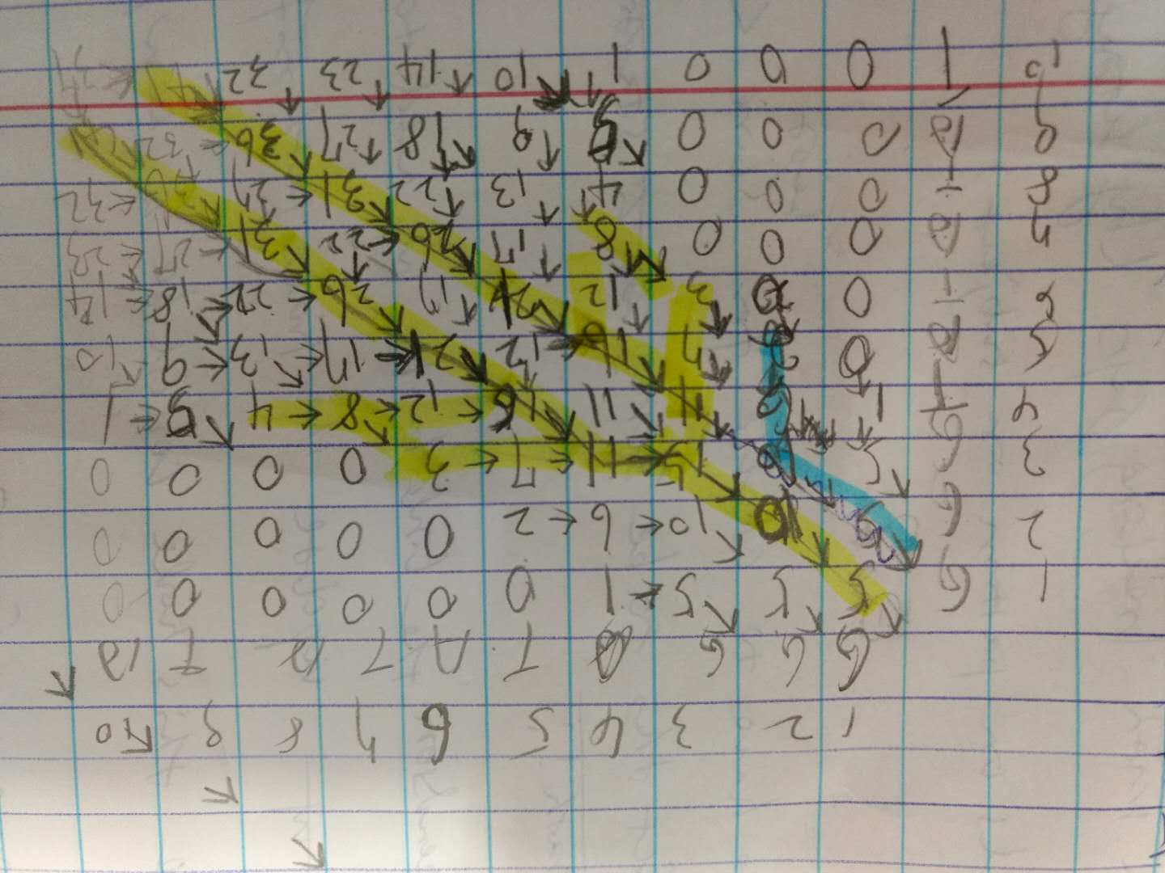

The problem:

when we have -g 0 -e4 and a nuc4.4 score matrix (5 for match, -4 for mismatch) the second best the blue line with first nt “GG” for alignment.

When we have 5 -e4 and a nuc4.4 matrix, the second best one is the second diagonal line, starting as the blue one and go down as a straight line to the right bottom corner with a score of much larger.

The above picture is for the first case score table. It seems in this case the first optimal alignment cut off the second one. Can we do anything in the future???