LLM‑Based Data Mining and Database Construction
A literature search was performed in PubMed using a query combining MeSH terms and free text: ("DNA Transposable Elements"[MeSH] OR "retrotransposon" OR "transposon" OR "retrotransposons" OR "transposons" OR "Retrotransposition" OR "transposition") AND ("humans"[MeSH Terms] OR "human" OR "homo sapiens"). The search yielded 34,788 articles (covering literature up to April 13, 2026). Human transposon names annotated in RMSK and the human transposon IDs together with the KW‑line texts in RepBase (Repeat Database) were extracted to form a whitelist, which contains all currently known human transposons as well as some noise. An initial whitelist‑based filtering was applied to the titles and abstracts of the 34,780 articles, retaining 5,362 articles. Subsequently, the API of the large language model DeepSeek‑V3 was called to identify and extract entities and entity‑relation pairs. The prompt was designed to filter out articles not related to human transposons, guide entity types, constrain relation predicates, and enforce a fixed output format.
A second filtering step based on the whitelist was applied to the output files generated by the LLM, excluding articles that did not contain any human transposon entity. After this step, 2,308 articles were retained. Concurrently, 1,803 articles that matched terms in the whitelist but did not fully include those terms in the final transposon entity set were flagged for further inspection. Next, entities of the same type were clustered using the Ratcliff/Obershelp algorithm with a similarity threshold of 80%, followed by manual curation to establish a mapping from synonyms to canonical names, thereby normalizing entity naming.

Entity Types
The knowledge graph comprises eleven entity types: disease, function, mutation, gene, RNA, protein, carbohydrate, lipid, peptide (<50 aa, not toxin/drug), pharmaceutical, and toxin. Relations are categorized into five semantic classes: causal, regulatory, interaction, association, and genetic information flow. These entity types and relations cover the molecular categories involved in all steps of human transposon biology, from genomic integration, transcription, and retrotransposition to post-translational modifications. Through this entity system, the knowledge graph can systematically characterize transposon-driven pathogenic mechanisms, thereby enabling the modeling of associations from molecular events to disease phenotypes.

Data Classification
The disease taxonomy was built upon the ICD-11 classification system. However, some diseases – such as monogenic disorders and inflammation – are scattered across different high-level categories in ICD-11, making classification overly broad and imprecise. Such diseases, together with transposon-induced genomic instability phenotypes, were grouped under a dedicated branch within the Others category. The transposon taxonomy was primarily based on annotations in RepBase. For transposons not recorded or not fully classified in RepBase, the RMSK classification was used as a secondary reference. To balance taxonomic rigor and completeness, two hierarchical transposon trees were constructed: the first tree contains only transposons explicitly annotated in RepBase or RMsk; the second tree is built upon the first and incorporates all transposon entities present in the knowledge graph.

Data Validation
Manual curation was performed on three sets of articles: 27,108 articles removed during the initial filtering stage, 5,362 articles removed during the secondary filtering stage, and 1,803 articles flagged as potentially missing transposons during graph integration. From each set, 50 articles were randomly selected using Python’s random function and manually reviewed. The correct-filtering rate was 100% for the 50 initially filtered articles, 94% for the 50 secondarily filtered articles, and 96% for the 50 articles from the integration-flagged set. The Clopper-Pearson exact method was used to estimate the 95% confidence interval (CI) for the initial filtering population, yielding (92.9%, 100%). The Wilson score interval was applied to the secondary filtering and flagged integration sets, giving 95% CIs of (83.78%, 97.94%) for secondary filtering and (93.19%, 97.9%) for the flagged integration set.
The few incorrect decisions in secondary filtering were due to human transposons not being present in RMsk or RepBase, while the missed extractions in the flagged set resulted from large language model inference bias. Overall, the literature screening and graph construction pipeline described here is reliable, with minor, well-characterized sources of error.

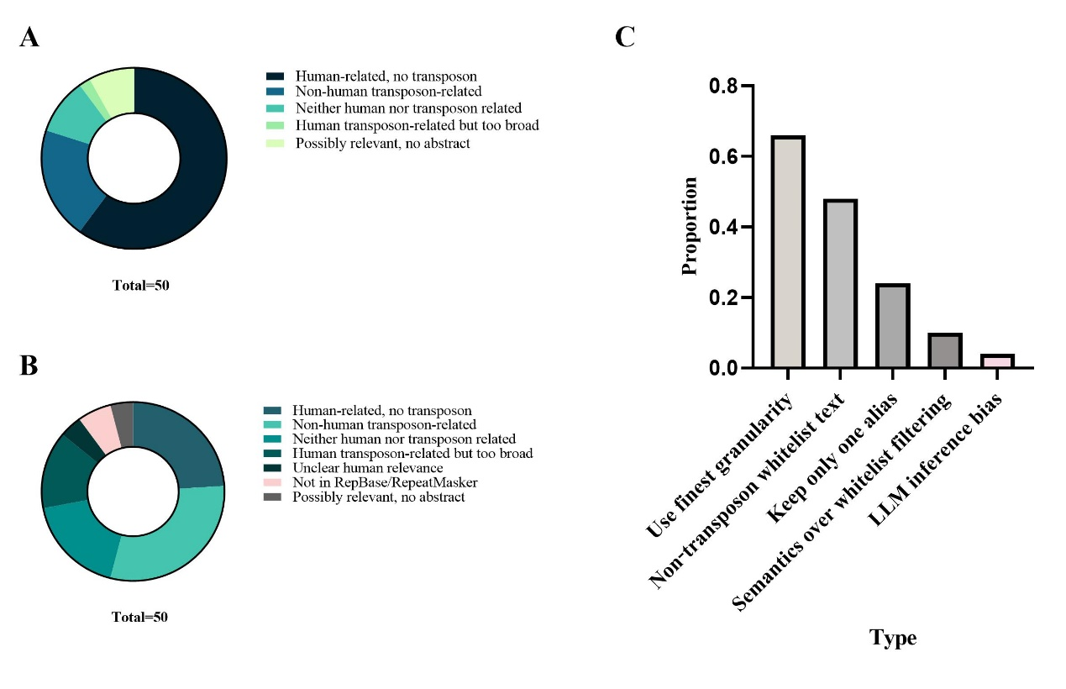
Figure 1 Classification of manually reviewed references
(A) For literature removed during the initial filtering stage.
(B) For literature removed during the secondary filtering stage, with “Not in RepBase/RepeatMasker” identified as the cause of filtering errors.
(C) For literature flagged as potentially missing transposons during graph integration, with “LLM inference bias” identified as the cause of extraction errors.

Appendix
Prompt:
You are a biomedical IE assistant for human transposon knowledge graph from PubMed abstracts.

Paper: PMID %(pmid)s, Title: %(title)s, Abstract: %(abstract)s

【Rules】
1. Extract only HUMAN transposons (per Repbase). Ignore transposons from other species.
2. Focus on activity, pathogenicity, expression abnormality, insertional mutation, DNA damage.
3. Output ONE JSON object. No extra text.

【Entity Types】(standardize name, add one short description per entity)
- transposon: subfamily > family > superfamily. e.g. L1HS. (For L1 retrotransposon, extract only L1; for hAT transposon, extract only hAT; similarly for others, extract only the transposon name.)
- disease
- function: biological process or mechanism.
- mutation
- paper: use title as description.
- gene: non-TE genes (protein-coding, ncRNA).
- rna: mRNA, lncRNA, miRNA, etc. (not from TE).
- protein
- carbohydrate
- lipid
- peptide (<50 aa, not toxin/drug)
- pharmaceutical: drug, compound, candidate.
- toxin

【Relation Types】
Use only these predefined types. If none fits, use generic `associate with`, `cooccur with`, `correlate with`.

A. Transposon-related:
cause|induce|promote|increaser isk|associate with|inhibit|involve in → Disease
participate in|mediate|perform|drive|affect|utilize → Function
regulate → Gene,RNA,Protein,Function
insert into|disrupt → Gene
activate|silence → Gene
express → RNA,Protein

B. Function-related:
lead to|trigger|promote|involve in|suppress|modulate|associate with → Disease

C. Gene/RNA/Protein/Peptide/Carbohydrate/Lipid:
encode (Gene→RNA,Protein)
express (Gene,Transposon→RNA,Protein)
regulate (any→any except Paper)
bind (Protein,RNA,Peptide,Carbohydrate,Lipid→Protein,RNA,DNA,Transposon)
catalyze (Protein,RNA→Function,Carbohydrate,Lipid,Peptide)
cleave (Protein→RNA,Protein,DNA)
modify (Protein→Gene,RNA,Protein,Carbohydrate,Lipid)
transport (Protein→Small molecule,Lipid,Ion)
interact with (Protein,RNA,Peptide→Protein,RNA,Gene,Transposon)
localize to (Protein,RNA→Cellular component)

D. Mutation:
cause→Disease; lead to→Function; affect→Transposon,Gene,RNA,Protein; create→Transposon,Gene; abolish→Gene,Protein; confer→Pharmaceutical,Protein

E. Pharmaceutical/Toxin:
inhibit→Transposon,Protein,RNA,Enzyme,Function; treat→Disease; induce→Disease,Mutation; activate→Gene,Protein,Function; cleave→Protein,RNA,DNA

F. Paper: report → any entity (except Paper)

【Output Format】
{
"pmid": "31234567",
"entities": {
"transposons": [{"name": "L1HS", "description": "L1HS is an active human LINE-1 subfamily."}],
"diseases": [{"name": "Colorectal cancer", "description": "Colorectal cancer is a malignant tumor of the colon or rectum."}],
"functions": [{"name": "Insertional mutagenesis", "description": "Insertional mutagenesis disrupts tumor suppressor genes."}],
"mutations": [{"name": "Alu insertion in c-mo", "description": "Alu insertion in c-mos is a mutation involving the insertion of Alu-family elements into the coding region of the human c-mos pseudogene."}],
"genes": [{"name": "APC", "description": "APC is a tumor suppressor gene involved in Wnt signaling."}],
"proteins": [{"name": "beta-catenin", "description": "Beta-catenin is a transcriptional co-activator."}],
"rnas": [],
"carbohydrates": [],
"lipids": [],
"peptides": [],
"pharmaceuticals": [{"name": "5-fluorouracil", "description": "5-FU is a chemotherapeutic agent."}],
"toxins": []
},
"relations": [
{"source": "L1HS", "relation": "insert into", "target": "APC", "description": "L1HS inserted into the APC gene."},
{"source": "L1 insertion in APC", "relation": "cause", "target": "Colorectal cancer", "description": "The insertion disrupts APC, leading to cancer."},
{"source": "L1HS", "relation": "mediate", "target": "Insertional mutagenesis", "description": "L1HS retrotransposition mediates insertional mutagenesis."},
{"source": "5-fluorouracil", "relation": "treat", "target": "Colorectal cancer", "description": "5-FU is used to treat colorectal cancer."}

【Important】
- Same entity per paper: once.
- Description: concise, from abstract.
- Output language: English.

