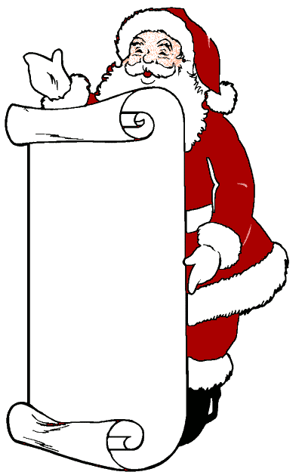
Santa Claus is
NOT REAL!

Santa Claus is a character from legends based on Saint Nicholas of Myra, a real-life fourth-century Roman Catholic (Christian) saint from the city of Myra, in Asia Minor, where Turkey is today. (The character in the red suit today that we know was never an actual person.) Little is known about Nicholas’ historical life, although he had a reputation for being generous, and many legends arose based on his acts that he performed for the poor ^{(Britannica)}. In the Middle Ages, children were given presents in his honour.
The Dutch brought the legendary Sinterklaas figure – who is said to keep records of the kids who were naughty and nice and give gifts just like the Western character of Santa Claus – to New Amsterdam, a 17th-century Dutch settlement at the southern end of Manhattan Island in New York City ^{(Britannica)}. Thomas Nast, a cartoonist, was a major contributor to the modern portrayal of Santa Claus. Clement Clarke Moore’s poem “ ’Twas the Night Before Christmas” further contributed to the modern portrayal of Santa Claus.

