Dossier Theater der Welt Chemnitz 2026
= Notwendigkeit im Programmbuch
Name Produktion | Nkoli: A Fierce & Fabulous Life
Künstler:in / Kompanie | Philip Miller MusoreliefSA
Spielort | Oper
Spieldatum & Uhrzeit | 23.06.2026 | 19:30 | 21:50 mit Pause
 | 24.06.2026 | 19:30 | 21:50 mit Pause

Projektbeschreibungen
Kurztext / A-Text (120 +- 10% Zeichen – 1 Zeile ca.)
Eine queere Oper über Simon Nkoli. Voguing, Protestlieder und Archivmaterial verbinden Politik, Körper und Clubkultur.

Langtext / B-Text (300 – 500 +- 10% Zeichen)
TEXT

Detailtext / Programmbuch / C-Text (DE: 1700 +- 10% Zeichen)
Willkommen zum grandiosesten Ball aller Zeiten! Ein Moderator, ein Voguing-Tänzer, betritt die Bühne. Er ist Gastgeber des Abends. Das Orchester setzt ein, und ein Chor aus 20 Sängerinnen und Tänzern schreitet durch einen riesigen Kleiderschrank auf die Rampe, begleitet vom stampfenden Rhythmus einer einzelnen Trommel. „Wir sind hier. Wir sind queer!“, skandieren sie. Mehrere Videoleinwände erscheinen im Hintergrund der Bühne, während der Moderator verkündet: „Und das Thema lautet: Stellt euch euren Widrigkeiten!“
Entwickelt von dem südafrikanischen Komponisten Philip Miller, mit Texten von S'BO GYRE und Philip Miller entstand unter der Regie von Greg Karvellas eine Oper, deren rasante Bilderfolge sich bewusst gegen klare Kategorisierung stellt.
Held der Geschichte ist Simon Nkoli. Ein Schwarzer, Anti-Apartheid-Aktivist, der offen schwul lebte. Nkoli: A Fierce & Fabulous Life ist kein biografisches Porträt, sondern ein hybrider Musikabend voller Energie, Lebensfreude und mit klarer politischer Botschaft. Der im südafrikanischen System mehrfach exponierte Simon Nkoli, erlebte Ausgrenzung, Apartheid, Homophobie und institutionelle Gewalt. Er lebte, wie Hunderttausende, in ständiger Gefahr.
Millers Komposition verbindet Operngesang mit Protestliedern und Club-Sounds mit Ballroom Culture. Bilder, Körper, Musik und Archivmaterial stehen gleichberechtigt nebeneinander. Auf der Bühne ist es voll und laut, alles befindet sich in permanenter Bewegung. Voguing, Rap, Lip-Sync und orchestrale Elemente überlagern einander in ständiger Aufgewühltheit. Die Geschichte entfaltet sich fragmentarisch, nicht chronologisch. Der Ballsaal, als politischer Raum, ist die Projektionsfläche für Fragen von Zugehörigkeit, Sichtbarkeit und Widerstand. Unterhaltung und Ernst sind hier keine Gegensätze, sondern untrennbar miteinander verbunden. Nkolis Coming-out ist dabei keine Privatangelegenheit, sie wird ein öffentlicher Akt in einem repressiven System. Die Show ist offen und durchlässig für eine Vielzahl musikalischer und performativer Sprachen, für Körper und Stimmen.
EN
Welcome to the grandest ball of all times! A host and voguing dancer steps on stage. He is the host of the show. The orchestra begins and a chorus of 20 singers and dancers strides through a huge wardrobe onto the apron, accompanied by the pounding rhythm of one single drum. “We’re here. We’re queer. We're everywhere.” they chant. Various video projections appear as the host announces, “The subject is: Face your adversities!” Developed by the South African composer Philip Miller, with lyrics by S'BO GYRE and Philip Miller, and directed by Greg Karvellas, an opera was created whose rapid sequence of images deliberately defies clear categorisation.

The hero of the story is Simon Nkoli, a black, anti-apartheid activist who was openly gay. Nkoli: A Fierce & Fabulous Life is not a biographical portrait, rather a hybrid music show full of energy and vitality with a clear political message. In the South African system, Simon Nkoli was variously exposed to discrimination, apartheid, homophobia, and institutional violence. He lived, as did hundreds of thousands, in constant danger.

Miller’s composition combines opera with protest songs and club sounds with ballroom culture. Images, bodies, music, and archival material are on equal footing with one another. On stage it’s loud and saturated, everything is in constant motion. Voguing, rap, lip-syncing and orchestral elements overlap in constant chaos. The story unfolds in fragments, not chronologically. The ballroom, a political space, serves as container for issues of belonging, visibility, and resistance. Entertainment and seriousness are not opposed here; they are inextricably linked. And Nkoli’s coming out is not a private matter, it becomes a public act in a repressive system. The show is open and permeable to a variety of musical and performative languages, to bodies and voices.

Faktenblock
Herkunftsland | Südafrika
Sprache(n) | Englisch, Zulu, Sotho (ein wenig)
Sprache(n) | In Englisch, Zulu und Sotho mit deutscher und englischer Übertitelung.
Übersetzung | Ja | ☒
 | Nein | ☐
Genre / Theaterform / Format | Zeitgenössische Oper
Art der Aufführung | Europapremiere
Länge in min. | 140 inkl. 1 Pause
Vorgespräch | Jeweils 30 Minuten vor Vorstellungsbeginn findet eine Stückeinführung im Foyer der Oper statt.
Nachgespräch | Am 23.06.2026 findet im Anschluss an die Vorstellung ein Nachgespräch im Foyer der Oper statt.
Zielgruppe(n)
Kurator:in | Faye Kabali-Kagwa
Barrierefreiheit
Kommentare
Preis | 22 – 49 €, 35 % Ermäßigung mit Festivalpass

Creditblock
Bezeichnungen sind bei Bedarf anzupassen
Mit | Niza Jay, Simbone Qonya, Ann Masina, Nokuthula Magubane und weiteren
Komposition, Konzept | Philip Miller
Lyrics | S'BO GYRE, Philip Miller
Regie | Tshegofatso Moeng
Kostüm, Styling | Sikelela Mr Allofit, Birrie Roux
Producer | Harriet Perlman, Philip Miller
Video | Catherine Meyburgh S.A.G.E
Motion Graphics | Marcos Martins
Choreografie | Llewellyn Mnguni

Biografien
- Philip Miller
Philip Miller (b.1964) is a South African composer and sound artist. His work is influenced by a range of musical genres, from contemporary electronic music and minimalism to South African choral and instrumental music. His works and collaborations cross various media, from live stage performance and film to video and sound installations, and contemporary dance.
Much of his work explores aural histories and testimonies found in both public and his own personal archives.
Philip's ability to work across different musical genres and media has led to him becoming a sought–after collaborator with choreographers, theatre-makers and visual artists. This includes his long- time collaborator, the internationally recognised South African artist William Kentridge.
He has composed over 80 scores for both the big and small screen which have earned prestigious awards and accolades, including an Emmy nomination for HBO’s "The Girl" and several other awards and nominations for best scores - like “The Book of Negroes" for CBC television, "The Bang Bang Club", the Emmy award-winning "Shot-Down", "Black Butterfly" and BBC’s "Seven –Up".
He has received commissions from The International Music Institute Darmstadt Festival, Celebrate Brooklyn Festival and MASSMoca (USA), Cape Town Opera, as well as both Venice Biennale and Kaunas Biennale. His seminal and award-winning choral work, "Rewind a Cantata" for voice, tape and testimony has been performed at venues across the world, including London’s Festival Hall, as well as The Market Theatre and the Baxter Theatre Centre in South Africa.
He has been the recipient of honorary fellowships and residencies including The Rockefeller Foundation’s Bellagio Center, Civitella Ranieri, Yaddo, and the Archive and Public Culture (APC) Research Initiative at the University of Cape Town.

- Rikki Beadle-Blair MBE
Born and raised by his lesbian mother in South East London, Rikki learned to read at the age of three and wrote his first play aged seven, and started to direct at the age of 11. He attended the experimental Bermondsey Lamp Post Free School, where he could study any subject he liked, and focused on theatre and film making.
Named several years running on the Independent on Sunday’s Pink List as one the 100 most influential gay people in Britain, multi-award-winner Rikki is perhaps best known for creating the cult series Metrosexuality for Channel 4, writing the screenplay for Nigel Finch’s Stonewall, and for his anti-homophobic-bullying films FIT and FREE, co-produced with Stonewall and seen by hundreds of thousands of schookids throughout the UK.
Rikki has a life-long commitment to creating challenging, transformative entertainment in the mediums of film, theatre, music, television, radio, dance and design. He created Team Angelica to pursue these goals and to share opportunities with performers, artists and practitioners from the widest possible range of backgrounds, and is a passionate and committed mentor. He and John have developed all sorts of writers, including Lynette Linton and Waleed Akhtar, showcasing their work at Theatre Royal Stratford East, the Bush Theatre, Theatro Technis, the Contact and the King’s Head, among many others.

Kritiken
- The Conversation, 2023, Gwen Ansell
- Weekend Special, 2024
- Daily Maverick, 2024, Keith Bain
- Music in Africa, 2023, Philile Nkabinde

Beschreibungen Produktion
Nkoli: The Vogue-Opera It’s part opera, part vogueing-ball. “Think if Hamilton and RuPaul’s Drag Race had a baby in South Africa. That’s Nkoli: The Vogue-Opera!”, says co-lyricist and rapper, S’boGyre. Following its hit run at The Market Theatre in Johannesburg in 2023, Nkoli: The Vogue-Opera is coming to the Flipside at The Baxter Theatre, Cape Town, from 9 – 19 October.
Nkoli: The Vogue-Opera is created and composed by Philip Miller, long-time collaborator with William Kentridge (most recently The Head and the Load) with direction by award-winning directors, Rikki Beadle Blair (UK) and John Trengove (South African Director, The Wound). Nkoli: The Vogue-Opera tells the story of gay anti-apartheid freedom fighter, Simon Nkoli. Set against the backdrop of one of the most tumultuous decades in South African history, the show is set within a voguing ballroom competition. Simon’s life story unfolds on the ramp, encompassing a range of performance styles including lip-syncing, rap, vogue dancing, together with video projections and archive. It’s a show not to be missed. Next year, it will tour internationally with tours being planned for the Queen Elizabeth Hall, South Bank Centre, London and the Apollo Theatre, New York.

- Weiterführende Informationen
- Weiterführende Informationen

Zitate
- “Think if Hamilton and RuPaul’s Drag Race had a baby in South Africa. That’s Nkoli: The Vogue-Opera!”

Medien & Zusatzmaterialien
Medium / Datei | Credits
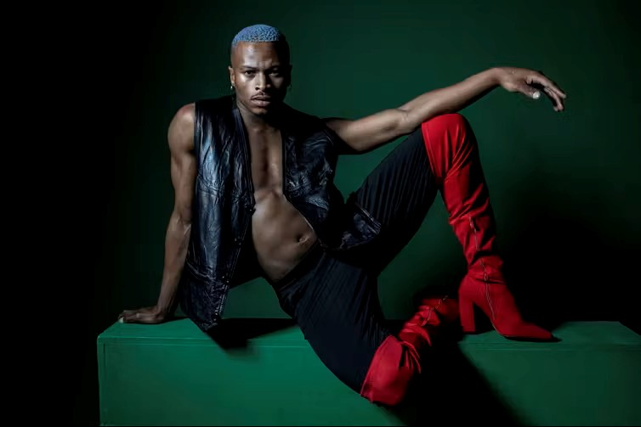 | Credits

