Dossier Theater der Welt Chemnitz 2026
= Notwendigkeit im Programmbuch
Name Produktion | Paper Planet
Künstler:in / Kompanie | Polyglot Theatre
Spielort | Hartmannfabrik
Spieldatum & Uhrzeit | 18.06.2026 | 09:30 | 10:30
 |  | 11:00 | 12:00
 |  | 14:00 | 16:00
 | 19.06.2026 | 09:30 | 10:30
 |  | 11:00 | 12:00
 |  | 14:00 | 16:00
 | 20.06.2026 | 10:00 | 12:00
 |  | 14:00 | 16:00
 | 21.06.2026 | 10:00 | 12:00
 |  | 14:00 | 16:00
Hinweis | Besucher:innen können innerhalb der gebuchten Vorstellungszeit beliebig kommen und gehen.

Projektbeschreibungen
Kurztext / A-Text (120 +- 10% Zeichen – 1 Zeile ca.)
TEXT

Langtext / B-Text (300 – 500 +- 10% Zeichen)
TEXT

Detailtext / Programmbuch / C-Text (1700 +- 10% Zeichen)
In der Hartmannfabrik wächst ein Wald aus Karton, mit hohen Bäumen, alles ist aus Pappe. Papier raschelt wie Laub, Licht fällt durch ein selbst gebasteltes Blätterdach. Kinder und Erwachsene sind hier nicht etwa Zuschauende – sie selbst entwerfen und bauen den Wald. Es wird gerissen, geklebt, gefaltet und Geschichten werden erfunden. Figuren entstehen, die sich verwandeln können, je nach Gefühlslage. Paper Planet ist kein fertiges Stück zum Anschauen, es ist eine Einladung an Kinder und Erwachsene, selbst kreativ zu werden – und sich einen eigenen Planeten zu erschaffen und diesen auch zu beleben.
Das Polyglot Theatre aus Melbourne bietet ein Theatererlebnis zum Selbermachen, in dem Spiel, Kunst und Performance ineinander übergehen. Die australischen Künstler:innen begleiten, reagieren, setzen Impulse, ohne zu lenken oder zu erklären. Kinder entscheiden selbst, ob sie still bauen, beobachten oder sich mitten ins Geschehen stürzen. Von Tag zu Tag wächst der Wald, jede:r Teilnehmende hinterlässt einen eigenen Fußabdruck in der Landschaft.
Für diese interaktive Theateraktion öffnet die Hartmannfabrik ihre Türen für vier volle Tage. Die australischen Künstler:innen bieten ein sinnliches, offenes Erlebnis für verschiedene Generationen. Das Polyglot Theatre ist international bekannt für außergewöhnliche Kunstformate für Kinder und Familien.
Zu einer nicht öffentlichen Veranstaltung ist das Polyglot Theatre zum Abschluss seines Gastspiels vom Terra Nova Campus eingeladen. Extra für Schüler:innen des Campus wird die Installation und partizipative Performance noch einmal zu erleben sein. Direkt an dem Ort, an dem sie lernen, leben und wohnen.

EN
At Hartmannfabrik a cardboard forest is growing with tall trees. Everything is made of cardboard. Paper rustles like leaves, light falls through a hand-made canopy. Kids and adults are not only spectators here – they design and build the forest themselves. They tear, fold, tape, and they invent stories. Characters emerge which transform according to one’s emotional state. Paper Planet is not a finished piece for viewing, it invites children and adults to be creative themselves – to create their own planet and animate it.
Polyglot Theatre from Melbourne puts on a do-it-yourself theatrical experience, in which play, art, and performance meld together. The Australian artists assist, react, and add momentum, without distracting or explaining. Kids decide for themselves if they want to build quietly, look on, or fling themselves into the middle of the action. Day to day the forest grows. Each participant leaves their footprint in the landscape.
For this interactive theatre action, Hartmannfabrik is opening its doors for four full days. The Australian artists offer an open, sensory experience for multiple generations. The Polyglot Theatre is internationally renowned for its extraordinary artistic formats for children and families.
To conclude its stay in Chemnitz, Polyglot Theatre has been invited by the Terra Nova Campus to a non-public performance. Students of the campus will have the opportunity to experience the installation and participatory performance right where they learn, live and reside.

Faktenblock
Herkunftsland | Australien
Sprache(n) | Mit wenig deutscher und englischer Sprache
Übersetzung | Ja | ☐
 | Nein | ☐
Genre / Theaterform / Format | Installation, Partizipative Performance
Art der Aufführung | Deutschlandpremiere
Länge in min. | 60 – 120
Vorgespräch
Nachgespräch
Zielgruppe(n) | Familien
Kurator:in | Simon Abrahams
Barrierefreiheit
Kommentare
Preis | Kinder: 6 €, Erwachsene: 12 €, 35 % Ermäßigung mit Festivalpass

Creditblock
Bezeichnungen sind bei Bedarf anzupassen
Tournee-Team | Briony Farrell, Lachlan MacLeod, Zak Pidd, Rainbow Sweeny, Meg Taranto, Alexandra Wood
Originalkonzept | Sue Giles AM
Originalkonzept Szenografie | Mischa Long
 | Polyglot Theatre is assisted by the Australian Government through Creative Australia, its principal arts funding and advisory body, and the Victorian Government through Creative Victoria.
Fotocredit

Biografien
- Polyglot Theatre
Polyglot Theatre is a world-renowned contemporary theatre company based in Melbourne/Naarm making exceptional arts experiences for children and families.
Our unique brand of theatre encompasses a wide variety of forms and is shared with audiences everywhere, from the world’s most prestigious theatres to the football grounds of regional Australia.
We advocate for the right of all children to experience arts and culture, and promote the importance of young people as a discerning audience from the earliest years.
Our artistic and philosophical approach of child-centred practice has earned us a strong reputation at home and abroad as a leader in the theatre for young audiences (TYA) sector, celebrated for creating distinctive, participatory and inclusive works that are playful and conceptually rigorous. Access is fundamental to our work at Polyglot; we are driven by the right of all children to experience growth and resilience through creative play.
Polyglot’s founder, Naomi Tippett, first received funding in 1978 to create a multilingual puppetry work that gave the company its name. In 2000, Sue Giles became Artistic Director, leading the company through a transformation to participatory practice across a range of artforms. Over her 22 years, Sue created bold, playful interactive experiences, immersive theatre productions, and collaborative projects with communities.
Polyglot has never veered from its ambition to bring theatre and creativity to children with the least access, and continues blazing this trail under the creative leadership of Cat Sewell, who commenced as Artistic Director and co-CEO in January 2023. Sue is still deeply connected with Polyglot as an artist, collaborator and friend, as well as advocating for the TYA sector globally in her role as President of ASSITEJ International. Naomi remained a staunch supporter of Polyglot until her death in 2022.

- Sue Giles AM
Artist. Former Artistic Director 2000-2022
Sue was the Artistic Director and co-CEO of Polyglot Theatre from 2000-2022. During her 22-year tenure, she flung herself into the joyous, chaotic, thoughtful and surprising world of children as audiences and as co-creators, extending her career experience as an actor, writer and director into the rich and ever-changing world of theatre for young audiences.
Sue was able to follow a particular path of participation with Polyglot, broadening ideas of what theatre can be, how play can re-imagine performance, how the benefits of fun are underestimated and how children can change the world with their instincts, voices, bodies, energy and opinions.
Sue has had many highlights at Polyglot – the unexpected artistic discoveries, the collaborations that turn into friendships, the passion and courage of her colleagues, and the way people fall in love with the infinitely satisfying work of making art with and for children.
She is an advocate for the sector in Australia as a Board member of Theatre Network Australia, and internationally as President of ASSITEJ International – the global association of theatre for young audiences. In 2018, Sue received the Green Room Lifetime Achievement Award for her work in the Australian arts industry, and authored a Platform Paper for Currency Press titled Young People And The Arts: Agenda for Change. In 2019, she received a Theatre Fellowship from the Australia Council for the Arts for her work in advocacy, and she was appointed Member of the Order of Australia (AM) for her significant service to the performing arts as an artistic director, and to theatre for children.

Kritiken
- Mirage News, 2021

Beschreibungen Produktion
Children and families are invited into a forest of tall cardboard trees and after exploring the space, they add to this strange and delicate planet using only paper, tape and their imaginations. Theatre and play merge in this magical place, as creatures, plants, costumes, characters, stories and adventures spring to life.
Paper Planet grows as more families visit, and every session is truly unique as imaginations go wild. Children choose how they interact with the performers and with other children; some children find themselves absorbed in quiet making, and others prefer to play and explore.
Paper Planet is child-led, deeply involving and highly sensory, and sure to delight the whole family.
“It was amazing. We felt inspired and safe.” Parent
Paper Planet is a universally accessible experience, there is no English language barrier, and it can be entirely non-verbal. Children and families choose how they engage with the performers and the space, moving around as they like.

Zitat
- "Paper Planet is child-led, deeply involving and highly sensory."
- "Children and families are invited into a forest of tall cardboard trees [....] and add to this strange and delicate planet using only paper, tape and their imaginations."

Medien & Zusatzmaterialien
Medium / Datei | Credits
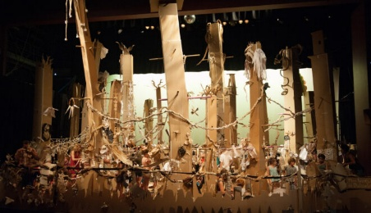 | Credits
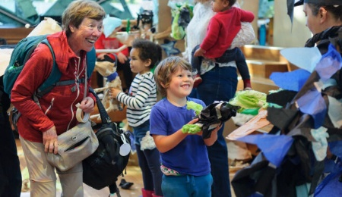 | Credits
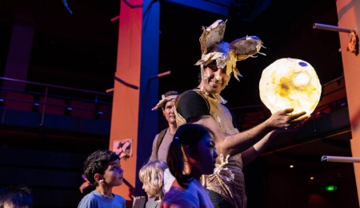 | Credits

