**INSTRUCTIONS FOR MEASUREMENT WITH T32 DEBUGGER**

1. **Activate the USE_DEBUG option**

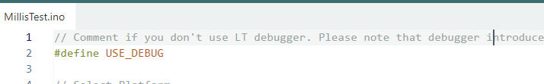

(please note that with this option selected, the board only works with the debugger attached)

1. **Select PLATFORM_PORTENTA_H7 as platform to use (OPTA is not yet supported by T32).**

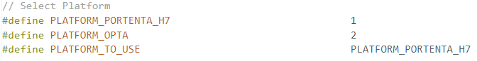

1. **Select Sketch/Export Compiled Binary (or press CTRL+ALT+S)**

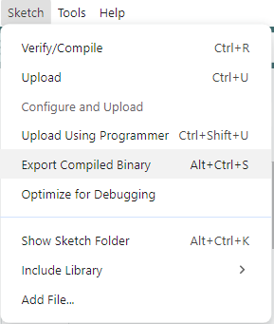

1. **Open T32 software and select:**

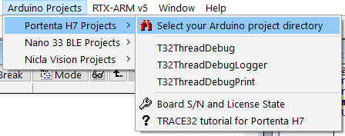

And select the project folder.

1. **Select file and the navigate to the .elf file under build\arduino.mbed_portenta.envie_m7**

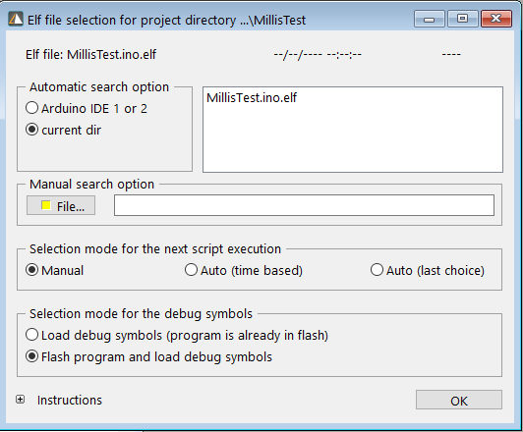

Fill the other options as in the picture and press OK (the SW will ask you to put the board in bootloader mode).

Now you’re ready for debugging!

