Mercury System

BB110

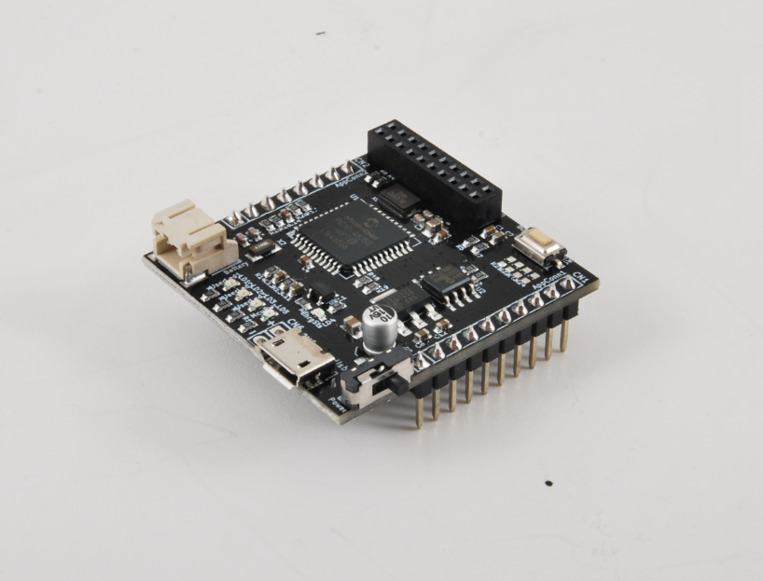

Base Board Model A - Product Datasheet

|  |  |
| --- | --- |
| Author | Francesco Ficili |
| Date | 01/11/2018 |
| Status | Released |

|  |  |  |  |
| --- | --- | --- | --- |
| Revision History | | | |
| Version | Date | Author | Changes |
| 1.0 | 01/11/2018 | Francesco Ficili | Initial Release. |
|  |  |  |  |
|  |  |  |  |
|  |  |  |  |
|  |  |  |  |
|  |  |  |  |

**SUMMARY**

1. Introduction 4

2. Block Diagram 6

3. Hardware 8

4. Pinouts 9

Mercury Connector 9

5. Mercury System Framework 11

6. Technical Specifications 13

# Introduction

The Mercury System (MS in short) is a modular system for the development of connectivity and IoT applications. The system uses various type of electronic boards (logic unit, modems, slave board equipped with sensors and actuators, power boards...) and a complete SW framework to allow the realization of complex applications. Scalability, ease of use and modularity are key factors and are granted by the use of a heterogeneous set of components that allow to assemble the system like a construction made with LEGO© bricks.

The board set which composes the system is made up by the following “families”:

* **Base Board (BB):** It’s the “brain” of the system and contains the main logic unit as well as different communication buses and connector to interfaces the slaves. It also contains a simple power supply system and a recharge unit for a single LiPo cell (it can satisfy the power requirements of simpler systems). It can exist in different variants, depending on the employed microcontroller unit.
* **Modem Board (MB):** this one is the board that allow network connectivity. It can exist in different variant, depending on the network interface (GSM/GPRS, Wi-Fi, BT, Radio…). It’s interfaced to the Base Board with a dedicated serial line.
* **Power Board (PB):** it’s the board that allow to satisfy the particular power requirement of the system, when it’s necessary. They can be vary depending on the particular power requirement to satisfy (high power, solar harvesting, piezo harvesting, etc.).
* **Slave Board (SB):** these are the system’s peripherals, and they vary depending on the specific mounted sensor or actuator. Typical examples are SB with relay, temperature sensors, RGB LED controller, servo controller, accelerometer, etc. They communicate with the BB with I2C or UART and a dedicated command set.
* **Expansion Board (EB):** these are the board that allow planar connection of Mercury boards. There are variants which can contains Displays, battery socket, etc.
* **Brain-Less Board (BL):** these are the controller-less boards. They in general contain really simple sensor or actuators that don’t need the bus interface. There are meant as an alternative to slave boards for cost-sensitive applications.

Slave Boards and Modem Board are provided pre-programmed with a FW which implements a dedicated command set for a high-level management of the boards, while the Base Boards are provided with a SW framework which provides all the low-level services (operative system, device drivers, system services, etc.), leaving to the user only the development of application level logic. Moreover, the Base Board comes with an USB bootloader, so it can be programmed without the need of a flashing device.

Figure 1 shows a typical system connection:

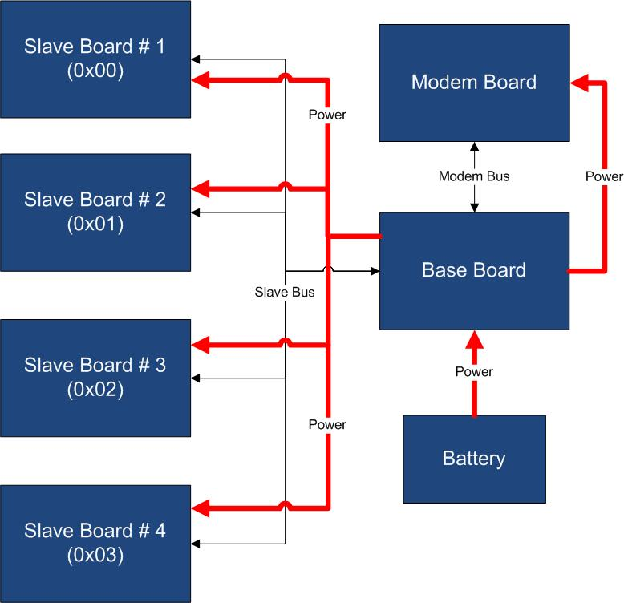

Figure 1 - Typical System Connection

Examples of application fields of MS are:

* Home automation System,
* IoT applications,
* Connectivity Applications,
* Monitoring and control Systems,
* Remote Control,
* Industrial Process control,
* Robotics applications,
* Test benches,
* Etc…

# Block Diagram

The BB110 is a Mercury System Base Board (BB). The BB family represent the Mercury System’s main logical unit and stores the user application. This board interacts with several Slave Boards (SBs) and Modem Boards (MBs) in order to implements various connected and IoT applications. Figure 2 shows the BB110 block diagram. The heart of the system is a PIC18F46J50 8-bit RISC microcontroller, produced by Microchip Technology Inc.

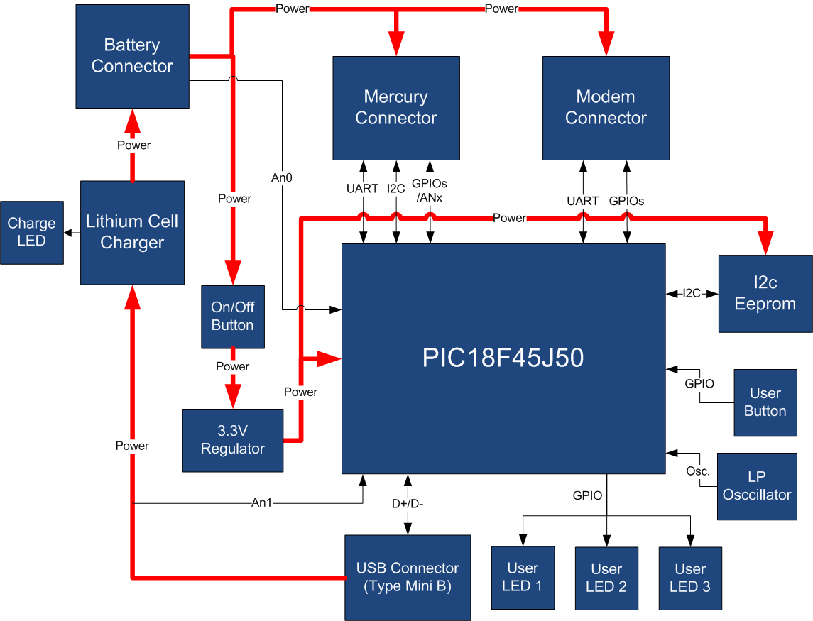

Figure 2 - BB110 Block Diagram

The main characteristics of the employed MCU are resumed in Table 1:

Table 1 - MCU characteristics

|  |  |
| --- | --- |
| Parameter Name | Description |
| Program Memory Type | Flash |
| Program Memory (KB) | 64 |
| CPU Speed (MIPS) | 12 |
| RAM Bytes | 3,800 |
| Digital Communication Peripherals | 2-UART, 2-A/E/USART, 2-SPI, 2-I2C2-MSSP(SPI/I2C) |
| Capture/Compare/PWM Peripherals | 2 ECCP |
| Timers | 2 x 8-bit, 3 x 16-bit |
| ADC | 13 ch, 10-bit |
| Comparators | 2 |
| USB (ch, speed, compliance) | 1, FS Device, USB 2.0 |
| Temperature Range (C) | -40 to 85 |
| Operating Voltage Range (V) | 2 to 3.6 |
| Pin Count | 44 |
| XLP | Yes |
| Cap Touch Channels | 13 |

The board is equipped with two connectors, the Mercury connector and the Modem connector, so it can be interfaced with Mercury System Slave boards (SB) and Mercury System Modem Board (MB). Moreover the board is equipped with a USB connector, for PC connectivity and bootloading purposes. The board features also an I2C EEPROM for non-volatile data storage, LowPower oscillator to enable MCU’s RTCC, some user LEDs and one user button. To satisfy power requirements of simple systems the board has an integrated 3,3V voltage regulator able to supply up to 1A and a single cell LiPo recharging circuitry.

Table 2 resumes the BB110 board main characteristics:

Table 2 - BB110 Characteristics

|  |  |  |
| --- | --- | --- |
| Parameter | Description | Notes |
| MCU Family | PIC18F |  |
| Supported Buses | I2C, UART |  |
| Connectivity | USB device |  |
| Eeprom Size | 2Kbyte |  |
| Max Reg. Power | 1A |  |
| Total IO number | 11 |  |
| RTCC | Yes |  |
| LiPo Battery Rech. Circuit | Yes |  |

# Hardware

This section goes deeper in the HW details of BB110. Figure 3 depicts the most important components of the board:

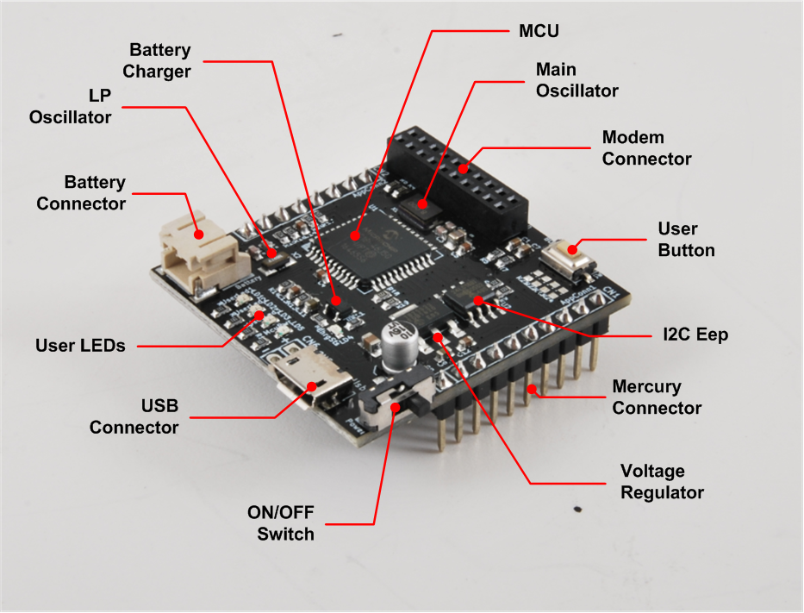

Figure 3 - BB110 Hardware Highlight

Table 3 provides a description of board’s main components:

Table 3 – BB110 Hardware characteristics

|  |  |
| --- | --- |
| Parameter Name | Description |
| User LEDs | 3 General Purpose User LEDs. |
| USB Connector | Connector of Full-Speed USB 2.0 bus. |
| ON/OFF Switch | Main Power Switch. |
| Voltage Regulator | 3,3V x 1A Voltage Regulator |
| Mercury Connector | Mercury Connector for the interfacing of Mercury Slaves. |
| I2C Eep | On-board I2C 16kbit EEPROM. |
| User Button | General Purpose User Button. |
| Modem Connector | Mercury Modem Connector for interfacing Mercury Modem Boards. |
| Main Oscillator | 8MHz main oscillator. |
| MCU | PIC18F46J50 Main Microcontroller Unit. |
| Battery Charger | Single cell LiPo battery charger. |
| LP Oscillator | Low Power 32KHz oscillator for internal RTCC. |
| Battery Connector | Connector for external LiPo battery. |

# Pinouts

This section highlights the pinouts of BB110 connectors.

## Mercury Connector

The Mercury Connector is the connector which interfaces the BB110 with Mercury System’s Slave Boards (SBs). The connector’s pinout is depicted in Figure 4 and Table 4 explains the meaning of each single pin (NC stands for “Not Connected”).

Table 4 - BB110 Mercury Connector Pinout

|  |  |  |
| --- | --- | --- |
| Pin Name | Pin Number | Description |
| VddBat | CN1 – 1 | This pin is connected to the main power source. |
| VddMcu | CN1 – 2 | This pin is connected to MCU regulated positive voltage reference (3,3V). |
| GND | CN1 – 3 | This pin is connected to the board reference voltage. |
| IO11/PGC | CN1 – 4 | This pin is connected to BB PGC (Program Clock) line, for advanced debugging features, and can be alternatively be used as generic IO (IO11). |
| IO10/PGD | CN1 – 5 | This pin is connected to BB PGD (Program Data) line, for advanced debugging features, and can be alternatively be used as generic IO (IO10). |
| MCLR | CN1 – 6 | This pin is connected to BB MCLR (Reset) line. |
| IO9 | CN1 – 7 | This pin is connected to BB generic IO6 line. |
| IO8 | CN1 – 8 | This pin is connected to BB generic IO7 line. |
| IO7 | CN1 – 9 | This pin is connected to BB generic IO8 line. |
| IO6 | CN1 – 10 | This pin is connected to BB generic IO9 line. |
| GND | CN2 – 1 | This pin is connected to the board reference voltage. |
| VddBat | CN2 – 2 | This pin is connected to the main power source. |
| IO5/INT0 | CN2 – 3 | This pin is connected to BB INT0 line and can be alternatively be used as generic IO (IO5). |
| IO4/INT1 | CN2 – 4 | This pin is connected to BB INT1 line and can be alternatively be used as generic IO (IO4). |
| McuRx/IO3 | CN2 – 5 | This pin is connected to BB UART Rx line and can be alternatively be used as generic IO (IO3). |
| McuTx/IO2 | CN2 – 6 | This pin is connected to BB UART Tx line and can be alternatively be used as generic IO (IO2). |
| SDA/IO1 | CN2 – 7 | This pin is connected to BB I2C SDA line (Data Line) and can be alternatively be used as generic IO (IO1). |
| SCL/IO0 | CN2 – 8 | This pin is connected to BB I2C SCL line (Clock Line) and can be alternatively be used as generic IO (IO0). |

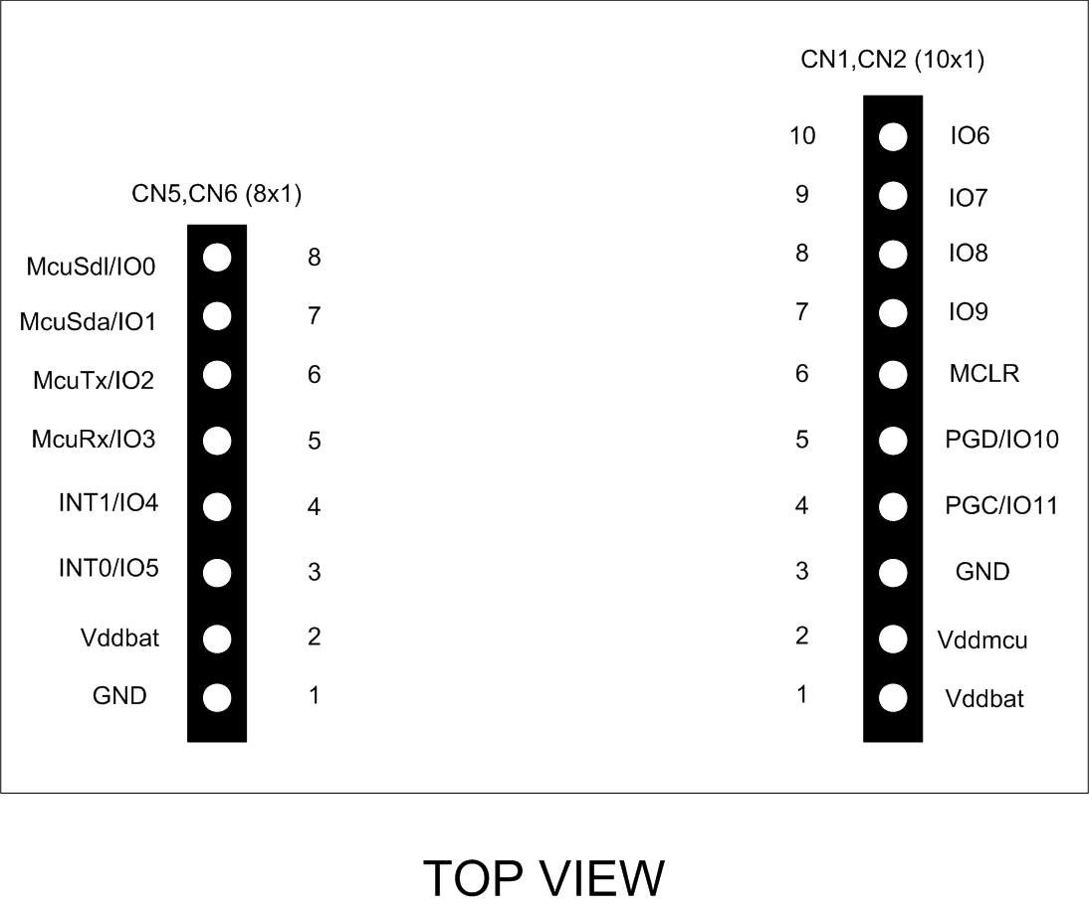

Figure 4 - BB110 Mercury Connector Pinout

# Mercury System Framework

The Mercury System Framework (MSF) is a layered SW framework specifically designed to support application development with Mercury System. It provides to the user a complete set of base functionalities to easily interface MS Slave Boards (SB) and Modem Boards (MB) as well as some infrastructural and system services SW. Figure 5 shows the layered Architecture of MSF.

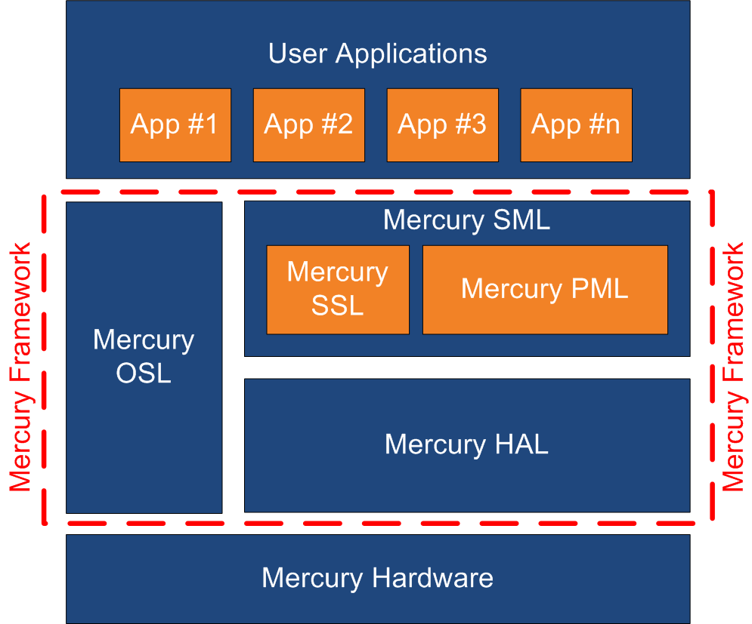

Figure 5 - Mercury System Framework Architecture

The framework is made up by the following components:

**HAL (Hardware Abstraction Layer):** the purpose of this layer is to abstract the HW dependencies to the upper layers.

**SML (System Management Layer):** the purpose of this layer is to provide services for the management of communication buses (I2C, UART) and for the management of Mercury System’s Modem Board (WiFi, BT, GSM/GPRS). It also provides a set of System Services, like System Power Management, RTCC, USB terminal, etc. It’s divided in two main components:

* PML: Peripheral Management Layer,
* SSL: System Services Layer.

**OSL (Operative System Layer):** this layer is made up by a lightweight RTOS that provides basic services to the system, like scheduling tables for the various tasks, Events, SW Timers, Alarms, etc…

Figure 6 provides a symbolic example about the positioning of a user application inside the MSF layered architecture.

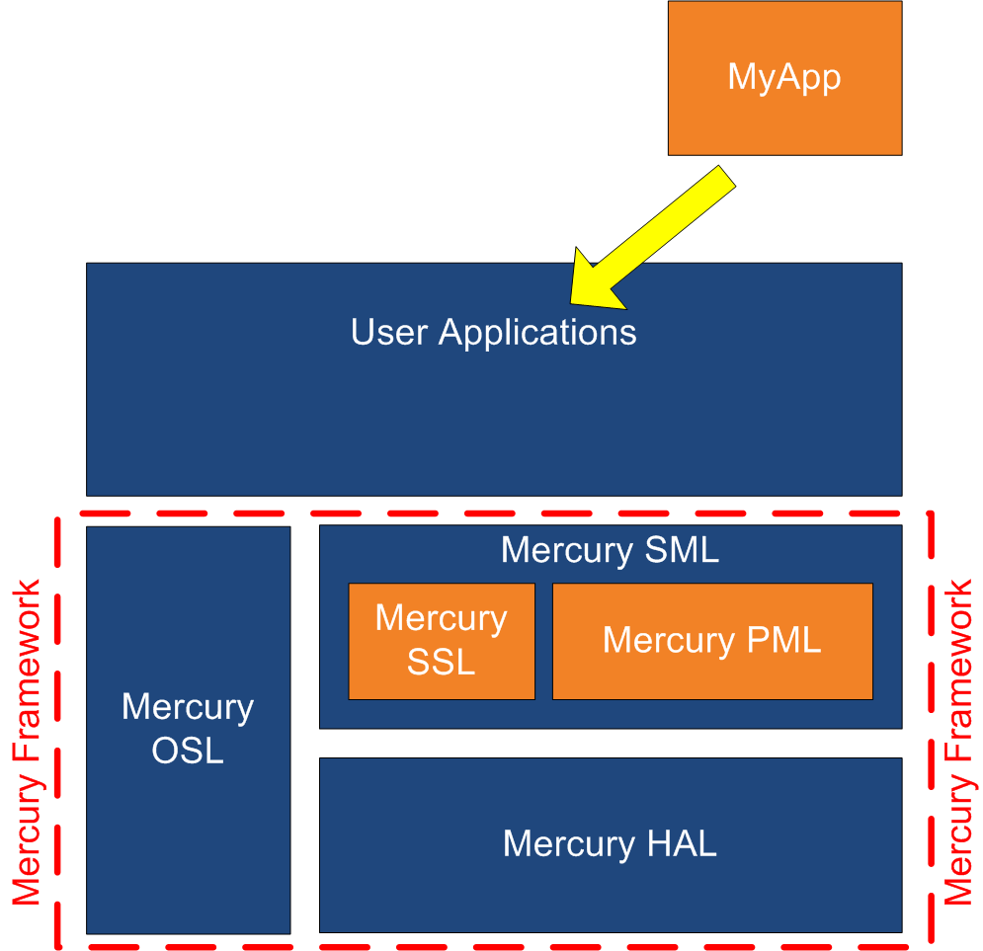

Figure 6 - App development with MSF

# Technical Specifications

Table 5 resumes the board technical specifications:

Table 5 - BB110 Technical Specifications

|  |  |  |  |  |  |
| --- | --- | --- | --- | --- | --- |
| Parameter | Max | Typ | Min | Unit | Notes |
| Supply Voltage | 5.5 | 5 | 4.2 | V |  |
| Current Cons. (Normal) |  | 1 |  | mA |  |
| Current Cons. (Peak) |  | 20 |  | mA |  |
| Current Cons. (Low Power) |  | 100 |  | nA |  |
| Startup Time |  | 100 |  | mS |  |