Mercury System

BL810

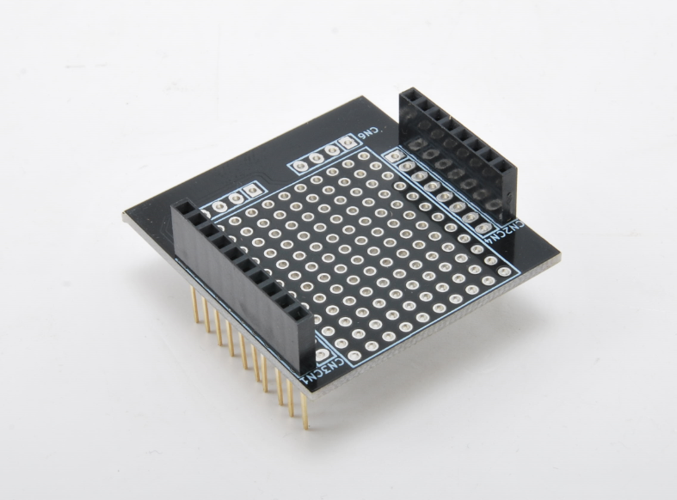

Brainless Proto - Product Datasheet

|  |  |
| --- | --- |
| Author | Francesco Ficili |
| Date | 16/06/2019 |
| Status | Draft |

|  |  |  |  |
| --- | --- | --- | --- |
| Revision History | | | |
| Version | Date | Author | Changes |
| 1.0 | 16/06/2019 | Francesco Ficili | Initial Release. |
|  |  |  |  |
|  |  |  |  |
|  |  |  |  |
|  |  |  |  |
|  |  |  |  |

**SUMMARY**

1. Introduction 4

2. Block Diagram 6

3. Hardware 7

4. Pinouts 8

Mercury Modem Connector Errore. Il segnalibro non è definito.

# Introduction

The Mercury System (MS in short) is a modular system for the development of connectivity and IoT applications. The system uses various type of electronic boards (logic unit, modems, slave board equipped with sensors and actuators, power boards...) and a complete SW framework to allow the realization of complex applications. Scalability, ease of use and modularity are key factors and are granted by the use of a heterogeneous set of components that allow to assemble the system like a construction made with LEGO© bricks.

The board set which composes the system is made up by the following “families”:

* **Base Board (BB):** It’s the “brain” of the system and contains the main logic unit as well as different communication buses and connector to interfaces the slaves. It also contains a simple power supply system and a recharge unit for a single LiPo cell (it can satisfy the power requirements of simpler systems). It can exist in different variants, depending on the employed microcontroller unit.
* **Modem Board (MB):** this one is the board that allow network connectivity. It can exist in different variant, depending on the network interface (GSM/GPRS, Wi-Fi, BT, Radio…). It’s interfaced to the Base Board with a dedicated serial line.
* **Power Board (PB):** it’s the board that allow to satisfy the particular power requirement of the system, when it’s necessary. They can be vary depending on the particular power requirement to satisfy (high power, solar harvesting, piezo harvesting, etc.).
* **Slave Board (SB):** these are the system’s peripherals, and they vary depending on the specific mounted sensor or actuator. Typical examples are SB with relay, temperature sensors, RGB LED controller, servo controller, accelerometer, etc. They communicate with the BB with I2C or UART and a dedicated command set.
* **Expansion Board (EB):** these are the board that allow planar connection of Mercury boards. There are variants which can contains Displays, battery socket, etc.
* **Brain-Less Board (BL):** these are the controller-less boards. They in general contain really simple sensor or actuators that don’t need the bus interface. There are meant as an alternative to slave boards for cost-sensitive applications.

Slave Boards and Modem Board are provided pre-programmed with a FW which implements a dedicated command set for a high-level management of the boards, while the Base Boards are provided with a SW framework which provides all the low-level services (operative system, device drivers, system services, etc.), leaving to the user only the development of application level logic. Moreover, the Base Board comes with an USB bootloader, so it can be programmed without the need of a flashing device.

Figure 1 shows a typical system connection:

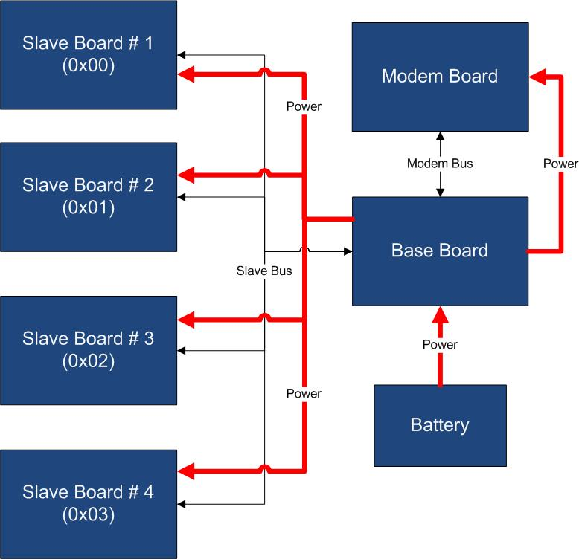

Figure 1 - Typical System Connection

Examples of application fields of MS are:

* Home automation System,
* IoT applications,
* Connectivity Applications,
* Monitoring and control Systems,
* Remote Control,
* Industrial Process control,
* Robotics applications,
* Test benches,
* Etc…

# Block Diagram

The BL810 is a prototype Brainless Board, able to provide prototyping platform for the addition of generic slave functionalities to a MS Base Board (BB). Figure 2 shows the BL810 block diagram.

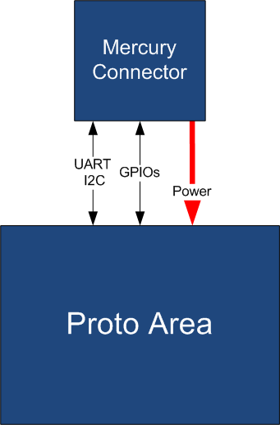

Figure 2 - Block Diagram

The BL810 is connected to the BB by means of the standard Mercury Connector. Table 1 resumes the BL810 board main characteristics:

Table 1 – Board Characteristics

|  |  |  |
| --- | --- | --- |
| Parameter | Description | Notes |
| Board Type | Brainless Board (BL) |  |
| Supported Bus | UART, I2C |  |
| Peripheral Description | Proto Area |  |

# Hardware

This section goes deeper in the HW details of BL810. Figure 3 depicts the most important components of the board:

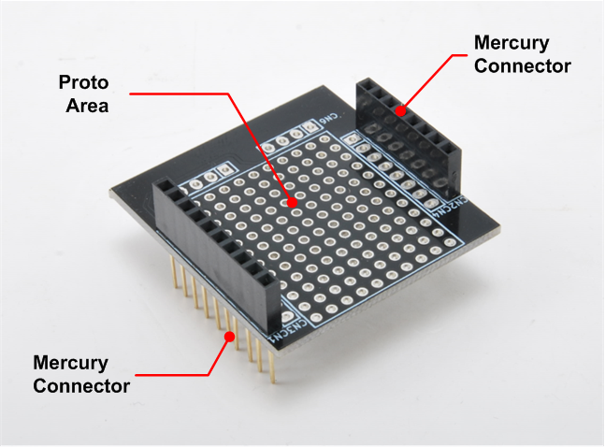

Figure 3 - Hardware Highlight

Table 2 provides a description of board’s main components:

Table 2 – Hardware characteristics

|  |  |
| --- | --- |
| Name | Description |
| Proto Area | BL810 prototyping area. |
| Mercury Standard Connector | Mercury connector used to interface the board with Mercury System’s Base Board. |

# Pinouts

This section highlights the pinouts of BL810 connector.

## Mercury Connector

The Mercury Connector is the connector which interfaces the BL810 with the rest of Mercury System. The connector’s pinout is depicted in Figure 4.

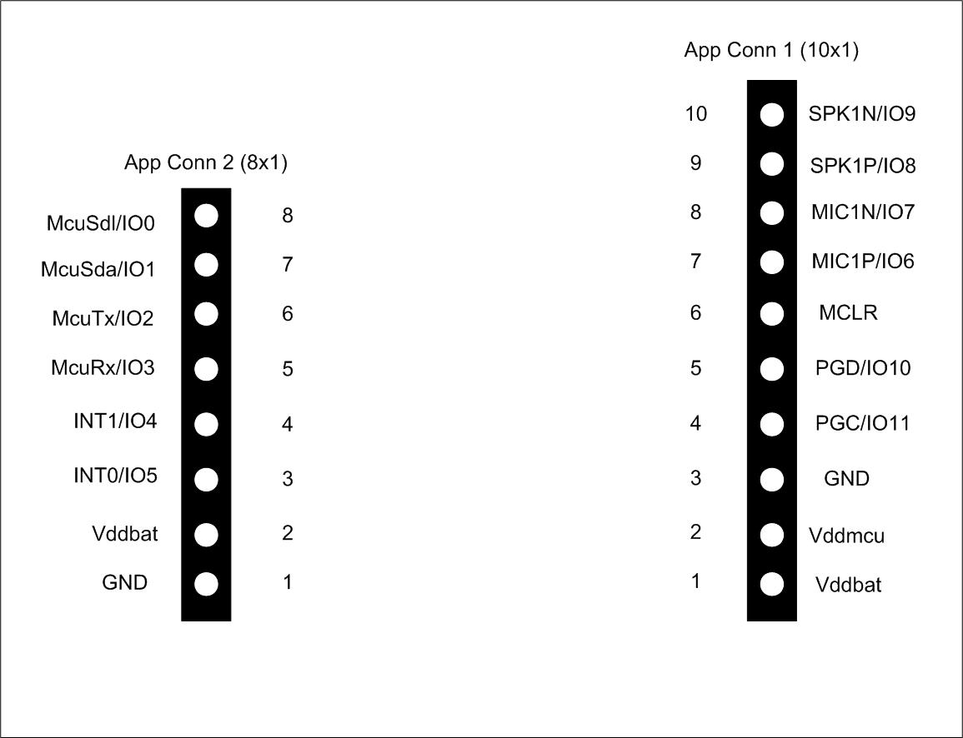

Figure 4 - Mercury Connector Pinout