Mercury System

EB111

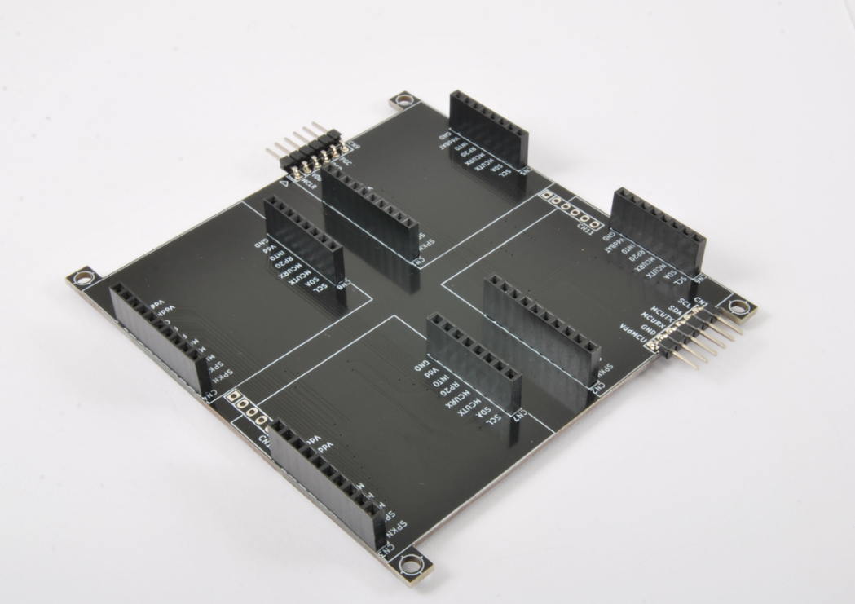

Expansion Board Quad - Product Datasheet

|  |  |
| --- | --- |
| Author | Francesco Ficili |
| Date | 01/11/2018 |
| Status | Released |

|  |  |  |  |
| --- | --- | --- | --- |
| Revision History | | | |
| Version | Date | Author | Changes |
| 1.0 | 01/11/2018 | Francesco Ficili | Initial Release. |
|  |  |  |  |
|  |  |  |  |
|  |  |  |  |
|  |  |  |  |
|  |  |  |  |

**SUMMARY**

1. Introduction 4

2. Block Diagram 6

3. Hardware 7

4. Pinouts 8

Mercury Connector 8

BB Programmer Connector 9

Communication Connector 10

Expansion Connector 11

# Introduction

The Mercury System (MS in short) is a modular system for the development of connectivity and IoT applications. The system uses various type of electronic boards (logic unit, modems, slave board equipped with sensors and actuators, power boards...) and a complete SW framework to allow the realization of complex applications. Scalability, ease of use and modularity are key factors and are granted by the use of a heterogeneous set of components that allow to assemble the system like a construction made with LEGO© bricks.

The board set which composes the system is made up by the following “families”:

* **Base Board (BB):** It’s the “brain” of the system and contains the main logic unit as well as different communication buses and connector to interfaces the slaves. It also contains a simple power supply system and a recharge unit for a single LiPo cell (it can satisfy the power requirements of simpler systems). It can exist in different variants, depending on the employed microcontroller unit.
* **Modem Board (MB):** this one is the board that allow network connectivity. It can exist in different variant, depending on the network interface (GSM/GPRS, Wi-Fi, BT, Radio…). It’s interfaced to the Base Board with a dedicated serial line.
* **Power Board (PB):** it’s the board that allow to satisfy the particular power requirement of the system, when it’s necessary. They can be vary depending on the particular power requirement to satisfy (high power, solar harvesting, piezo harvesting, etc.).
* **Slave Board (SB):** these are the system’s peripherals, and they vary depending on the specific mounted sensor or actuator. Typical examples are SB with relay, temperature sensors, RGB LED controller, servo controller, accelerometer, etc. They communicate with the BB with I2C or UART and a dedicated command set.
* **Expansion Board (EB):** these are the board that allow planar connection of Mercury boards. There are variants which can contains Displays, battery socket, etc.
* **Brain-Less Board (BL):** these are the controller-less boards. They in general contain really simple sensor or actuators that don’t need the bus interface. There are meant as an alternative to slave boards for cost-sensitive applications.

Slave Boards and Modem Board are provided pre-programmed with a FW which implements a dedicated command set for a high-level management of the boards, while the Base Boards are provided with a SW framework which provides all the low-level services (operative system, device drivers, system services, etc.), leaving to the user only the development of application level logic. Moreover, the Base Board comes with an USB bootloader, so it can be programmed without the need of a flashing device.

Figure 1 shows a typical system connection:

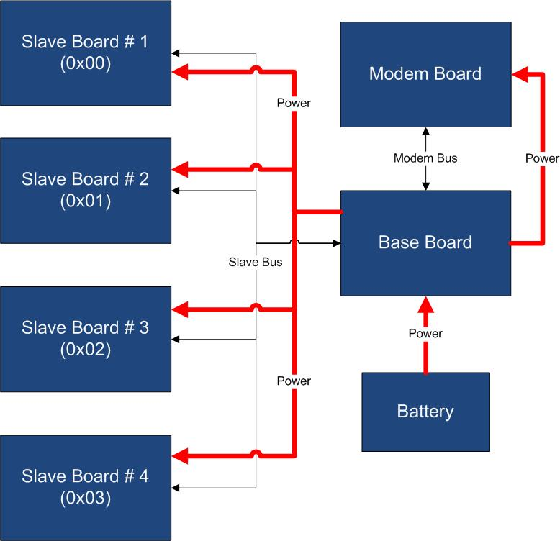

Figure 1 - Typical System Connection

Examples of application fields of MS are:

* Home automation System,
* IoT applications,
* Connectivity Applications,
* Monitoring and control Systems,
* Remote Control,
* Industrial Process control,
* Robotics applications,
* Test benches,
* Etc…

# Block Diagram

The EB111 is a Mercury System expansion board with two Mercury System Sockets. The board allows to connect Mercury System BB with SBs, PBs and BLs in planar configuration. Figure 2 shows the EB111 block diagram.

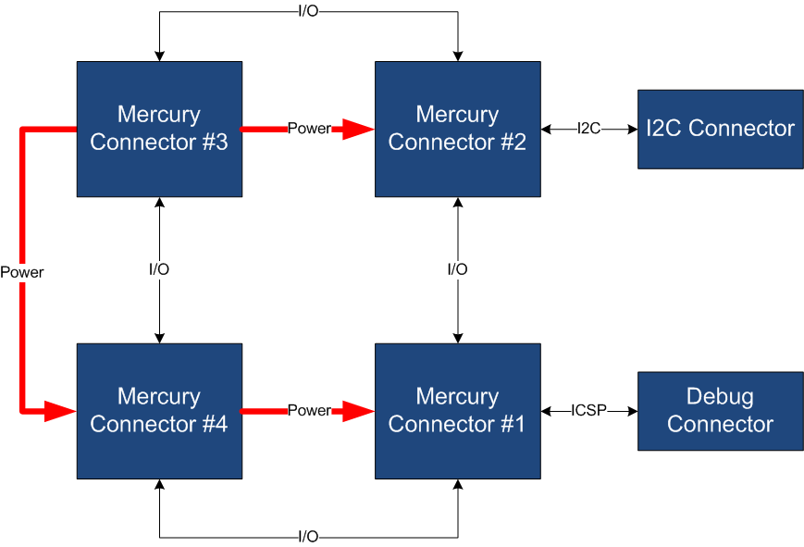

Figure 2 - Block Diagram

Table 1 resumes the EB111 board main characteristics:

Table 1 – Board Characteristics

|  |  |  |
| --- | --- | --- |
| Parameter | Description | Notes |
| Board Type | Expansion Board (EB) |  |
| Supported Bus | I2C, UART |  |
| # Mercury Connectors | 4 |  |

# Hardware

This section goes deeper in the HW details of EB111. Figure 3 depicts the most important components of the board:

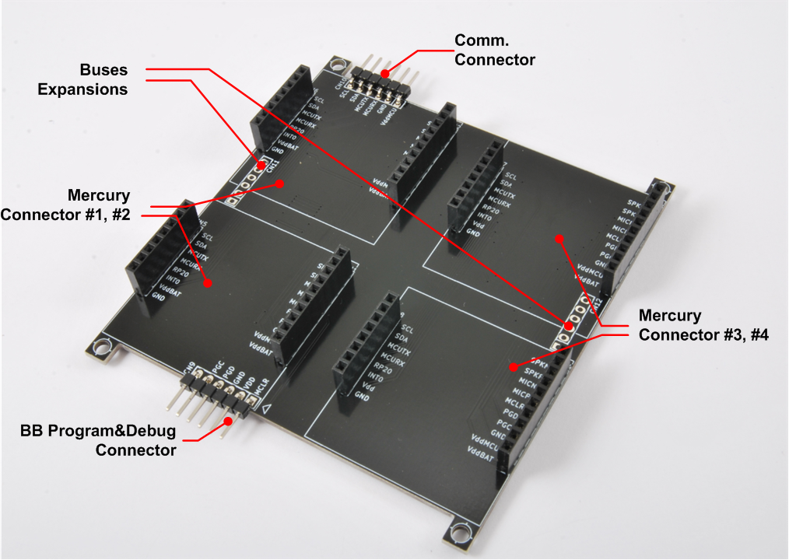

Figure 3 – Hardware Highlight

Table 2 provides a description of board’s main components:

Table 2 – Hardware characteristics

|  |  |
| --- | --- |
| Name | Description |
| Mercury Connectors #1 #2 #3 and #4 | Mercury connector used to interface the board with the others MS boards. |
| BB Program&Debug Connector | PicKit 3 Microchip Programmer/debugger connector. It is directly connected to the BB (Base Board) MCU debug port, in order to allow advanced debugging and programming features, if needed. |
| Buses Expansion | Expansions connectors that carry power as well as I2C and UART connection. |
| Comm. Connector | Connector containing I2C and UART communication buses (for communication expansion). |

# Pinouts

This section highlights the pinouts of EB111 connectors.

## Mercury Connector

The Mercury Connector is the connector which allows the interconnection of the various Mercury System Boards. The connector’s pinout is depicted in Figure 4 and Table 3 explains the meaning of each single pin (NC stands for “Not Connected”).

Table 3 - Mercury Connector Pinout

|  |  |  |
| --- | --- | --- |
| Pin Name | Pin Number | Description |
| VddBat | CN1,2,3,4 – 1 | This pin is connected to the main power source. |
| VddMcu | CN1,2,3,4 – 2 | This pin is connected to MCU regulated positive voltage reference (3,3V). |
| GND | CN1,2,3,4 – 3 | This pin is connected to the board reference voltage. |
| IO11/PGC | CN1,2,3,4 – 4 | This pin is connected to BB PGC (Program Clock) line, for advanced debugging features, and can be alternatively be used as generic IO (IO11). |
| IO10/PGD | CN1,2,3,4 – 5 | This pin is connected to BB PGD (Program Data) line, for advanced debugging features, and can be alternatively be used as generic IO (IO10). |
| MCLR | CN1,2,3,4 – 6 | This pin is connected to BB MCLR (Reset) line. |
| IO9 | CN1,2,3,4 – 7 | This pin is connected to BB generic IO6 line. |
| IO8 | CN1,2,3,4 – 8 | This pin is connected to BB generic IO7 line. |
| IO7 | CN1,2,3,4 – 9 | This pin is connected to BB generic IO8 line. |
| IO6 | CN1,2,3,4 – 10 | This pin is connected to BB generic IO9 line. |
| GND | CN5,6,7,8 – 1 | This pin is connected to the board reference voltage. |
| VddBat | CN5,6,7,8 – 2 | This pin is connected to the main power source. |
| IO5/INT0 | CN5,6,7,8 – 3 | This pin is connected to BB INT0 line and can be alternatively be used as generic IO (IO5). |
| IO4/INT1 | CN5,6,7,8 – 4 | This pin is connected to BB INT1 line and can be alternatively be used as generic IO (IO4). |
| McuRx/IO3 | CN5,6,7,8 – 5 | This pin is connected to BB UART Rx line and can be alternatively be used as generic IO (IO3). |
| McuTx/IO2 | CN5,6,7,8 – 6 | This pin is connected to BB UART Tx line and can be alternatively be used as generic IO (IO2). |
| SDA/IO1 | CN5,6,7,8 – 7 | This pin is connected to BB I2C SDA line (Data Line) and can be alternatively be used as generic IO (IO1). |
| SCL/IO0 | CN5,6,7,8 – 8 | This pin is connected to BB I2C SCL line (Clock Line) and can be alternatively be used as generic IO (IO0). |

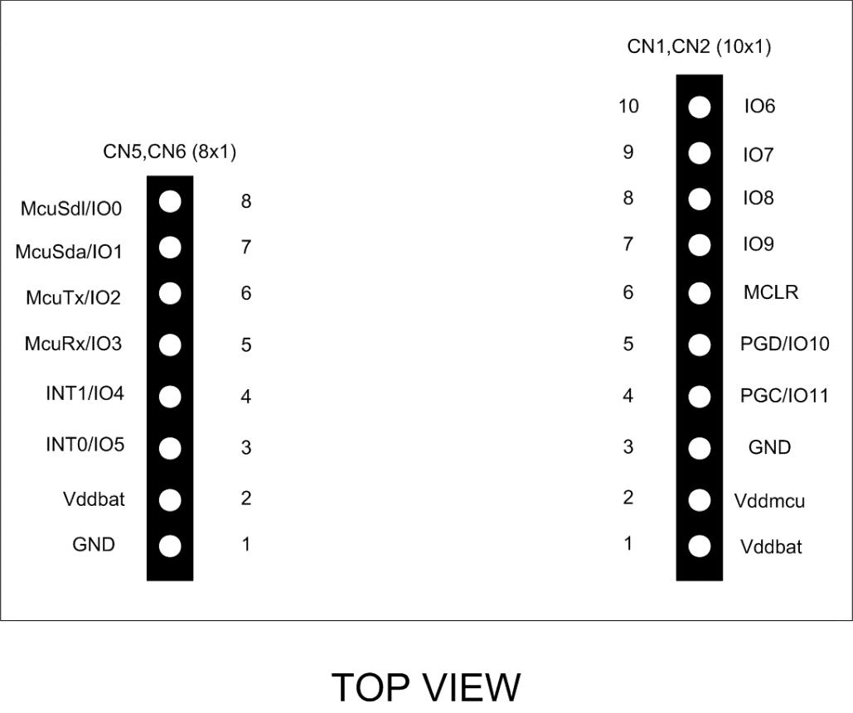

Figure 4 - Mercury Connector Pinout

## BB Programmer Connector

The BB Programmer Connector is the connector which allows to re-program the BB (Base Board) using Microchip Technology ICSP (In-Circuit Serial Programming) interface. The connector’s pinout is depicted in Figure 5 and Table 4 explains the meaning of each single pin (NC stands for “Not Connected”).

Table 4 – BB Programmer Connector Pinout

|  |  |  |
| --- | --- | --- |
| Pin Name | Pin Number | Description |
| MCLR | CN9 – 1 | Microcontroller Master Clear (RESET) pin. |
| Vdd | CN9 – 2 | Positive power supply reference. |
| GND | CN9 – 3 | Negative power supply reference. |
| PGD | CN9 – 4 | Program Data pin. |
| PGC | CN9 – 5 | Program Clock pin. |

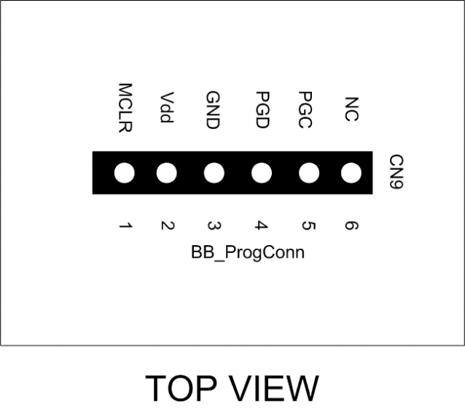

Figure 5 - BB Programmer Connector Pinout

## Communication Connector

The Communcation Connector allow the connection of the communication buses (UART and I2C) to other boards. The connector’s pinout is depicted in Figure 6 and Table 5 explains the meaning of each single pin (NC stands for “Not Connected”).

Table 5 – Comm Connector Pinout

|  |  |  |
| --- | --- | --- |
| Pin Name | Pin Number | Description |
| VddMcu | CN10 – 1 | This pin is connected to MCU regulated positive voltage reference (3,3V). |
| GND | CN10 – 2 | Negative power supply reference. |
| McuTx | CN10 – 3 | BB UART Tx Line. |
| McuRx | CN10 – 4 | BB UART Rx Line. |
| McuSDA | CN10 – 5 | BB I2C SDA Line. |
| McuSDL | CN10 – 6 | BB I2C SCL Line. |

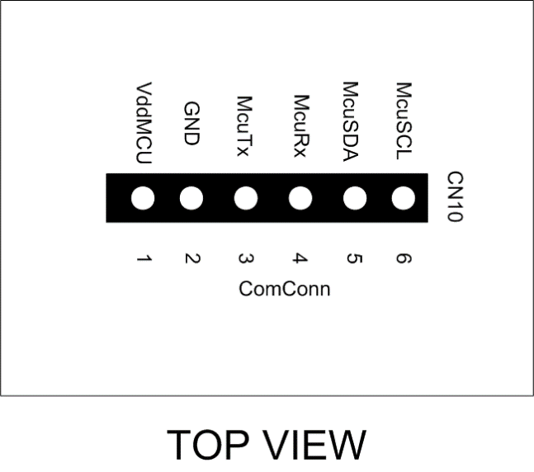

Figure 6 - Comm Connector Pinout

## Expansion Connector

The Expansion Connector allow to connect the EB111 with another Expansion Board. The connector’s pinout is depicted in Figure 7 and Table 6 explains the meaning of each single pin (NC stands for “Not Connected”).

Table 6 – Expansion Connector Pinout

|  |  |  |
| --- | --- | --- |
| Pin Name | Pin Number | Description |
| VddMcu | CN11,12 – 1 | This pin is connected to MCU regulated positive voltage reference (3,3V). |
| GND | CN11,12 – 2 | Negative power supply reference. |
| VddBat | CN11,12 – 3 | This pin is connected to the main power source. |
| INT0 | CN11,12 – 4 | BB INT0 Line. |
| McuSDA | CN11,12 – 5 | BB I2C SDA Line. |
| McuSDL | CN11,12 – 6 | BB I2C SCL Line. |

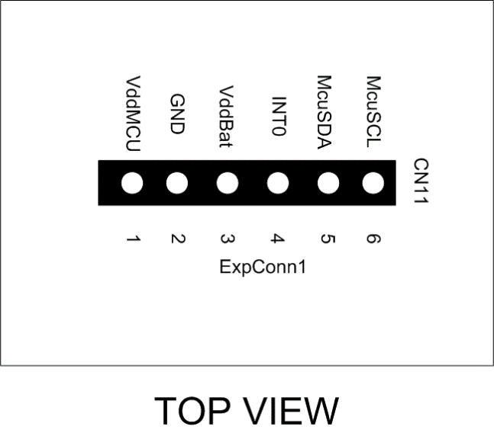

Figure 7 - Expansion Connector Pinout