Mercury System

MB810

[IMAGE]

Proto Modem Board - Product Datasheet

|  |  |
| --- | --- |
| Author | Francesco Ficili |
| Date | 10/07/2018 |
| Status | Draft |

|  |  |  |  |
| --- | --- | --- | --- |
| Revision History | | | |
| Version | Date | Author | Changes |
| 1.0 | 10/07/2018 | Francesco Ficili | Initial Release. |
|  |  |  |  |
|  |  |  |  |
|  |  |  |  |
|  |  |  |  |
|  |  |  |  |

**SUMMARY**

1. Introduction 4

2. Block Diagram 6

3. Hardware 7

4. Pinouts 8

Mercury Modem Connector 8

# Introduction

The Mercury System (MS in short) is a modular system for the development of connectivity and IoT applications. The system uses various type of electronic boards (logic unit, modems, slave board equipped with sensors and actuators, power boards...) and a complete SW framework to allow the realization of complex applications. Scalability, ease of use and modularity are key factors and are granted by the use of a heterogeneous set of components that allow to assemble the system like a construction made with LEGO© bricks.

The board set which composes the system is made up by the following “families”:

* **Base Board (BB):** It’s the “brain” of the system and contains the main logic unit as well as different communication buses and connector to interfaces the slaves. It also contains a simple power supply system and a recharge unit for a single LiPo cell (it can satisfy the power requirements of simpler systems). It can exist in different variants, depending on the employed microcontroller unit.
* **Modem Board (MB):** this one is the board that allow network connectivity. It can exist in different variant, depending on the network interface (GSM/GPRS, Wi-Fi, BT, Radio…). It’s interfaced to the Base Board with a dedicated serial line.
* **Power Board (PB):** it’s the board that allow to satisfy the particular power requirement of the system, when it’s necessary. They can be vary depending on the particular power requirement to satisfy (high power, solar harvesting, piezo harvesting, etc.).
* **Slave Board (SB):** these are the system’s peripherals, and they vary depending on the specific mounted sensor or actuator. Typical examples are SB with relay, temperature sensors, RGB LED controller, servo controller, accelerometer, etc. They communicate with the BB with I2C or UART and a dedicated command set.
* **Expansion Board (EB):** these are the board that allow planar connection of Mercury boards. There are variants which can contains Displays, battery socket, etc.
* **Brain-Less Board (BL):** these are the controller-less boards. They in general contain really simple sensor or actuators that don’t need the bus interface. There are meant as an alternative to slave boards for cost-sensitive applications.

Slave Boards and Modem Board are provided pre-programmed with a FW which implements a dedicated command set for a high-level management of the boards, while the Base Boards are provided with a SW framework which provides all the low-level services (operative system, device drivers, system services, etc.), leaving to the user only the development of application level logic. Moreover, the Base Board comes with an USB bootloader, so it can be programmed without the need of a flashing device.

Figure 1 shows a typical system connection:

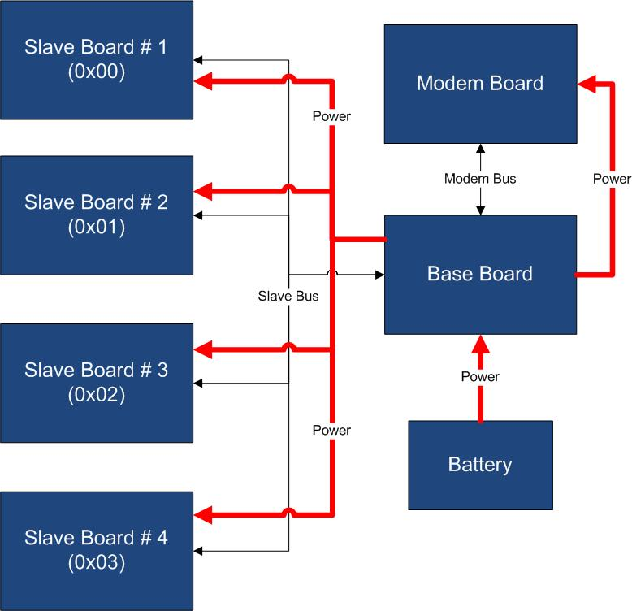

Figure 1 - Typical System Connection

Examples of application fields of MS are:

* Home automation System,
* IoT applications,
* Connectivity Applications,
* Monitoring and control Systems,
* Remote Control,
* Industrial Process control,
* Robotics applications,
* Test benches,
* Etc…

# Block Diagram

The MB810 is a prototype Modem Board, able to provide prototyping platform for the addition of generic modem functionalities to a MS Base Board (BB). Figure 2 shows the MB810 block diagram.

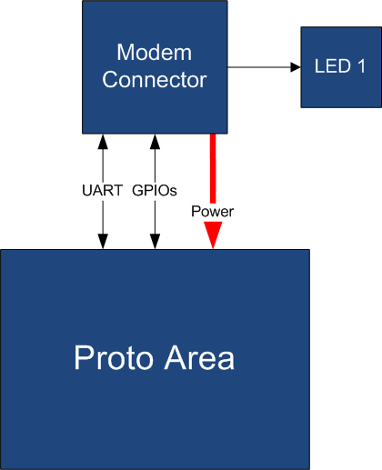

Figure 2 - Block Diagram

The MB810 is connected to the BB by means of an UART link plus other GPIO lines, so the connection between the BB and the MB is dedicated and no address is required. Table 2 resumes the MB810 board main characteristics:

Table 2 – Board Characteristics

|  |  |  |
| --- | --- | --- |
| Parameter | Description | Notes |
| Board Type | Modem Board (MB) |  |
| Supported Bus | UART |  |
| Peripheral Description | Proto Area |  |

# Hardware

This section goes deeper in the HW details of MB810. Figure 3 depicts the most important components of the board:

[IMAGE]

Figure 3 - Hardware Highlight

Table 3 provides a description of board’s main components:

Table 3 – Hardware characteristics

|  |  |
| --- | --- |
| Name | Description |
| User LED | This LED indicates the pairing status of the MB. |
| Proto Area | MB810 prototyping area. |
| Mercury Modem Connector | Mercury connector used to interface the board with Mercury System’s Base Board. |

# Pinouts

This section highlights the pinouts of MB810 connector.

## Mercury Modem Connector

The Mercury Modem Connector is the connector which interfaces the MB810 with the Mercury System’s Base Board. The connector’s pinout is depicted in Figure 4 and Table 4 explains the meaning of each single pin (NC stands for “Not Connected”).

Table 4 – Mercury Connector Pinout

|  |  |  |
| --- | --- | --- |
| Pin Name | Pin Number | Description |
| VddMcu | 10 | This pin is connected to Module positive voltage (3,3V). |
| GND | 18,20 | This pin is connected to the board reference voltage. |
| VddBat | 17,19 | This pin is connected to Module battery voltage. |
| MdmRst | 16 | This pin is connected to Modem Reset line. |
| MdmTx | 12 | This pin is connected to Modem UART Tx line. |
| MdmRx | 14 | This pin is connected to Modem UART Rx line. |
| MdmRi | 8 | This pin is connected to Modem Ri Line. |
| MdmOn | 1 | This pin is connected to Modem On Line. |

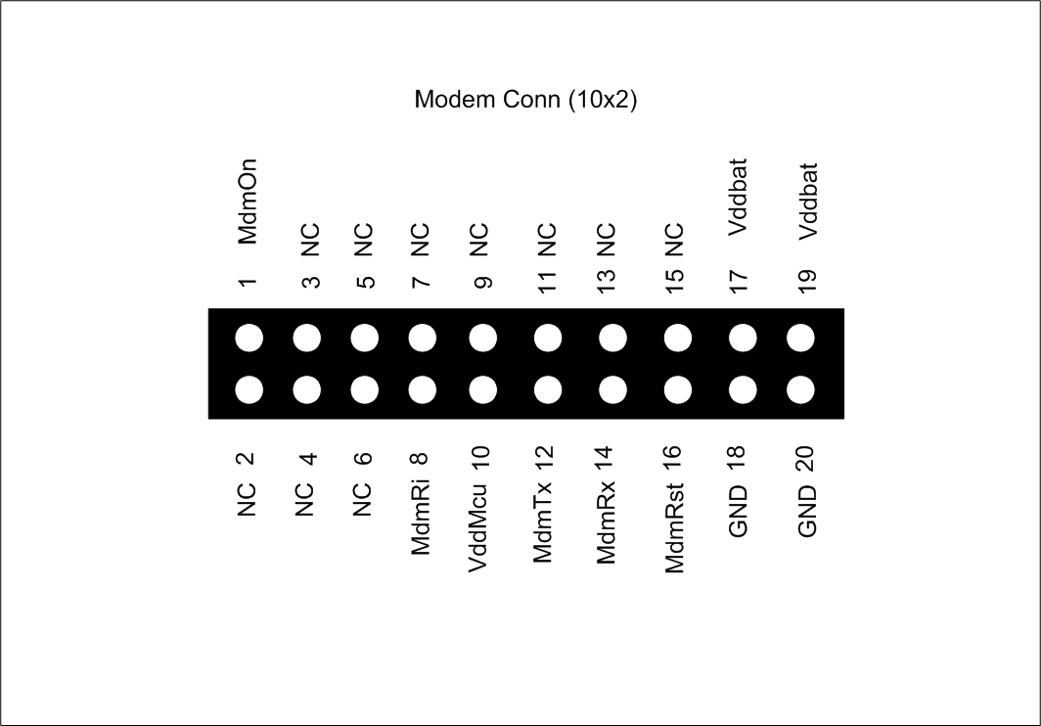

Figure 4 – MB810 Mercury Modem Connector Pinout