Mercury System

SB310

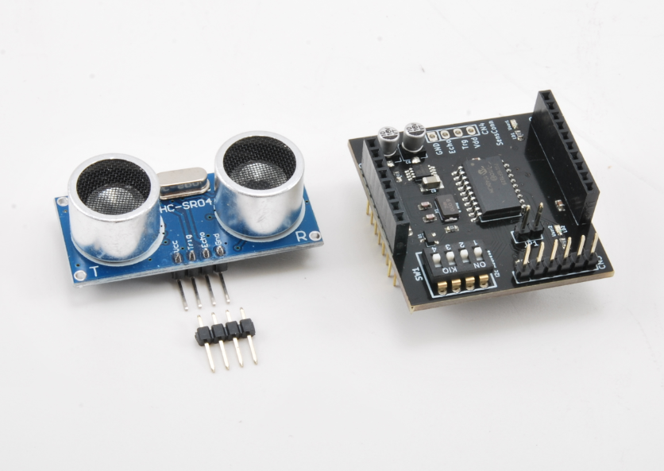

Ultrasonic Board - Product Datasheet

|  |  |
| --- | --- |
| Author | Francesco Ficili |
| Date | 20/05/2018 |
| Status | Released |

|  |  |  |  |
| --- | --- | --- | --- |
| Revision History | | | |
| Version | Date | Author | Changes |
| 1.0 | 20/05/2018 | Francesco Ficili | Initial Release. |
|  |  |  |  |
|  |  |  |  |
|  |  |  |  |
|  |  |  |  |
|  |  |  |  |

**SUMMARY**

1. Introduction 4

2. Block Diagram 6

3. Hardware 8

4. Pinouts 9

Mercury Connector 9

Programmer Connector 10

5. Command Set 11

Specific Command Set 11

Examples 11

6. Technical Specifications 12

# Introduction

The Mercury System (MS in short) is a modular system for the development of connectivity and IoT applications. The system uses various type of electronic boards (logic unit, modems, slave board equipped with sensors and actuators, power boards...) and a complete SW framework to allow the realization of complex applications. Scalability, ease of use and modularity are key factors and are granted by the use of a heterogeneous set of components that allow to assemble the system like a construction made with LEGO© bricks.

The board set which composes the system is made up by the following “families”:

* **Base Board (BB):** It’s the “brain” of the system and contains the main logic unit as well as different communication buses and connector to interfaces the slaves. It also contains a simple power supply system and a recharge unit for a single LiPo cell (it can satisfy the power requirements of simpler systems). It can exist in different variants, depending on the employed microcontroller unit.
* **Modem Board (MB):** this one is the board that allow network connectivity. It can exist in different variant, depending on the network interface (GSM/GPRS, Wi-Fi, BT, Radio…). It’s interfaced to the Base Board with a dedicated serial line.
* **Power Board (PB):** it’s the board that allow to satisfy the particular power requirement of the system, when it’s necessary. They can be vary depending on the particular power requirement to satisfy (high power, solar harvesting, piezo harvesting, etc.).
* **Slave Board (SB):** these are the system’s peripherals, and they vary depending on the specific mounted sensor or actuator. Typical examples are SB with relay, temperature sensors, RGB LED controller, servo controller, accelerometer, etc. They communicate with the BB with I2C or UART and a dedicated command set.
* **Expansion Board (EB):** these are the board that allow planar connection of Mercury boards. There are variants which can contains Displays, battery socket, etc.
* **Brain-Less Board (BL):** these are the controller-less boards. They in general contain really simple sensor or actuators that don’t need the bus interface. There are meant as an alternative to slave boards for cost-sensitive applications.

Slave Boards and Modem Board are provided pre-programmed with a FW which implements a dedicated command set for a high-level management of the boards, while the Base Boards are provided with a SW framework which provides all the low-level services (operative system, device drivers, system services, etc.), leaving to the user only the development of application level logic. Moreover, the Base Board comes with an USB bootloader, so it can be programmed without the need of a flashing device.

Figure 1 shows a typical system connection:

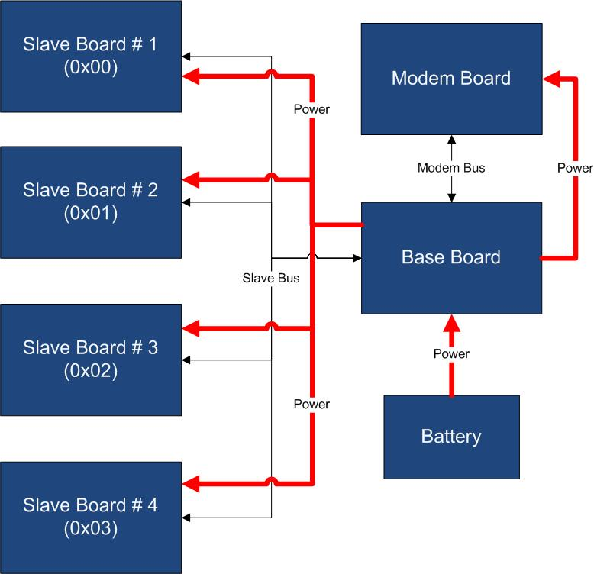

Figure 1 - Typical System Connection

Examples of application fields of MS are:

* Home automation System,
* IoT applications,
* Connectivity Applications,
* Monitoring and control Systems,
* Remote Control,
* Industrial Process control,
* Robotics applications,
* Test benches,
* Etc…

# Block Diagram

The SB310 is an Ultrasonic Sensor Board, able to interface an HC-SR04 ultrasonic range finder. Figure 2 shows the SB310 block diagram. The heart of the system is a PIC16F1829 8-bit RISC microcontroller, produced by Microchip Technology Inc.

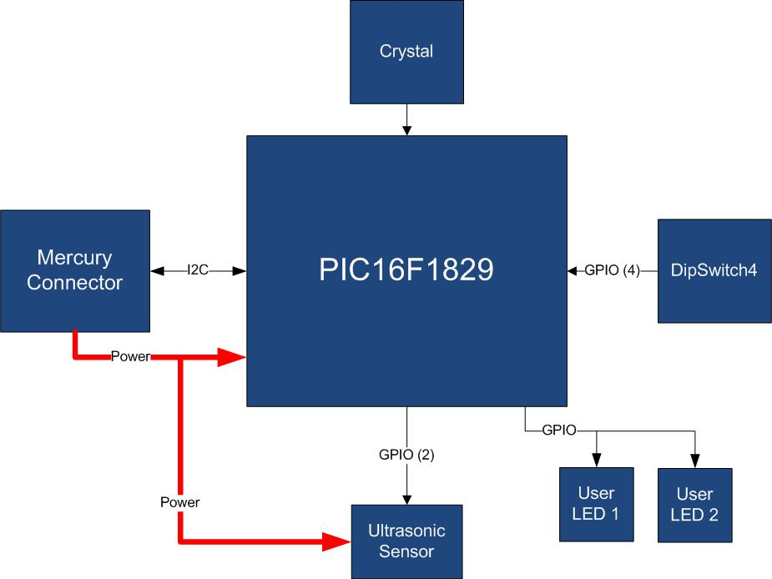

Figure 2 - Block Diagram

The main characteristics of the employed MCU are resumed in Table 1:

Table 1 - MCU characteristics

|  |  |
| --- | --- |
| Parameter Name | Description |
| Program Memory Type | Flash |
| Program Memory (KB) | 14 |
| CPU Speed (MIPS) | 8 |
| RAM Bytes | 1,024 |
| Data EEPROM (bytes) | 256 |
| Digital Communication Peripherals | 1-UART, 1-A/E/USART, 1-SPI, 1-I2C1-MSSP(SPI/I2C) |
| Capture/Compare/PWM Peripherals | 2 CCP, 2 ECCP |
| Timers | 4 x 8-bit, 1 x 16-bit |
| ADC | 12 ch, 10-bit |
| Comparators | 2 |
| Temperature Range (C) | -40 to 125 |
| Operating Voltage Range (V) | 1.8 to 5.5 |
| Pin Count | 20 |
| XLP | Yes |

The SB310 is connected to a Mercury System Base Board by means of I2C bus. The address of the board could be dynamically set by means of a 4 positions dip switch, allowing up to 15 address values (address 0x00 is reserved for I2C general call broadcast addressing scheme). The ultrasonic sensor is able to detect distances in the range 2-450 cm.

Table 2 resumes the SB310 board main characteristics:

Table 2 – Board Characteristics

|  |  |  |
| --- | --- | --- |
| Parameter | Description | Notes |
| Board Type | Slave Board (SB) |  |
| Supported Bus | I2C |  |
| Addressing | Dip Switch 4 |  |
| Peripheral Description | Ultrasonic Sensor Input |  |

# Hardware

This section goes deeper in the HW details of SB310. Figure 3 depicts the most important components of the board:

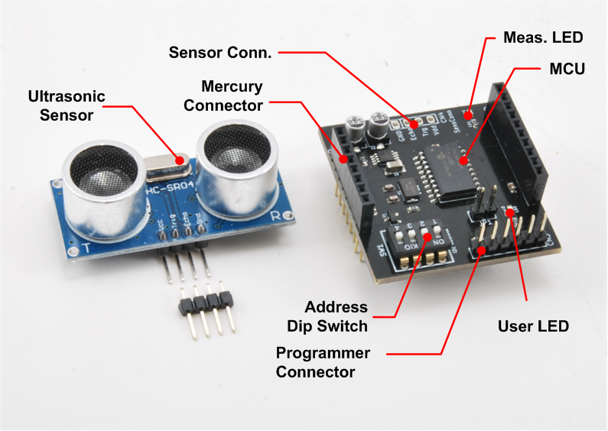

Figure 3 – SB310 Hardware Highlight

Table 3 provides a description of board’s main components:

Table 3 – Hardware characteristics

|  |  |
| --- | --- |
| Parameter Name | Description |
| User LED | Board User LED, by default it’s configured as heartbeat LED (periodic pulses). |
| Ultrasonic Sensor | HC-SR04 ultrasonic range finder. |
| Mercury Connector | Mercury connector used to interface the board with the others MS boards. |
| Address Dip Switch | Dip Switch to set the address of the board within the Mercury System. |
| MCU | PIC16F1829 main controller board. |
| Programmer Connector | PicKit 3 Microchip Programmer/debugger connector. It is directly connected to the MCU debug port, in order to allow advanced debugging and programming features, if needed. |
| Sensor Connector | Connector of the Ultrasonic Sensor. |
| Measure LED | LED that indicates the execution of a range measurement. |

# Pinouts

This section highlights the pinouts of SB310 connectors.

## Mercury Connector

The Mercury Connector is the connector which interfaces the SB310 with the rest of Mercury System. The connector’s pinout is depicted in Figure 4 and Table 4 explains the meaning of each single pin (NC stands for “Not Connected”).

Table 4 - Mercury Connector Pinout

|  |  |  |
| --- | --- | --- |
| Pin Name | Pin Number | Description |
| VddBat | CN1 – 1  CN2 – 2 | This pin is connected to the main power source. |
| VddMcu | CN1 – 2 | This pin is connected to MCU regulated positive voltage reference (3,3V). |
| GND | CN1 – 3  CN2 – 1 | This pin is connected to the board reference voltage. |
| INT0 | CN2 – 3 | Interrupt INT0 pin. |
| SDA | CN2 – 7 | This pin is connected to I2C SDA line (Data Line). |
| SCL | CN2 – 8 | This pin is connected to I2C SCL line (Clock Line). |

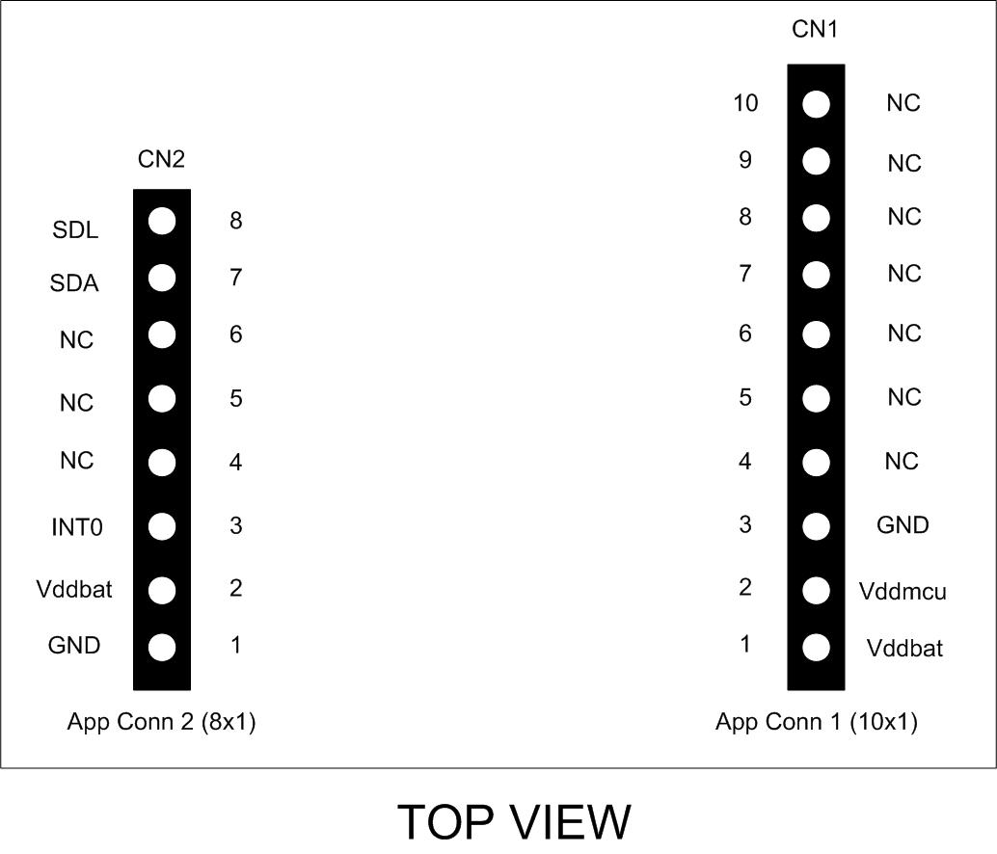

Figure 4 - Mercury Connector Pinout

## Programmer Connector

The Programmer Connector is the connector which allows to re-program the SB310 using Microchip Technology ICSP (In-Circuit Serial Programming) interface. The connector’s pinout is depicted in Figure 5 and Table 5 explains the meaning of each single pin (NC stands for “Not Connected”).

Table 5 - Programmer Connector Pinout

|  |  |  |
| --- | --- | --- |
| Pin Name | Pin Number | Description |
| MCLR | CN3 – 1 | Microcontroller Master Clear (RESET) pin. |
| Vdd | CN3 – 2 | Positive power supply reference. |
| GND | CN3 – 3 | Power ground. |
| PGD | CN3 – 4 | Program Data pin. |
| PGC | CN3 – 5 | Program Clock pin. |

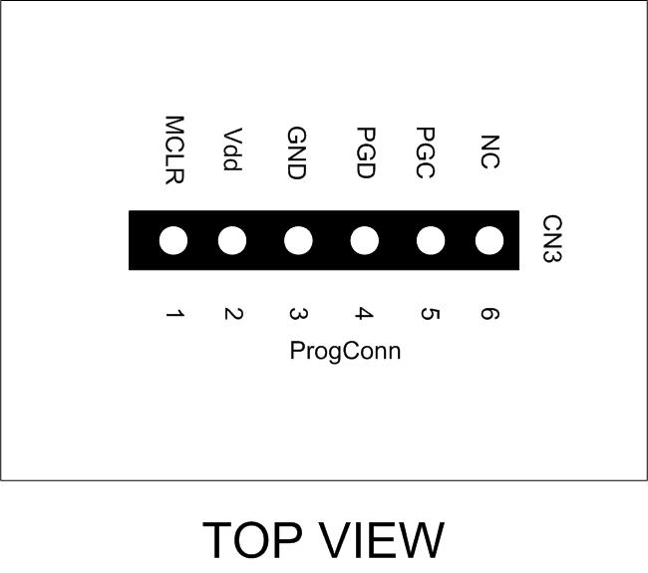

Figure 5 - Programmer Connector Pinout

# Command Set

## Specific Command Set

The SB310 board supports both the MS Generic Command Set (see document MS_GenericCommandSet) and a set of specific commands (also called Specific Command Set).

Table 6 lists the SB310 Specific Command Set:

Table 6 - Command Set

|  |  |  |  |
| --- | --- | --- | --- |
| Code | Cmd Name | Parameters | Description |
| 0x50 | Trigger Measure | None | Trigger the execution of a distance measurement, if the automeasure option is not enabled. |
| 0x51 | Automeasure Option | Automeasure ON/OFF (1 byte) | Enabled (parameter 0x01) or disabled (parameter 0x00) the automeasure option (automatic execution of measure round in background). |
| 0x60 | Request Distance cm | None | This command requests the preparation of the distance data in binary format and cm resolution. The board will prepare 2 bytes of data containing the distance read by the sensor in binary format.The data have then to be read by a proper I2C read request. |
| 0x61 | Request Distance cm ASCII | None | This command requests the preparation of the distance data in ASCII format and cm resolution. The board will prepare 3 bytes of data containing the distance read by the sensor in ASCII format. The data have then to be read by a proper I2C read request. |

## Examples

Some examples of Specific Command Set usage are listed below:

1. Trigger a measure: **[0x50]**
2. Switch automeasure ON: **[0x51] [0x01]**
3. Request data in binary: **[0x60] + Read Request**
4. Request data in ASCII: **[0x61] + Read Request**

**Note**: the board start with automeasure option enabled by default.

# Technical Specifications

Table 7 resumes the board technical specifications:

Table 7 - Board Technical Specifications

|  |  |  |  |  |  |
| --- | --- | --- | --- | --- | --- |
| Parameter | Max | Typ | Min | Unit | Notes |
| Supply Voltage | 3.6 | 3.3 | 2.0 | V |  |
| Current Cons. (Normal) |  | 2 |  | mA |  |
| Current Cons. (Peak) |  | 3 |  | mA |  |
| Current Cons. (Low Power) |  | 100 |  | nA |  |
| Startup Time |  | 100 |  | mS |  |
| Ultrasonic Sensor Range | 450 |  | 2 | cm |  |