|  |
| --- |
| Mercury System |
| Slave FW Upgrade Package |
| IoT and Connectivity Made Simple |

|  |
| --- |
| Francesco Ficili  13/01/2019 |

|  |  |  |  |  |
| --- | --- | --- | --- | --- |
| **Revision Log** | | | | |
| **Author** | **Date** | **Major** | **Minor** | **Description** |
| Francesco Ficili | 13/01/2019 | 1 | 0 | Initial Release. |
| Francesco Ficili | 22/12/2019 | 1 | 1 | Updated with detailed programming steps. |
|  |  |  |  |  |
|  |  |  |  |  |
|  |  |  |  |  |
|  |  |  |  |  |
|  |  |  |  |  |
|  |  |  |  |  |
|  |  |  |  |  |
|  |  |  |  |  |
|  |  |  |  |  |
|  |  |  |  |  |
|  |  |  |  |  |

**Summary**

1. Introduction 4

2. Update Procedure 4

3. FW Images Package 5

4. Programming Steps 5

# Introduction

This manual briefly explains the use of the SlaveFwUpgradePackage. Currently all the MS boards that have a local controller inside are sold with a pre-loaded FW inside, which implements the specific features of that board. This bunch of FWs is periodically updated with new features and fixings, and distributed to the users that can then upgrades their Slave Boars.

# Update Procedure

Differently from the BB, which have his own bootloader, the MS slaves can be currently re-programmed only using an external device, like an official Microchip Programmer/debugger (Figure 1):

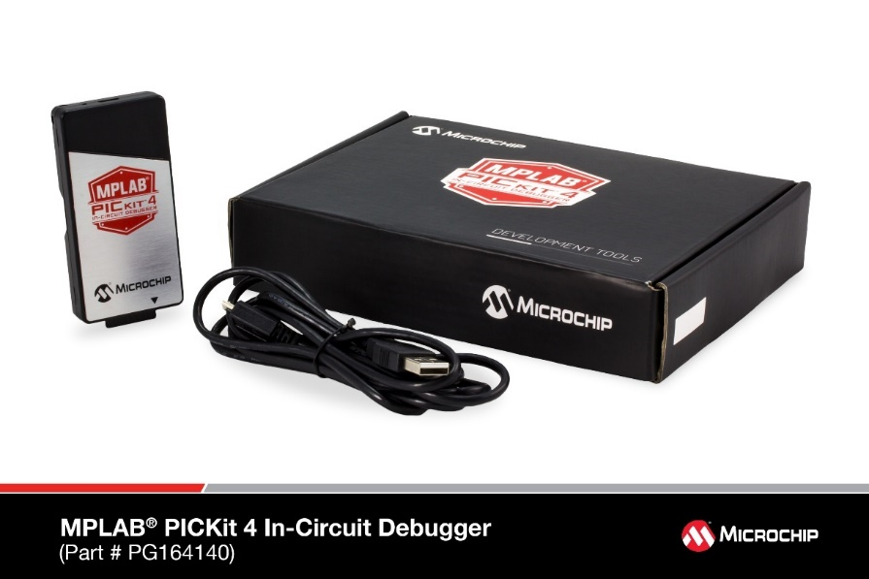

Figure 1 - PicKit 4 programmer/debugger

Suitable programmer/debuggers are:

* MPLAB PicKit3/4
* MPLAB ICD 3/4

Each MS board that have a local controller inside got a programming connector on it, check the board DS for more details. To program the board we suggest to use one of the official Microchip SW, like MPLab IPE (check Microchip documentation for more details).

**We suggest to use the following version of MPLAB IPE:**

* MPLAB IPE v5.10

Please note that other versions may not work properly. You can download the right MPLAB IPE version from here:

<https://www.microchip.com/development-tools/pic-and-dspic-downloads-archive>

MPLAB IPE v5.10 comes with the equivalent version of MPLAB X IDE.

# FW Images Package

The FW Images package contains all the hex files of the various Slaves FW and the overall revision history file (Figure 2):

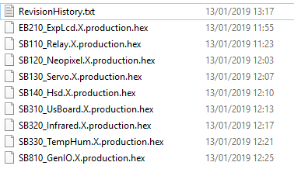

Figure 2 - Content of the Upgrade package

**Note:** the same procedure can be used to program the BB bootloader, in case the device has been accidentally erased.

# Programming Steps

To program the device follow the steps below:

1. Select the device under MPLAB IPE from **Operate** menu and click on **Apply** Button (the correct MCU to select depends on the MS board, please check the board DS for more details):

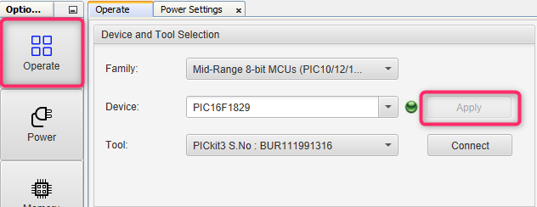

1. From the **Power** menu select the option “Power Target Circuit from Tool” and select the appropriate **VDD** level (this depends on the selected MCU):

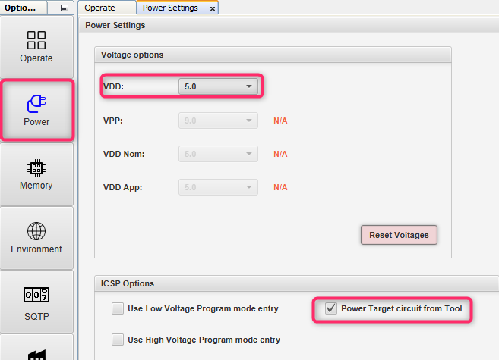

1. Now from the **Operate** menu select the programming tool and press the button **Connect**:

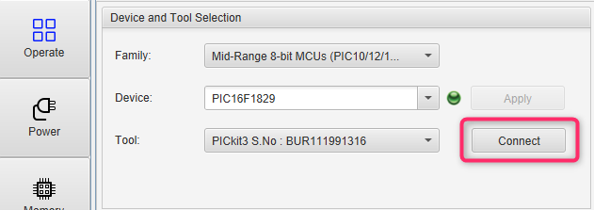

1. The output of the IPE should then indicate that the MCU has been recognized and connected:

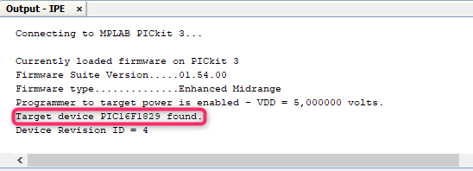

1. Again, from the Operate menu press the browse button and find the right hex version to flash and then press the Program button:

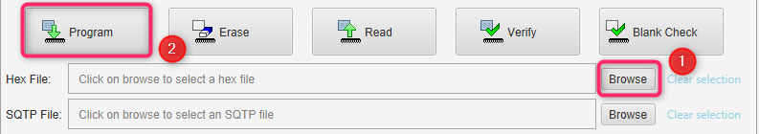

1. If the programming is successful, you should see a message like the one below:

