|  |
| --- |
| Mercury System |
| MS_AN_001 |
| Flash Mercury Slave Boards |

|  |
| --- |
| Francesco Ficili  18/05/2018 |

|  |  |  |  |  |
| --- | --- | --- | --- | --- |
| **Revision Log** | | | | |
| **Author** | **Date** | **Major** | **Minor** | **Description** |
| Francesco Ficili | 18/05/2019 | 1 | 0 | First issue. |
|  |  |  |  |  |
|  |  |  |  |  |
|  |  |  |  |  |
|  |  |  |  |  |
|  |  |  |  |  |
|  |  |  |  |  |
|  |  |  |  |  |
|  |  |  |  |  |
|  |  |  |  |  |
|  |  |  |  |  |
|  |  |  |  |  |
|  |  |  |  |  |

**Table of Content**

1. Introduction 4

2. Upgrade Slave FW 5

3. Programming Interface 6

# Introduction

This Application Note explains how to flash the FW image of Mercury System Slave Boards, in order to upgrade slave functionalities on physical devices once new version of the FW are released. The Mercury System main SW container is the MSF (Mercury System Framework) and this is a package maintained and periodically released by the MS development team.

# Upgrade Slave FW

Each MS generic slave device (where with this term we identify each board that contains a microcontroller inside) has a programming header available and so can be upgraded by means of a flashing operation. Currently no bootloader is available for slave devices, so this operation must be carried out with an external programmer. The pictures below show the position of the programming header on a couple of MS generic slave device. This is in general identified and **CN3** on most of the slave boards.

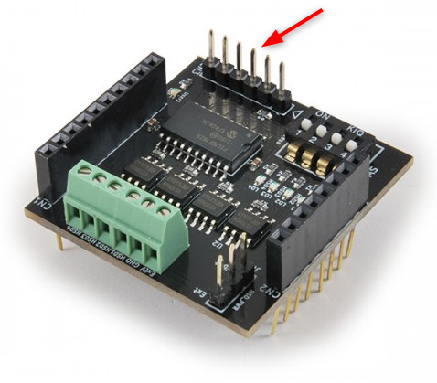

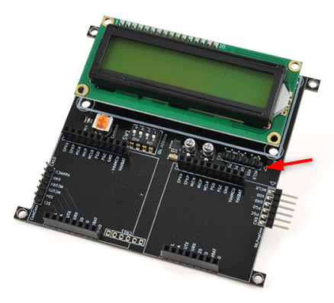

In order to flash the slave device we suggest to use one of the official Microchip Technology programmer/debugger, the most cheaper one being the PicKit device. Simply connect the programmer to the slave header (either plugging it directly or using a proper cable) and launch a programming interface.

# Programming Interface

The programming SW we suggest to use is MPLAB IPE, downloadable from the Microchip Technology website. You can find some instructions here:

<https://microchipdeveloper.com/ipe:installation>

Once MPLAB IPE is installed, open it and you will be prompted with a screen like the one below:

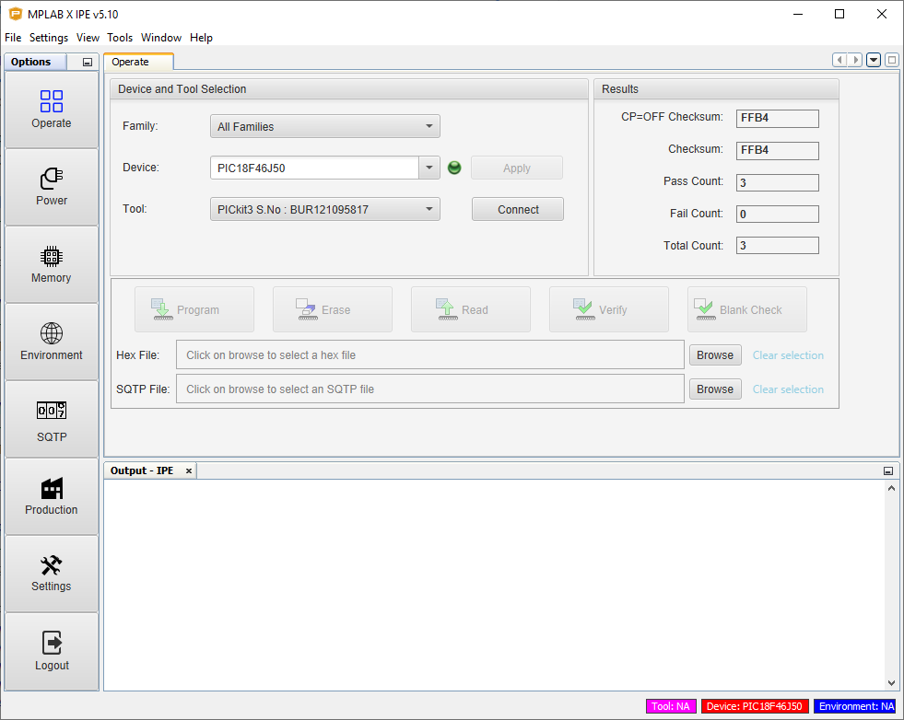

There are some operations to carry out in order to correctly program the board.

1. **Power the Board from the tool:** From the left-hand side menu select power and then the option “Power target circuit from the tool” as depicted in the picture below.

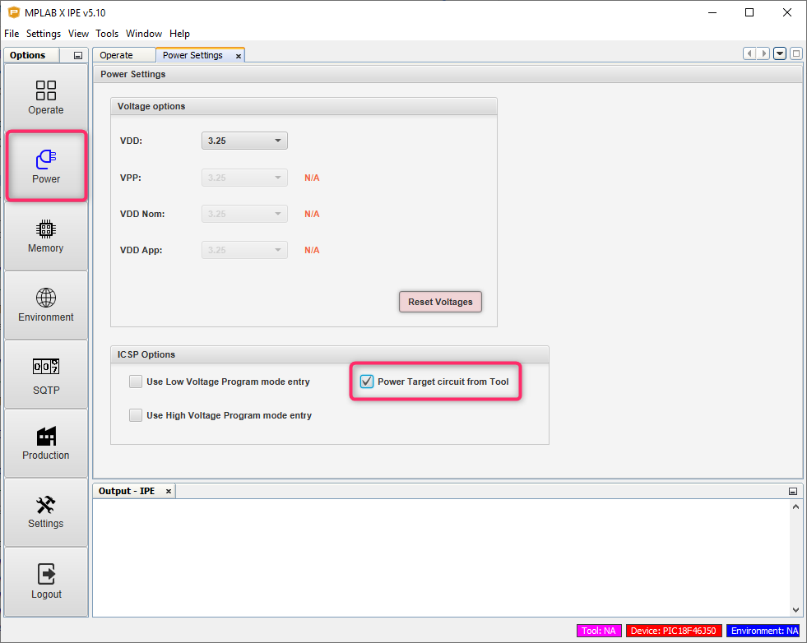

1. **Select the target:** select the Operate option from the left-hand side menu and the correct derivative to program (you can find the correct derivative from the board Datasheet). See picture below for more details:

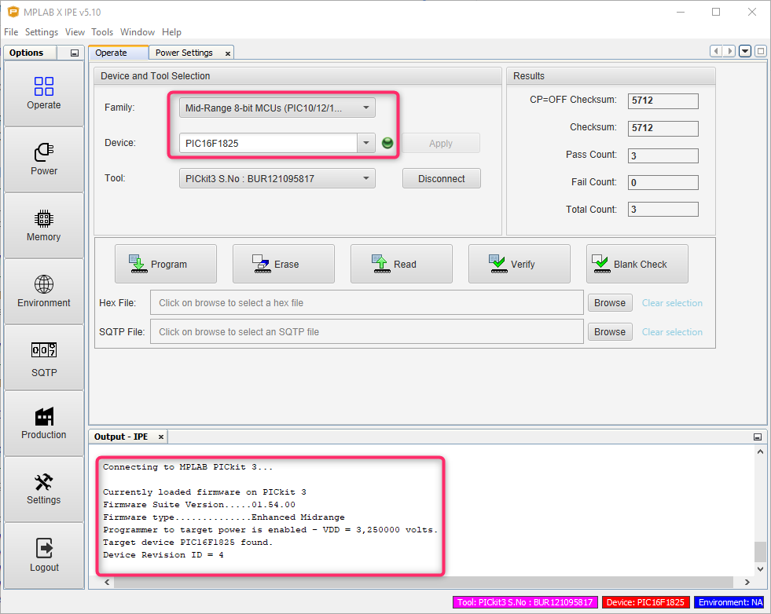

1. **Program the device:** at this point you can select the FW image to use and hit the Program button:

