# Mercury System BL810 – Brainless Proto Board

The BL810 is a prototype Brainless Board, able to provide prototyping platform for the addition of generic slave functionalities to a MS Base Board (BB). Figure 2 shows the BL810 block diagram.

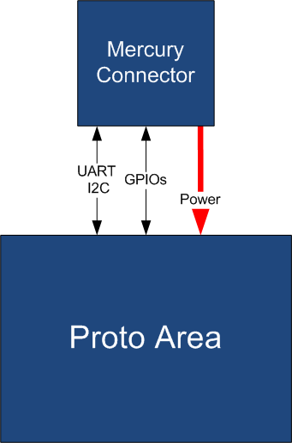

Figure 2 - Block Diagram

The BL810 is connected to the BB by means of the standard Mercury Connector. Table 1 resumes the BL810 board main characteristics:

Table 1 – Board Characteristics

|  |  |  |
| --- | --- | --- |
| Parameter | Description | Notes |
| Board Type | Brainless Board (BL) |  |
| Supported Bus | UART, I2C |  |
| Peripheral Description | Proto Area |  |

Figure 3 depicts the most important components of the board:

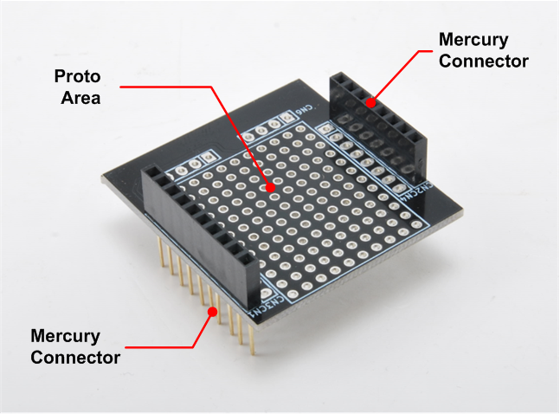

Figure 3 - Hardware Highlight

Table 2 provides a description of board’s main components:

Table 2 – Hardware characteristics

|  |  |
| --- | --- |
| Name | Description |
| Proto Area | BL810 prototyping area. |
| Mercury Standard Connector | Mercury connector used to interface the board with Mercury System’s Base Board. |