# Mercury System – EB111 Expansion Board Quad

The EB111 is a Mercury System expansion board with two Mercury System Sockets. The board allows to connect Mercury System BB with SBs, PBs and BLs in planar configuration. Figure 1 shows the EB111 block diagram.

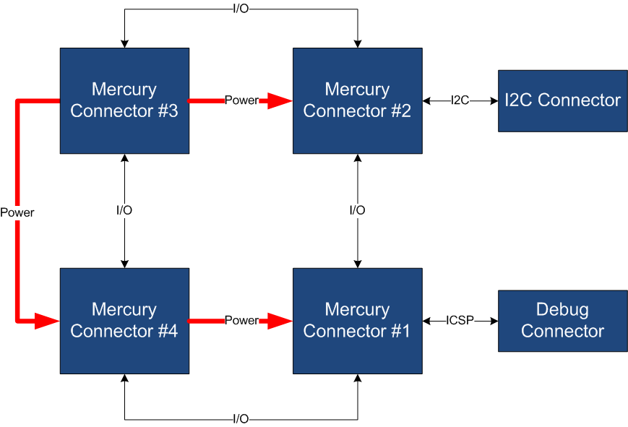

Figure 1 - Block Diagram

Table 1 resumes the EB111 board main characteristics:

Table 1 – Board Characteristics

|  |  |  |
| --- | --- | --- |
| Parameter | Description | Notes |
| Board Type | Expansion Board (EB) |  |
| Supported Bus | I2C, UART |  |
| # Mercury Connectors | 4 |  |

Figure 2 depicts the most important components of the board:

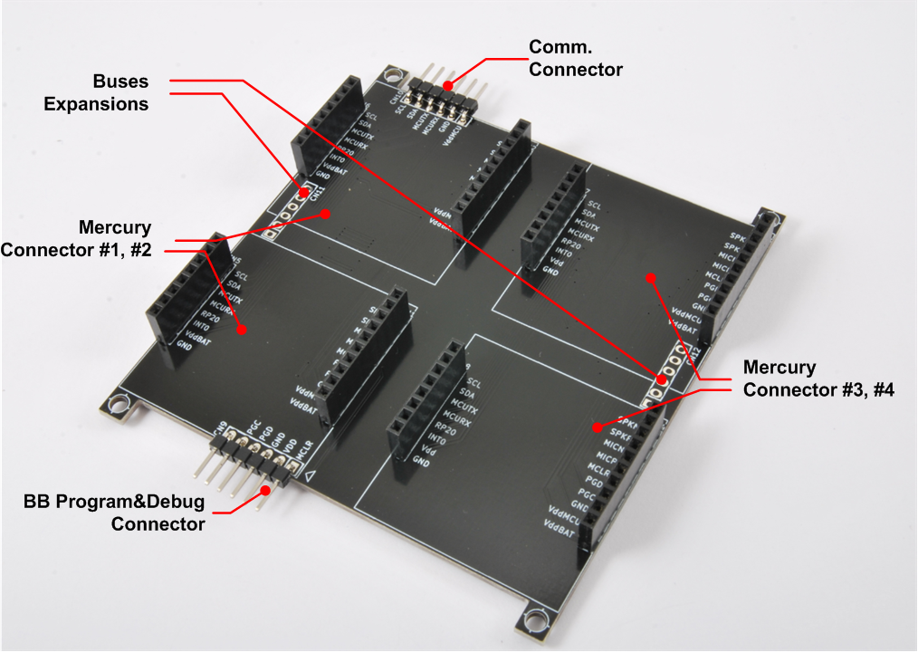

Figure 2 – Hardware Highlight

Table 2 provides a description of board’s main components:

Table 2 – Hardware characteristics

|  |  |
| --- | --- |
| Name | Description |
| Mercury Connectors #1 #2 #3 and #4 | Mercury connector used to interface the board with the others MS boards. |
| BB Program&Debug Connector | PicKit 3 Microchip Programmer/debugger connector. It is directly connected to the BB (Base Board) MCU debug port, in order to allow advanced debugging and programming features, if needed. |
| Buses Expansion | Expansions connectors that carry power as well as I2C and UART connection. |
| Comm. Connector | Connector containing I2C and UART communication buses (for communication expansion). |