# Mercury System MB210 – WiFi Modem Board

The MB210 is a WiFi Modem Board, able to add WiFi functionalities to a MS Base Board (BB). Figure 1 shows the MB210 block diagram. The heart of the system is an ESP8266 module, produced by Expressif Systems.

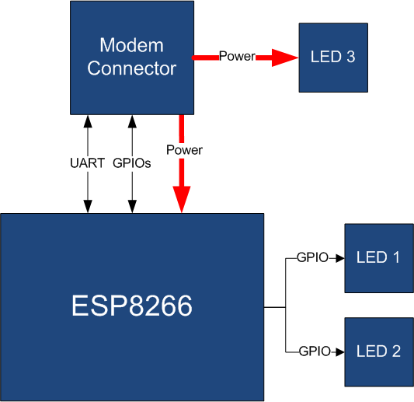

Figure 1 - Block Diagram

The main characteristics of the employed Module are resumed in Table 1:

Table 1 – WiFi Module characteristics

|  |  |
| --- | --- |
| Parameter Name | Description |
| Processor | L106 32-bit RISC microprocessor core |
| Clock | 80 MHz |
| RAM | 64KB instruction + 80KB user data + 16KB System |
| Flash | 512 KiB to 4 MiB external QSPI FLASH typically included |
| Link | IEEE 802.11 b/g/n Wi-Fi |
| Interface | UART |
| Other | External Reset Pin |

The MB210 is connected to the BB by means of an UART link, so the connection between the BB and the MB is dedicated and no address is required. Table 2 resumes the MB210 board main characteristics:

Table 2 – Board Characteristics

|  |  |  |
| --- | --- | --- |
| Parameter | Description | Notes |
| Board Type | Modem Board (MB) |  |
| Supported Bus | UART |  |
| Peripheral Description | WiFi modem | ESP8266 |

Figure 2 depicts the most important components of the board:

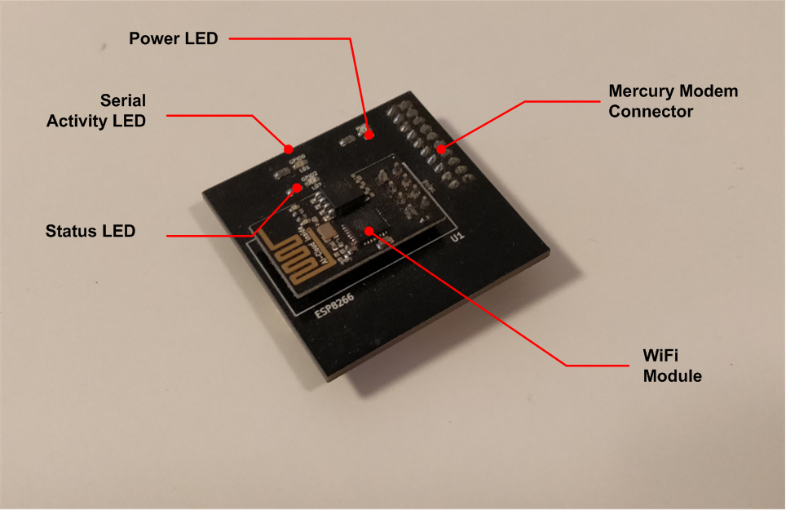

Figure 2 - Hardware Highlight

Table 3 provides a description of board’s main components:

Table 3 – Hardware characteristics

|  |  |
| --- | --- |
| Name | Description |
| Power LED | LED that indicates the power status of the board. |
| Serial Activity LED | LED that indicates the serial line activity of the board. |
| Status LED | LED that indicates the status of the board. |
| WiFi Module | ESP8266 WiFi module. |
| Mercury Modem Connector | Mercury connector used to interface the board with Mercury System’s Base Board. |