# Mercury System MB310 – BT Modem Board

The MB310 is a Bluetooth Modem Board, able to add Bluetooth functionalities to a MS Base Board (BB). Figure 1 shows the MB310 block diagram. The heart of the system is an HC-05 module, produced by Itead Studio.

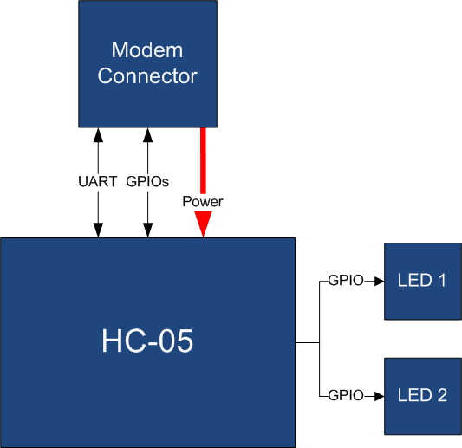

Figure 1 - Block Diagram

The main characteristics of the employed Module are resumed in Table 1:

Table 1 – BT Module characteristics

|  |  |
| --- | --- |
| Parameter Name | Description |
| Processor | CSR BC417 |
| Flash | External 8Mbit Flash |
| Link | Bluetooth Specification v2.0 + EDR |
| Interface | UART |
| Other | External Reset and Mode Pin |

The MB310 is connected to the BB by means of an UART link, so the connection between the BB and the MB is dedicated and no address is required. Table 2 resumes the MB310 board main characteristics:

Table 2 – Board Characteristics

|  |  |  |
| --- | --- | --- |
| Parameter | Description | Notes |
| Board Type | Modem Board (MB) |  |
| Supported Bus | UART |  |
| Peripheral Description | BT modem | HC-05 |

Figure 2 depicts the most important components of the board:

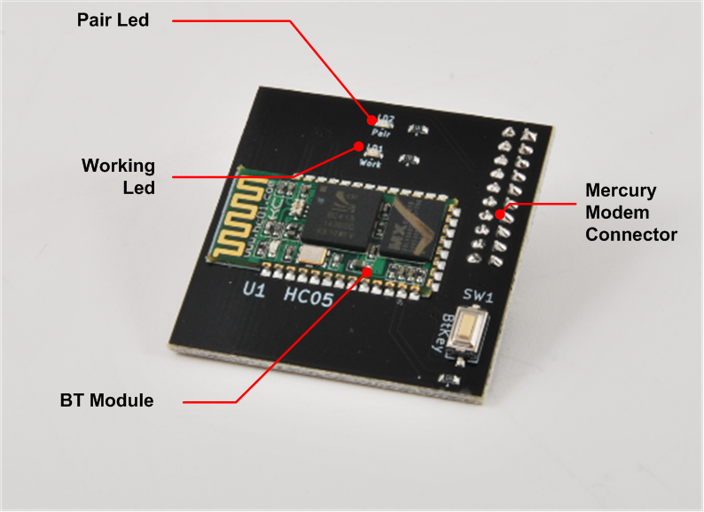

Figure 2 - Hardware Highlight

Table 3 provides a description of board’s main components:

Table 3 – Hardware characteristics

|  |  |
| --- | --- |
| Name | Description |
| Pair LED | This LED indicates the pairing status of the MB. |
| Work LED | This LED indicates the working status of the MB. |
| BT Module | HC-05 BT modem. |
| Mercury Modem Connector | Mercury connector used to interface the board with Mercury System’s Base Board. |