# Mercury System SB120 – Neopixel Slave Board

The SB120 is a 3-channel Neopixel board, able to interface Neopixel LEDs strips or rings. Figure 1 shows the SB120 block diagram. The heart of the system is a PIC16F1829 8-bit RISC microcontroller, produced by Microchip Technology Inc.

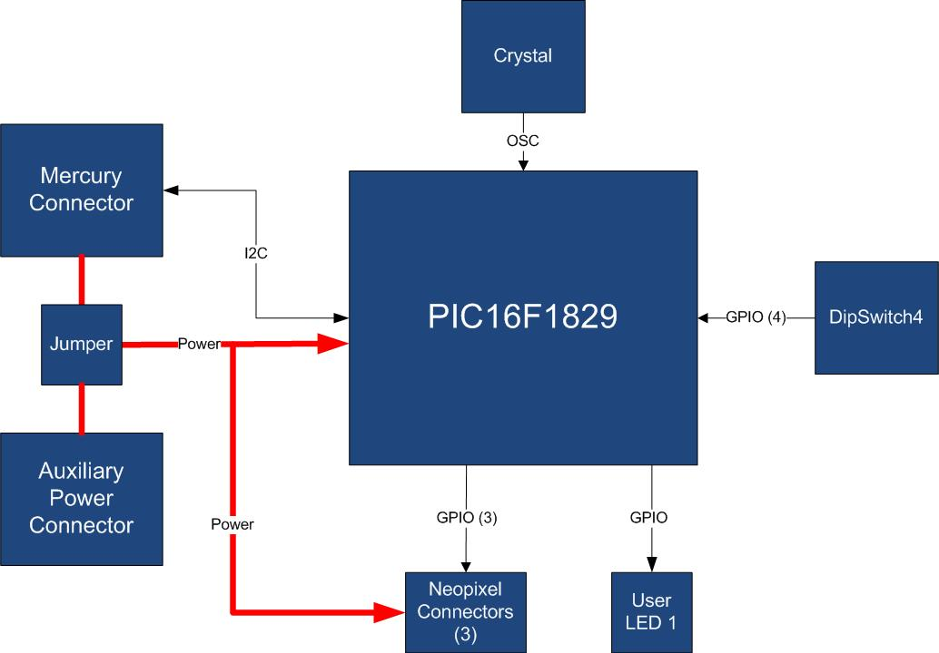

Figure 1 - Block Diagram

The main characteristics of the employed MCU are resumed in Table 1:

Table 1 - MCU characteristics

|  |  |
| --- | --- |
| Parameter Name | Description |
| Program Memory Type | Flash |
| Program Memory (KB) | 14 |
| CPU Speed (MIPS) | 8 |
| RAM Bytes | 1,024 |
| Data EEPROM (bytes) | 256 |
| Digital Communication Peripherals | 1-UART, 1-A/E/USART, 1-SPI, 1-I2C1-MSSP(SPI/I2C) |
| Capture/Compare/PWM Peripherals | 2 CCP, 2 ECCP |
| Timers | 4 x 8-bit, 1 x 16-bit |
| ADC | 12 ch, 10-bit |
| Comparators | 2 |
| Temperature Range (C) | -40 to 125 |
| Operating Voltage Range (V) | 1.8 to 5.5 |
| Pin Count | 20 |
| XLP | Yes |

The SB120 is connected to a Mercury System Base Board by means of I2C bus. The address of the board could be dynamically set by means of a 4 positions dip switch, allowing up to 15 address values (address 0x00 is reserved for I2C general call broadcast addressing scheme). The Neopixel channels could be supplied by means of VddBat from Mercury System network or by means of an external power source (a jumper and a proper screw-terminal connector are provided for this purpose).

Table 2 resumes the SB120 board main characteristics:

Table 2 – Board Characteristics

|  |  |  |
| --- | --- | --- |
| Parameter | Description | Notes |
| Board Type | Slave Board (SB) |  |
| Supported Bus | I2C |  |
| Addressing | Dip Switch 4 |  |
| Peripheral Description | 3 Neopixel Channels |  |

Figure 2 depicts the most important components of the board:

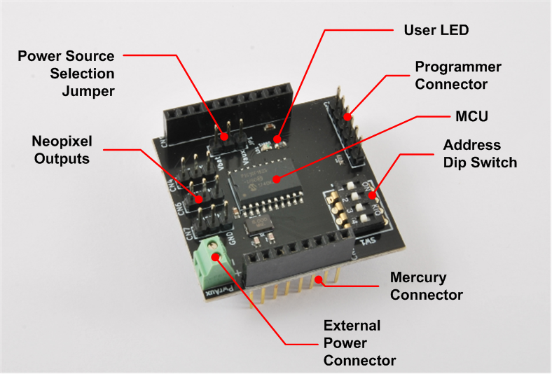

Figure 2 - Hardware Highlight

Table 3 provides a description of board’s main components:

Table 3 – Hardware characteristics

|  |  |
| --- | --- |
| Parameter Name | Description |
| User LED | Board User LED, by default it’s configured as heartbeat LED (periodic pulses). |
| Neopixel Outputs | Neopixel channels connectors. |
| Mercury Connector | Mercury connector used to interface the board with the others MS boards. |
| Address Dip Switch | Dip Switch to set the address of the board within the Mercury System. |
| MCU | PIC16F1829 main controller board. |
| Programmer Connector | PicKit 3 Microchip Programmer/debugger connector. It is directly connected to the MCU debug port, in order to allow advanced debugging and programming features, if needed. |
| Power Source Sel. Jumper | Jumper to select between internal (VddBat) and externally provided power source for Neopixel Channels. |
| External Power Connector | Screw-terminal connector for external power source. |