# Mercury System SB140 – HSD Slave Board

The SB140 is a 4-channel HSD (High Side Driver) board, able to control load up to 1A per channel. Figure 1 shows the SB140 block diagram. The heart of the system is a PIC16F1829 8-bit RISC microcontroller, produced by Microchip Technology Inc.

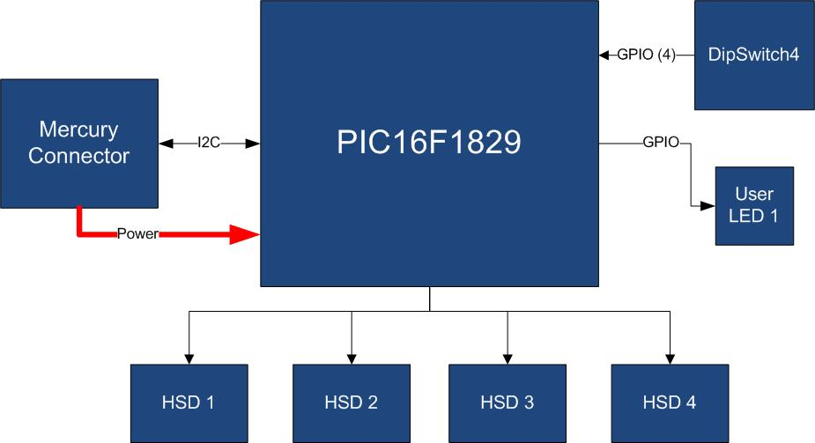

Figure 1 - Block Diagram

The main characteristics of the employed MCU are resumed in Table 1:

Table 1 - MCU characteristics

|  |  |
| --- | --- |
| Parameter Name | Description |
| Program Memory Type | Flash |
| Program Memory (KB) | 14 |
| CPU Speed (MIPS) | 8 |
| RAM Bytes | 1,024 |
| Data EEPROM (bytes) | 256 |
| Digital Communication Peripherals | 1-UART, 1-A/E/USART, 1-SPI, 1-I2C1-MSSP(SPI/I2C) |
| Capture/Compare/PWM Peripherals | 2 CCP, 2 ECCP |
| Timers | 4 x 8-bit, 1 x 16-bit |
| ADC | 12 ch, 10-bit |
| Comparators | 2 |
| Temperature Range (C) | -40 to 125 |
| Operating Voltage Range (V) | 1.8 to 5.5 |
| Pin Count | 20 |
| XLP | Yes |

The SB140 is connected to the BB by means of I2C bus. The address of the board could be dynamically set by means of a 4 positions dip switch, allowing up to 15 address values (address 0x00 is reserved for I2C general call broadcast addressing scheme).

Table 2 resumes the SB140 board main characteristics:

Table 2 – Board Characteristics

|  |  |  |
| --- | --- | --- |
| Parameter | Description | Notes |
| Board Type | Slave Board (SB) |  |
| Supported Bus | I2C |  |
| Addressing | Dip Switch 4 |  |
| Peripheral Description | 4 HSD Channels | ST VN7040A |

Figure 2 depicts the most important components of the board:

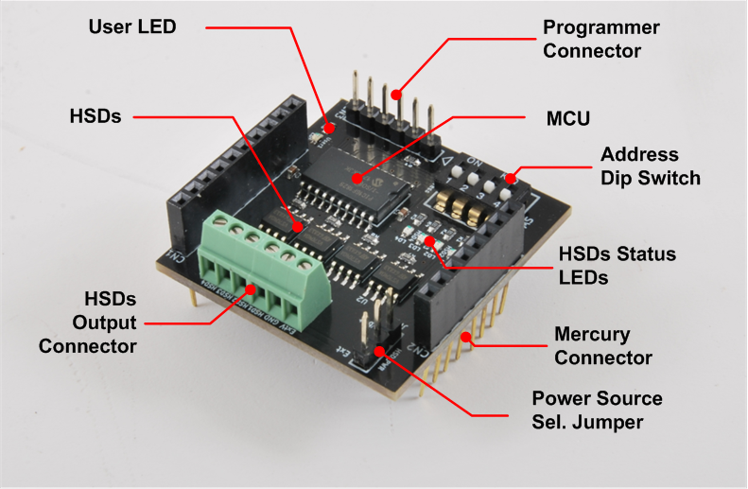

Figure 2 - Hardware Highlight

Table 3 provides a description of board’s main components:

Table 3 – Hardware characteristics

|  |  |
| --- | --- |
| Name | Description |
| User LED | Board User LED, by default it’s configured as heartbeat LED (periodic pulses). |
| HSDs | The SB140 is equipped with 4 ST HSD driver model VN7040A. |
| HSD Output Connector | Output HSD connector. Contains the 4 HSDs channels, GND reference and the External Power Connector. |
| Mercury Connector | Mercury connector used to interface the board with the others MS boards. |
| Address Dip Switch | Dip Switch to set the address of the board within the Mercury System. |
| MCU | PIC16F1829 main controller board. |
| Programmer Connector | PicKit 3 Microchip Programmer/debugger connector. It is directly connected to the MCU debug port, in order to allow advanced debugging and programming features, if needed. |
| HSDs Status LEDs | LEDs that indicate the HSD channels status (ON or OFF). |
| Power Source Sel. Jumper | Jumper to select from internal (Vbat) or externally provided (via Ext_Vdd pin of HSD Output Connector) power source. |