# Mercury System SB310 – Ultrasonic Slave Board

The SB310 is an Ultrasonic Sensor Board, able to interface an HC-SR04 ultrasonic range finder. Figure 1 shows the SB310 block diagram. The heart of the system is a PIC16F1829 8-bit RISC microcontroller, produced by Microchip Technology Inc.

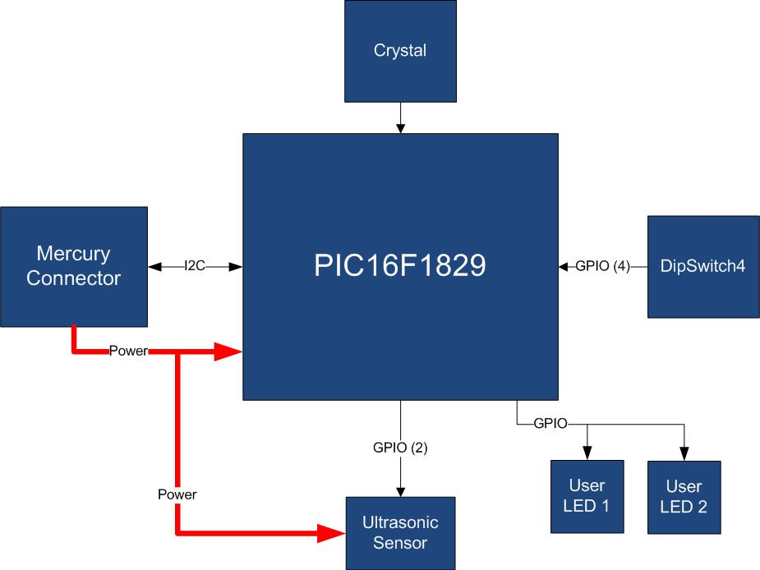

Figure 1 - Block Diagram

The main characteristics of the employed MCU are resumed in Table 1:

Table 1 - MCU characteristics

|  |  |
| --- | --- |
| Parameter Name | Description |
| Program Memory Type | Flash |
| Program Memory (KB) | 14 |
| CPU Speed (MIPS) | 8 |
| RAM Bytes | 1,024 |
| Data EEPROM (bytes) | 256 |
| Digital Communication Peripherals | 1-UART, 1-A/E/USART, 1-SPI, 1-I2C1-MSSP(SPI/I2C) |
| Capture/Compare/PWM Peripherals | 2 CCP, 2 ECCP |
| Timers | 4 x 8-bit, 1 x 16-bit |
| ADC | 12 ch, 10-bit |
| Comparators | 2 |
| Temperature Range (C) | -40 to 125 |
| Operating Voltage Range (V) | 1.8 to 5.5 |
| Pin Count | 20 |
| XLP | Yes |

The SB310 is connected to a Mercury System Base Board by means of I2C bus. The address of the board could be dynamically set by means of a 4 positions dip switch, allowing up to 15 address values (address 0x00 is reserved for I2C general call broadcast addressing scheme). The ultrasonic sensor is able to detect distances in the range 2-450 cm.

Table 2 resumes the SB310 board main characteristics:

Table 2 – Board Characteristics

|  |  |  |
| --- | --- | --- |
| Parameter | Description | Notes |
| Board Type | Slave Board (SB) |  |
| Supported Bus | I2C |  |
| Addressing | Dip Switch 4 |  |
| Peripheral Description | Ultrasonic Sensor Input |  |

Figure 2 depicts the most important components of the board:

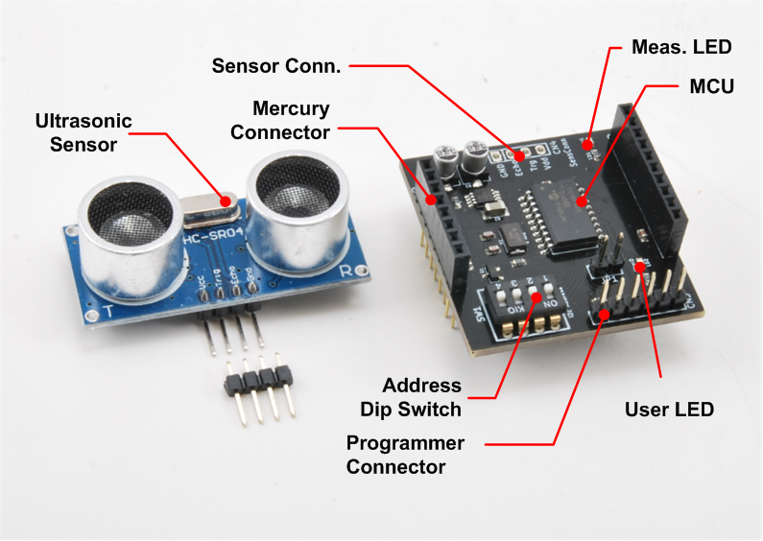

Figure 2 – SB310 Hardware Highlight

Table 3 provides a description of board’s main components:

Table 3 – Hardware characteristics

|  |  |
| --- | --- |
| Parameter Name | Description |
| User LED | Board User LED, by default it’s configured as heartbeat LED (periodic pulses). |
| Ultrasonic Sensor | HC-SR04 ultrasonic range finder. |
| Mercury Connector | Mercury connector used to interface the board with the others MS boards. |
| Address Dip Switch | Dip Switch to set the address of the board within the Mercury System. |
| MCU | PIC16F1829 main controller board. |
| Programmer Connector | PicKit 3 Microchip Programmer/debugger connector. It is directly connected to the MCU debug port, in order to allow advanced debugging and programming features, if needed. |
| Sensor Connector | Connector of the Ultrasonic Sensor. |
| Measure LED | LED that indicates the execution of a range measurement. |