# Mercury System SB320 – Infrared Slave Board

The SB320 is a 2-channel Infrared Sensor Board, able to interface two GP2Y0D810Z0F infrared proximity sensors. Figure 1 shows the SB320 block diagram. The heart of the system is a PIC16F1825 8-bit RISC microcontroller, produced by Microchip Technology Inc.

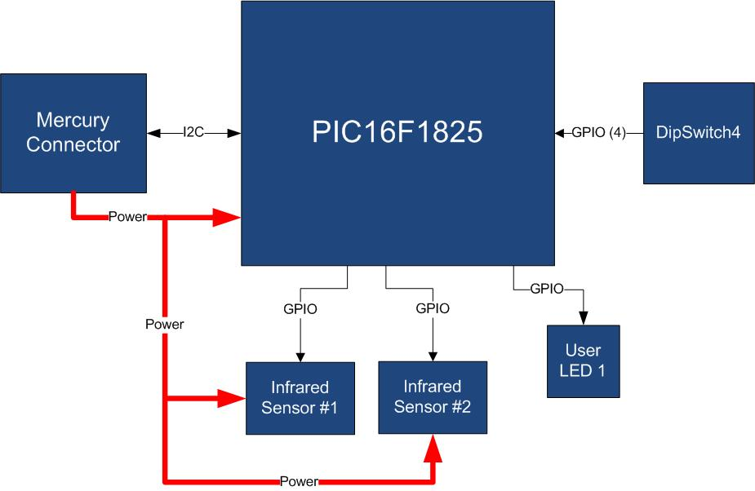

Figure 1 - Block Diagram

The main characteristics of the employed MCU are resumed in Table 1:

Table 1 - MCU characteristics

|  |  |
| --- | --- |
| Parameter Name | Description |
| Program Memory Type | Flash |
| Program Memory (KB) | 14 |
| CPU Speed (MIPS) | 8 |
| RAM Bytes | 1,024 |
| Data EEPROM (bytes) | 256 |
| Digital Communication Peripherals | 1-UART, 1-A/E/USART, 1-SPI, 1-I2C1-MSSP(SPI/I2C) |
| Capture/Compare/PWM Peripherals | 2 CCP, 2 ECCP |
| Timers | 4 x 8-bit, 1 x 16-bit |
| ADC | 8 ch, 10-bit |
| Comparators | 2 |
| Temperature Range (C) | -40 to 125 |
| Operating Voltage Range (V) | 1.8 to 5.5 |
| Pin Count | 14 |
| XLP | Yes |

The SB320 is connected to a Mercury System Base Board by means of I2C bus. The address of the board could be dynamically set by means of a 4 positions dip switch, allowing up to 15 address values (address 0x00 is reserved for I2C general call broadcast addressing scheme). The infrared sensors can detect objects in the range 2-10 cm. Each channel provides a digital proximity indication: 1 means than an object has been detected in the sensor proximity range, 0 that the range is free.

Table 2 resumes the SB320 board main characteristics:

Table 2 – Board Characteristics

|  |  |  |
| --- | --- | --- |
| Parameter | Description | Notes |
| Board Type | Slave Board (SB) |  |
| Supported Bus | I2C |  |
| Addressing | Dip Switch 4 |  |
| Peripheral Description | Infrared Sensor Input | GP2Y0D810Z0F |

Figure 2 depicts the most important components of the board:

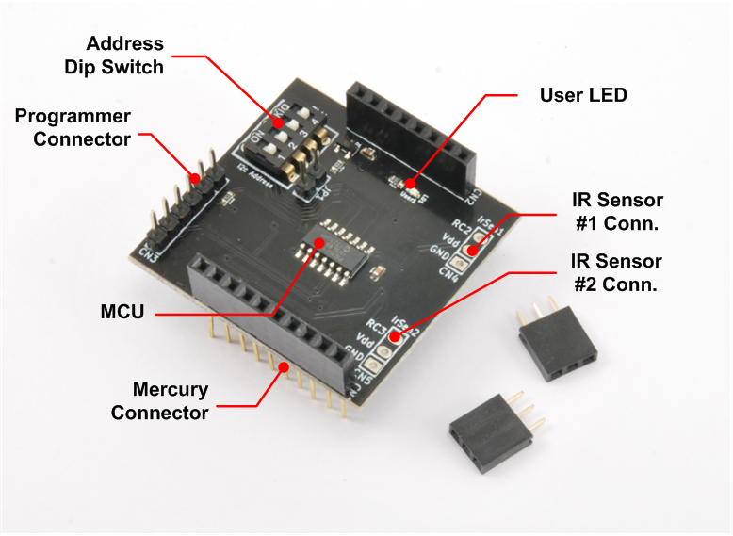

Figure 2 – SB320 Hardware Highlight

Table 3 provides a description of board’s main components:

Table 3 – Hardware characteristics

|  |  |
| --- | --- |
| Parameter Name | Description |
| User LED | Board User LED, by default it’s configured as heartbeat LED (periodic pulses). |
| IR Sensor Connectors | Connectors for GP2Y0D810ZOF Infrared Sensor. |
| Mercury Connector | Mercury connector used to interface the board with the others MS boards. |
| Address Dip Switch | Dip Switch to set the address of the board within the Mercury System. |
| MCU | PIC16F1825 main controller. |
| Programmer Connector | PicKit 3 Microchip Programmer/debugger connector. It is directly connected to the MCU debug port, in order to allow advanced debugging and programming features, if needed. |