*Parental Involvement Month Activities / November 2013*









**Office of Community Engagement *community.dadeschools.net***

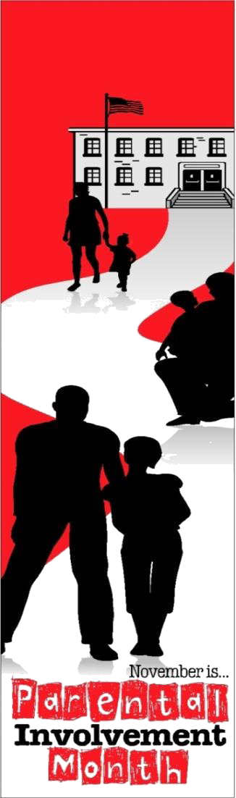

|  |  |  |  |  |  |  |
| --- | --- | --- | --- | --- | --- | --- |
| **Sunday** | **Monday** | **Tuesday** | **Wednesday** | **Thursday** | **Friday** | **Saturday** |
|  |  |  |  |  | **1**  **FAMILY LITERACY DAY**  Read a favorite story from childhood at bedtime. | **2**  **Have a movie night. Check out the public library for free movies. Pop some popcorn.** |
| **3**  **Browse through the newspaper and discuss current events.** | **4**  Listen! It’s the #1 thing a parent can do to support their child. | **5**  Talk to your kids about what’s in their food and make a healthy dinner together. | **6**  Ask the teacher what your child is learning and how you can support this at home. | **7**  Make it a habit to review and discuss homework. | **8**  **NO SCHOOL**  Watch your favorite  TV show together  and discuss the main event. | **9**  **Relax under the stars and discuss the constellations.** |
| **10**  **Donate canned goods to help other families in your school or community.** | **11**  **NO SCHOOL**  **VETERANS DAY** Talk to your child about Veterans Day and why we honor veterans. | **12**  Write a note or email to your child’s teachers to thank them or ask a question. | **13**  Check out your school’s website [www.dadeschools.net/schools/schoolinformation/](http://www.dadeschools.net/schools/schoolinformation/) | **14**  Get out a tape measure and measure different items. | **15**  Show school spirit! Attend a school sporting event with your child | **16**  **Get outside and have some family fun in the beautiful Fall leaves!** |
| **17**  **Take your child to the grocery store. Help them make a list and find the items on it.** | **18**  **AMERICAN EDUCATION WEEK**  Talk to your child about his/her favorite subject in school. | **19**  Join the PTA, or a parent group. | **20**  Sneak a note into your child’s school bag  reminding them of  how proud you are of them. | **21**  **NATIONAL PARENT INVOLVEMENT DAY**  Take the Pledge  [www.fldoe.org](http://www.fldoe.org)  /family/title1/ | **22**  Talk with your child daily about homework, classroom activities, and events. | **23**  **Play a favorite board game or card game as a family.** |
| **24**  **Flip through old family photos. Tell stories about what you see.** | **25**  Compare tastes in music. Actually listen to what your child listens to. | **26**  Encourage reading, writing, and discussions among family members. | **27**  Participate in your child’s favorite hobby. | **28**  **NO SCHOOL THANKSGIVING DAY**  Talk about things for which your family is grateful. | **29**  **NO SCHOOL** Spend the day as a family at your favorite place. | **30**  **Visit a local zoo or park and talk about what you see there.** |