According to Sun " An applet is a small program that is inteded not to be run on its own, but rather to be embedded inside another application"
Some definition of an applet:
A small application
A secure program that runs inside a web browser
A subclass of java.applet.Applet

An applet can:
draw pictures on webpage
receive input from the user through keyboard or the mouse
incorporate a set of GUI devices
Trigger events
Play animation

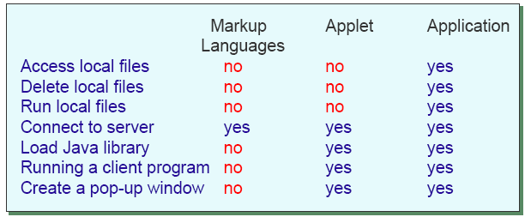

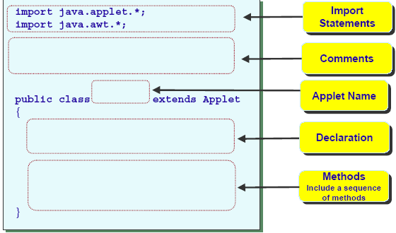

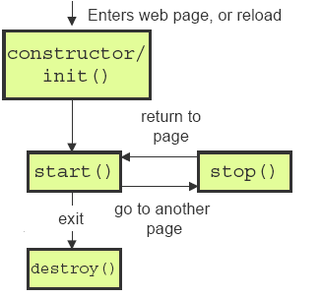

Recall that applets do not have a main()
The browser use the constructor init(), start(), stop() and destroy() methods to control the applets
The constructor init() is invoked when the applet is first loaded
Although the init() should be used rather than the constructor to initialize your applet, it is possible to define a constructor for your applet class
In this case, the constructor runs before init()

To draw in applet, define the method
public void paint (Graphics g)
The Graphics object g is created by the browser, not by the programmer, is use for drawing operation
The method paint is called by the browser.
The drawing co-ordinate:

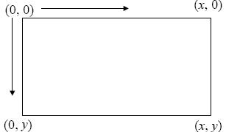

import java.applet.Applet;
import java.event.*;

public class GreetingApplet extends Applet implements ActionListener
{
private Label prompt;
private Label greeting;
private TextField inputLine;

public init() {
prompt= new Label("Please enter your name");
greeting = new Label();
inputLine= new TextField(15);

this.add(prompt);
//add(greeting);
this.add(inputLine);
inputLine.addActionListener(this);

}
public void actionPerformed(ActionEvent event)
{
greeting.setText("Nice to meet your, "+inputLine.getText()+".");
add(greeting);
this.doLayout();
}
}

