

MEGACITIES PARTNERSHIP
Inception Report / Project Workplan Template

May 2021

Overview
The Inception Report and Workplan outlines the organizational structure and relationships between stakeholders, presents the results of the data collection process and major data gaps, and creates a well-defined timeline of agreed upon tasks and responsibilities. The workplan guides key next steps and actions throughout the Partnership to ensure progress and accountability. Where previous deliverables focus on characterizing air pollution and contextualizing air quality management, the Inception Report and Workplan lay out project specific management, organization, and concrete actions to reaching the ultimate goal decided by the stakeholders. These deliverables require focused back-and-forth communication between the Megacity and partners to determine appropriate options for collaboration and project details to move forward. The outline below can be used as the template for any Partnership Inception Report and Workplan, with locally information and workplan activities to be added as indicated in italics below.

Table of Contents
- Megacities Partnership Goals and Objectives
  - Institutional Roles and Responsibilities
- Approach and Methodologies
- Results of Data Collection and Initial Needs Assessment
- Work Plan and Proposed Timeline

Megacities Partnership Goals and Objectives
The partnership sponsors [insert names] and megacity hosting agency [insert name] are collaborating under the Megacities Partnership to strengthen air quality management through policy development, community outreach, and stakeholder engagement; to support air quality monitoring initiatives; and to build technical capacity for scientific and economic analyses and communication planning in support of air quality management plan (AQMP) development. The Megacities Partnership is action oriented – based on the premise that where pollution levels are high, it is very likely that initial measures to improve air quality can be identified and justified even where air quality and source attribution information is initially sparse and/or of low quality. In addition, the process of developing an air quality plan is essential to identifying capacity and information gaps and provides a clear and evidence-based focus for future investments in capacity building, equipment investments, and regulatory and legal enhancements.
Work to date has progressed from the overall goals of the Megacities Partnership to specific objectives that are responsive to the air pollution and institutional context in [megacity], and also are feasible to accomplish within time and budget constraints. The proposed objectives are listed below:
- Outline city-defined objectives of Megacities Partnership as a result of the Inception Mission and Information Collection Report
- Confirm roles, responsibilities, and points of contact in the host agency, host city, and collaborating partners
Include detailed description of the agencies committed to dedicating time and resources towards the identified objectives. This should include points of contact, positions, and project responsibilities. Schematics showing the organizational structure of the partnership are helpful in illustrating the communication links between stakeholders.
The hosting megacity agency may elect to create additional, cross-agency working groups to undertake specific objectives of the partnership and/or an advisory committee to lead project management and overall direction. The members and responsibilities of the working groups should be discussed in this section. Example working groups could include:
- An air quality management plan (AQMP) drafting group with members from the ultimate regulatory agency responsible for disseminating and implementing the AQMP
- An impact analysis group with members from health agencies to focus on analyzing the health and economic benefits of the AQMP goals
- An air quality measurement and planning group with members from local meteorological agencies or departments responsible for air quality monitoring and planning to build air quality monitoring capacity
- A communications group to develop a plan for public participation and communication of AQMP outputs

Approach and Methodologies
A generic illustration of the overall proposed approach is presented in Figure 1 below. The approach is an adaptation of the process described in Bachmann (2007), and further elaborated for developing countries in Johnson et al. (2011). The green cells, representing steps 1 through 3 in the process, represent the steps that we anticipate will be the main focus of this project, as described further in the last section of this report. This section will be the most detailed of the report and may include:
2.1 An overview of any additional detail for analytical or policy approaches
2.2 Emissions Inventory Characterization
2.3 Source Attribution (Top-down) and Emissions Dispersion Estimation (Bottom-up)
2.4 Health and Economic Effects Estimation
2.5 Capacity Building and Workshop Design
2.6 Communications Plan Development

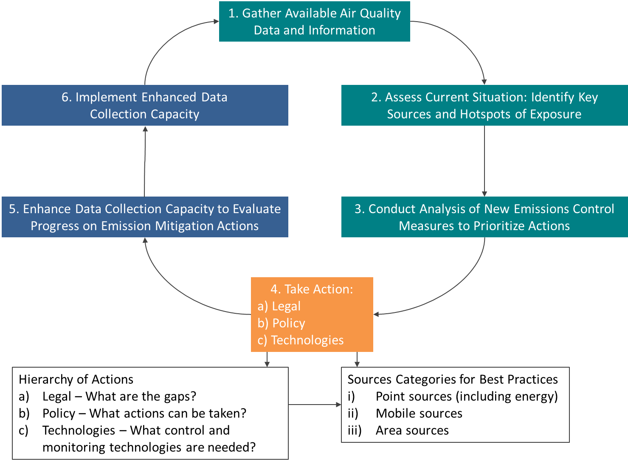
Figure 1: Integrated air quality management model for cities

- Present a summary level description of data collection and initial needs assessment process and any relevant information from scoping and inception phases.
  - The results of the initial needs assessment include a catalog of data sources and availability, confirmation or revision of ICR findings, analysis of current capacity, and any outstanding items, including but not limited to potential partner connections, missing data sources, and additional capacity not identified by the ICR.

Work Plan and Proposed Timeline
This section should include an overview of the main milestones for each partner throughout the project, description and expectations of the main milestones, and a more detailed list of action items for the upcoming months. A flow diagram showing the timeline, roles, and outputs of each partner is a useful illustration of collaboration and actions to be completed.
The proposed tasks are most easily organized in a table format; this table should be updated frequently and shared with partners throughout the project to ensure continuity, alignment, and accountability. An example table is shown below. It is essential that all collaborating partners agree and sign-off on the proposed tasks and timelines, with acknowledgement that unexpected challenges may arise and deadlines will be adjusted accordingly.
Table 1. Example Task/Timeline Table
ACTIVITY | Responsibility | Deadline | Status?
Submit data collection requests to Ministry of Transport and Statistical Agency | US EPA | Oct. 2024 | Completed
Follow up with data collection requests | Host Agency | Nov. 2024 | All data requests fulfilled in Oct. 2024
Provide examples of sample communications products | USEPA | Nov. 2024
Send letters or make other contact with key national institutions to facilitate cooperation, including data sharing and invitations to capacity building activities | Host Agency | Dec. 2024
Finalize Project Workplan | All partners | Jan. 2025
First Capacity Building Workshop | All partners | April 2025
Draft health burden assessment | Impact Analysis Group | June 2025
Second Capacity Building Workshop  Draft AQMP | All partners | September 2025
Launch AQMP | All partners | March 2026

