About Cybersecurity Awareness Month
Cybersecurity Awareness Month (CSAM), every October, is a collaboration between government and private industry to raise awareness about digital security and empower everyone to protect their personal data from digital forms of crime. The month is dedicated to creating resources and communications for organizations to talk to their employees and customers about staying safe online. The HHS 405(d) Program celebrates this month each year and provides awareness of cyber in the HPH sector.
The overarching theme for 2022 is “See Yourself In Cyber” and instead of focusing on themes, we will focus on four key behaviors:
- Enabling Multifactor Authentication
- Using Strong Passwords and a password manager
- Updating software
- Recognizing and reporting phishing
This toolkit was designed for you to promote this very important month within your organizations and continue to help your employees understand that Cyber Safety is Patient Safety.

Toolkit Use and Contents
This toolkit is designed to help you promote cyber safety as patient safety during the month of October to your organization. With this toolkit you will have the ability to highlight important cyber tips and information that can help your employees grow their cyber awareness and increase their ability to keep patients safe from cyber threats. We have put together 4 emails and 4 social posts and one poster HERE based on the “behaviors” set out by the National Cyber Alliance. These emails can be distributed weekly, or however you wish to distribute these within your organization.

Emails

Email #1 – Intro to CSAM / Multi-Factor Authentication
October is National Cybersecurity Awareness Month!
Dear Colleagues,
October is National Cybersecurity Awareness Month, and we are taking this opportunity to discuss how Cyber Safety is Patient Safety. Cyber-attacks have the potential to shut down care facilities, including ours, forcing them to resort to diverting patients, inability to access patient files to perform accurate care, and puts our patients’ data at risk. Therefore, we must stay vigilant to protect our patients and ensure we are aware of the most recent and relevant cybersecurity best practices to protect our patients. This week we are discussing “Multi-Factor Authentication”!
One thing is important to remember: Always enable multi-factor authentication.
Also known as two-factor authentication and two-step verification. No matter what you call it, multi-factor authentication, or MFA, is a security measure that requires anyone logging into an account to navigate a two-step process to prove their identity. It makes it twice as hard for criminals to access an online account. When it’s available, always turn it on because it’s easy to do and greatly increases your security.
How Does MFA work?
By adding one more simple step when logging into an account, multi-factor authentication greatly increases the security of your account. Here’s how it works. Just like logging into your account, the first step is giving your password or passphrase. The second step is to provide an extra way of proving that you’re you, like entering a PIN code or texting/emailing a code to your mobile device, or accessing an authenticator app.
How Does MFA Protect Patients?
By ensuring the person accessing our secure emails, servers, or patient data is who they say they are, MFA protects our patients from cyber threat actors gaining access to our systems and ultimately causing harm to our organization.
For more information on available resources on MFA and just how important it is to keep patients safe, check out the HHS 405(d) Program’s resource titled: “Have you Heard about MFA?”
Stay tuned this month for more information on how you can keep our patients safe from cyber threats!

Email #2 – Using Strong Passwords
Dear Colleagues,
Welcome to week 2 of Cybersecurity Awareness Month!
This week we are focusing on keeping strong passwords. Strong passwords can thwart cyber actors and are one way you can continue keeping our patients safe from cyber threats.
Passwords and strong authentication are like keys to your information and organization. You should do everything you can to prevent people from gaining access to your password. You can further secure your accounts by using additional authentication methods- like MFA.
Passwords can be inconvenient, but they’re important if you want to keep your information and your organization safe. Here are some simple ways to secure your accounts through better password practices.
LONG, UNIQUE, COMPLEX
No matter the account, all passwords should be created with these three words in mind.
Long – At least 12 characters
Unique – Never reuse passwords. Each account needs its own unique password
Complex – Use a combination of upper and lower case letters, numbers and special characters. Some websites will even let you include spaces.
This week we encourage you to take stock of your passwords and ensure you are following these guidelines. For more information on how to keep your patients safe from cyber threats, check out this resource!

Email #3 – Software Updates
Dear Colleagues,
Welcome to Week 3 of Cybersecurity Awareness Month!
This week we are discussing how ensuring our software is up-to-date can keep our patients safe from cyber threats!
One of the easiest ways to keep your patient’s information secure is to keep our software and apps updated. When we think about keeping our systems up to date, it is important that we ensure we are receiving software updates from the manufacturer and that we are following our internal policies appropriately for updating. Our patients rely on us to ensure their information and our systems are secure, therefore if you encounter a notification for a software update it is important to remember the following things:
Update often.
Always keep your software updated when updates become available and don’t delay. These updates fix general software problems and provide new security patches where criminals might get in. You can be sure the bad guys are always looking for new ways to get to your data through software, so updating your software is an easy way to stay a step ahead.
Get it from the source.
When downloading a software update, only get it from the company that created it. Never use a hacked, pirated or unlicensed versions of software (even if your friend gave it to you). These often contain malware and cause more problems than they solve.
Make it automatic.
Software from legitimate companies usually provide an option to update your software automatically. When there’s an update available, it gives a reminder so you can easily start the process. If you can’t automatically update it, remind yourself to check quarterly if an update is available.
Watch for fakes!
Maybe you’ve seen these pop-up windows when visiting a website or opening software that urgently asks you to download something or fill out a form? These are always fake and should not be followed. A browser will only warn you not to move forward or stay on a specific web address because it might be unsecured, or it could contain malware.
For more information on how software updates protect patients, check out the HHS 405(d) Health Industry Cybersecurity Practices Publication!

Email #4 – Email Phishing
Dear Colleagues,
Welcome to week 4 of Cybersecurity Awareness Month!
This week we are discussing one of the most common ways cyber threat actors use to infiltrate healthcare facilities- PHISHING!
Phishing is when criminals use fake emails to lure you into clicking on them and handing over your personal information or installing malware on your device. One simple wrong click on a phishing email can lead to Ransomware attacks that have the potential to shut down care facilities and cause harm to patients in many ways- including diverting care and the inability to access patient records.
See it so you don’t click it.
The signs can be subtle, but once you recognize a phishing attempt you can avoid falling for it. Here are some quick tips on how to clearly spot a phishing email:
- Contains an offer that’s too good to be true
- Language that’s urgent, alarming, or threatening
- Poorly crafted writing with misspellings, and bad grammar
- Greetings that are ambiguous or very generic
- Requests to send personal information or PHI unsecured
- Urgency to click on an unfamiliar hyperlink or attachment
- Strange or abrupt business requests
- Sending e-mail address doesn’t match the company it’s coming from
If the email came to your work email address, report it to (Insert proper person to notify here) as quickly as possible.
For more information on cyber hygiene tips check out this poster!

Cybersecurity Awareness Month Social Media Outreach!

Week 1
October is National Cybersecurity Awareness Month! This week’s topic is Multi-Factor Authentication (MFA).
One thing to remember: Always enable multi-factor authentication. This action makes it twice as hard for criminals to gain access to your account and protects patients from cyber threats. MFA is a security measure that proves your identity by taking steps to confirm your information and the user.
Learn more about MFA and other threats that can impact patient safety at 405d.hhs.gov and stay tuned for our weekly emails!
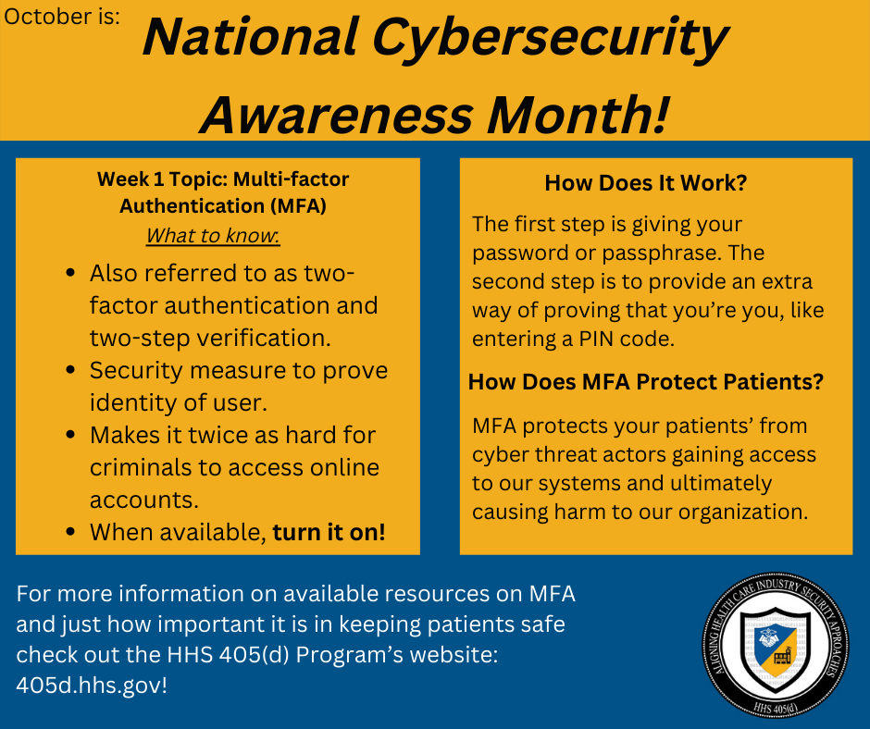

Week 2
Week two of National Cybersecurity Awareness Month features Using Strong Passwords!
Passwords are gateways to patient and organization information. This is why it is important to know how to use them. Use long, unique, and complex passwords to fight threats that can impact patient safety.
Learn more about using strong passwords and other threats that can impact patient safety at 405d.hhs.gov and stay tuned for our weekly emails!
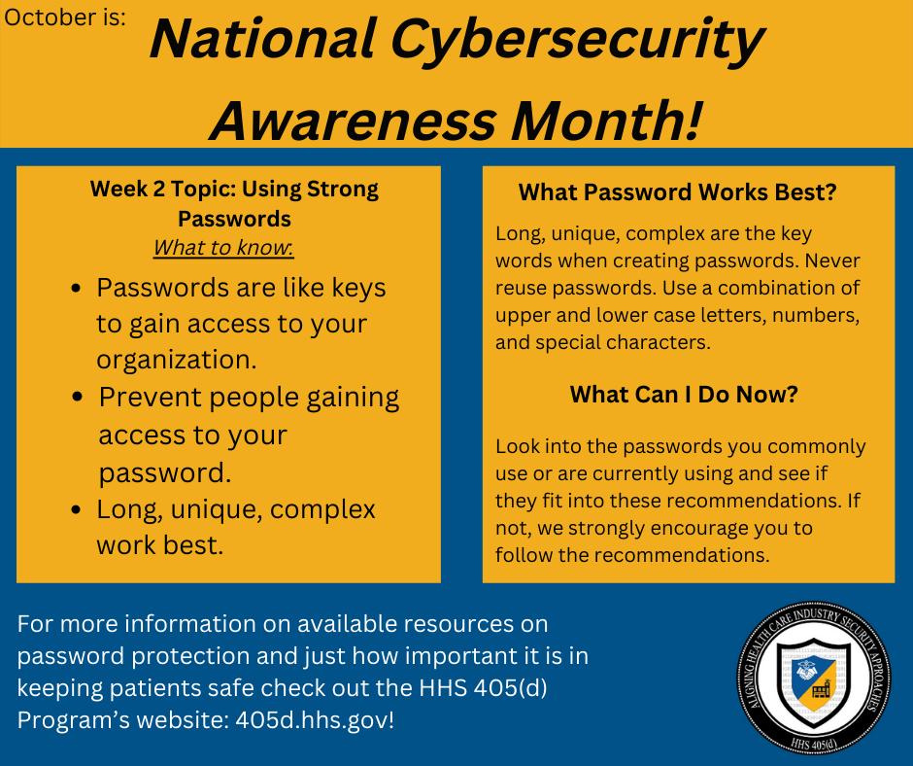

Week 3
Week three of Cybersecurity Awareness Month features software updates!
Software updates can seem like a daunting or boring task but is very important to keep patient safety at the highest priority. We’ve listed some simple recommendations that can help you tackle updating equipment and devices that limit attackers’ ability to impede patient safety.
Learn more about implementing software updates and other threats that can impact patient safety at 405d.hhs.gov and stay tuned for our weekly emails!
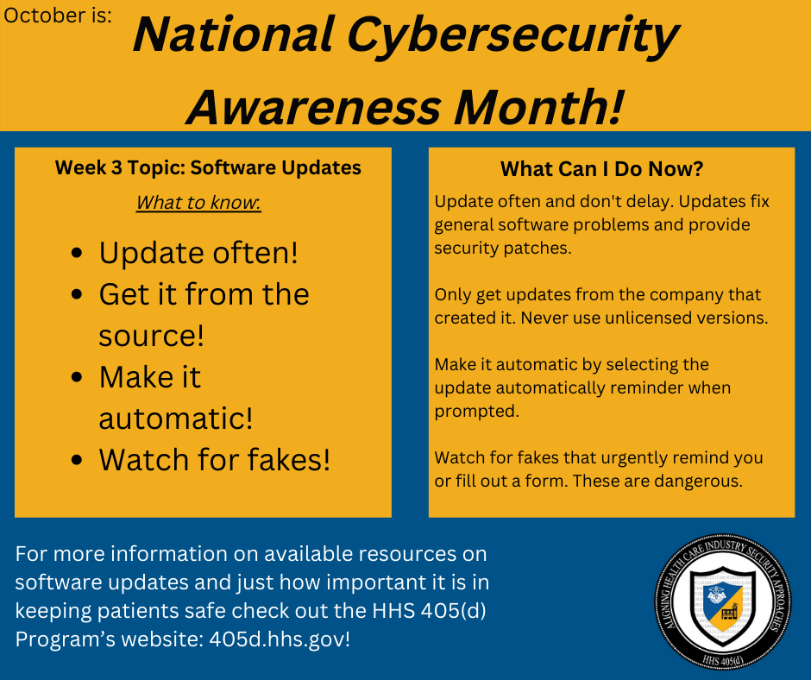

Week 4
The final week’s topic of Cybersecurity Awareness Month features email phishing.
Phishing is when criminals use fake emails to lure you into clicking on them and handing over your personal information or installing malware on your device. One wrong click can lead to ransomware attacks that can shut down facilities and cause patient safety to be at risk. Check out our recommendations on preparing, preventing, and fighting against email phishing attacks.
Learn more about implementing software updates and other threats that can impact patient safety at 405d.hhs.gov and stay tuned for our weekly emails!
