An intern experience with NASA’s Artemis Program

A Work Experience Report

by

Sarah Bianco
Department of Electrical and Computer Engineering
Texas A&M University
Prob for Coop Students, ENGR 385, Section 507
Spring
4/29/2021

Presented to

Dr. Aydin I. Karsilayan
Department of Electrical and Computer Engineering
Texas A&M University

Approved by

Dean C. Orr
Dean C. Orr
Avionics Branch Chief NE XA
NASA
Kennedy Space Center Fl 32899
321-747-6976
Dean.c.orr@nasa.gov

Abstract
“3…2…1…Go For Launch”. Nasa’s Kennedy Space Center is projected to launch the first mission of the Artemis Program by the end of this year, 2021. I have had the opportunity to contribute directly to this mission through my internship with their Engineering organization from January to August of 2021. Within their Engineering organization, I am an intern for the Avionics branch. Throughout this experience I have completed two projects with one project still in progress. These projects allowed me to work directly with the Orion vehicle’s software and hardware power ups, checkouts, and tests. I became familiarized with the engineering concepts that allowed this advanced technology to perform as intended. In addition, I became acquainted with the operations and tasks that are completed during a Launch Countdown, both at a detailed level as well as a higher managerial level. Lastly, I worked directly with the software algorithm that detects and responds to onboard faults and failures. I have analyzed and made conclusions based on data and documentation, allowing my team to benefit from a condensed, centralized informational file. In addition to my technical experience, I have learned a significant amount about how the Kennedy Space Center operates, it’s history, and the history of the agency. The education I received from the Engineering department at Texas A&M University not only allowed me to obtain this internship, but provided me with the required background in computer and electrical engineering principles to be successful in this organization.

Introduction
Forty-seven years ago, the National Aeronautics Space Administration (NASA) landed Apollo 17. Since then, the United States has not returned to the moon. However, this period of silence is projected to be broken by 2024 when they send the next man and first woman to the moon through the Artemis missions. NASA’s future holds great promise for the men and women desiring to explore deep space.

From January 2021 to the present, I have worked for NASA’s Kennedy Space Center as an engineering student intern within their Avionics Engineering Branch. The Avionics branch has various responsibilities including but not limited to: processing and installation of flight hardware and payloads, testing and checkout of flight computer and flight software, and checkout of guidance, navigation, flight controls, and propulsion avionics systems. [1] I specifically worked under a subdivision of the Avionics branch called Command and Data Handling (C&DH). Throughout my experience as an intern, I have worked on various projects to support the C&DH group in their responsibilities to launch Artemis I, specifically associated with the Orion vehicle. The Orion vehicle is the spacecraft that will carry the crews of Artemis into space, provide emergency abort capability, sustain astronauts during their missions and provide safe re-entry from deep space return velocities. [2]

Overview of Artemis
What is Artemis and why is it the name of the space program that is to send the next man and first woman to the moon by 2024? Artemis is the name of a Greek goddess who is the twin sister of the Greek god Apollo. Apollo is the name of the previous program that sent twelve Americans to the moon, ending with Apollo 17 in 1972. It has been just short of fifty years since the United States has gone back. Thus, the program to return is named after Apollo’s twin sister, Artemis. Although returning to the moon is a great accomplishment within itself, the more advanced goal of the Artemis program is to prepare humans for even deeper space exploration, preparing and propelling us to Mars. The Artemis program comprises of three missions, each serving an individual purpose to serve the overall goal of the program. Artemis I is an uncrewed test flight where the Orion capsule will spend over a week in lunar orbit. The spacecraft will be following a trajectory that will take it to the dark side of the moon where ground operations will lose all communication for a few minutes. Artemis I will provide data and analysis to determine the preparedness for a crewed flight. Given that the data produced by Artemis I is as expected and proves to be safe for human exploration, Artemis II will take flight. Artemis II is another test of the vehicles before landing on the moon. Artemis II can hold up to four crew members and will slightly vary in the trajectory from Artemis I. The crew will go into a lunar orbit where they will be able to view the rise of Earth from the perspective of the moon. The crew and vehicle will perform tasks and checks to test the readiness for Artemis III. Artemis III is the last of the missions. Artemis III will be supported by commercial companies to assist in the lunar landing. In this mission, the Orion spacecraft will doc with a lunar orbiting vehicle that has been propelled into its orbit before the launch of Artemis III. This docking station is known as Gateway. Gateway will contain the lunar landing technology required for the crew to touch down onto the surface of the moon. The crew will spend some time on the moon, performing at least two moon walks before redocking with Gateway. The crew can then utilize Orion to undock from Gateway and return safely back to Earth. This technology differs greatly from that seen of the Apollo missions and will provide a more substantial platform to return to the moon and beyond. [2]

This is all made possible by utilizing the most powerful rocket ever created, the Space Launch System (SLS). The SLS carries the largest seen payloads beyond Earth’s gravity, sending astronauts to the moon in a way that we never have before. The Artemis rocket encompasses three different components: The Space Launch System (SLS), the Interim Cryogenic Propulsion Stage (ICPS), and the MPCV (Multi-Purpose Crew Vehicle/Orion). These components construct the largest rocket on Earth. The SLS contains the engines and boosters needed to exceed Earth’s gravitational pull and surpass Earth’s orbit. For Artemis I, approximately two minutes into the flight, the boosters will be jettisoned as it has consumed all the solid propellant. The core stage engine is not jettisoned until the vehicle has reached a target velocity. Once the core stage is separated, the entirety of SLS will be ditched and the ICPS and Orion will continue the flight. The ICPS will propel the spacecraft forward onto its trajectory, increasing its velocity significantly. The ICPS is then jettisoned and the Orion spacecraft begins coasting completely on its own. In Artemis I, the uncrewed Orion will be in deep space orbit for over a week testing its systems before returning home. In Artemis II, Orion will contain a crew of four astronauts to continue testing the spacecrafts capabilities. The second mission will last just over ten days, following a different trajectory than Artemis I. Finally, Artemins III’s Orion vehicle will take the next man and first woman back to the moon in 2024. In all three missions, along the journey back to earth, the Orion spacecraft separates into it’s two components: the European Service Module and the Crew Module. The European Service Module is not needed for reentry and is detached before returning into Earth’s orbit. The Crew Module encounters Earth’s atmosphere at approximately 24,500 mph and will approach a temperature of 5,000 degrees Fahrenheit. [3] Orion will decelerate through the sound barrier and parachute deployment begins for safe landing in the Pacific Ocean. The various parts of the rocket that can or will be jettisoned throughout flight can be seen in detail in Figure 1. While Figure 1 shows the various parts of the entire rocket, Figure 2 demonstrates the duality of the Orion spacecraft. It shows the European Service Module and the Crew Module which will eventually separate before re-entry into Earth.

Figure I
Orion Spacecraft
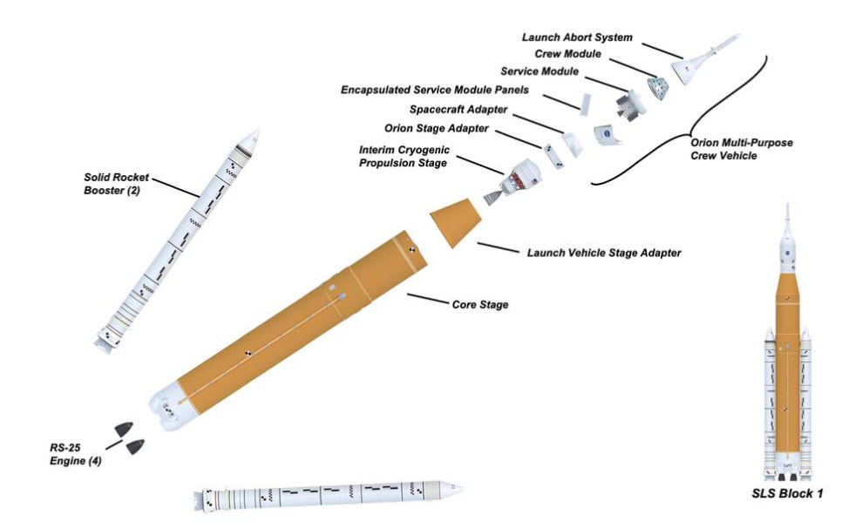
Fig. 1. Diagram of the Artemis Rocket parts

Figure II
Orion Spacecraft parts design
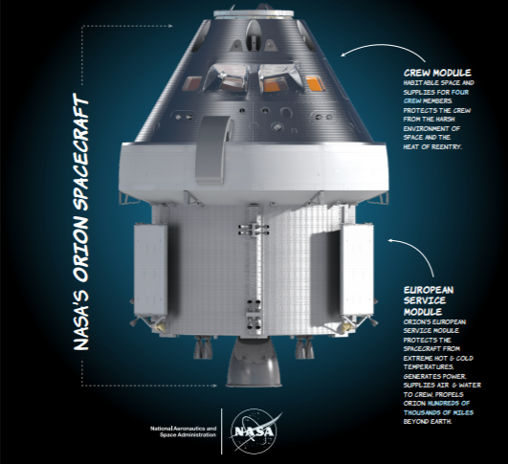
Fig. 2. Diagram of the Orion’s dual part design containing the Crew Module and the European Service Module

Completed Projects
Over the past 4 months, I have completed two projects, and I am currently working on an assignment that I plan to complete by the beginning of May. All the projects relate to the avionics responsibilities of the Artemis I, II, and III missions.

A. The Power Up Project
In order to support the launch of Artemis I, testing and health checks must be performed on the Orion Spacecraft to ensure a smooth and successful mission. For any team to perform a check or test on their equipment within Orion, the avionics C&DH team must be present to support. These checks and tests are only possible if the spacecraft is powered on. In powering on the vehicle, the Avionics team monitors the commands being sent to and from the vehicle. Aside from supporting testing conducted by other teams, the avionics branch must perform testing of their own. Both circumstances listed above require continuous monitoring of the spacecraft behavior. Because the task of monitoring the spacecraft is so significant, there are documented procedures for the avionics team to follow. Within these procedures, certain requirements must be met to verify proper behavior of electronic systems contained within the spacecraft. Two types of communication can exist between the avionics team and the vehicle: manual and automated. The project I was first tasked dealt with the automated command and data handling operations and procedures. I studied three different documents associated with powering up Orion which discussed the procedures and operations, the requirements, and the code that automated communication to and from the vehicle. After carefully reviewing all three documents, I created an excel file which organized and combined the information from each document into one flowchart. This flowchart had a time related organization so the Avionics C&DH team could follow the chart as they monitored the vehicle’s health in real time. This project took me about two months to complete and will be utilized by my team in the continuing processing of the Orion vehicle before launch. This project enabled me to further my understanding of python code, the computer architecture not only within Orion, but also throughout the entire rocket, and the tasks that the C&DH team regularly executes. Figure III pictures the Orion spacecraft inside of a facility in the Kennedy Space Center.
Figure III
Orion Spacecraft
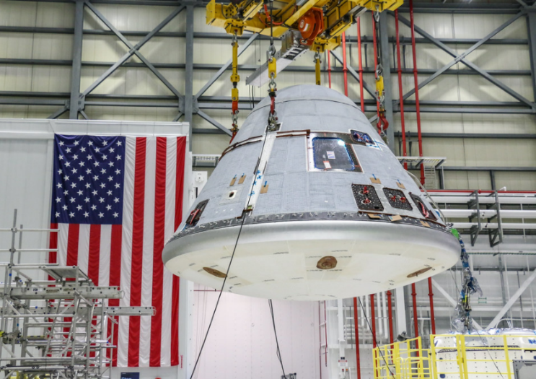
Fig. 3. NASA’s Orion Spacecraft at Kennedy Space Center in Cape Canaveral, FL pictured by NASA images

The Power Up Project, being my first project, took longer than expected as I had to familiarize myself with the language and processes at Kennedy Space Center. I needed to learn more about the center in general to really begin the project. Once I obtained the necessary information, I relied heavily on my A&M education to produce a successful product. As I was examining thousands of lines of code written by many different employees, I used techniques and previous coding experience that I gained through my engineering classes to understand exactly what I was reading. The coding experience I have gained in C++ and python in the past three years allowed me to understand the code that I was given. The code was a combination of coding languages which would have made it more difficult to understand if I had not had a diverse experience with coding languages in school. Not only did my experience in coding help me with this project, but the proper coding techniques I was taught also played a crucial role in my success. Specifically, the class Programming Studio gave me the necessary tool to read and understand code written by others. The completed project is accredited to a combination of my onboard training and schooling

My computer engineering degree is a mix of electrical engineering and computer science, allowing my internship experience to improve my skills in a multitude of ways. I relied on my electronic engineering education to understand how the software affects the electrical aspect of Orion. The code I reviewed automated command sequences that needed to be sent to the vehicle. These commands often affected the way a piece of electronic hardware behaved. I spent the first few weeks of my internship studying the electronic and computer architecture of the vehicle. The electronic engineering aspect of my degree plan allowed for the architecture designs to be more easily understood as I was already familiar with some of the terminology and equipment. This area of knowledge I received from A&M was essential to my ease of understanding the technical hardware aspects of the entire rocket.

B. Launch Countdown Road Map
The Kennedy Space Center in Cape Canaveral, Florida is the NASA center where most missions are launched. For each mission, there are an extraordinary amount of moving parts that come together to successfully launch both crewed and uncrewed missions. Because the nature of a launch is so dynamic and requires attention from numerous branches within the center, it is important for supervisors to swiftly and effortlessly know which teams are performing specific tasks at what time during the launch sequence. Per request of both my mentor and matrix supervisor, another intern and I collaborated to produce a road map of the Artemis I launch countdown. We were tasked with producing a road map that highlighted the Avionics tasks as well as key milestones for all divisions. In order to gain a better understanding of the events that the Avionics branch was responsible for, we set up meetings with a representative of each subsystem within Avionics. The Avionics group is comprised of four different subsystems: Command and Data Handling (C&DH), Guidance and Navigation/ Flight Controls (GNC), Engine Avionics (Engines), and Customer Avionics Interface Development and Analysis (CAIDA). The subsystems we needed a better understanding of included C&DH, GNC and Engines; CAIDA is not directly involved in a launch countdown. Once we were knowledgeable of all avionics responsibilities during the countdown, we spent a significant amount of time researching the best way to represent such a dynamic road map. We heavily considered the possibility of writing code to complete this project; however, because of cyber safety concerns and ease of accessibility, we decided on using excel to create our road map. We created four total roadmaps: an overview of every subsystem intended for use by supervisors for planning purposes and three individual in-depth, detailed subsystem roadmaps intended for use by any representative of the appropriate subsystem. This project was a key factor which contributed to my knowledge of the events that KSC performs throughout the two days of a launch countdown. These tasks range from monitoring the health of electronic components on the rocket to physically fueling the tanks. This project enabled me to understand how massive a launch is and how important it is to have everything go correctly in order to stay on track with the timeline. It helped me to appreciate the relevance of structural and maintenance tasks as it proved to be just as imperative to the team than a project directly related to hardware or software. The Launch Countdown Roadmap demonstrated the importance of proper preparation and planning of engineering developments, especially with massive projects such as a rocket launch.

Figure III
all systems road map
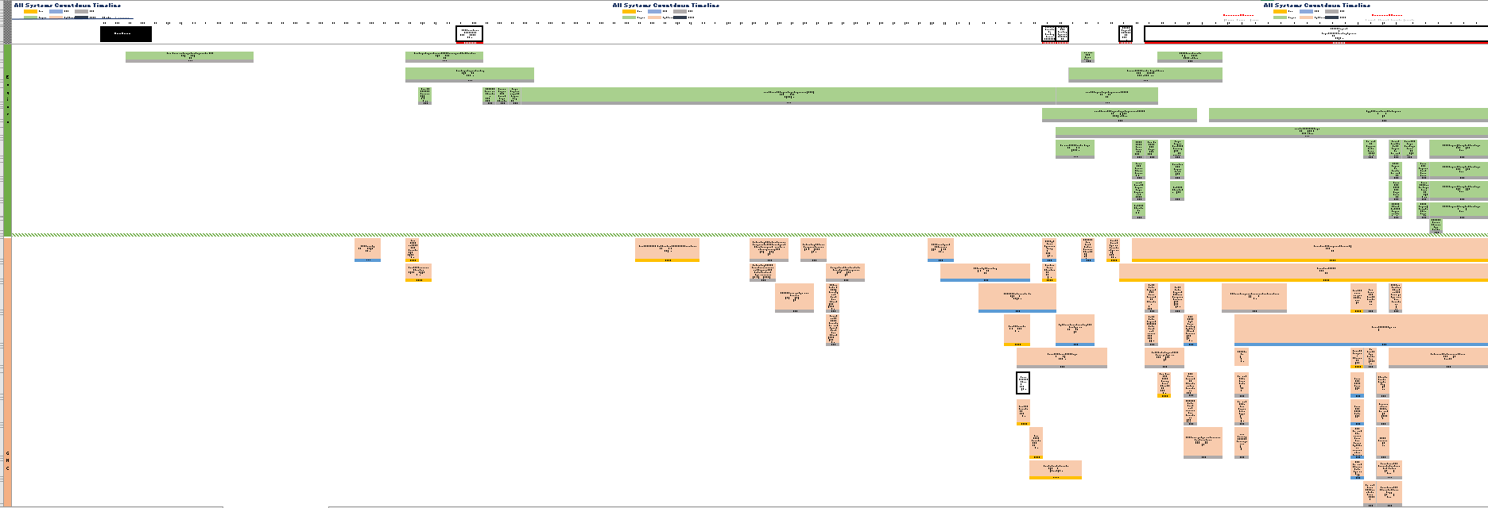

Fig. 3. Example of the overview roadmap created for supervisor use
Note this figure are not meant to be readable in order to preserve the confidentiality of the project

Figure IV
individual system road map
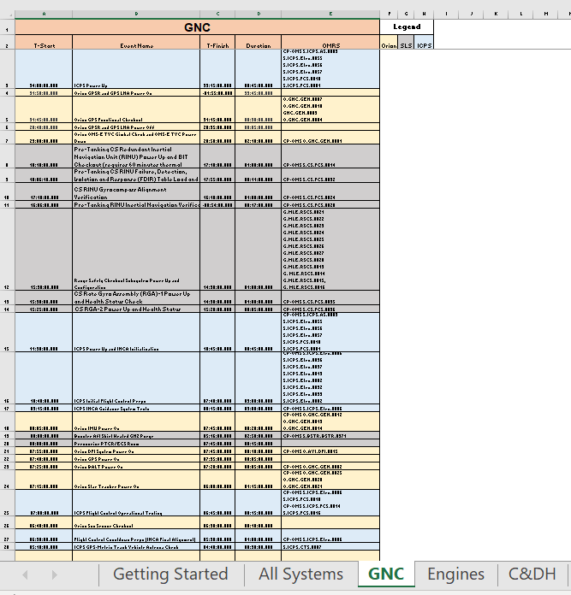

Fig. 4. Example of the detailed, individual subsystem roadmap
Note this figure are not meant to be readable in order to preserve the confidentiality of the project

Current Project
The C&DH group at Kennedy Space Center has masses of information to monitor during power ups, testing, and launches. While many commands are monitored and sent manually, there are a great deal handled by software. One of these software applications includes Fault Detection Isolation and Recovery (FDIR). FDIR is an algorithm created to detect and respond to onboard failures and faults. These failures can be caused by errors in telemetry, hardware failures, and even software issues. Although FDIR is a software that constantly checks for issues with the Orion vehicle, the C&DH group is still needed to manage the algorithm. My current project is related to the FDIR software. The FDIR algorithm is complex in nature and required me to spend a week and a half reading and digesting documentation and data spreadsheets related to the algorithm. As I understood the algorithm and its uses well enough, I began to write a python script which could map FDIR documentation to its associated data based off a common characteristic. This would then aid my mentor and his colleagues when they received any notification displaying an occurrence of a fault. Because my algorithm had not produced the correct output, I began doing a few instances manually in hopes of finding a pattern within the data. I believed having done a few of them manually would also help to debug my script. After a few days of working on this script, I was informed by my mentor that a different employee had completed a script accomplishing what I had set out to do. I then refocused my energy towards condensing the data and information about FDIR into a centralized document. This algorithm is used by many different branches; however, I plan to organize the information in a way that is most useful to the Avionics branch. My reasoning for this is because of the role Avionics has in FDIR related faults and failures. Any notifications that are displayed by the algorithm is noted by the avionics group, specifically the C&DH group. Many systems oversee the hardware and software related to FDIR issues, but it is the C&DH team that directs the faults to the right system for further handling. Essentially, they are the middlemen between the FDIR failures and faults and the system they belong to. Because of the important role C&DH has with communicating when an error has occurred, I will be tailoring the documentation to that group. The information related to FDIR contains algorithm flow charts and explanations which I will be extremely familiar with by the end of the project. This knowledge will help me with future tasks as I will have a better understanding of any faults and failures seen on the vehicles, expediting identification and recovery from such failures. Furthermore, this in-depth understanding will carry into my next project.

My next, and likely last project within this internship period, involves improving and expanding the current python script that was developed to map FDIR data and documentation to each other. The script I was given violates numerous python standards and can be significantly improved upon. This is not a highly critical task considering the script was written for personal reference but improving it can prove to be useful for my team. In addition to improving the code’s integrity, I will also develop and test a Graphical User Interface and create a user-friendly application where this script can be utilized by any employee within the Engineering organization. In doing so, I will eliminate the need to recreate the script if the data is updated or revised. The details of this project are confidential and cannot be further explained by figures or images.

Topics Learned
A. Life Lessons
NASA has over sixty years of experience and history before I came along as an intern. History that has transformed knowledge, technology, and science. This internship opportunity has been largely about learning what I can from them as much as it is bringing a fresh face and new ideas to the agency. Moreover, the history of NASA is more than mere facts; the risks that space exploration imposes on humans is significant as seen in the Challenger and Colombia accidents. Learning about the agency is vital to me so that as an engineer, I learn from the mistakes that have been made in the past. Throughout my internship experience, my mentors in the Avionics branch have been diligent in teaching me to respect the authority that exists in the agency, but to also have a voice and speak up when something does not seem correct. As an engineer, it is imperative that I have the comfort to speak up if something seems to go awry as it could save a life. The KSC employees have done an excellent job in providing me the opportunity to learn the history of NASA by requiring training sessions and intern meetings.

B. Technical Lessons
Although my education brought me where I am today, I have learned valuable lessons throughout my internship that I will carry into my future. I came into this internship at an opportune time where years of work are finally coming to fruition. Because of this, I spent much of my time learning the systems that have already been engineered. From my first project, I was able to conceptualize and comprehend some of the most complex pieces of code I have yet to encounter. Interacting with the code has broadened my understanding of programing languages and their capabilities which I can carry forward into my future endeavors. Not only did this project expand my knowledge of how coding can be used in the most advanced ways, having to read code that was written by teams of people also improved my current skillset. As I was reading the code, I often got lost in what the code was trying to execute. Since I did not write it myself, I had no true insight to the exact intent of the coders. After some time, I was able to find an answer to my own questions. Going through this process improved my skillset as a coder and as a code reviewer. From this project, I witnessed computer architecture apart from a textbook and school environment. I was given real life applications of FPGA programming and computer hardware architecture. These applications were brought to life when I was studying the SLS, ICPS, and Orion vehicles. The Orion spacecraft has several hardware boxes that enable its successful mission to the moon and back. I had the opportunity to understand the electrical and software components of these boxes. The complexity of these boxes alone provided a learning experience for me as I was able to draw on my previous electrical engineering experience and examine how my basic knowledge of circuitry and hardware components are used in advanced systems and applications.

My second project, the Countdown Timeline Project, extended my knowledge of the Avionics Branch past C&DH. With this project, I received a direct insight to the tasks that the Flight Controls and Engines teams complete throughout countdown. To have a better understanding of each group’s responsibilities for the Artemis missions, I requested meetings with a representative of each group to review their tasks in detail. Through these meetings, I not only gained exposure to other systems’ requirements and events, but I also realized the importance of completing each task with diligence and accuracy to contribute to the success of the Avionics branch. On a higher level, this project has given me insight on how to collaborate with others. The other intern and I had to meet with a handful of people to get the best understanding of their responsibilities. In doing so, I scheduled meetings with each individual requiring proactiveness and prompt communication. It also required adaptation and flexibility as the team was extremely busy and their schedules often did not align with ours. I also learned to be flexible in the way we constructed the product. The assignment was dynamic in nature, causing difficulty in choosing a product that could reflect such versatility. This challenged my previous experience with school projects where there is a clear and concise objective to achieve. The other intern and I had to use methods not used in our studies to brainstorm and decide on an overall design for the product. Having diversity between us taught me how to communicate our vastly different ideas in a respectful manner. Through our collaboration, I learned how to work closely with a peer and how to produce the most appropriate, unique solution in a timely, efficient manner. This project was extremely useful to enhance my knowledge of the more organizational roles that can exist within an engineering job.

Project three allowed me to grow the most technically. My time at A&M has taught me to code in mostly C++ programming language. While I believe C++ is extremely useful and versatile, I was tasked with programming in python. I had only taken one class on python about three years ago. Given this lack of preparation, I spent a few days researching python packages and syntax requirements. In the script that I had started on, I used two packages that I believed would be essential to its success: Numpy and Pandas. While using these two packages, I also learned a significant amount about python itself, thus expanding my coding skillset along the way. Although my project got interrupted before I could finish, I was still able to grow as a computer engineering student by exposing myself to the many capabilities within python.

IV. Conclusion
The dream of exploring the deeper sections of our solar system now seems attainable because of NASA and the Artemis mission. Artemis is the first step to taking humans beyond the Earths grasp and beyond our moon into deep space, millions of miles away. My internship with the Kennedy Space Center has given me the greatest opportunity to be affiliated with something revolutionary in the fields of science and technology. NASA requires adaptability, innovation, and dedication to achieve success. As an intern, I acknowledge that these characteristics are essential for an employee which is why I strive to have my work exemplify the ability to adapt and create individual solutions with each task I am given. As an intern, I hope to offer fresh ideas and a new perspective on the engineering work that my branch completes. My hard work and dedication to produce the most effective and creative solutions to unique problems is exemplified in the three projects I have contributed to: the Orion Power Up Project, the Launch Countdown Roadmap Project, and the FDIR project.

Furthermore, my education as an engineering student at Texas A&M adequately prepared me with the necessary knowledge and to perform my job duties. However, I realize that my knowledge has been expanded profoundly through the hand’s on experience of completing the projects and tasks I was assigned. In fact, I have tried to take initiative to expand my learning by the many training sessions and meetings that I have taken along with constantly asking my mentor questions. I have tried to take advantage of any opportunity to learn and I strive to complete all my tasks and actions at NASA with the highest quality I can achieve. It is extremely important to me that I work efficiently and effectively in order to minimize errors and produce useful products. In each of my projects, I took the necessary time to make they would be efficient and beneficial to our Avionics team. To perform at the best of my ability, I put in the required effort to research and study materials from the agency and I also had an open line of communication with my team. In addition to preparing me for coding and engineering projects, Texas A&M University prepared me exceptionally well in the area of communication. Throughout my three years studying at A&M, I have taken classes by professors who emphasize the student professor relationship. Thus, communication between student and professor was required. Not only has this helped me greatly in my professional relationship with my mentor and supervisor, it has also enabled me to excel in communication with my entire team and those supporting other branches. I feel comfortable talking in front of a group due to my experience in project presentations at A&M, and I feel I have been well-prepared in terms of communication and approachability by the University.

Part of my determination to perform at my best comes from the years of hard work that was required to succeed in the engineering program at Texas A&M. The professors ensured that nothing would come easily; that you must work for the grade you get. This mentality has strengthened me as an engineer because I do not expect anything to happen without putting in the proper effort. Furthermore, my classes required critical thinking, correct analysis of information, and innovative solutions to unique problems. In the subject of rockets and deep space, it is vital to think critically as issues and failures arise spontaneously and solutions must be conducted in a timely manner. These solutions also require the correct analysis of incoming data. In the realm of space and rocket science, it is imperative that these characteristics are present in employees. Although I have been and will continue to be excellently trained within the agency, I came into this internship having been finely prepared by my university.

My education both inside the classroom and out has allowed me to take on this internship with confidence along with a fair amount of humility about how much there is to learn. Without my education, I would not have qualified for this internship, a once in a lifetime experience, and is just the beginning of what I may achieve throughout my career.

Appendix
N/A

Acknowledgments
I express my utmost thanks to Dean Orr, Avionics Engineering Branch Chief and Bob Panzak, Avionic Systems Engineer for providing me with the unwavering guidance and support to enable my success in a telework setting. Despite their busy schedules, they took the time to listen, ask questions, and ensure they were available should I need anything. Their dedication to me as an intern enhanced my desire to perform optimally and furthered my desire to work in the Avionics branch.

References
- Engler, Tom. “Avionics Engineering.” NASA, NASA, .
- Dunbar, Brian. “Artemis.” NASA, NASA, nasa.gov/sites/default/files/atoms/files/artemis_plan-20200921.pdf
- Dunbar, Brian. “Humanity’s Return To The Moon.” NASA, NASA, nasa.gov/specials/artemis.

