Executive Summary

TITLE – Short Policy Brief

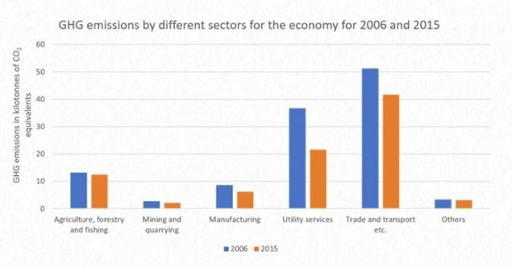
Graphs/Data (example)
Background
Context/Scope
Approach/Methodology

Place your own logos below

References
Image/Visual
Policy Recommendations
Results and Findings

