Lab 10  
Forrest Fallon  
  
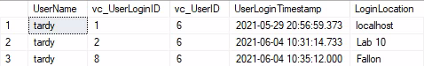

1. Because we selected the user “Tardy” and created a form dedicated to that user, Access sent that info over to the SQL server and let it know “hey, these changes were just made to this user on our software…thought you should know.” And the UserLogin timestamp is simply a datetime variable, so it automatically knows when this info was input or modified.
2. We told Access what relationship these two tables had to each other, so it knew that anything changed in one table should be noted on the other, based on what we told it to look for (UserID to UserID relationship).
3. Access is a bit more user friendly, we can simply click the dialog boxes and enter in the given data rather than run INPUT statements that could potentially affect all our data in the wrong hands.

**Part 2  
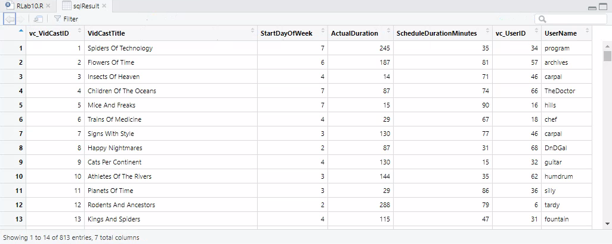**

1. This SQL code selects the vidcastID’s, title, and by using a DATEPART it separates the selected vidcasts into days of the week of which they were uploaded. This code then selects the total duration of minutes, and then the UserID’s and usernames.
2. We could create a function that returns the above for any given week. It would be more work up front than this single select statement but would save time later by just entering dbo.GetDayofWeek (or whatever it would be named).