Lab 05  
Forrest Fallon  
5/7/21  
  
**User Table  
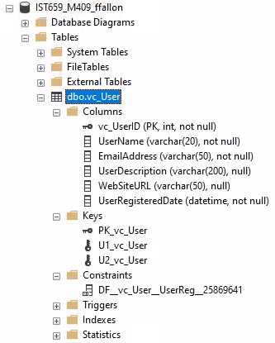**

**User Login Table  
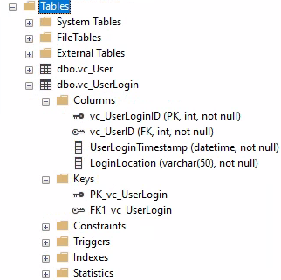**

**User Records  
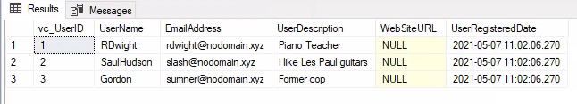**

**User Tables VidCast Tables  
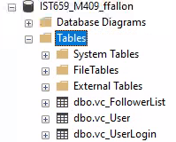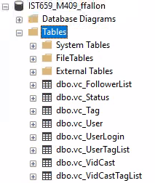**

/*

Author : Forrest Fallon

Script : Lab 05

Course : IST659 M400

Term   : April, 2021

*/

--Creating the User Table

Create Table vc_User (

--Columns for the User Table

vc_UserID int identity,

UserName varchar(20) not null,

EmailAddress varchar(50) not null,

UserDescription varchar(200),

WebSiteURL varchar(50),

UserRegisteredDate datetime not null default GetDate(),

--Constraints on the User Table

Constraint PK_vc_User Primary Key (vc_UserID),

Constraint U1_vc_User Unique(UserName),

Constraint U2_vc_User Unique(EmailAddress)

)

--End Creating the User table

--Creating the UserLogin table

Create Table vc_UserLogin (

--Columns for the UserLogin table

vc_UserLoginID int identity,

vc_UserID int not null,

UserLoginTimestamp datetime not null default GetDate(),

LoginLocation varchar(50) not null,

--Constraints on the User Login Table

Constraint PK_vc_UserLogin Primary Key (vc_UserLoginID),

Constraint FK1_vc_UserLogin Foreign Key (VC_UserID) References vc_User(vc_UserID)

)

--End Creating the User Login Table

--Adding Data to the User Table

insert into vc_User(UserName, EmailAddress, UserDescription)

values

('RDwight', 'rdwight@nodomain.xyz', 'Piano Teacher'),

('SaulHudson', 'slash@nodomain.xyz', 'I like Les Paul guitars'),

('Gordon', 'sumner@nodomain.xyz', 'Former cop')

select * from vc_User

--Creating the Follower List table

create table vc_FollowerList (

--Columns for the follower list table

vc_FollowerListID int identity,

FollowerID int not null,

FollowedID int not null,

FollowerSince datetime not null,

--Constraints on the Follower List table

constraint PK_vc_FollowerList primary key (vc_FollowerListID),

constraint U1_vc_FollowerList unique (FollowerID, FollowedID),

constraint FK1_vc_FollowerList foreign key (FollowerID) references vc_User(vc_UserID),

constraint FK2_vc_FollowerList foreign key (FollowedID) references vc_User(vc_UserID)

)

--End creating the Follower List table

create table vc_Tag (

vc_TagID int identity not null,

TagText varchar(20) not null,

TagDescription varchar(100),

constraint PK_vc_Tag primary key (vc_TagID),

constraint U1_vc_Tag unique (TagText)

)

create table vc_Status (

vc_StatusID int identity not null,

StatusText varchar(20),

constraint PK_vc_Status primary key (vc_StatusID),

constraint U1_vc_Status unique (StatusText)

)

create table vc_VidCast (

vc_VidCastID int identity not null,

VidCastTitle varchar(50) not null,

StartDateTime datetime,

EndDateTime datetime,

ScheduledDurationMinutes int,

RecordingURL varchar(50),

vc_UserID int,

vc_StatusID int,

constraint PK_vc_VidCast primary key (vc_VidCastID),

constraint FK1_vc_VidCast foreign key (vc_UserID) references vc_User(vc_UserID),

constraint FK2_vc_VidCast foreign key (vc_StatusID) references vc_Status(vc_StatusID)

)

create table vc_VidCastTagList (

vc_VidCastTagListID int identity not null,

vc_TagID int not null,

vc_VidCastID int not null,

constraint PK_vc_VidCastTagList primary key (vc_VidCastTagListID),

constraint FK1_vc_VidCastTagList foreign key (vc_TagID) references vc_tag(vc_tagID),

constraint FK2_vc_VidCastTagList foreign key (vc_VidCastID) references vc_VidCast(vc_VidCastID),

constraint U1_vc_VidcastTagList unique (vc_tagID, vc_VidCastID)

)

create table vc_UserTagList (

vc_UserTagListID int identity not null,

vc_TagID int not null,

vc_UserID int not null,

constraint PK_vc_UserTagList primary key (vc_UserTagListID),

constraint FK1_vc_UserTagList foreign key (vc_TagID) references vc_Tag(vc_TagID),

constraint FK2_vc_UserTagList foreign key (vc_UserID) references vc_User(vc_UserID),

constraint U1_vc_UserTagList unique (vc_TagID, vc_UserID)

)