**Lab 6  
Forrest Fallon**

**First VidCast  
**

**Saul’s First VidCast  
**

**Update a user  
**

**No more on time  
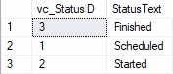**

**Tags**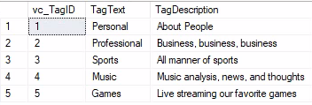Fixed it! I couldn’t truncate because of the foreign keys tied to other tables, and I didn’t want to start messing with relationships, so I deleted everything and re-entered. All set now!

**Users  
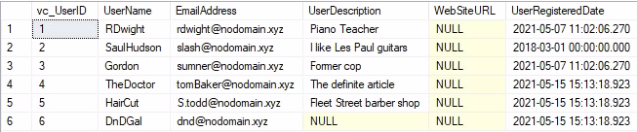**

**User Tag List  
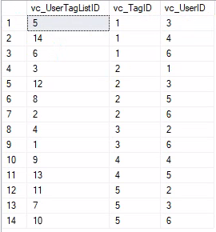**  
**UserTagsReport  
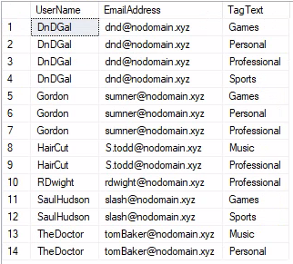**

-- Adding a row to the vc_Status table--

insert into vc_Status (StatusText)

values ('Scheduled')

select * from vc_Status

--Adding three more rowst ot he vc_stuatus table

insert into vc_Status (StatusText)

values ('Started'), ('Finished'), ('On Time')

select * from vc_User where UserName = 'SaulHudson'

select * from vc_Status where StatusText = 'Finished'

--adding a vidcast record to the VidCast table

insert into vc_VidCast

(VidCastTitle, StartDateTime, EndDateTime,  ScheduledDurationMinutes, RecordingURL, vc_UserID, vc_StatusID)

values

('December Snow', '3/1/2018 14:00', '3/1/2018 14:30', 30, '/XVF1234', 2, 3)

--read all rows from vc_VidCast

select * from vc_VidCast

select

vc_User.UserName,

vc_User.EmailAddress,

vc_VidCast.VidCastTitle,

vc_VidCast.StartDateTime,

vc_VidCast.EndDateTime,

vc_VidCast.ScheduledDurationMinutes / 60.0 as ScheduledHours,

vc_Status.StatusText

from vc_VidCast

join vc_User on vc_VidCast.vc_UserID = vc_user.vc_UserID

join vc_Status on vc_VidCast.vc_StatusID = vc_Status.vc_StatusID

where vc_User.UserName = 'SaulHudson'

order by vc_VidCast.StartDateTime

--correcting a user's UserRegisteredDate

update vc_User set UserRegisteredDate = '3/1/2018' where UserName = 'SaulHudson'

select * from vc_User where UserName = 'SaulHudson'

--see what rows we have in status

select * from vc_Status

--delete the On time status

delete vc_Status where StatusText = 'On time'

-- see the effect

select * from vc_Status

select * from vc_Tag

insert into vc_Tag (TagText, TagDescription) values ('Personal', 'About People'),

('Professional', 'Business, business, business'),

('Sports', 'All manner of sports'),

('Music', 'Music analysis, news, and thoughts'),

('Games', 'Live streaming our favorite games')

insert into vc_User (UserName, EmailAddress, UserDescription) values ('TheDoctor', 'tomBaker@nodomain.xyz', 'The definite article'),

('HairCut', 'S.todd@nodomain.xyz', 'Fleet Street barber shop'),

('DnDGal', 'dnd@nodomain.xyz', null)

select * from vc_User

INSERT INTO vc_UserTagList (vc_UserID, vc_TagID) VALUES(( SELECT vc_UserID FROM vc_User WHERE UserName='DnDGal'),

(SELECT vc_TagID FROM vc_Tag WHERE TagText='Sports')), (( SELECT vc_UserID FROM vc_User WHERE UserName='DnDGal'),

(SELECT vc_TagID FROM vc_Tag WHERE TagText='Professional')), (( SELECT vc_UserID FROM vc_User WHERE UserName='RDwight'),

(SELECT vc_TagID FROM vc_Tag WHERE TagText='Professional')), (( SELECT vc_UserID FROM vc_User WHERE UserName='SaulHudson'),

(SELECT vc_TagID FROM vc_Tag WHERE TagText='Sports')), (( SELECT vc_UserID FROM vc_User WHERE UserName='Gordon'),

(SELECT vc_TagID FROM vc_Tag WHERE TagText='Personal')), (( SELECT vc_UserID FROM vc_User WHERE UserName='DnDGal'),

(SELECT vc_TagID FROM vc_Tag WHERE TagText='Personal')), (( SELECT vc_UserID FROM vc_User WHERE UserName='Gordon'),

(SELECT vc_TagID FROM vc_Tag WHERE TagText='Games')), (( SELECT vc_UserID FROM vc_User WHERE UserName='HairCut'),

(SELECT vc_TagID FROM vc_Tag WHERE TagText='Professional')), (( SELECT vc_UserID FROM vc_User WHERE UserName='TheDoctor'),

(SELECT vc_TagID FROM vc_Tag WHERE TagText='Music')), (( SELECT vc_UserID FROM vc_User WHERE UserName='DnDGal'),

(SELECT vc_TagID FROM vc_Tag WHERE TagText='Games')), (( SELECT vc_UserID FROM vc_User WHERE UserName='SaulHudson'),

(SELECT vc_TagID FROM vc_Tag WHERE TagText='Games')), (( SELECT vc_UserID FROM vc_User WHERE UserName='Gordon'),

(SELECT vc_TagID FROM vc_Tag WHERE TagText='Professional')), (( SELECT vc_UserID FROM vc_User WHERE UserName='HairCut'),

(SELECT vc_TagID FROM vc_Tag WHERE TagText='Music')), (( SELECT vc_UserID FROM vc_User WHERE UserName='TheDoctor'),

(SELECT vc_TagID FROM vc_Tag WHERE TagText='Personal'))

select * from vc_UserTagList

select vc_User.UserName, vc_User.EmailAddress, vc_Tag.TagText from vc_User

join vc_UserTagList on vc_UserTagList.vc_UserID = vc_User.vc_UserID

join vc_Tag on vc_Tag.vc_TagID = vc_UserTagList.vc_TagID

order by vc_User.UserName, vc_Tag.TagText