Lab 04  
Forrest Fallon  
5/4/21

**Case Study 2  
2NF:** OrderItem(*Order Num,* Line, Item Number, Description, Qty Ordered, Price Each)

**3NF:** OrderItem(*Order Num,* Line, Item Number, Qty Ordered)

ItemData(*Item Number,* Description, Price Each)

**Case Study 3  
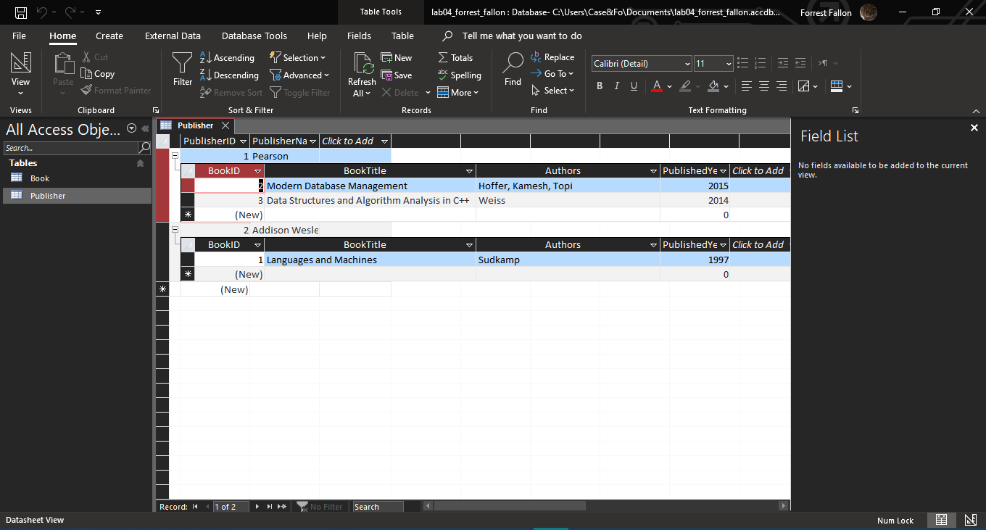**

**Part 2  
1NF:**

VideoData(Video ID, Video Title, User Name, User Tier, Min Tier Followers, Stream Start, Video Duration (mins), Content Rating, Rating Description)

**2NF:**

VideoData(Video ID, Video Title, User Name, Stream Start, Video Duration (Mins), Content Rating, Rating Description)

UserData(*User Name,* User Tier, Min Tier Followers)

**3NF:**

VideoData(Video ID, Video Title, User Name, Stream Start, Video Duration (Mins), Content Rating)

RatingData(*Content Rating,* Rating Description)

UserData(*Video ID, User Name,* User Tier)

FollowerData(*User Tier*, Min tier followers)