Procedural Terrain Generation for Games Project

Fabio Peres Filho

ma301fp

Supervisor: Dr Marco Gillies

\begin{center}

**\includegraphics**[height=70mm]{MERLIN.jpg}

\end{center}

\cite{KuhnScottAndreev2008}

**Acknowledgments**

I would like to thank everyone who was involved in this project somehow, in particular I would like to thank Marco Gillies for spending his time supervising me in this project and for his guidance and advice through the course and this project. I also need to give a big thank you to Lahcen Quarbya and Kate Devlin, for supporting me when times were pretty dark in my life. A special thank you for Liam Robinson, my classmate and currently business partner for helping always push a little more when coding come to the table, another one to Aonghus O’Kelly, good friend and adviser.

A huge thank you to my family, my father Miguel Peres Filho, my mother Magda Freire Peres and my brother, Rodrigo Freire Peres for always believe on me and to my dear wife Krittika Phakbunduphong, for all support along last three years.

Contents

Introduction 4

1.1 The project and Aims 4

1.2 Motivation 4

1.3 Required Tools 4

1.4 Overview of report 5

2 Background Research 6

2.1 Procedural Content Generation Overview 6

2.2 Existing Games Using PCG 6

2.3 Motivation and Justification 6

2.4 Project Aims 6

3 System Design 7

4 Implementation 8

5 Testing 9

6 Evaluation 10

7 Conclusion 11

A Reference 12

B Bibliography 13

C Screen Shots 14

D C# Code 15

Chapter 1

# Introduction

## The project and Aims

This project is named Procedural Terrain Generation Project and as the name suggests it will use procedural content generation - PCG – and related techniques, a good understanding of random numbers generation, such as noise, and polygons to create meshes. The aim here is to produce terrain meshes and different biomes using height map to produce random numbers.

## 1.2 Motivation

The idea for this project came after I gave up a super ambitious idea to make a MMO for this project. As my supervisor Marco advise me that would be too much to research and implement for the time available for doing this project.

Then after looking on the internet about old games styles with friends, the game ‘Diablo I’ came to my screen. I was always intrigued by the fact that every time I played this game, all dungeons were different. Besides any boss level, all level maps were different. After some very preliminary research about those maps, I have discovered that the maps were actually created procedurally and not architecture by an artist level designer of some kind.

Allied to the fact that I was extremely involved in a level design map in a project during my second year, ‘The Midnight Man’ project, it seems to be irresistible the possibility to create a level map again but at this time with a different approach, instead of doing a terrain map using a graphical 3D renderer software to create the level, I could use procedural content generation to create the map using just code, what would be a perfect project idea taking in mind that my degree is a programming oriented course.

## 1.3 Required Tools

The project will be produced by using the Unity3D game engine, and such requires a very good understanding of C# programming language. In addition to that, mathematical understanding of random numbers generation, in particularly to noise and perlin noise to produce a height map that will be used to determine the shape of the terrain level. Once the shape of the terrain is done, we will generate meshes based in a colour map and set the height of the Y-axis to the height value generate by the noise function.

This project is hosted at **LINK TO REPOSITORY**

## 1.4 Overview of report

Must be done yet

Chapter 2

# Background Research

This chapter will list and detail most of the research undertaken for this project, but not all, since before starting the development of the project itself, during the development and further research on later stages of the implementation. I would say the research for this project could defined as a ‘work in progress research’.

## Procedural Content Generation Definition

Before start the overview of procedural content generation and defines what it is, we need to start with something a little bit more dry: definitions, of course.

Julian Togelius on his book, ‘What is Procedural Content Generation?’ (2011) stated the definition of procedural content generation as the algorithmical creation of content with limited or indirect user input.

That means, PCG is related to a software that can create own its own, or using parameters entered in the system by a user, content.

## Definition of the word Content

The definition of content here is my own definition after extensive research. Content here is anything that can be described and coded. If you can describe a feature, what it is, how it works or how it could behave, then a programmer can code this feature. Content here is this feature. Could be many things, such as terrains, levels, maps, textures, items, music. Bringing this more related to games (after all I am a game programming student), content could easily be quests, weapons, cars, cities, enemies, world maps, set of rules that must be follow by an AI agent (such as in Stellaris).

Therefore, the word content here cannot be misunderstood as the game itself or a non-player character behaviour – NPC. The game itself is not considered to be content itself because it is not created completely by a software although it is a software. A Non player character behaviour is a method related to artificial intelligence – AI - as an autonomous agent instead of procedural content. PCG is of course a branch of artificial intelligence, because it is largely based on AI methods.

## Definition of procedural and generation

The word generation is almost self-explanatory, is means something created by the procedural method of generation (creation). Procedural is related to something created by procedures. A computer follows procedures to executes code. Therefore, procedural is an algorithm, is computer code that creates, generates something (content).

## 2.1.3 Procedural Content Generation in Games

Procedural content generation in games is when part of the game, some features or just one of its features are created and generated by code, without data entered by the user or with indirect input by the gamer/user.

These features could be of many types and for many different reasons. For example:

* In the game series Diablo, created and developed by Blizzard Entertainment Inc., there is a PCG feature that creates dungeons for an action, role play game – RPG, hack-and-slash game without any input by the player-hero.
* In the game series Civilization, Sid Meyers Studios uses procedural content generation to create the world map, without user input or with few parameters input by the user, such as size of the world, type of the world (which includes temperature of the world, age of the world, level of water of the world). All those parameters changes how the final world map will look like, but the landscape and shape have no parameters what so ever.
* PCG could be used to populate a world with vegetation, animals, people, etc.
* A feature that procedurally generates different races with different traits in every single game in Stellaris.
* And of course, a feature that could generate a terrain map, with or without different biomes for a game as well, which is the scope of this project.

## Why use PCG and Existing Games Using PCG

Nowadays, exists almost an uncountable number of game studios that uses procedural content generation as a tool to create part of the features of their games.

One of the first and maybe most important reason to procedurally create game content is financial. Human work is either expensive and slow (comparing to computers for calculations). If one can remove the human component (an artist or level game designer) for example, and replace it with a creating of content by code, that means, procedurally generation, it reduces the costs significantly, which gives more room to a game become profitable and then commercially successful.

Another reason is the fact that, to procedurally create something, the description must be near perfection. If one can describe so good a system, this person will understand better the design process of that feature, which increases the performance of the system that uses it.

For one of the two reasons above, or even for another reason not actually mentioned on this report, some of the listed games below incorporated procedural content generation of some kind on their games:

* Diablo series (<https://en.wikipedia.org/wiki/Diablo_(series))>

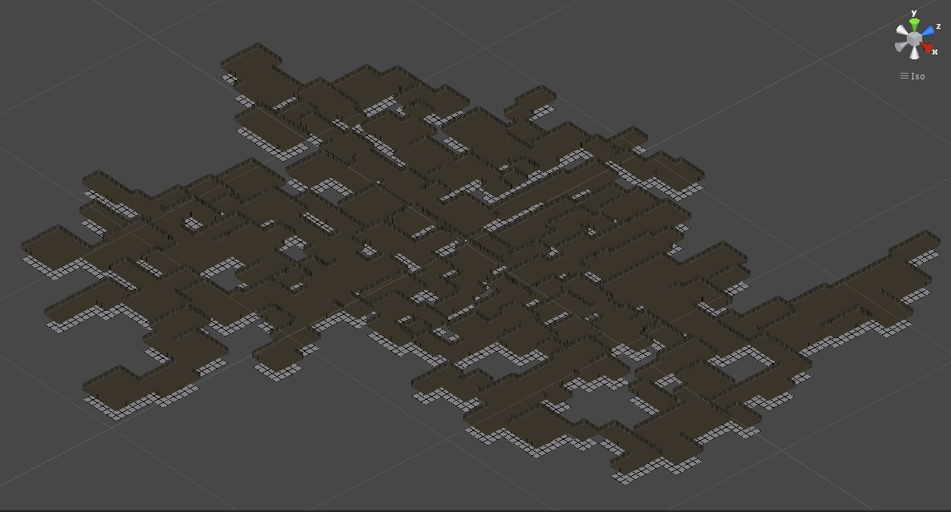

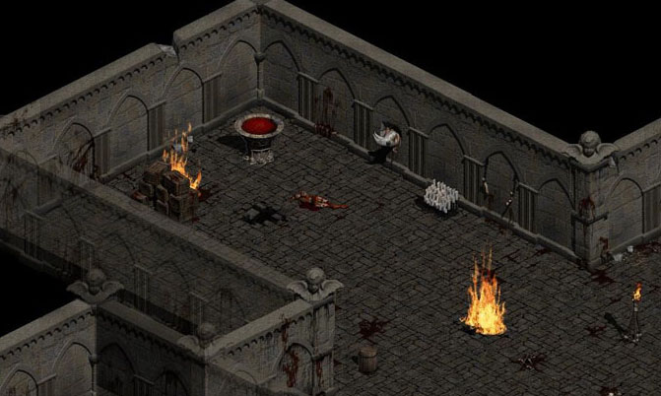

* Civilization series (<https://en.wikipedia.org/wiki/Civilization_(series)>)

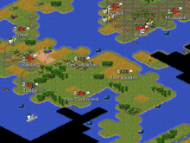

* Minecraft (<http://minecraft.gamepedia.com/Minecraft_Wiki>)

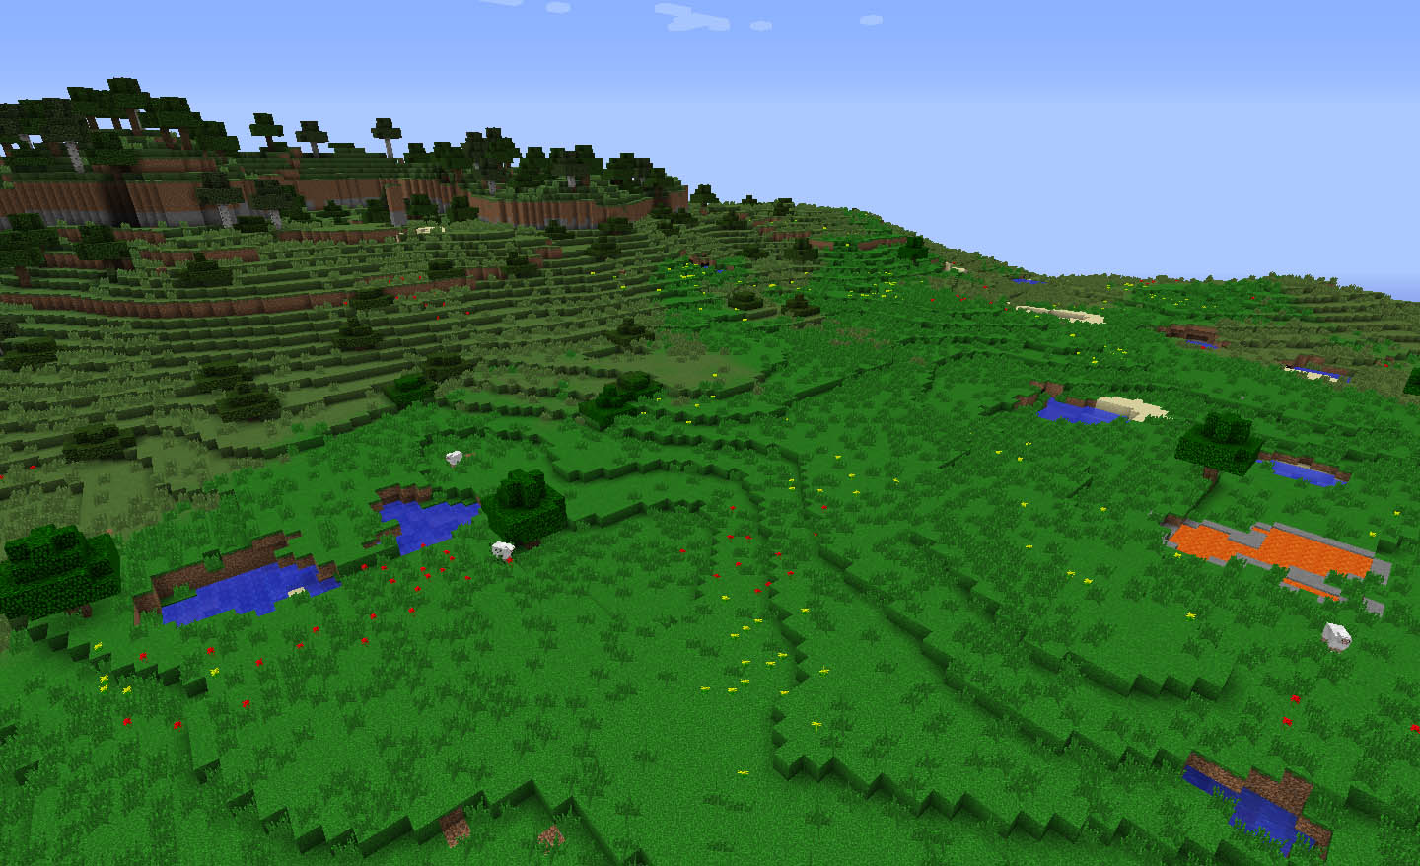

The games listed above are just an exemplification and not an exhaustive list of the games currently using PCG.

## Random Numbers Generation and seed

There are two main methods today to generate random numbers. The first method of generate random numbers is to measure physical phenomena. These physical phenomena are expected to be random. Example of this is atmospheric noise, thermal noise and quantum phenomena.

The second type of random numbers generation is the one that actually interest to this project, the computational algorithms that can produce very long streams of apparently random results. This sequence of random numbers, are in fact completely determined by a shorter initial value know as seed value or key.

As a product of this seed or key, the entire result that seems to be a random sequence of numbers, can be reproduced any time on demand, if and only if the exact same seed is entered again in the algorithm that generates the random number, reason why is also called pseudo-random numbers.

In conclusion, a pseudo-random number generator based only on a deterministic logic (not include natural source), can never be considered as a “true” random number. The function that actually calculate this number will eventually show some form of pattern, but the time consumed to us notice that is so big, that we still can use as ‘randomness’.

There are also some other methods that try to generate a random number based on a probability density function, or generation from a probability distribution.

## 2.2.1 Probability and Non-Uniform Distribution

Probability is defined in the Wikipedia as the measure of the likelihood that an event will occur. Probability is scale from 0 to 1, where 0 is the impossibility and 1 is the certain occurrence of the event.

A non-uniform distribution is when some weight is added to the probability of an event. For example: if a random number generator is set to return 3 values, 1, 2 or 3. If we add those numbers to an array of size 5, and add number 1 to first two elements of the array, number 2 to the third element and number 3 to fourth and fifth elements, then we randomly generate a number between 1 and 5, which will return on of the elements of the array, we have a non-uniform distribution of the numbers 1, 2 and 3, because we have 40% chance to return number 1 and 3 and 20% to return number 2.

## 2.2.2 Normal Distribution of Random Numbers

Normal distribution, also known as Gaussian Distribution is when all values are in a determined range but they are clustered at the average or mean point between both minimum and maximum values.

Any value is generated by a function, which is defines the probability of likelihood that value can occur, comparing it to the mean.

In a Gaussian Distribution, some concepts are important to define: mean, difference from mean, variance, average variance and standard deviation.

The mean is calculated by the average of the values.

Difference from mean is the subtraction of the value by the mean, on this order.

Variance is square root of the difference from mean of the value previously calculated by difference from mean.

Average variance is the average of all variance values, added together and divided by the number of values.

Standard deviation is the square root of the average variance.

The following example was extracted from Daniel Shiffman, “The Nature of Code”, 2012, online version at <http://natureofcode.com/book/introduction/> last visited on 15/08/2016.

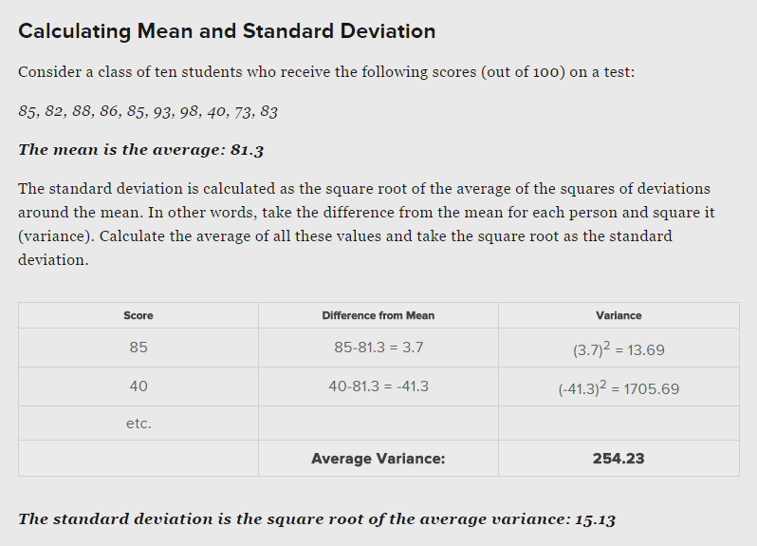

2.2.2 Regular Noise

Values picked randomly between 0 and 1

## 2.2.3 Perlin Noise

Is a type of coherent noise, which means changes occur gradually

## 2.3 Motivation and Justification

## 2.4 Project Aims

# Chapter

# System Design

* 1. Terminology

Amplitude is related to the Y-axis

Frequency is related to the X-axis

Octave will be consisted of a noise map

Layering octaves will be to add detail and preserve the actual shape of the noise

* 1. System Requirements

In order to ensure that aims and objectives set for this project are met and, to help testing e evaluating this procedural terrain generation software, a set of clear requirements for each component of the project are defined as follows:

3.2.1 C# Programme Requirements

1. Program the noise generation class using perlin noise

To add detail and preserve the actual shape, it can be done by laying multiple levels of noise.

Then we can have 3 noise maps, commonly called octaves, and add then together to get a map

As each octave increases in detail, its influence should decrease.

Generating height maps using perlin noise

Assigning terrain types to the vary height ranges

Construct 3D mesh using this information

# Chapter 4

# Implementation

In this chapter, the implementation of the project will be explained in detail. The code for the critical parts of the project will be included here with a correlated description of how the code works, what is doing and what result it achieves.

The chapter is broken down into sections in the same order of implementation when writing the code.

4.1 C# Programme

The following code is some of the key programming features of the project. It is written in the programme language C#, in Visual Studio for Unity3d game engine. It is explained in detail. The complete code of the program will be added to the appendix.

The program is divided into 6 parts:

* 1st part is the creation of a noise generator
* 2nd part is the creation of a map generator
* 3rd is the creation a map displayer
* 4th is the creation of an editor setting
* 5th is the creation of a texture generator
* 6th is the creation of a mesh generator

Disclaimer: in order to obtain more flexibility when writing and testing the code in Unity3D game engine, most of the variables DO NOT respect the encapsulation rule for object oriented programming.

## 4.1.1 Noise Generator

The following code is the final version of the a NoiseGenerator class. It is one of the most important features of the entire program. It is responsible for create and store perlin values by using the build-in random perlin noise function: Mathf.PerlinNoise(float a, float b) to a two-dimensional array. It also made use of seed, and therefore one could repeat the same noise map once the parameters a set equal of a previous one.

It does not inherit from monobehaviour because it will not be instantiated any object from it in the scene and will also be a static class because it does not need to create multiple instances of this class.

public static class NoiseGenerator {

// a method to generate a noise map and return a grid o values to be returned between 0 and 1

public static float [,] MapNoiseGenerator (int mapWidth, int mapHeight,

float scale, int numberOctaves, float persistance, float lacunarity, int seed, Vector2 offset)

{

The class start with a function with a massive number of parameters.

The MapNoisegenerator take as parameters 8 values: mapWidth and mapHeight are the dimensions of the terrain that will be created. numberOctaves are the number of layers, or number of noise maps that the terrain will have. Seed is an integer that controls the creation of pseudo random number generation. With the build-in system of Unity3D, when a parameter is entered, the random number will always be the same. If the seed is always the same, the ‘random number’ will always be the same.

Persistence is related to control the decrease of amplitude of the octaves and lacunarity is related to control the increase of frequency of the octaves.

float[,] mapNoise = new float[mapWidth, mapHeight];

System.Random pseudoRandomNumberGenerator = new System.Random(seed);

// In order to sampling from different locations, and array of vector2 is used

Vector2[] octaveOffsets = new Vector2[numberOctaves];

Then a two-dimensional array of float is used to store the map noise generated by the class and afterwards transfer the information to different parts of the code.

Then a pseudo random number generator is used to delivery numbers. A seed is passed as parameter to allow the reproduction of same noise maps.

To store samples from different parts of the noise map, a 2D vector is used and its size is the number of layers that the ultimate noise map will have, provided by the number of octaves.

for(int i = 0; i < numberOctaves; i++)

{

// we also could scroll through the noise by providing our own offset value

float offsetX = pseudoRandomNumberGenerator.Next(-100000, 100000) + offset.x;

float offsetY = pseudoRandomNumberGenerator.Next(-100000, 100000) + offset.y;

octaveOffsets[i] = new Vector2(offsetX, offsetY);

}

This for loop have a special intension. To iterate through the number of octaves or noise layers and generate two numbers in between a hundred thousand negative and a hundred thousand, plus a user input offset, for both x and y coordinates. It will then store the values into the Vector2D array.

// an error handler in case of scale is set to 0 (impossible division by zero)

if (scale <= 0)

{

scale = 0.000001f;

}

The next piece of code is simply an error handler to avoid the division by zero.

for (int y = 0; y < mapHeight; y++)

{

for (int x = 0; x < mapWidth; x++)

{

float amplitude = 1;

float frequency = 1;

float noiseHeight = 0;

for(int i = 0; i < numberOctaves; i++)

{

// accessing sample coordinates

// adding a scale for the noise in order to not get rounded integer values

// the higher the frequency, more distant the sample points will be and therefore, more

// rapidly that values will change

float coordinateSampleX = (x - halfWidth) / scale * frequency + octaveOffsets[i].x;

float coordinateSampleY = (y - halfHeight) / scale * frequency + octaveOffsets[i].y;

// generate a 2D perlin noise value

// by multiplying by 2 and subtracting by 1 we will

// increase the range from 0 to 1 to -1 to 1, since the PerlinNoise function only deliveries

// values in the range of 0 to 1

float perlinValue = Mathf.PerlinNoise(coordinateSampleX, coordinateSampleY) * 2 -1;

// apply the values to the noise map

noiseHeight += perlinValue * amplitude;

// at the end of each octave

amplitude *= persistance;

frequency *= lacunarity;

}

if(noiseHeight > maxNoiseValue)

{

maxNoiseValue = noiseHeight;

} else if(noiseHeight < minNoiseValue)

{

minNoiseValue = noiseHeight;

}

// it will apply the noiseHeight to the noiseMap

mapNoise[x, y] = noiseHeight;

}

}

The code above is the heart of the noise generator class. It iterates the noise map two-dimensional array to store noise height values. It accesses a particular coordinate, within an octave (or layer). Then to calculate a noise value to a particular sample, it divides the coordinate sample by the scaler, multiply by the frequency, which a higher frequency, more distant the sample point will be and therefore more rapidly changes will occur and add on octave offset.

Then invoke the build-in perlin noise function of Unity3D game engine, which we already explain how it works during our research explanation of requirements. Calculates the perlin noise value to the coordinate sample for both x and y access.

To make more interesting results, we enlarge the range of the perlin noise from the default mode from 0 to 1 to -1 to 1 by multiplying the perlin noise value by 2 and subtracting 1.

Apply persistance and lacunarity to amplitude and frequency respectively.

In order to be able to normalized afterwards, the maximum and minimum noise values are saved.

Finally, the function will return the noise map generated.

## 4.1.2 Map Generator

The map generator class must inherit from monobehaviour because will be instantiated in the scene. Once again a disclaimer here: all variables here DO NOT respect the encapsulation rule of the object oriented programming and are set to be public in order to easily changes in the inspector and instant feedback.

public class MapGenerator : MonoBehaviour {

// Create a enumerator to determine which mode it will be displayed

public enum DisplayMode { NoiseMap, ColourMap, Mesh};

public DisplayMode displayMode;

public int mapWidth;

public int mapHeight;

public float scale;

public int numberOfOctaves;

[Range(0, 1)] // set the persistance to range between 0 and 1

public float persistance;

public float lacunarity;

public int seed;

public Vector2 offset;

// a boolean to update the noise map when the generateMap is pressed again

public bool updateNoiseMap;

public TypesOfTerrain[] biomes;

public float meshHeightValueMultiplier;

public AnimationCurve meshHeightCurve;

Almost all input that can be changed by the user is found here. Variables are defined here first, such as octaves, persistence and lacunarity, seed, and is carried out through the program from here.

The first thing in the class is to declare an enumeration of three different types of enumerators, which are one for noise map mode, another one for colour map mode and finally one to display a mesh mode. Also creates a reference to an DisplayMode object called displayMode.

The range of the persistence is set be in between 0 and 1. Later in the code, other constrains to those variables are added.

Also a reference to a struct array is created. This struct will hold all the possible biomes that someone can enter in the inspector.

A float that will store the value that will actually multiplier the Y-axis of the 3D mesh making all the terrain goes up from its original point.

Last variable is an animation curve to deal with the problem encountered when there is not a trash-hold for the height value of the water biome.

public void mapGen()

{

float[,] noiseMap = NoiseGenerator.MapNoiseGenerator(mapWidth, mapHeight, scale, numberOfOctaves, persistance, lacunarity, seed, offset);

Color[] colourMap = new Color[mapWidth * mapHeight];

for(int y = 0; y < mapHeight; y++)

{

for (int x = 0; x < mapWidth; x++)

{

float currentHeightValue = noiseMap[x, y];

for(int j = 0; j < biomes.Length; j++)

{

if(currentHeightValue <= biomes[j].height)

{

colourMap[y * mapWidth + x] = biomes[j].colour;

break; // we have found our biome and dont need to continue

}

}

}

}

// Reference to map displayer class

MapDisplayer dis = FindObjectOfType<MapDisplayer>();

if(displayMode == DisplayMode.NoiseMap)

{

dis.DrawTextureToScreen(TextureGenerator.TextureFromHeightMap(noiseMap));

}

else if(displayMode == DisplayMode.ColourMap)

{

dis.DrawTextureToScreen(TextureGenerator.TextureFromColourMap(colourMap, mapWidth, mapHeight));

}

else if(displayMode == DisplayMode.Mesh)

{

dis.DrawMeshToScreen(MeshCreator.TerrainMeshCreator(noiseMap, meshHeightValueMultiplier, meshHeightCurve),

TextureGenerator.TextureFromColourMap(colourMap, mapWidth, mapHeight));

}

}

The mapGen function is responsible for actually generate the colour map from the noise map.

It will iterate through the values of the noise map, and based on the values of each biome, which were set in the inspector, will store a colour value to an array of colours for that particular x and y coordinate.

The function will also check which mode is currently set in the inspector, and then will call the display function of the appropriated mode to be drawn in the scene.

void OnValidate()

{

if(mapWidth < 10)

{

mapWidth = 10;

}

if(mapHeight < 10)

{

mapHeight = 10;

}

if (lacunarity < 1)

{

lacunarity = 1;

}

if (numberOfOctaves < 1)

{

numberOfOctaves = 1;

}

}

This function just imposes limits to the values, acting like constrains of values in the inspector.

## 4.1.3 Map Displayer

This class is a support class for this project.

Using many build-in features of Unity3D game engine, such as, the Renderer class, MeshFilter class, MeshRenderer class and Texture2D. It allows the display of the textures and meshes on the screen.

It set a reference to the plane primitive game object in the scene, so then we could manipulate values on it and render textures, attached to materials using shaders, by using the textureRenderer renderer to transform a 2D texture in a 3D world space. This is exact what happen when textureRenderer.transform.localScale = new Vector3(texture.width, 1, texture.height); is invoked.

// It will also be instantiate in the scene and therefore must inherit from monobehaviour

public class MapDisplayer : MonoBehaviour {

// Here we will need to set a reference of the renderer of the plane in the scene to be used

// later on the set its texture

public Renderer textureRenderer;

// a public reference to a mesh filter

public MeshFilter meshFilter;

// a public reference to a mesh renderer

public MeshRenderer meshRenderer;

public void DrawTextureToScreen(Texture2D texture)

{

textureRenderer.sharedMaterial.mainTexture = texture;

textureRenderer.transform.localScale = new Vector3(texture.width, 1, texture.height);

}

public void DrawMeshToScreen(MeshData meshData, Texture2D texture)

{

meshFilter.sharedMesh = meshData.CreateMesh();

meshRenderer.sharedMaterial.mainTexture = texture;

}

}

## 4.1.4 Editor Setting

The editor setting class as works for monobehaviour, inherits its functionalities from the UnityEditor library, and therefore it inherits from the Editor super class.

In the editor setting class a public void function that allow this class to override OnInspectorGUI UnityEditor function is created.

public override void OnInspectorGUI()

This function is needed to create a reference to the map generator class.

MapGenerator mg = (MapGenerator)target;

Where the word target here is the object that this custom editor is inspecting and then cast that object to a map generator.

if (DrawDefaultInspector())

{

if (mg.updateNoiseMap)

{

mg.mapGen();

}

}

if(GUILayout.Button("GenerateMap"))

{

mg.mapGen();

}

The first of the nested if statement is to detected when the default inspector, and in the second nested if statement, the object mg, in case of its updateNoiseMap box is selected, it will generate a map.

The second if statement creates a button writing now on it GenerateMap. Once this button is pressed, it will also generate the map.

## 4.1.5 Texture Generator

The texture generator class is a class used to generate textures within two different possibilities, from a height map and from a colour map.

Due to the fact that this class will not be instantiated in the scene, it will not inherit from monobehaviour. It will also be a static void once we do not need multiple instances of this class.

// This will create a texture from an one-dimensional array colour map

public static Texture2D TextureFromColourMap(Color [] colourMap, int width, int height)

{

Texture2D texture = new Texture2D (width, height);

// This fix the blurring effect of the texture

texture.filterMode = FilterMode.Point; // instead of bilinear

// To fix the border of the map

texture.wrapMode = TextureWrapMode.Clamp;

texture.SetPixels(colourMap);

texture.Apply();

return texture;

}

The first function of this class is to generate a texture from a colour map stored in an one-dimensional array of colours, as the name suggests TextureFromColourMap.

It takes 3 parameters, one being the already mentioned one-dimensional array of colours, a width and a height for that colour.

Then a reference to an 2D texture in Unity3D is created using the parsed width and height.

The next two lines of code is just to correct some of the blurring and wrap imperfections of the map created.

Then we set to the texture the values in the colour map itself. Then finally we apply the buffered texture to the texture variable itself and return it.

// another method to get a texture based on a 2D height map

public static Texture2D TextureFromHeightMap(float[,] heightMap)

{

int width = heightMap.GetLength(0); // for the first dimension

int height = heightMap.GetLength(1); // for the second dimension

// Create a colour array to store all the colour of the pixels.

// For efficiency, all values will be added to a one-dimensional array

Color[] colourMapContainer = new Color[width * height];

//Then I need to loop through noiseMap array to extract the value

for (int y = 0; y < height; y++)

{

for (int x = 0; x < width; x++)

{

// This technique is used to turn values from a two-dimensional array

// into a one-dimensional array

// in the lerp function, the first 2 parameters are the colours set as minimum and

// maximum values to lerp through, and the percentage will be 0 and 1, which is the same

// as the range of the noiseMap

colourMapContainer[y * width + x] = Color.Lerp(Color.black, Color.white, heightMap[x, y]);

}

}

return TextureFromColourMap (colourMapContainer, width, height);

}

This second function of the class texture generator is used to return a 2D texture from a two-dimensional array height map.

The first two variables in the body of this function width and height and both are checked by the size of the two-dimensional array, where 0 is the marking the beginning and 1 is the end of the array.

Then a one-dimensional array of type Color is instantiated to store all the colour values of the pixels.

A nested for loop to iterate through the two-dimensional array to extract the values in it and store them into the one-dimensional array. Before those values are stored, a Lerp function from the Color class is used to interpolate the values of the height map into a black and white gradient. Where black is the minimum value of 0, white is the maximum value of 1, and all other values in the height map are interpolated within this range of 0 and 1.

## 4.1.6 Mesh Creator

Mesh creator class is another key feature of this program. It generates a flat plane setting the height of individual vertices, creates the terrain mesh for this project.

It is a static class and do not extend from monobehaviour class.

The only function of the class returns a Mesh Data object and it is called TerrainMeshCreator.

First two variables sets of variables declare and initialize the width and height that is used as parameters of the reference of a MeshData class variable called meshData. The last variable is the vertexIndex and its goal it to keep track of the index in the triangules array in the meshData object.

The nested for loop is used to iterate in the two-dimensional array heightMap and inside of its body set the vertices array in the meshData current object to be the values of the topLeftX coordinate of the triangle in the X-axis, in the Y-axis a threshold that uses the build-in function Evaluate(), which as the names suggests, evaluate the a value. In this case, the value is the height value in the heightMap multiplied by a modifier called heightValueMultiplier. And for last, the Z-axis is filled with the value of the topLeftZ subtract by Y coordinate.

To the mesh be perfectly centred on the screen, we have considered three points:

x, x, x

In order to this to be centred, the x value must have the value of zero, the one on the left must have value -1 and to the right value equal to 1.

We can work out the value of the most x left point by going to x = ((width -1)/-2). In this case, width is the number of points, which is three. X = 3-1/-2 = -1

For this reason, we have declared and initialized the variables topLeftX and topLeftZ with the respective values.

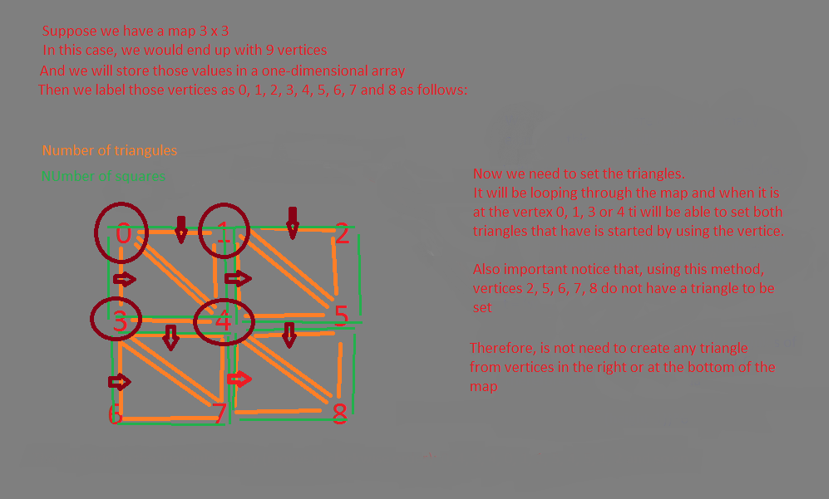

In the if statement (x < width – 1 && y < height -1) we are simply ignoring the right and bottom values of the map as shown in the figure above. Then we can add the two triangles that the square is made of, by following the rule in the chart below:

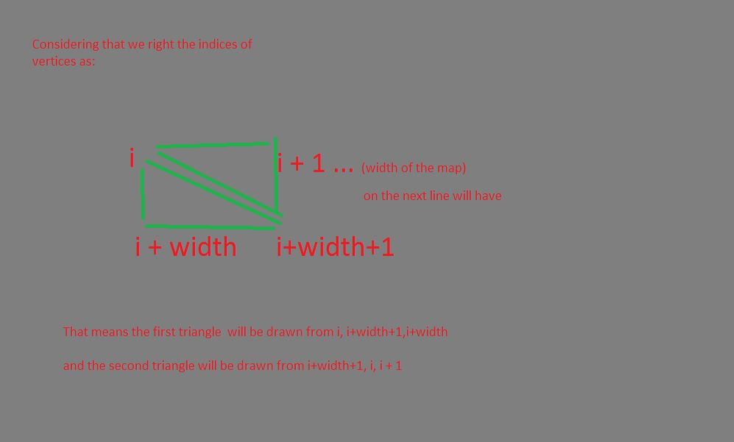

public static MeshData TerrainMeshCreator(float [,] heightMap, float heightValueMultiplier, AnimationCurve trashHold)

{

int width = heightMap.GetLength(0);

int height = heightMap.GetLength(1);

float topLeftX = (width - 1) / -2f;

float topLeftZ = (height - 1) / 2f;

MeshData meshData = new MeshData(width, height);

int vertexIndex = 0;

// Need a loop to go through the heightMap

for(int y = 0; y < height; y++)

{

for(int x = 0; x < width; x++)

{

meshData.vertices[vertexIndex] = new Vector3(topLeftX + x, trashHold.Evaluate(heightMap[x, y]) * heightValueMultiplier, topLeftZ - y);

meshData.uvs[vertexIndex] = new Vector2(x / (float)width, y / (float)height);

if(x < width -1 && y < height - 1)

{

meshData.AddTriangule(vertexIndex, vertexIndex + width + 1, vertexIndex + width);

meshData.AddTriangule(vertexIndex + width + 1, vertexIndex, vertexIndex + 1);

}

vertexIndex++;

}

}

return meshData;

}

## 4.1.7 Mesh Data

This class stores most of the data-structure to create the mesh of the program, with exception of the noise values.

It declares a vector3 array of vertices, to store obviously, the vertices of a given triangle. It also declares a variable to store the triangles in an integer array and a vector2 array to store the UV, also known as texture coordinates (to differentiate of the XYZ world coordinates).

A quick explanation about UV map extract from the online source <http://blenderartists.org/forum/archive/index.php/t-173777.html> last visited on 16/08/2016.

*The UV map contains a polygon (which, by definition, is "flat") for every face (which is also "flat") of the object.  
  
The location of the face, on the object, is expressed using (X, Y, Z) coordinates.  
  
The location of the polygon, on the image, is (U, V, [W]).  
  
So, to find what to draw onto any face, the computer consults the UV map. The polygon on the map, which corresponds to the face on the object, provides the location of the image-data that should be used.*

Then its constructor will initialize the declared variables mentioned above following the rules of this chart:

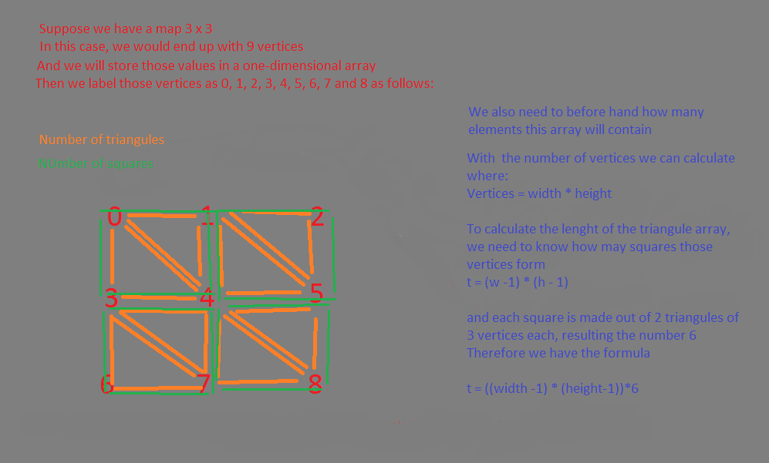

Where the size of the array of vertices is given by the formula vertices = width * height, same for the UV and the size of the triangles array is calculated by the formula:

(width – 1) * (height-1) * 6.

public Vector3[] vertices;

public int[] triangules;

// UV map to create textures in 2D to be applied to a 3D object

public Vector2[] uvs;

// to keep track of the current trianguloe index

int trianguleIndex;

public MeshData(int meshWidth, int meshHeight)

{

vertices = new Vector3[meshWidth * meshHeight];

//We need here an UV for each vertex

uvs = new Vector2[meshWidth * meshHeight];

// we need to know where it is each vertex in relation to the rest of the map

// as percentage of both x and y axis

// this percentage would be between 0 and 1

triangules = new int[(meshWidth - 1) * (meshHeight - 1) * 6];

}

The second part of the class is a function take three vertices and add then to form a triangle and then incrementing a variable that keeps track of the triangle index array.

public void AddTriangule (int firstVertice, int secondVertice, int thirdVertice)

{

triangules[trianguleIndex] = firstVertice;

triangules[trianguleIndex + 1] = secondVertice;

triangules[trianguleIndex + 2] = thirdVertice;

// increment the triangule index

trianguleIndex += 3;

}

In the last part of the class a create mesh function that returns a mesh object to its caller.

First it creates a reference to a mesh game object in Unity3D. Then it assigns the values of the vertices, triangles and UVs to a particular object at the time, use a build-in function in Unity3D to recalculate the normal for lighting and finally return the mesh.

public Mesh CreateMesh()

{

Mesh mesh = new Mesh();

mesh.vertices = vertices;

mesh.triangles = triangules;

mesh.uv = uvs;

mesh.RecalculateNormals(); // In order to light work properly

return mesh;

}

# 5 Testing

# 6 Evaluation

# 7 Conclusion

# A Reference

Togelius, J., Kastbjerg, E., Schedl, D., Yannakakis, G.N.: What is procedural content generation?: Mario on the borderline. In: Proceedings of the 2nd Workshop on Procedural Content Generation in Games (2011)

# B Bibliography

# C Screen Shots

# D C# Code